**ASSIGNMENT-16.1**

1. Given a list of numbers - List[Int] (1, 2, 3, 4, 5, 6, 7, 8, 9, 10)

- find the sum of all numbers

Spark to be run in local needs to have **setMaster** value set and that needs to be set to *local* for local runs. In the below screenshot,

* The List of integer input values are taken as input using parallelize.
* Iterate the list using *map* and sum it using *sum()*

**PROGRAM:**

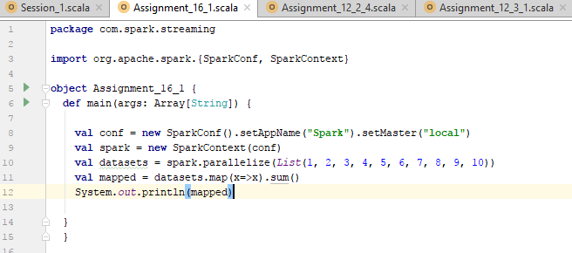

**RESULT:**

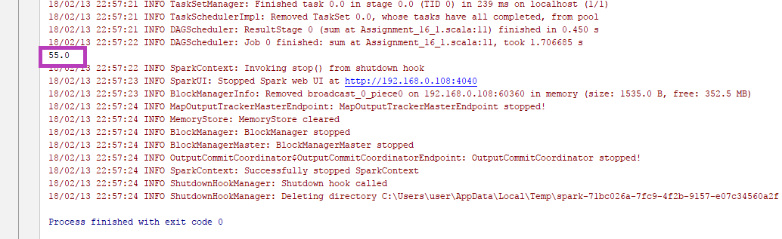

Solution is: 55.0

- find the total elements in the list

* Total elements are calculated using count

**PROGRAM:**

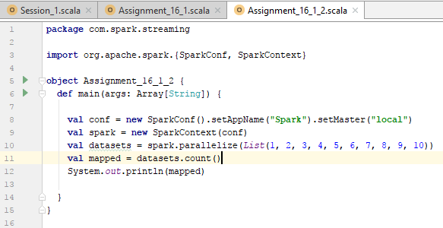

**RESULT:**

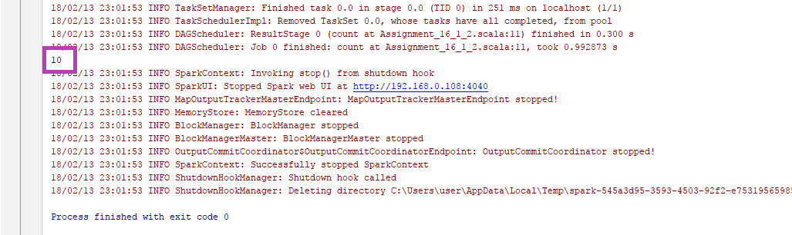

Solution is : 10

- calculate the average of the numbers in the list

* Sum is calculated using sum()
* Count is calculated using count and stored in variables
* The average is calculated by doing sum/count operation.

**PROGRAM:**

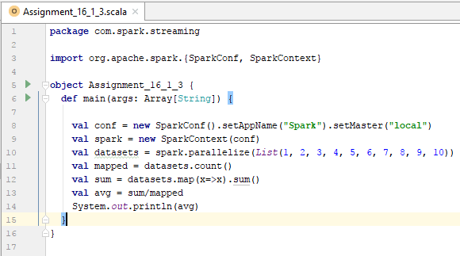

**RESULT:**

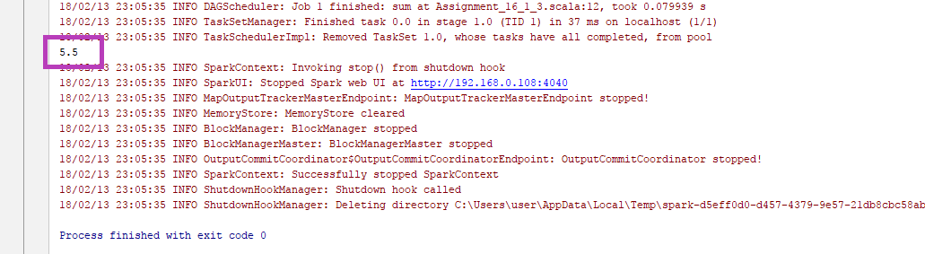

Solution is : 5.5

- find the sum of all the even numbers in the list

**PROGRAM:**

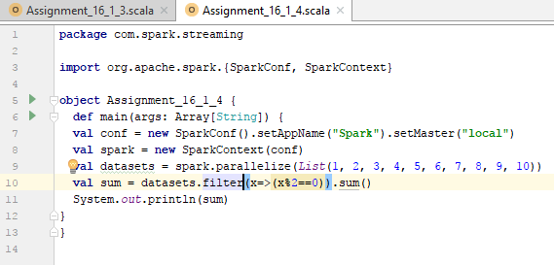

**RESULT:**

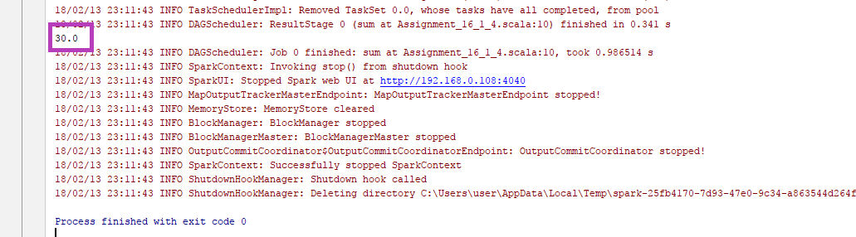

Solution is : 30

- find the total number of elements in the list divisible by both 5 and 3

**PROGRAM:**

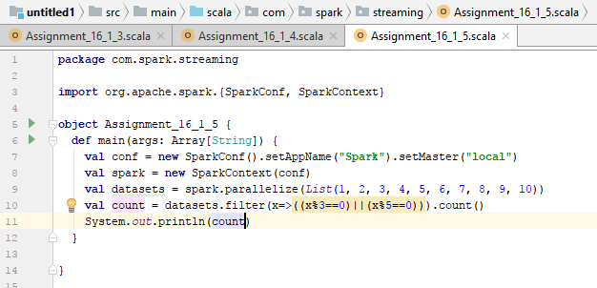

**RESULT:**

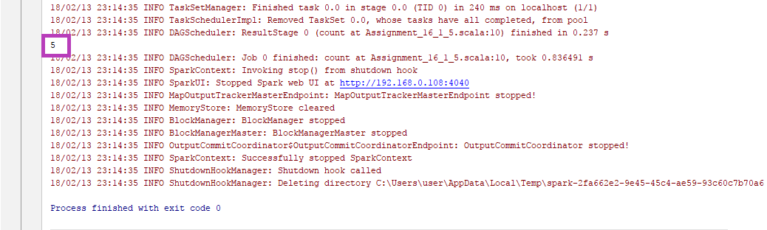

Solution is: 5