**ASSIGNMENT-18.1**

1) What is the distribution of the total number of air-travelers per year

2) What is the total air distance covered by each user per year

3) Which user has travelled the largest distance till date

4) What is the most preferred destination for all users.

**PROGRAM:**

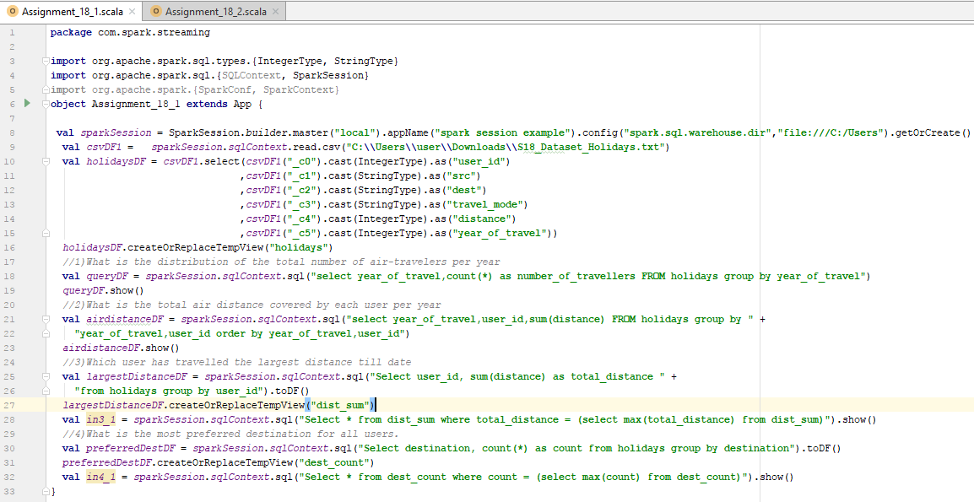

**RESULT -** What is the distribution of the total number of air-travelers per year

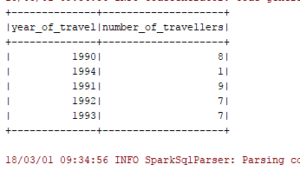

**RESULT -** What is the total air distance covered by each user per year

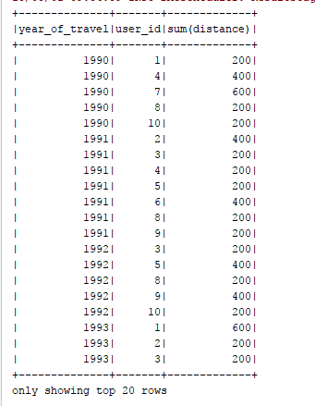

**RESULT -** Which user has travelled the largest distance till date

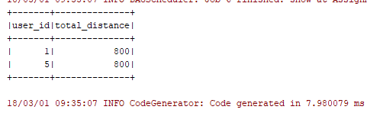

**RESULT -** What is the most preferred destination for all users.

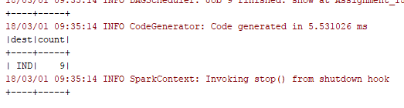

*Below is the program file for reference:*

**