**ASSIGNMENT-18.2**

1) Which route is generating the most revenue per year

2) What is the total amount spent by every user on air-travel per year

3) Considering age groups of < 20 , 20-35, 35 > ,Which age group is travelling the most

every year.

**PROGRAM –** *Text file data is stored in a view for analysis*

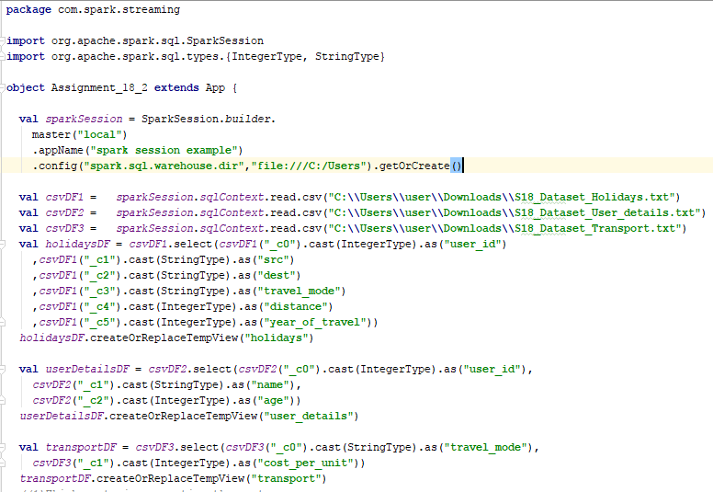

**PROGRAM –***Analysis Queries for the questions provided*

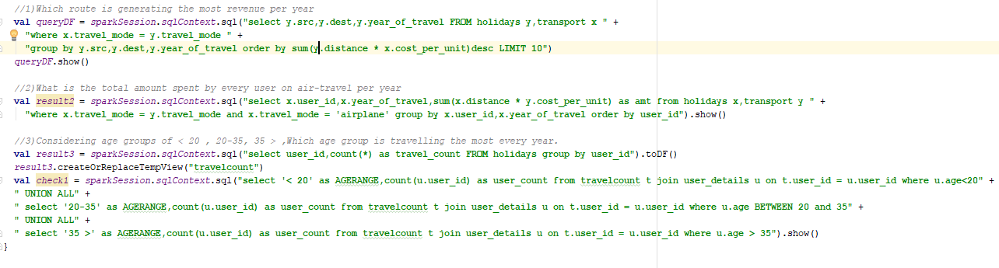

1. Which route is generating the most revenue per year

**QUERY:**

**val** *queryDF* = *sparkSession*.*sqlContext*.sql(**"select y.src,y.dest,y.year_of_travel FROM holidays y,transport x "** +  
 **"where x.travel_mode = y.travel_mode "** +  
 **"group by y.src,y.dest,y.year_of_travel order by sum(y.distance * x.cost_per_unit)desc LIMIT 10"**)  
*queryDF*.show()

**RESULT:**

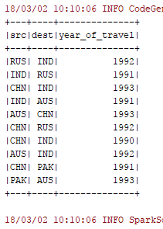

1. What is the total amount spent by every user on air-travel per year

**QUERY:**

**val** *result2* = *sparkSession*.*sqlContext*.sql(**"select x.user_id,x.year_of_travel,sum(x.distance * y.cost_per_unit) as amt from holidays x,transport y "** +  
 **"where x.travel_mode = y.travel_mode and x.travel_mode = 'airplane' group by x.user_id,x.year_of_travel order by user_id"**).show()

**RESULT:**

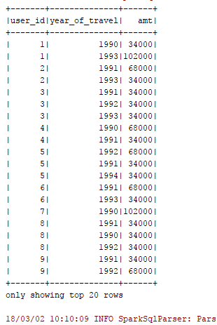

1. Considering age groups of < 20 , 20-35, 35 > ,Which age group is travelling the most

every year.

**QUERY:**

**val** *result3* = *sparkSession*.*sqlContext*.sql(**"select user_id,count(*) as travel_count FROM holidays group by user_id"**).toDF()  
*result3*.createOrReplaceTempView(**"travelcount"**)  
**val** *check1* = *sparkSession*.*sqlContext*.sql(**"select '< 20' as AGERANGE,count(u.user_id) as user_count from travelcount t join user_details u on t.user_id = u.user_id where u.age<20"** +  
**" UNION ALL"** +  
**" select '20-35' as AGERANGE,count(u.user_id) as user_count from travelcount t join user_details u on t.user_id = u.user_id where u.age BETWEEN 20 and 35"** +  
**" UNION ALL"** +  
**" select '35 >' as AGERANGE,count(u.user_id) as user_count from travelcount t join user_details u on t.user_id = u.user_id where u.age > 35"**).show()

**RESULT:**

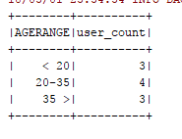

*Attached the below file for reference:*

**