**ASSIGNMENT-19.1**

Using spark-sql, Find:

1. What are the total number of gold medal winners every year

2. How many silver medals have been won by USA in each sport

**PROGRAM**

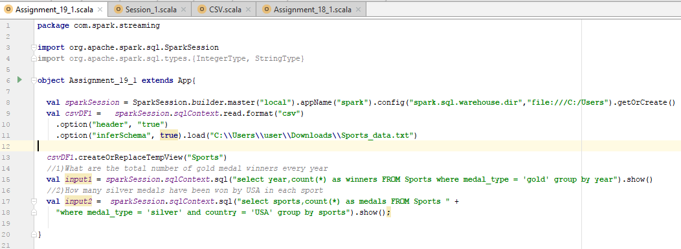

In the above program, as the headers are already provided in the file it need not be explicitly specified and the same can be used for analysis.

**RESULT -** What are the total number of gold medal winners every year

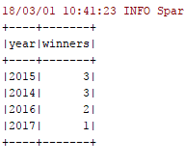

**RESULT -** How many silver medals have been won by USA in each sport

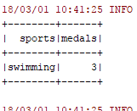

*Below is the file used and attached for reference:*

**