**ASSIGNMENT-19.3**

1. Create a dataframe with 1 to 100 and save as parquet file.

**PROGRAM SCREENSHOT:**

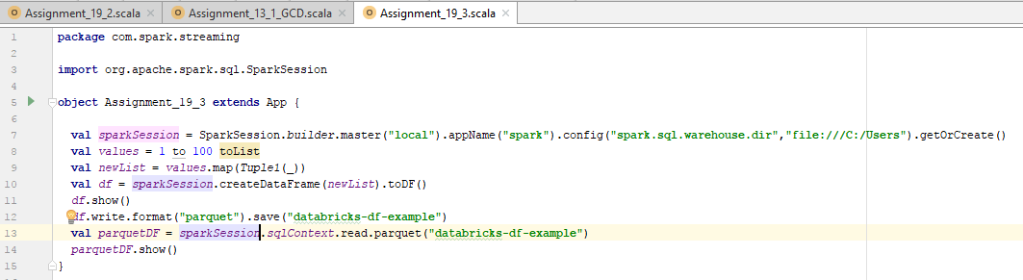

In the above program,

* sparkSession value is initialised.
* 1 to 100 values as a list is created and it is converted to map.
* The map values are created to dataframe.
* The values once converted to dataframe is written in the parquet format to the file.
* And the values are read using “**sparkSession.sqlContext.read.parquet(“ ”)**”

**RESULT –** *Dataframe displayed below in the screenshot*

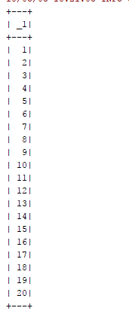

**RESULT –** *Parquet file schema below:*

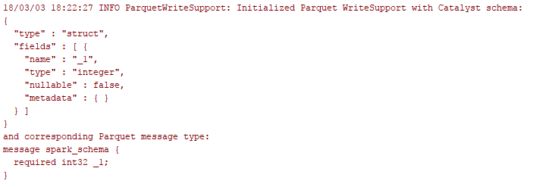

*Attached files for reference:*

**