**ASSIGNMENT – 2.1**

1. Creating /user/acadgild/hadoop directory. Checking if the hadoop directory exists using –ls command in Hadoop. Creating directory /user/acadgild/hadoop usinh mkdir command.

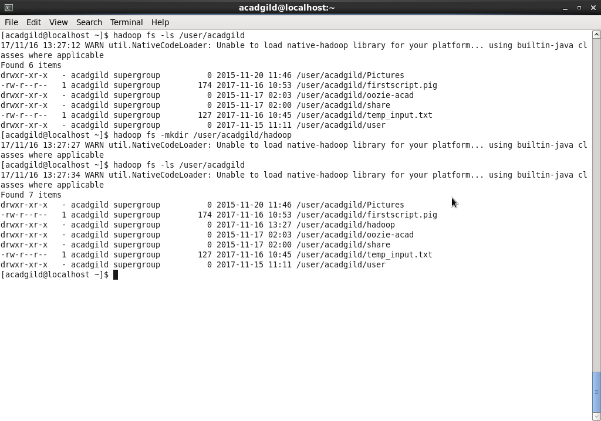

1. File word-count.txt is created in /user/acadgild/hadoop directory. The size of the file is initially zero. The contents are appended to the file and the file is not empty now.

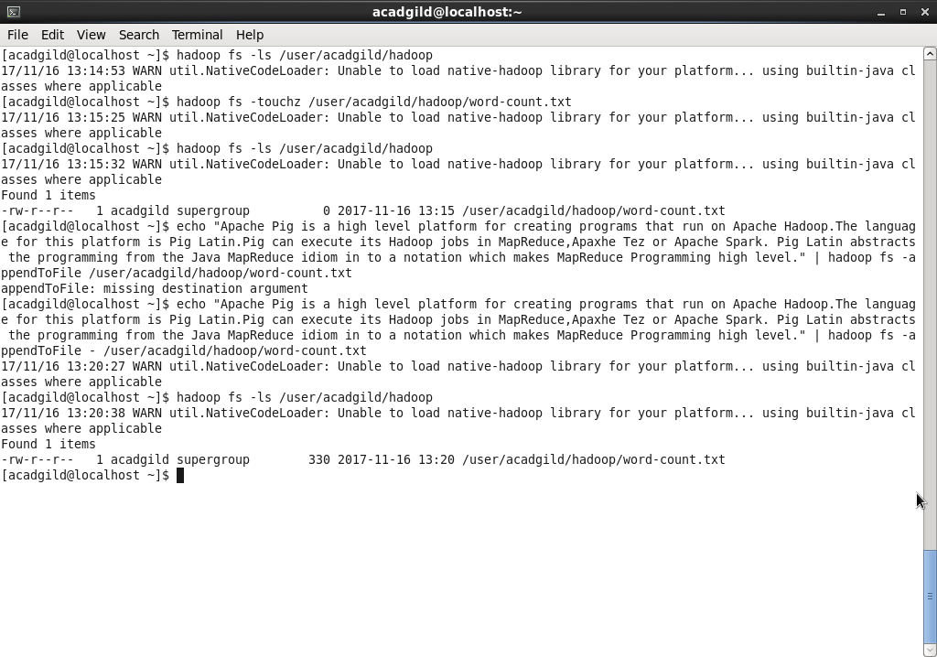

1. Contents of word-count.txt file

