**ASSIGNMENT-2.2**

1. Create a file in Local file system and move it to hadoop file system.

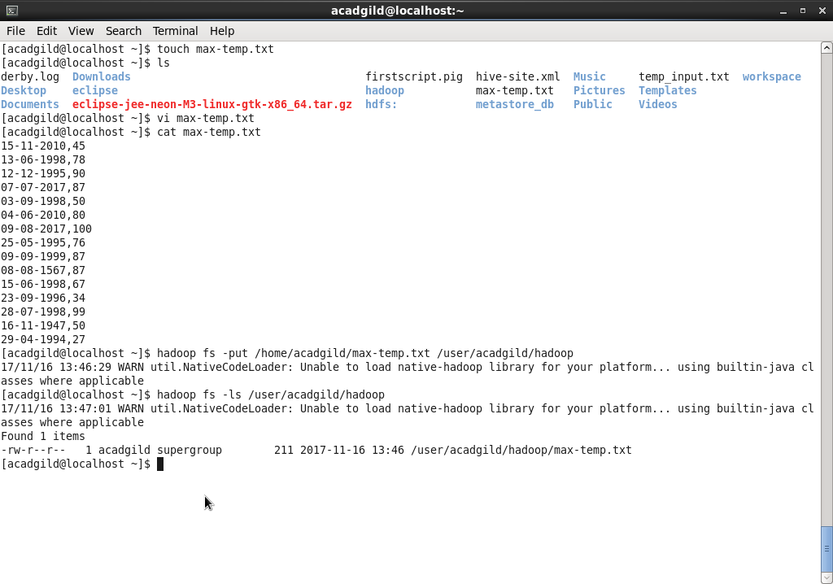

1. Changing file permissions giving owner and group full permissions and revoking permission for others.

