**ASSIGNMENT – 4.3**

1. Input file to calculate word count:

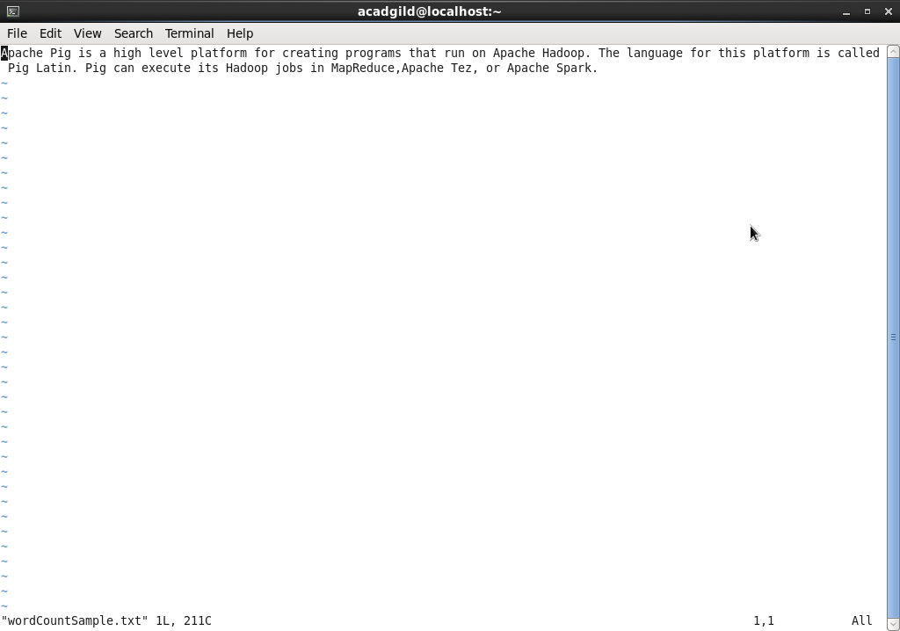

1. Pig Script to calculate wordcount

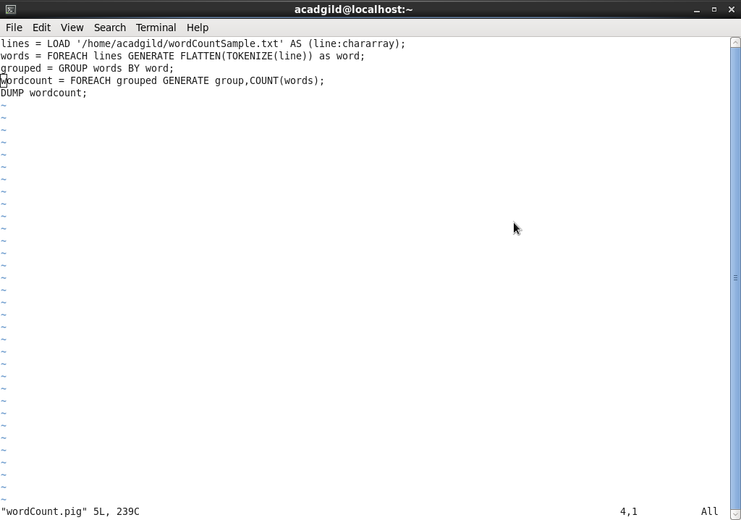

1. Run pig in local mode and the output generated is:

