**ASSIGNMENT-5.1**

1. Top 5 employees (employee id and employee name) with highest rating. (In case two

employees have same rating, employee with name coming first in dictionary should get

preference)

**PIG LATIN SCRIPT:**

*emp_group = GROUP emp_details by rating;*

*emp_5 = FOREACH emp_group {*

*da = ORDER emp_details BY rating DESC,name;*

*db = LIMIT da 1;*

*GENERATE FLATTEN(group), FLATTEN(db.id), FLATTEN(db.name);*

*}*

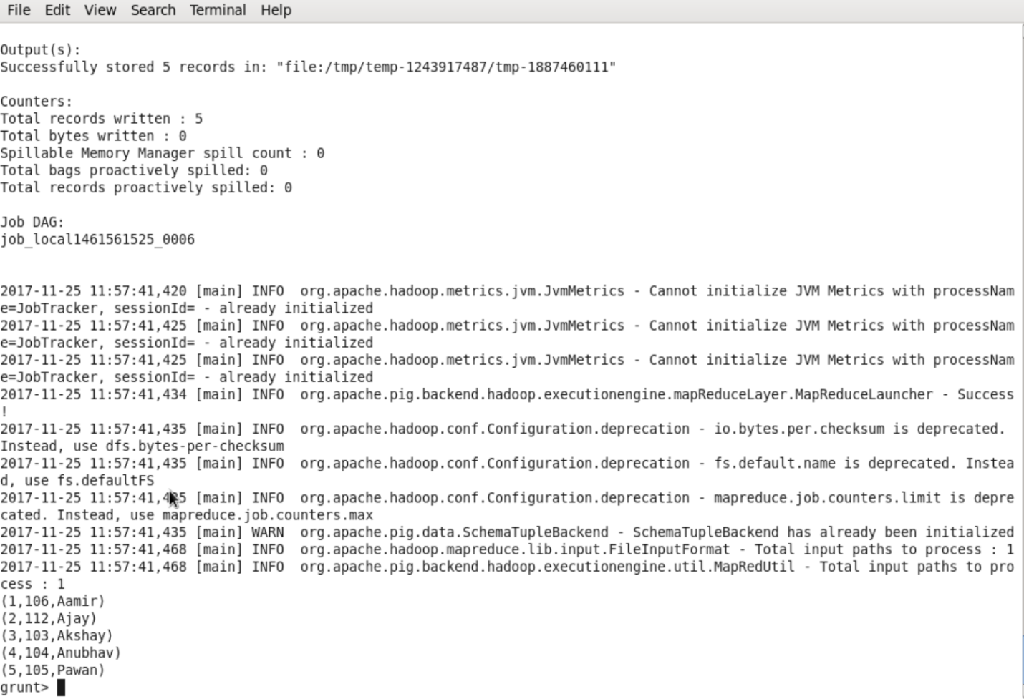

1. Top 3 employees (employee id and employee name) with highest salary, whose employee id is an odd number. (In case two employees have same salary, employee with name coming first in dictionary should get preference)

**PIG LATIN SCRIPT:**

*emp_odd = FILTER emp_details BY (id%2 !=0);*

*emp_odd_order = ORDER emp_odd BY salary desc, name;*

*emp = LIMIT emp_odd_order 3;*

*emp_result = FOREACH emp GENERATE id, name;*

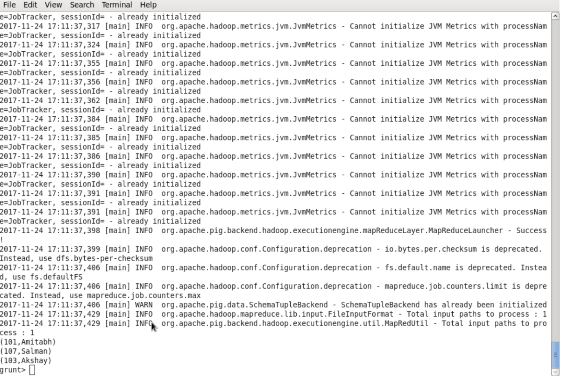

1. Employee (employee id and employee name) with maximum expense (In case two

employees have same expense, employee with name coming first in dictionary should get preference).

**PIG LATIN SCRIPT:**

*A = JOIN emp_details BY id, emp_expenses BY id;*

*B = ORDER A BY expense DESC, name;*

*C = LIMIT B 1;*

*D = FOREACH C GENERATE emp_details::id, name;*

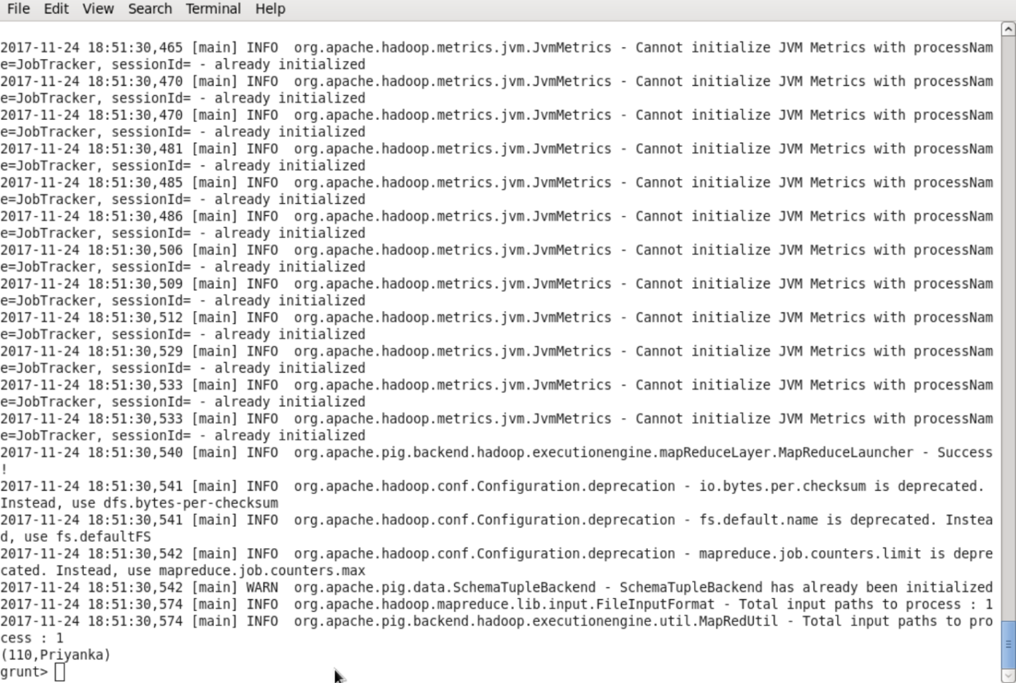

1. List of employees (employee id and employee name) having entries in employee_expenses file.

**PIG LATIN SCRIPT:**

*joined = JOIN emp_details BY id, emp_expenses BY id;*

*emp = FOREACH joined GENERATE emp_details::id, name;*

*emp_data = DISTINCT emp;*

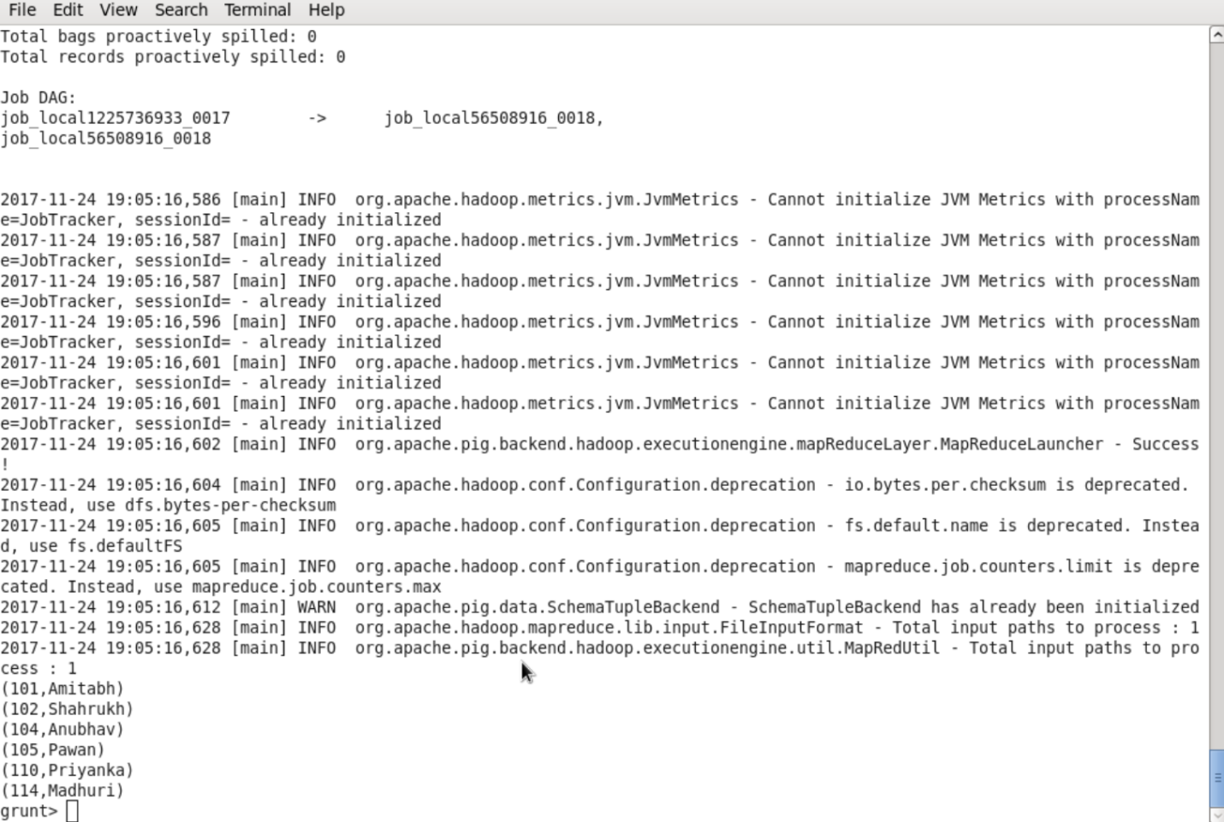

1. List of employees (employee id and employee name) having no entry in employee_expenses file.

**PIG LATIN SCRIPT:**

*joined = JOIN emp_details BY id, emp_expenses BY id;*

*a = FILTER joined BY IsEmpty(emp_expenses);*

*b = FOREACH a GENERATE FLATTEN(emp_details.id), FLATTEN(emp_details.name);*

