**ASSIGNMENT-5.2**

1. Find out the top 5 most visited destinations.

**QUERY 1:**

*REGISTER '/usr/local/pig/lib/piggybank.jar';*

*A = load 'DelayedFlights.csv' USING org.apache.pig.piggybank.storage.CSVExcelStorage(',','NO_MULTILINE','UNIX','SKIP_INPUT_HEADER');*

*A_LIMIT = LIMIT A 5;*

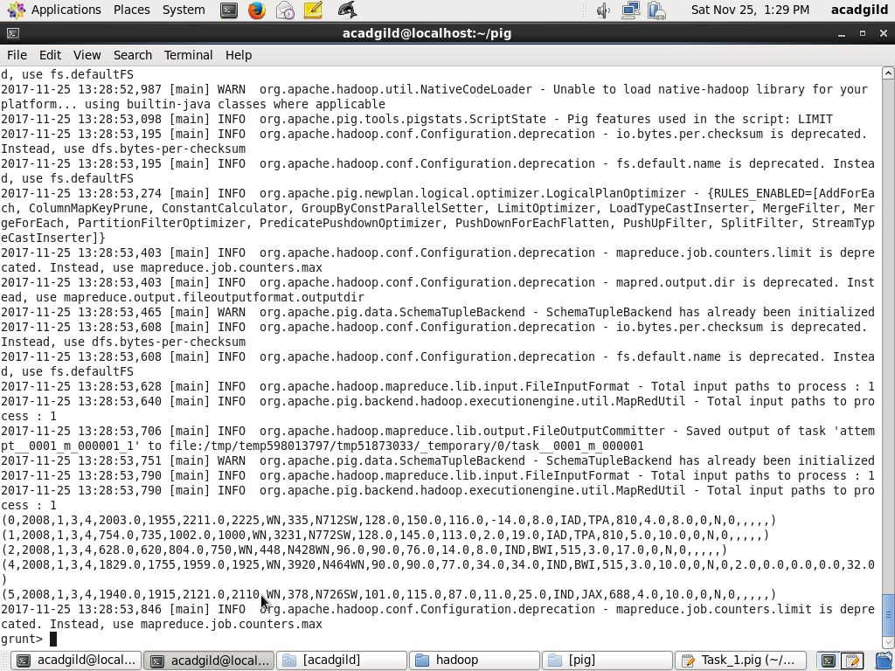

*B = foreach A generate (int)$1 as year, (int)$10 as flight_num, (chararray)$17 as origin,(chararray) $18 as dest;*

*B_LIMIT = LIMIT B 5;*

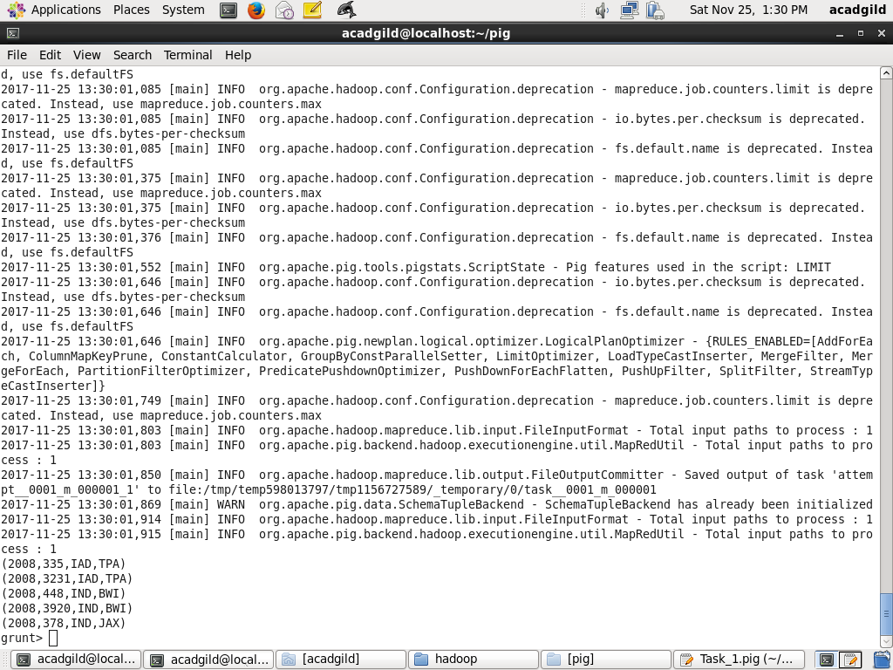

*C = filter B by dest is not null;*

*C_LIMIT = LIMIT C 15;*

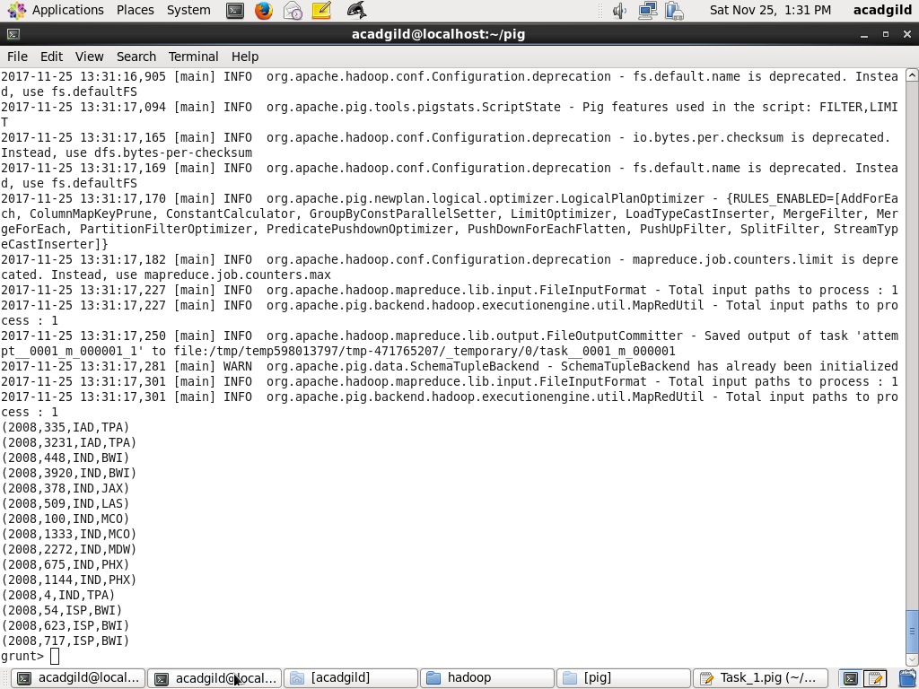

*D = group C by dest;*

*D_LIMIT = LIMIT D 15;*

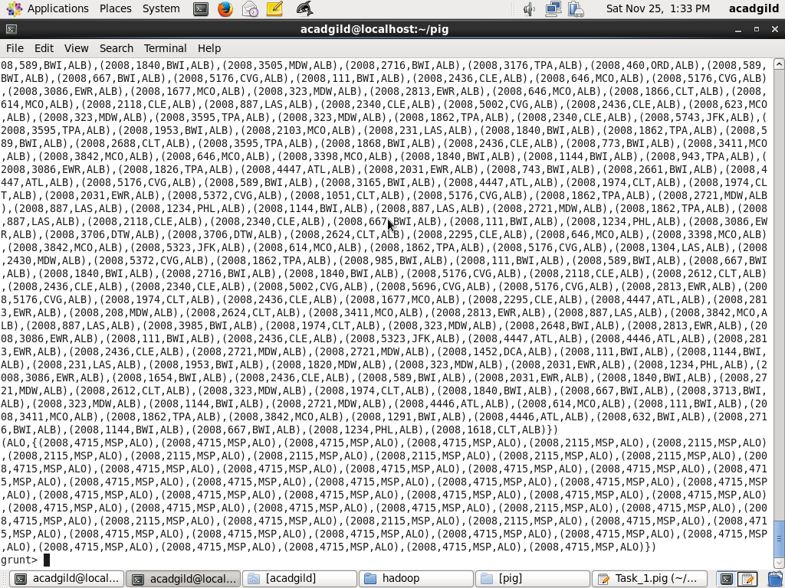

*E = foreach D generate group, COUNT(C.dest);*

*E_LIMIT = LIMIT E 15;*

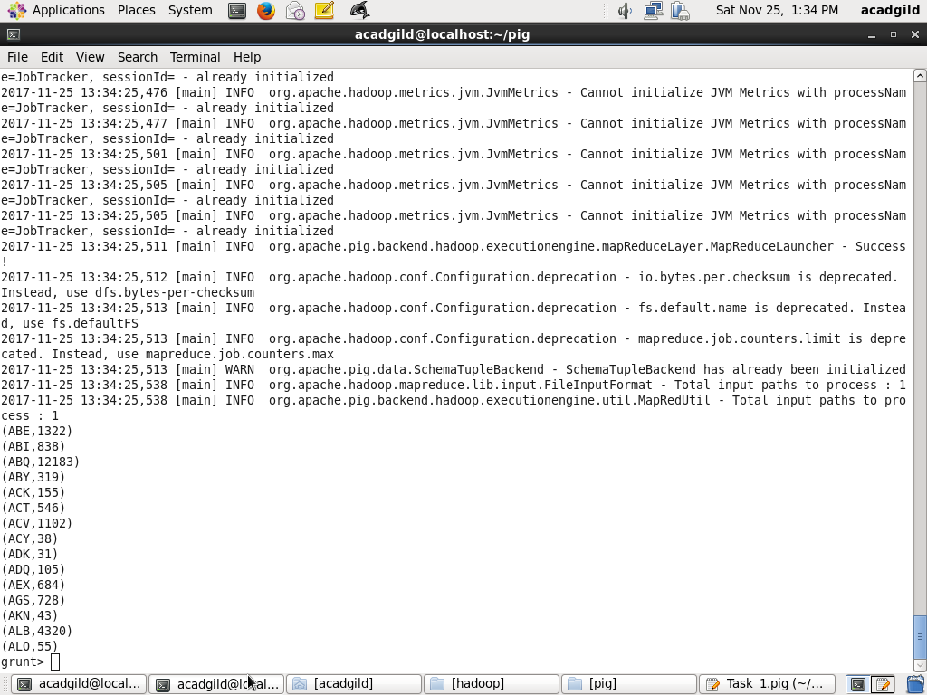

*F = order E by $1 DESC;*

*Result = LIMIT F 5;*

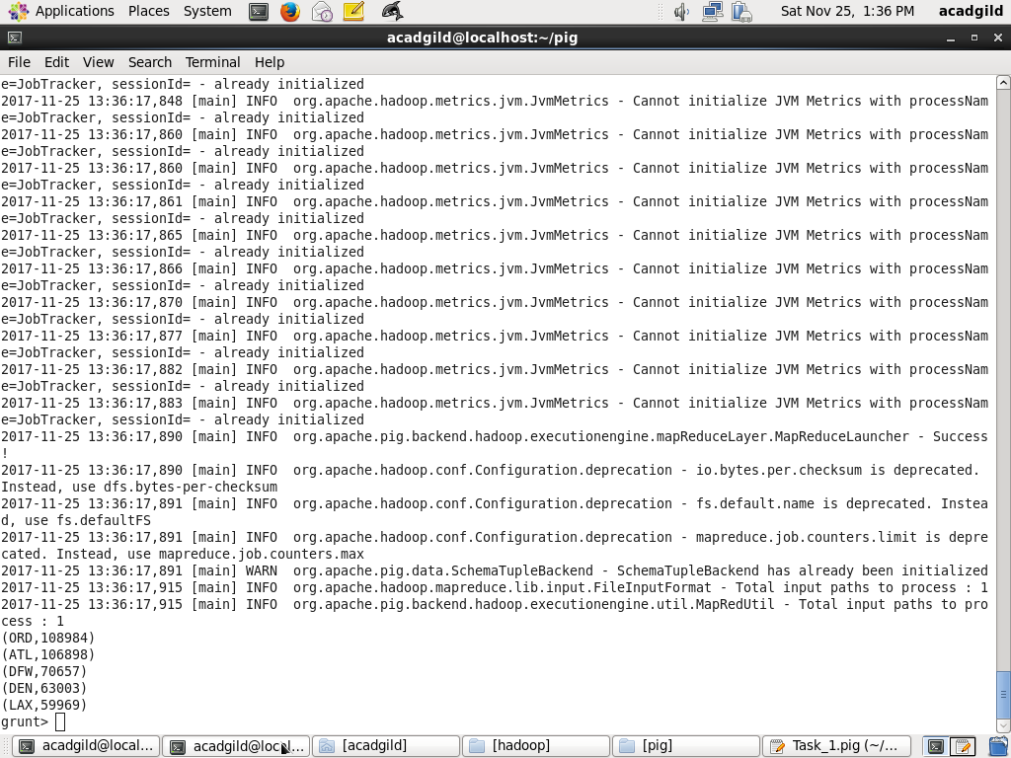

*A1 = load 'airports.csv' USING org.apache.pig.piggybank.storage.CSVExcelStorage(',','NO_MULTILINE','UNIX','SKIP_INPUT_HEADER');*

*A2 = foreach A1 generate (chararray)$0 as dest, (chararray)$2 as city, (chararray)$4 as country;*

*joined_table = join Result by $0, A2 by dest;*

*dump joined_table;*

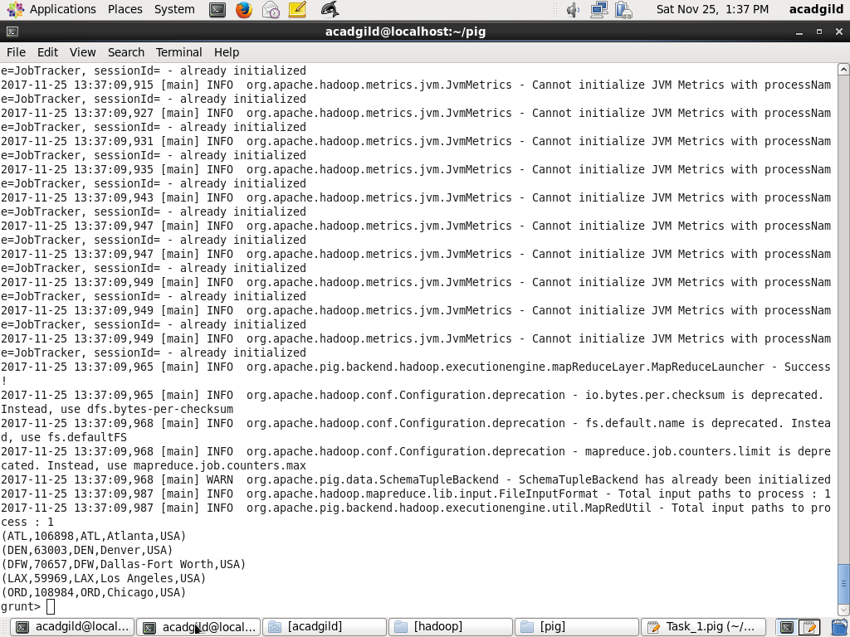

1. Which month has seen the most number of cancellations due to bad weather?

*REGISTER '/usr/local/pig/lib/piggybank.jar';*

*A = load 'DelayedFlights.csv' USING org.apache.pig.piggybank.storage.CSVExcelStorage(',','NO_MULTILINE','UNIX','SKIP_INPUT_HEADER');*

*A_LIMIT = LIMIT A 5;*

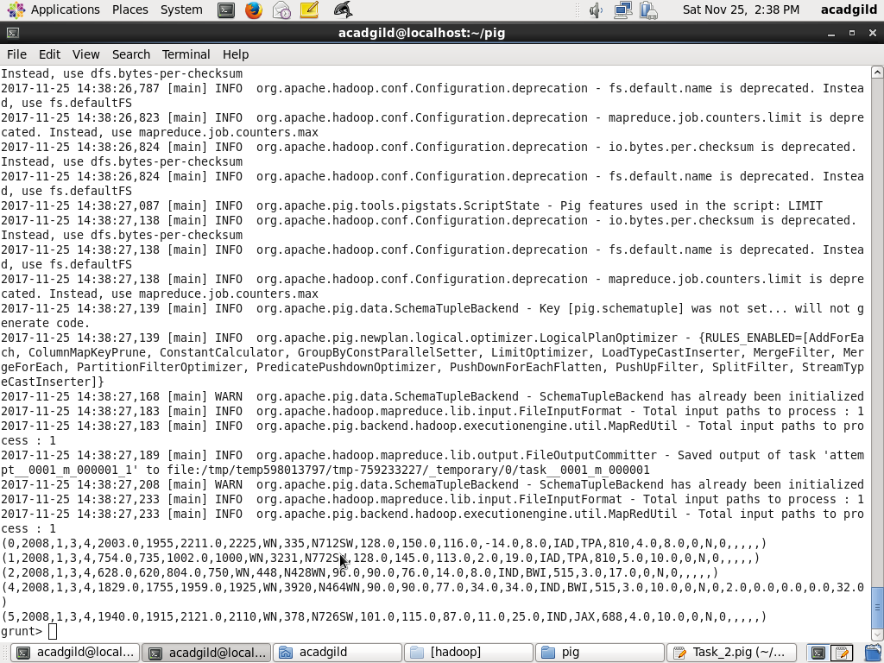

*B = foreach A generate (int)$2 as month,(int)$10 as flight_num,(int)$22 as cancelled,(chararray)$23 as cancel_code;*

*B_LIMIT = LIMIT B 5;*

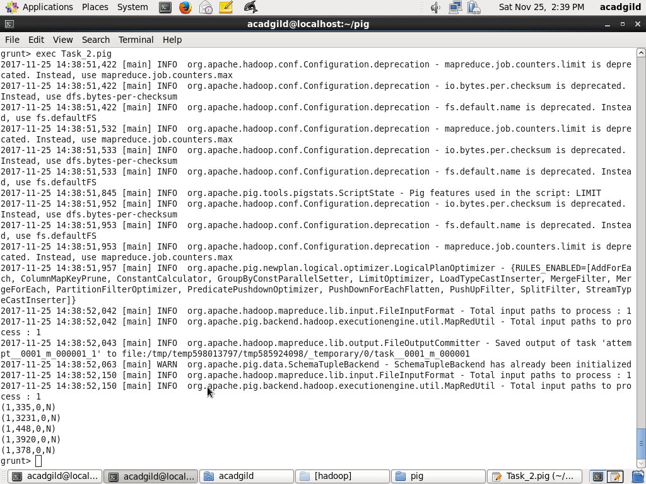

*C = filter B by cancelled == 1 AND cancel_code =='B';*

*C_LIMIT = LIMIT C 5;*

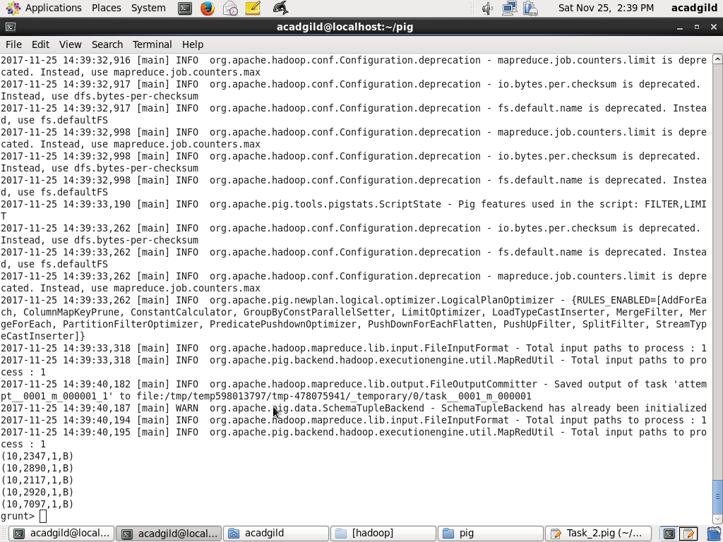

*D = group C by month;*

*D_LIMIT = LIMIT D 5;*

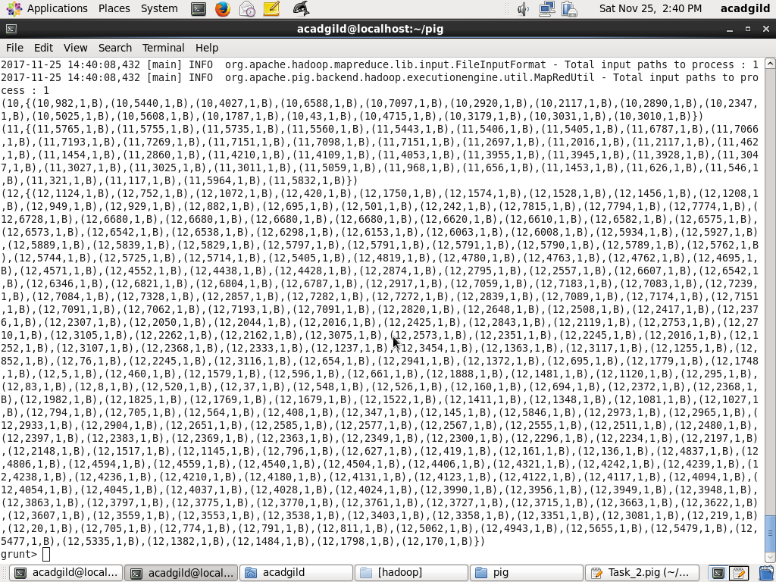

*E = foreach D generate group, COUNT(C.cancelled);*

*E_LIMIT = LIMIT E 5;*

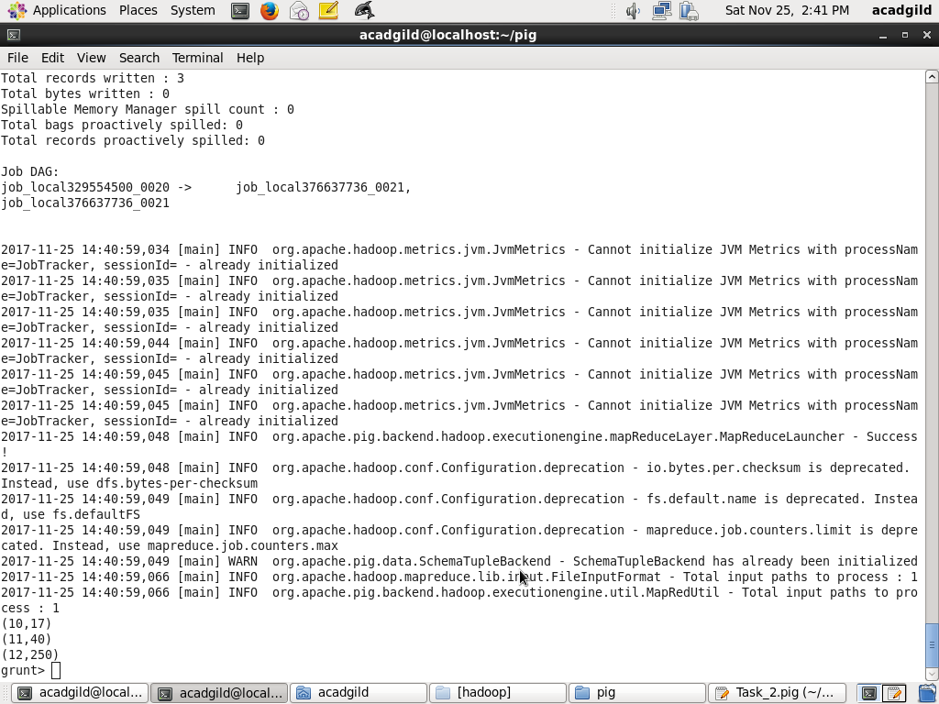

*F= order E by $1 DESC;*

*Result = limit F 1;*

*dump Result;*

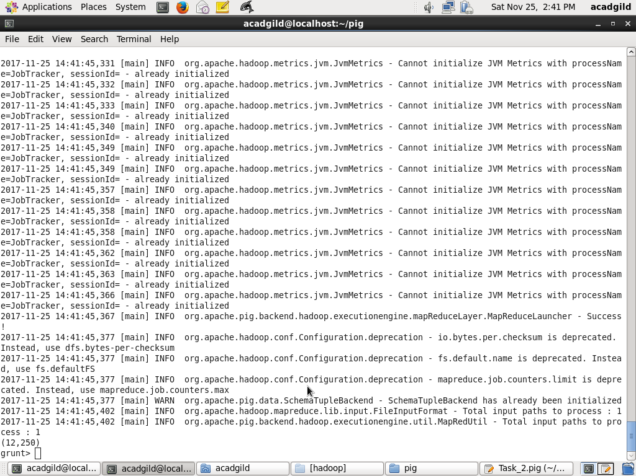

1. Top 10 origins with the highest average departure delay

*REGISTER '/usr/local/pig/lib/piggybank.jar';*

*A = load 'DelayedFlights.csv' USING org.apache.pig.piggybank.storage.CSVExcelStorage(',','NO_MULTILINE','UNIX','SKIP_INPUT_HEADER');*

*A_LIMIT = LIMIT A 5;*

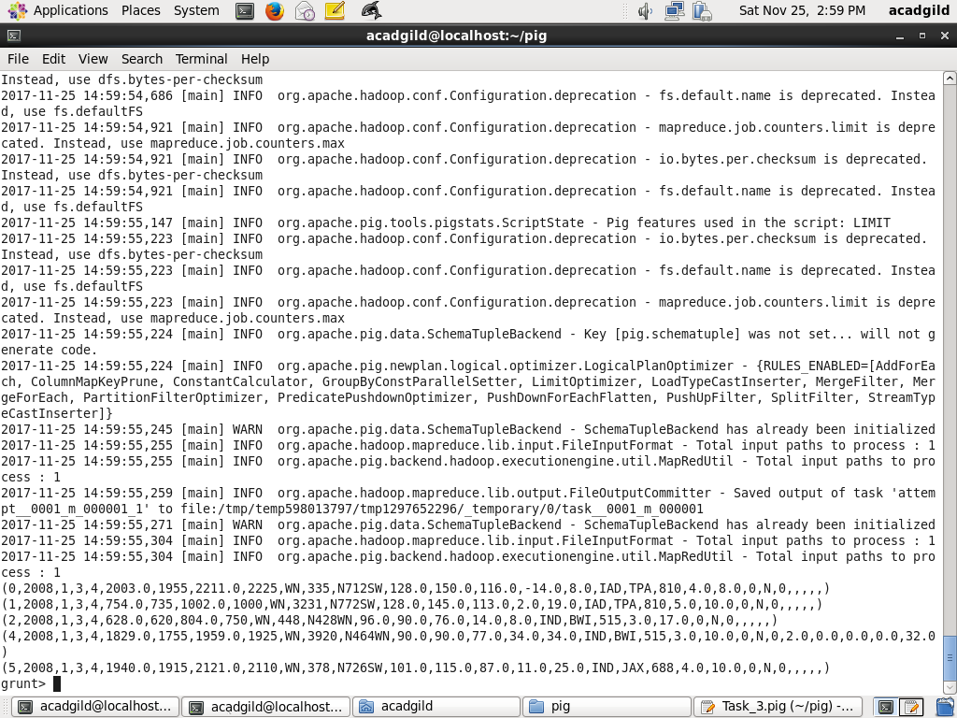

*B1 = foreach A generate (int)$16 as dep_delay, (chararray)$17 as origin;*

*B1_LIMIT = LIMIT B1 5;*

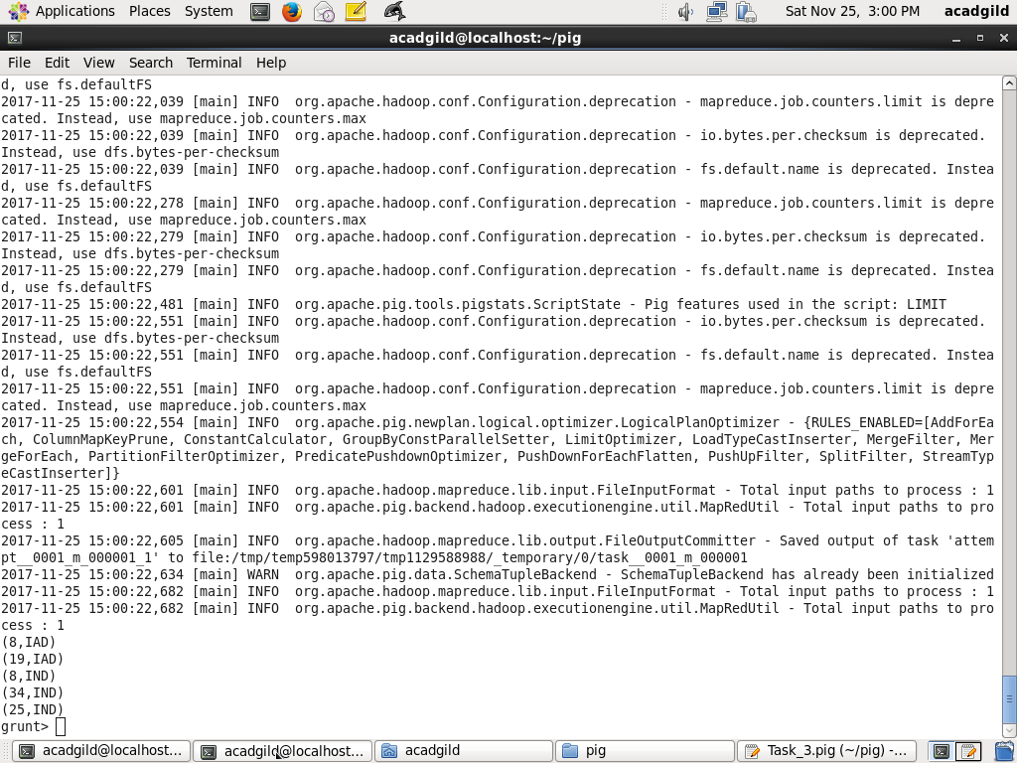

*C1 = filter B1 by (dep_delay is not null) AND (origin is not null);*

*C1_LIMIT = LIMIT C1 5;*

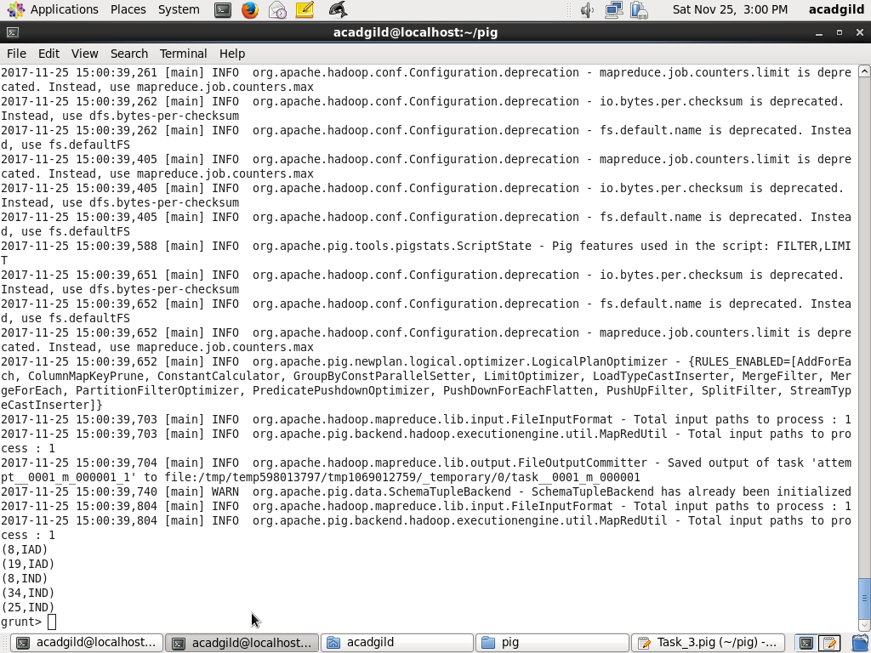

*D1 = group C1 by origin;*

*D1_LIMIT = LIMIT D1 5;*

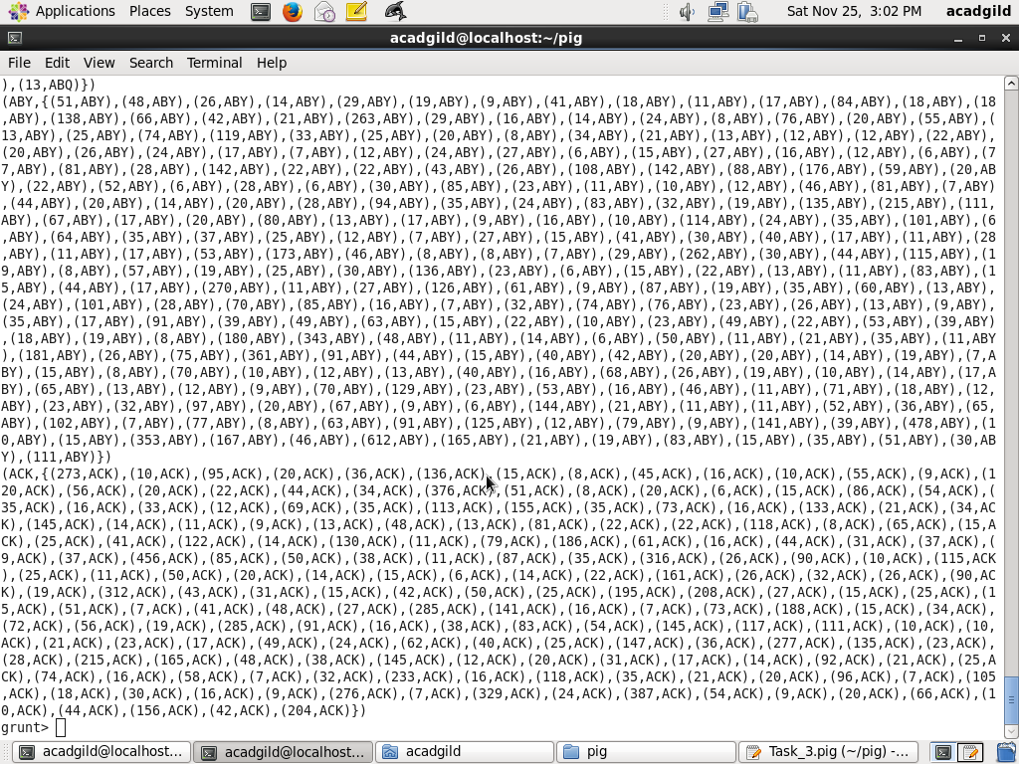

*E1 = foreach D1 generate group, AVG(C1.dep_delay);*

*Result = order E1 by $1 DESC;*

*Top_ten = limit Result 10;*

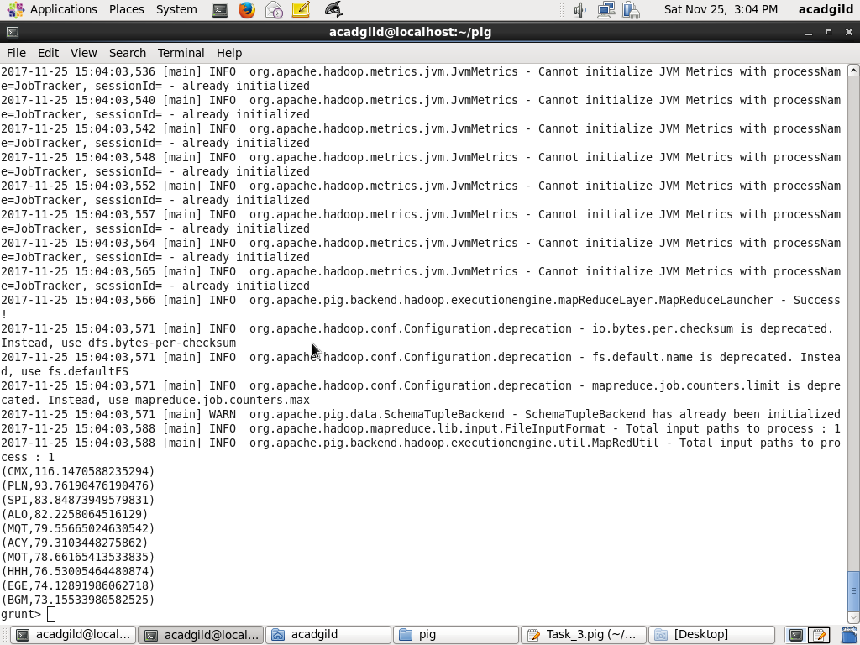

*Lookup = load 'airports.csv' USING org.apache.pig.piggybank.storage.CSVExcelStorage(',','NO_MULTILINE','UNIX','SKIP_INPUT_HEADER');*

*Lookup1 = foreach Lookup generate (chararray)$0 as origin, (chararray)$2 as city, (chararray)$4 as country;*

*Joined = join Lookup1 by origin, Top_ten by $0;*

*Final = foreach Joined generate $0,$1,$2,$4;*

*Final_Result = ORDER Final by $3 DESC;*

*dump Final_Result;*

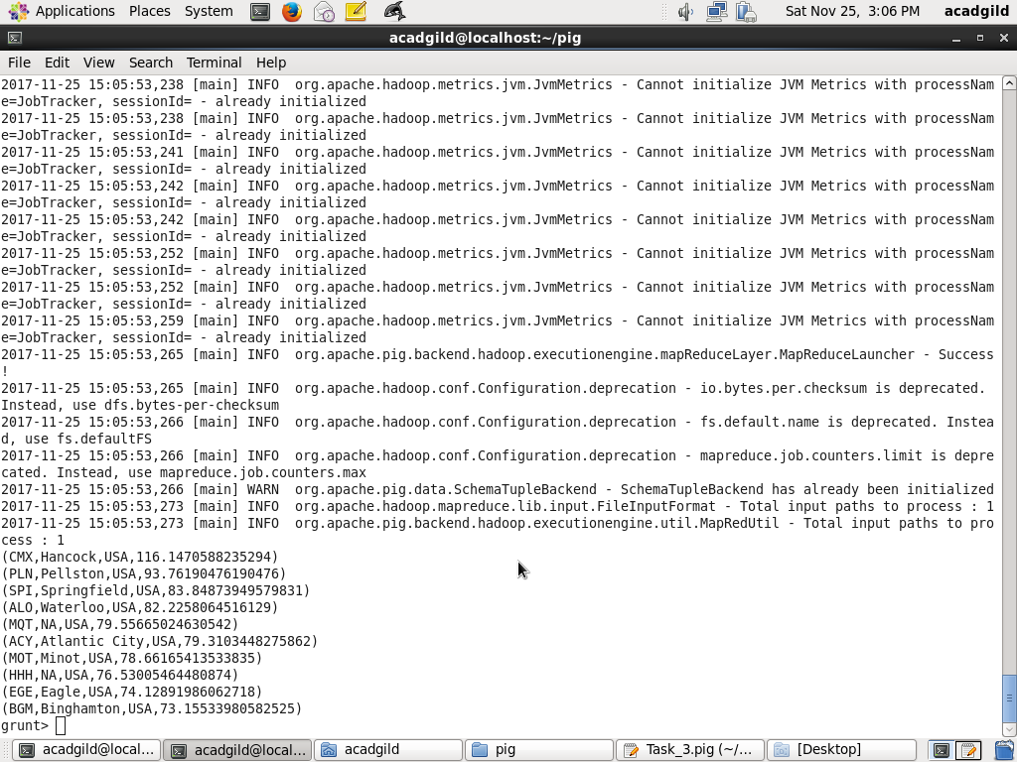

1. Which route (origin & destination) has seen the maximum diversion?

