ASSIGNMENT 5.3

PROBLEM: To form two lists of 5 randomly selected Pokémons with some parameters set by the management.

## Ques 1: Find the list of players that have been selected in the qualifying round (DEFENCE>55).

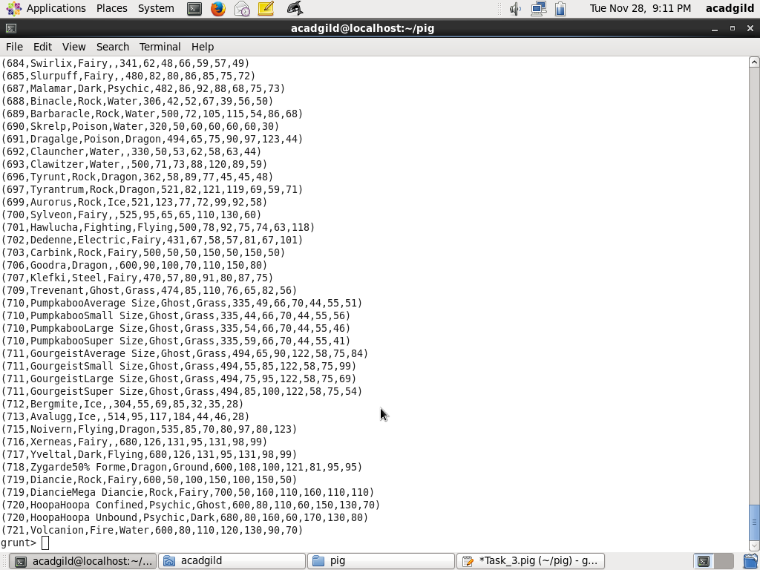

## Ques 2: State the number of players taking part in the competition after getting selected in the qualifying round.

## Ques 3: Using random() generate random numbers for each Pokémon on the selected list.

## Ques 4: Arrange the new list in a descending order according to a column randomly.

### Ques: Now on a new relation again associate random numbers for each Pokémon and arrange in descending order according to column random.

### Ques: From the two different descending lists of random Pokémons, select the top 5 Pokémons for 2 different players.

### Ques: Store the data on a local drive to announce for the final match. By the name player1 and player2 (only show the NAME and HP).

