**ASSIGNMENT – 6.1**

1. Creating Database named **Custom**

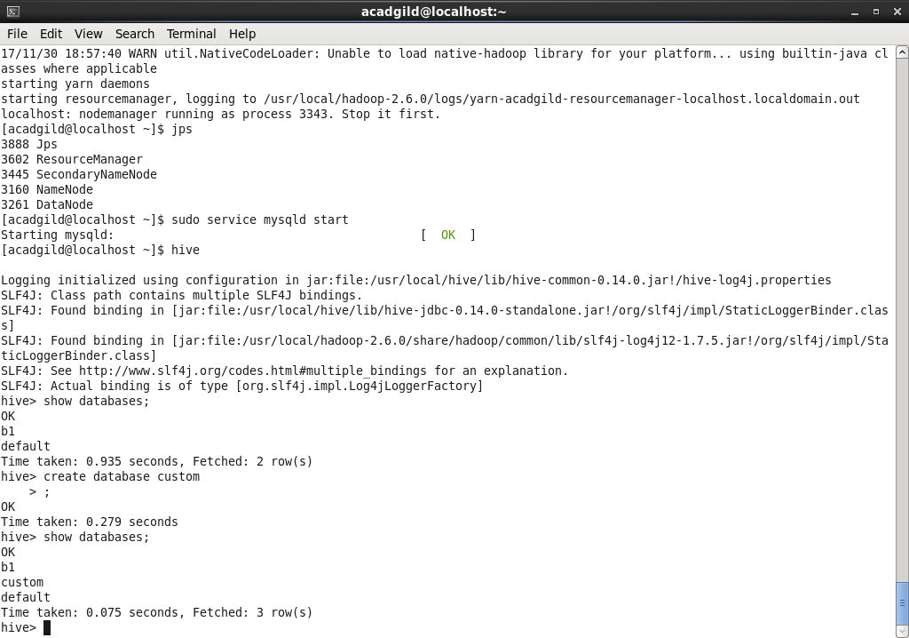

1. Create table **temperature_data**

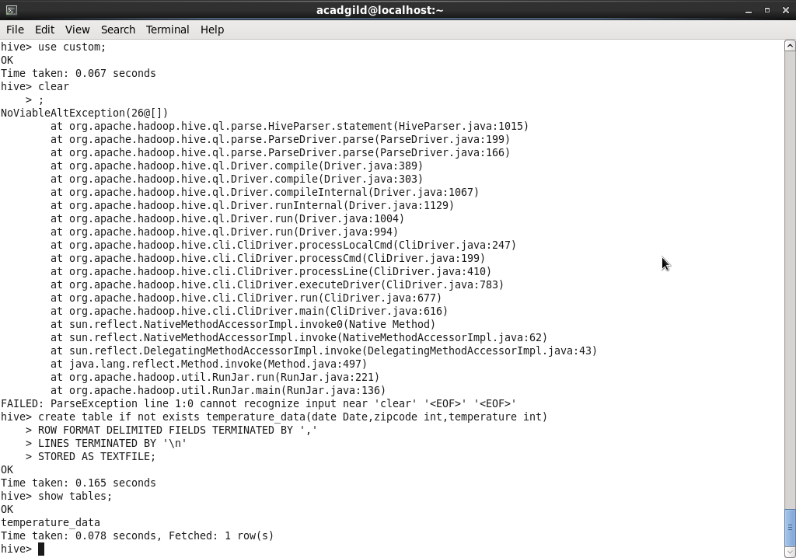.

1. Describe table **temperature_data**

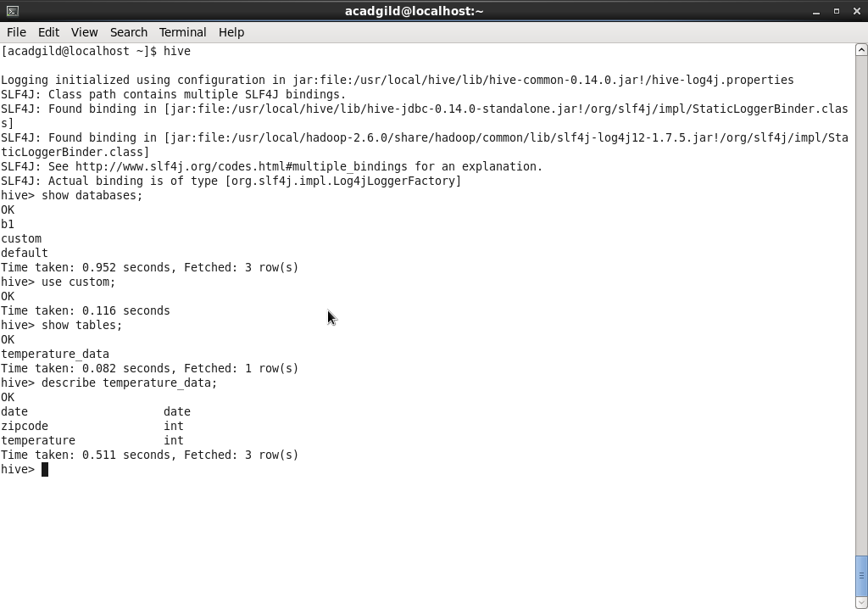

1. Load Table with the ‘,’ delimited file from local

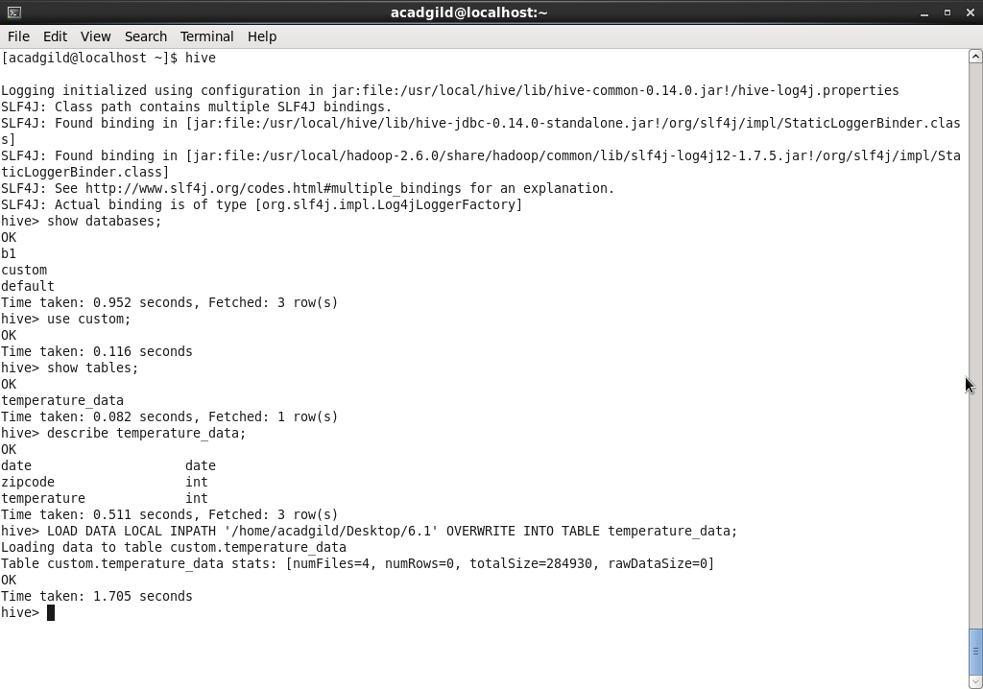

1. View the data loaded in table using select Query

