**ASSIGNMENT-7.1**

1. Calculate the number of employees corresponding to each skill from the table 'employee' which is loaded in the Demo.

Create table employee:

C:\Users\user\Desktop\Acadgild Assignments\Assignment-7.1\1.png

Load data from file in local filesystem:

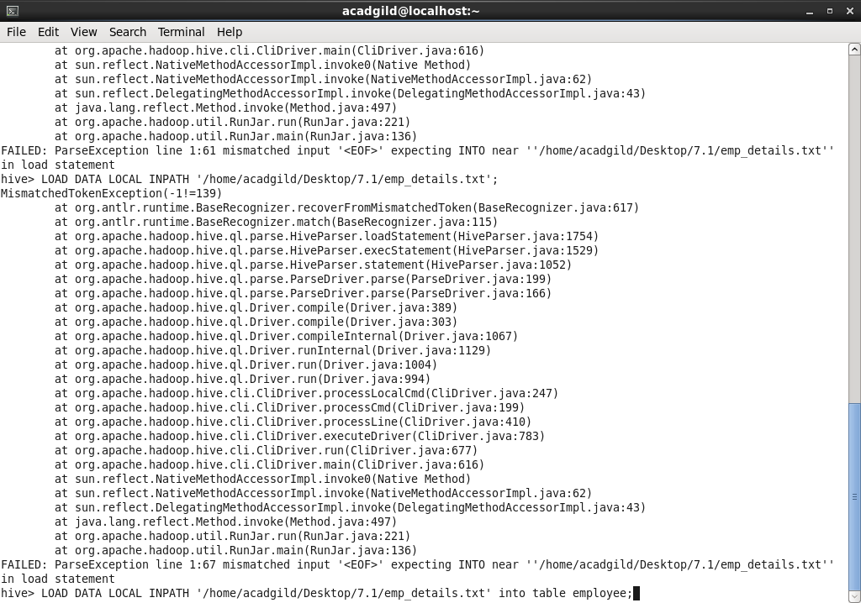

Check if the table is loaded successfully using select statement:

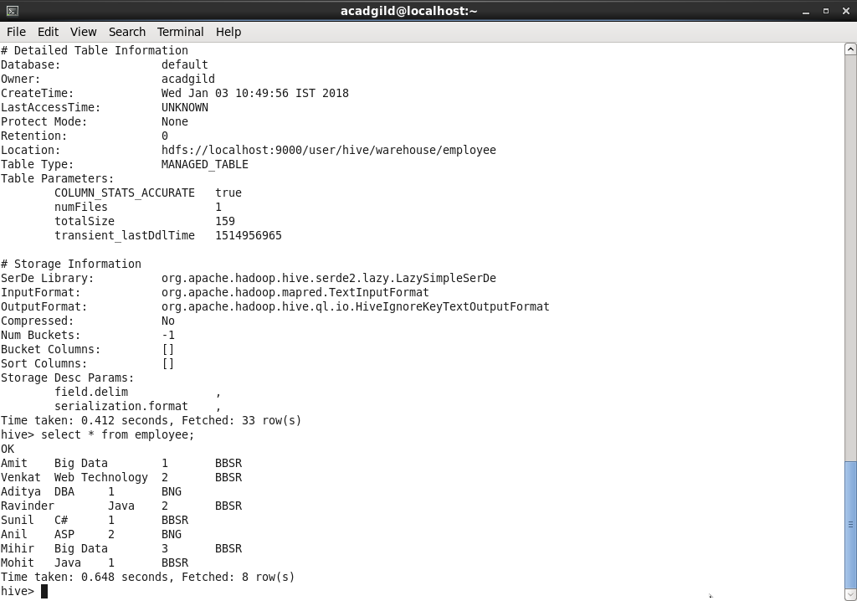

Number of employees corresponding to each skill:

