**ASSIGNMENT-7.2**

1. Write a Hive program to find the number of medals won by each country in swimming.

Query(Last Line):

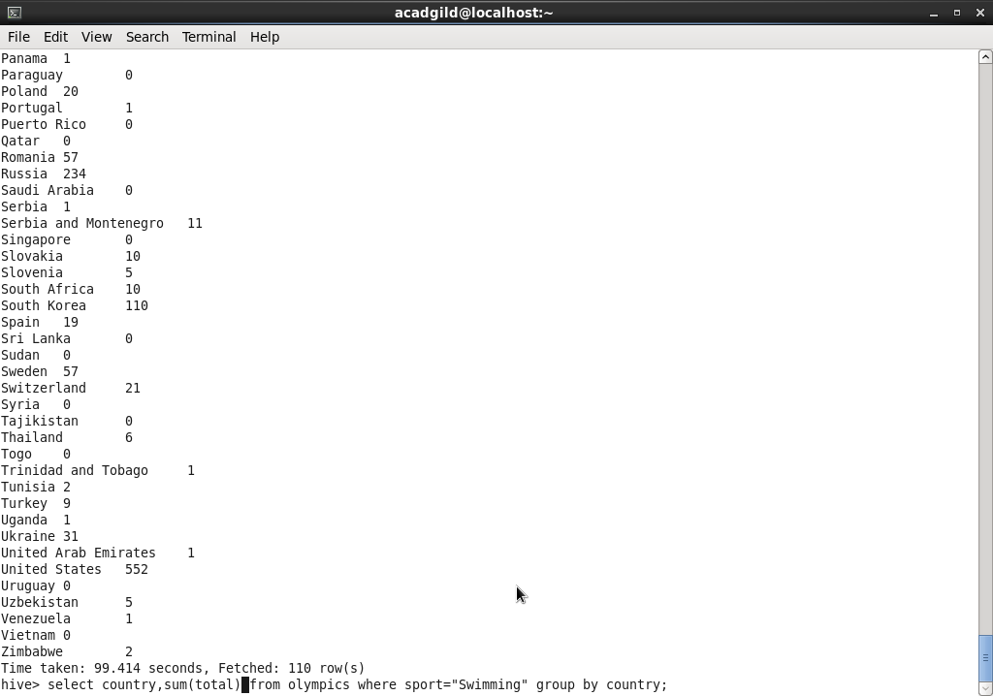

Result:

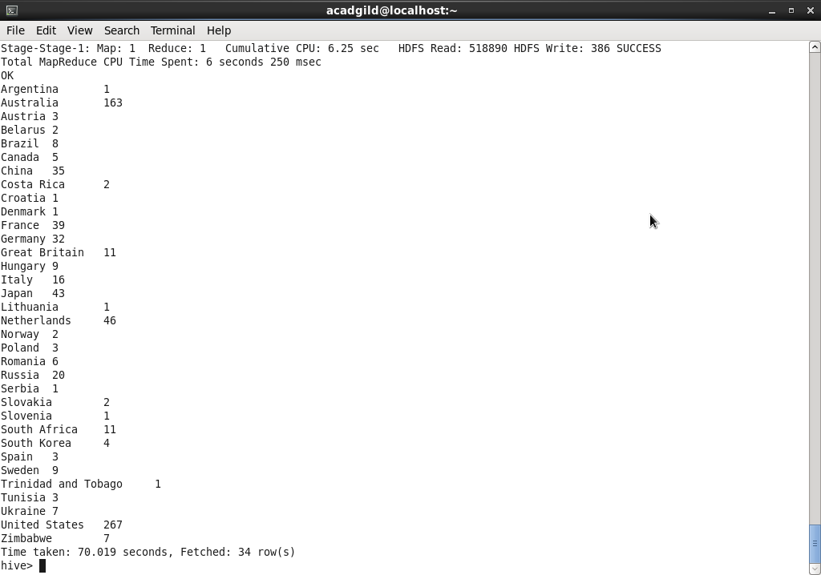

1. Write a Hive program to find the number of medals that India won year wise.

Query:

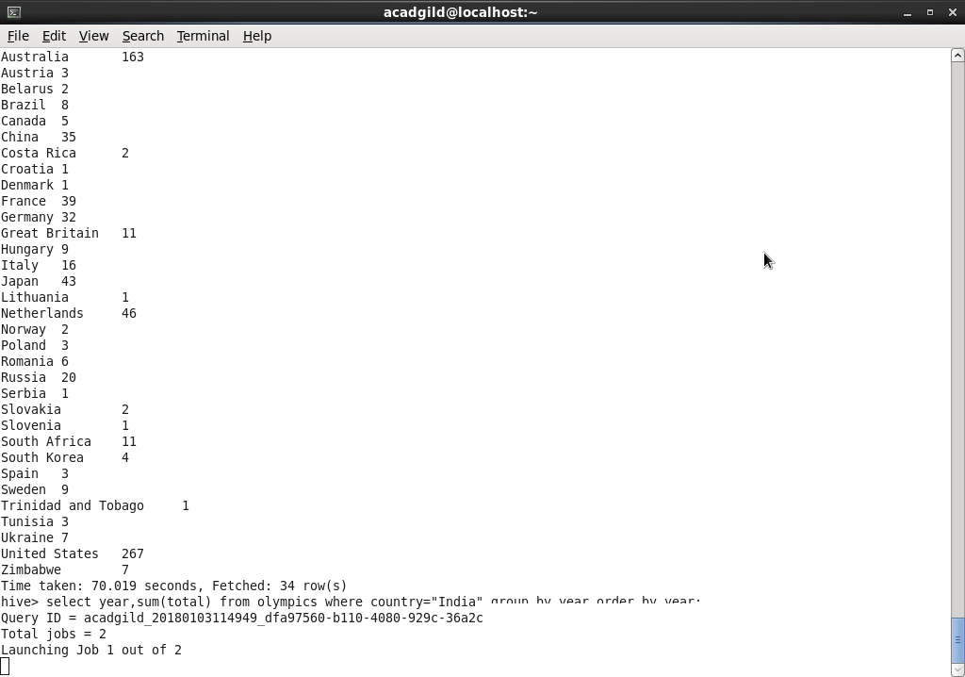

Result:

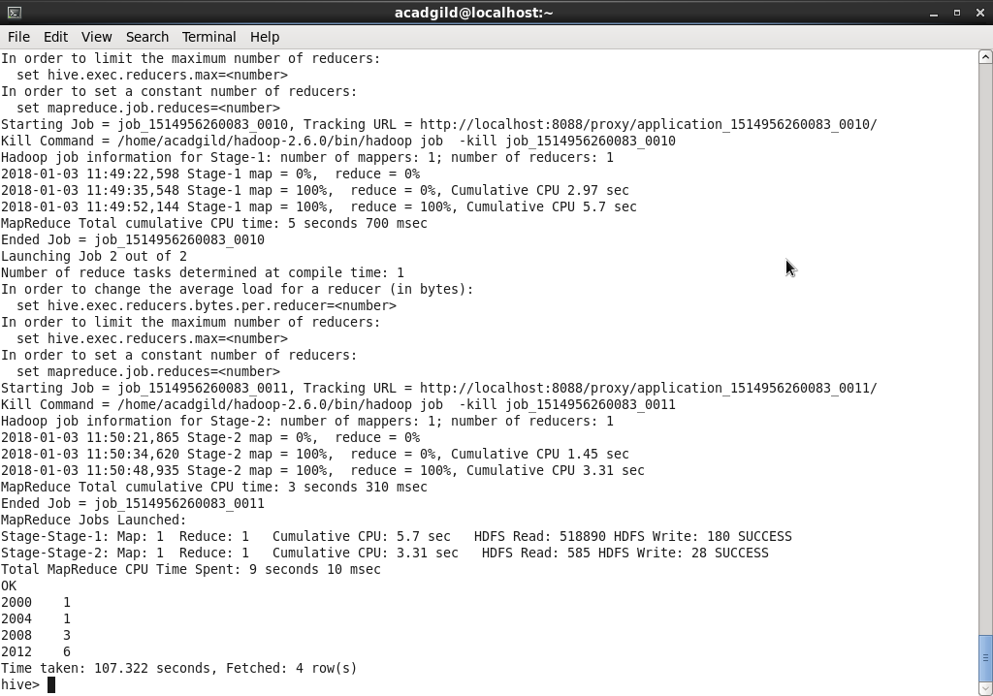

1. Write a Hive Program to find the total number of medals each country won.

Query:

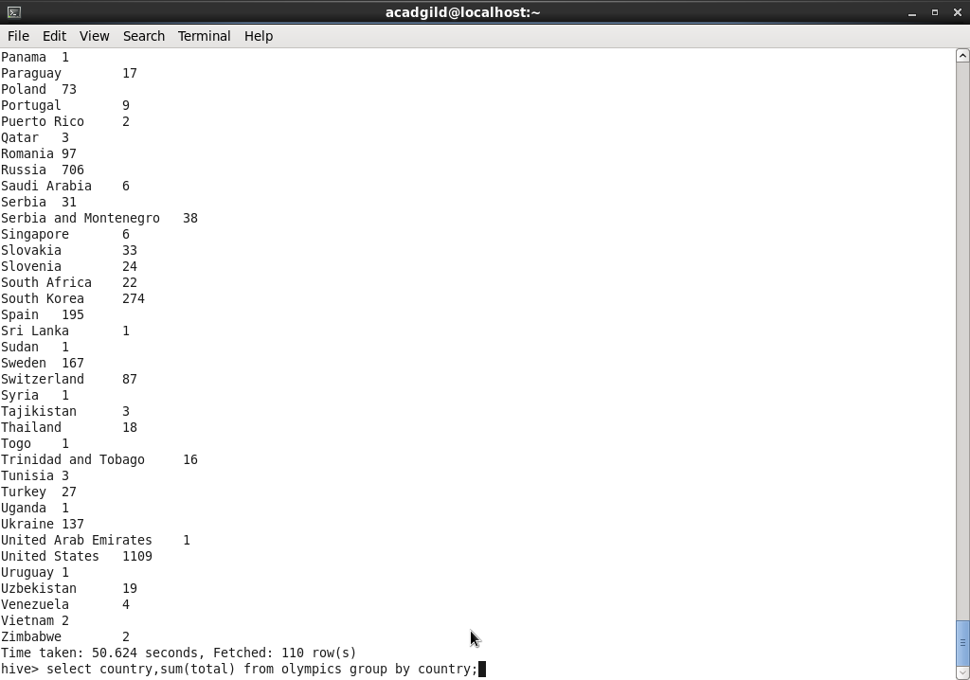

Result:

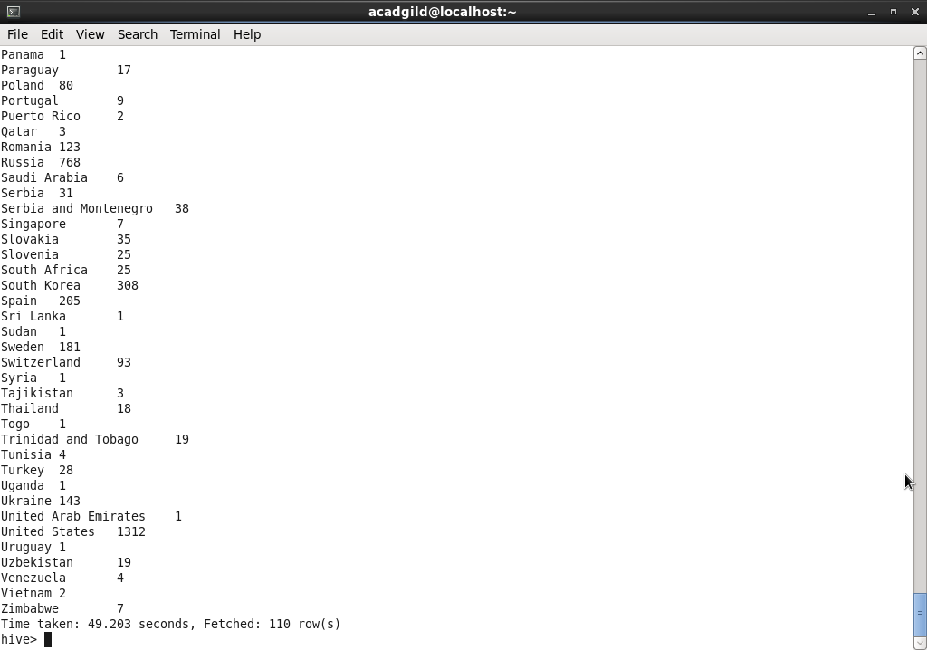

1. Write a Hive program to find the number of gold medals each country won.

Query:

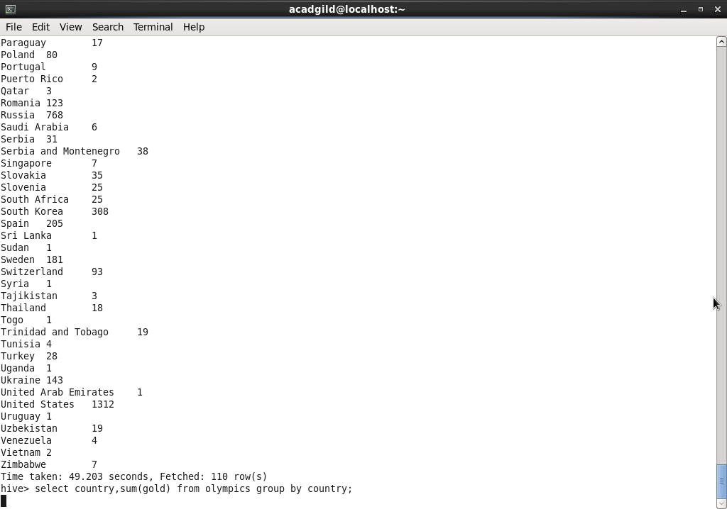

Result:

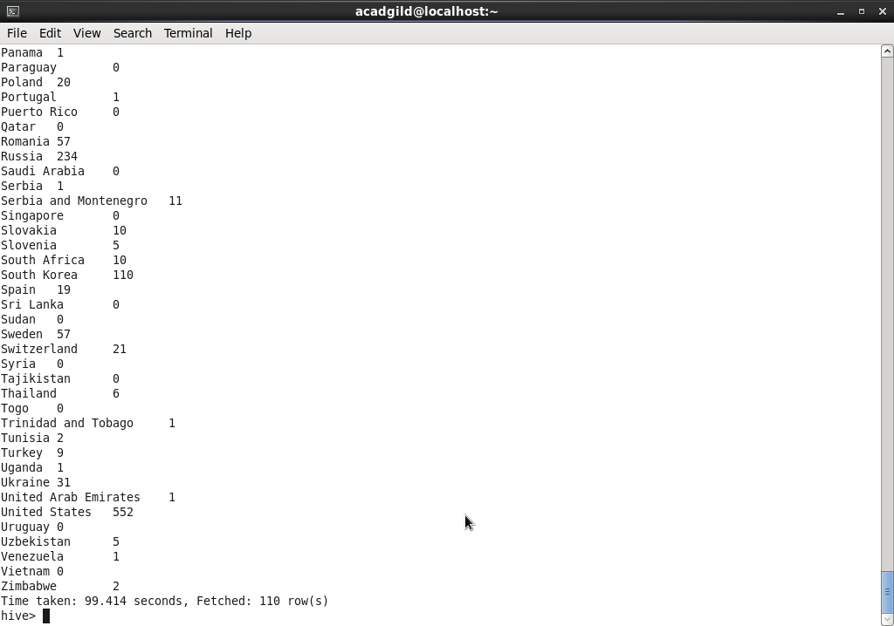

Create table olympics and table loading from local file:

