**ASSIGNMENT -8.2**

SeparatorUDF:

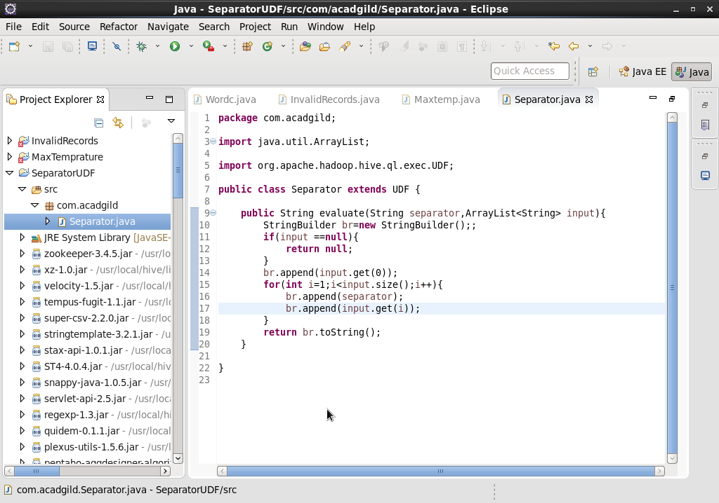

Create table and run query:

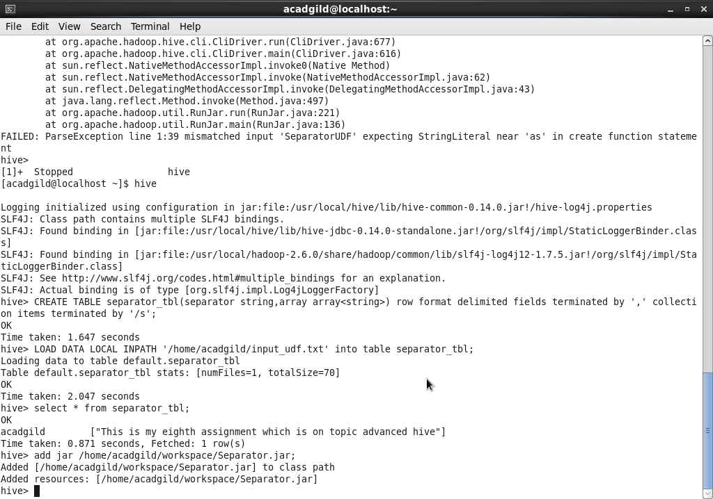

CREATE TEMPORARY FUNCTION up as ‘Separator.Separator’;

Select up(separator,array) from seperator_tbl;

Output:

Thisacadgildisacadgildmyacadgildeighthacadgildassignmentacadgildwhichacadgildisacadgildonacadgildtopicacadgildadvancedacadgildhive