**ASSIGNMENT-8.3**

Transactions in Hive

Below are the properties to be set to implement transactions in Hive.

* *set hive.support.concurrency = true;*
* *set hive.enforce.bucketing = true;*
* *set hive.exec.dynamic.partition.mode = nonstrict;*
* *set hive.txn.manager = org.apache.hadoop.hive.ql.lockmgr.DbTxnManager;*
* *set hive.compactor.initiator.on = true;*
* *set hive.compactor.worker.threads = 2;*

**CREATE TABLE – To Implement Bucketing Concept:**

1. *CREATE TABLE college(clg_id int,clg_name string,clg_loc string) clustered by (clg_id) into 5 buckets stored as orc TBLPROPERTIES('transactional'='true');*

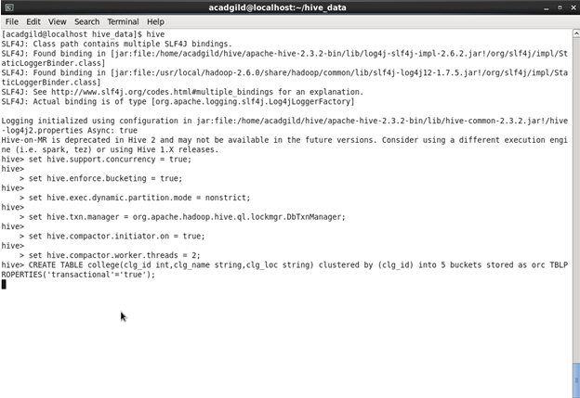

1. *INSERT INTO table college values(1,'nec','nlr'),(2,'vit','vlr'),(3,'srm','chen'),(4,'lpu','del'),(5,'stanford','uk'),(6,'JNTUA','atp'),(7,'cambridge','us');*

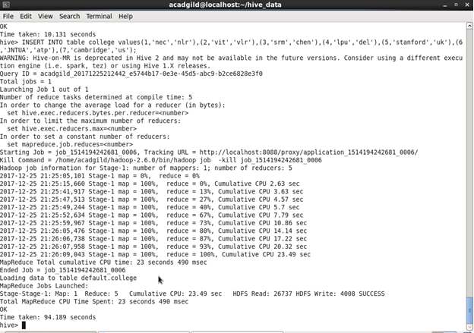

1. Those column values used for bucketing cannot be updated.

**QUERY:**

*UPDATE college set clg_id = 8 where clg_id = 7;*

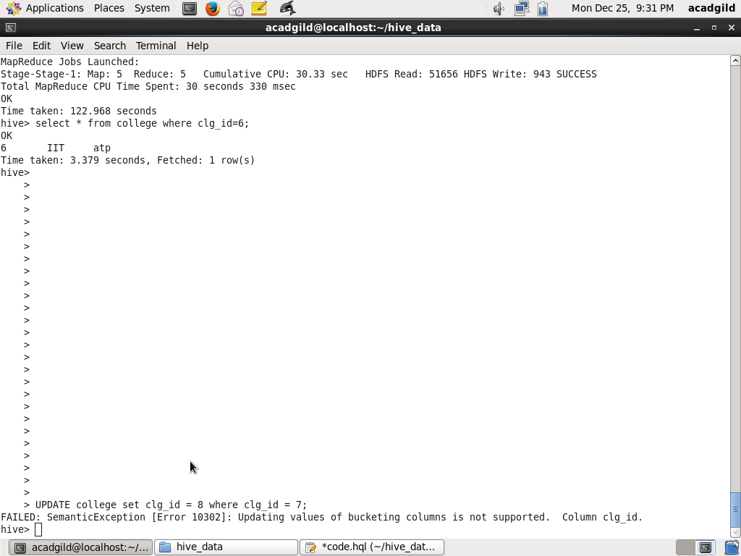

1. **UPDATE QUERY:**

*UPDATE college set clg_name = 'IIT' where clg_id = 6;*

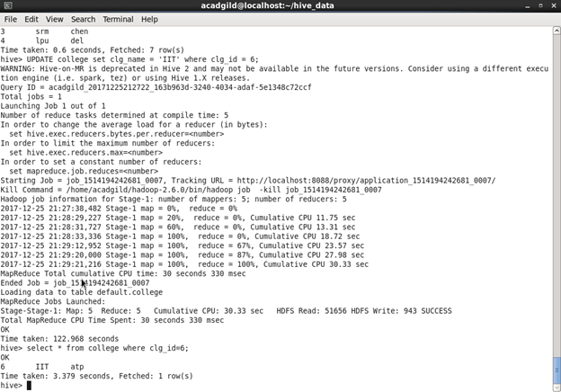

1. **DELETE QUERY:**

*delete from college where clg_id=5;*

