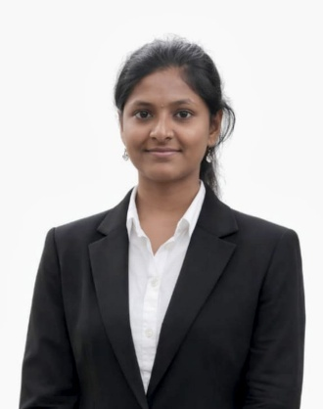
ABINAYA S

Address: 1/124, Pudhu street Vembadithalam, Salem-637504
Phone no: 9566846626
Email ID: abinayasivakumar423@gmail.com
Github : https://github.com/AbinayaSivakumar26
Linked in : https://www.linkedin.com/in/abinaya-sivakumar-359604305

EDUCATION

K S Rangasamy College of Technology Nov 2023 – Mar 2027
Bachelor of Technology in INFORMATION TECHNOLOGY(2026) Tamilnadu, India
(Percentage – 8.63% *(Upto 5th Semester)
Government Higher Secondary School Vembadithalam Mar 2023
XII - State Board of Higher Secondary Education(Percentage – 82%) Tamilnadu,India

INTERNSHIP
GOOGLE CLOUD (AICTE &EduSkills)-Virtual Internship(April 2025 - June 2025)

Completed a 10-week Generative AI Virtual Internship organized by AICTE, EduSkills, and Google Cloud. Gained hands-on experience in generative models, prompt engineering, ethical AI, and real-world applications like text generation, image captioning, and code synthesis using Vertex AI tools.

COURSEWORK

Data Structures and Algorithms, Python and java Programming, HTML, CSS, JavaScript, Database Management Systems.

PROJECTS

HOTEL MANAGEMENT SYSTEM
Designed and developed a static hotel management website using HTML and CSS for structure and styling. Implemented interactive elements and basic form validations using JavaScript.
CALCULATOR
Developed a responsive web-based calculator using HTML, CSS, and JavaScript. Implemented core arithmetic functions (addition, subtraction, multiplication, division) using JavaScript logic.

TECHNICAL SKILLS
Programming: Java, Python, Javascript.
Technologies/Frameworks/Libraries: Angular js.
VCS: Github, Vs code.

ACHIEVEMENTS
- Completed course on Infosys - Data Structure and Algorithms.
- Completed Course on Coursera - SQL JOINTS
- Completed course on NPTEL -Design & Implementation of Human-Computer Interfaces(Elite), Privacy and Security in Online Social Media(Elite)

HOBBIES

Listening Music, Pencil drawing, Watching movies, Art & craft

