# Task11: Java Exception and Error handling

### 1.Access modifiers in java:

There are four types of access modifiers available in Java:

1. Default – No keyword required
2. Private
3. Protected
4. Public

### **1. Default Access Modifier**

When no access modifier is specified for a class, method, or data member – It is said to be having the **default** access modifier by default. The data members, classes, or methods that are not declared using any access modifiers i.e. having default access modifiers are accessible **only within the same package**.

### **2. Private Access Modifier**

The private access modifier is specified using the keyword **private**. The methods or data members declared as private are accessible only **within the class** in which they are declared.

* Any other **class of** the **same package will not be able to access** these members.

### **3. Protected Access Modifier**

The protected access modifier is specified using the keyword **protected**.

The methods or data members declared as protected are **accessible within the same package or subclasses in different packages.**

### **4. Public Access modifier**

The public access modifier is specified using the keyword **public**.

* The public access modifier has the **widest scope** among all other access modifiers.
* Classes, methods, or data members that are declared as public are **accessible from everywhere** in the program. There is no restriction on the scope of public data members.

### 2. Difference between Exception and Error:

|  |  |
| --- | --- |
| **Exception** | **Error** |
| An issue that can disrupt the normal flow of a program but can be caught and handled. | A serious problem that cannot be recovered from, typically arising from system-level issues. |
| Application code, including invalid input or incorrect API usage. | System abnormalities such as hardware failures, system crashes, or out of memory. |
| Can often be recovered from using try-catch blocks. | Fatal and non-recoverable. |
| Checked Exceptions (detected at compile time) and Unchecked Exceptions (occur at runtime). | Syntax Error, Runtime Error, Logical Error. |
| IOException, NullPointerException, SQLException, etc. | OutOfMemoryError, StackOverflowError. |
| Can be caught and handled in the program to maintain flow or recover from the situation. | Cannot be handled or caught by the program. |
| Extends the Exception class in the hierarchy. | Extends the Error class in in Java’s class hierarchy. |
| Primarily occur at runtime, though checked exceptions can be detected at compile time. | Can occur both at compile time and runtime. |
| Disrupts the normal flow but allows for redirection or handling within the program. | May cause the program (and potentially the system) to terminate. |
| Can be anticipated and handled through proper coding practices. | Unpredictable and often outside the control of the application. |

### 3.Differences between Checked and Unchecked Exceptions

|  |  |  |
| --- | --- | --- |
| **S.no** | **Unchecked Exceptions** | **Unchecked Exceptions** |
| 1 | Checked exceptions happen at compile time when the source code is transformed into an executable code. | Unchecked exceptions happen at runtime when the executable program starts running. |
| 2 | The checked exception is checked by the compiler. | This exception is not checked by the compiler. |
| 3 | Checked exceptions can be created manually | These exceptions can also be created manually |
| 4 | This exception is counted as a sub-class of the class. | This exception happens in runtime, and hence it is not included in the exception class. |
| 5 | Java Virtual Machine requires the exception to be caught or handled. | Java Virtual Machine does not need the exception to be caught or handled. |

### 4.Java program for arithematic exception:

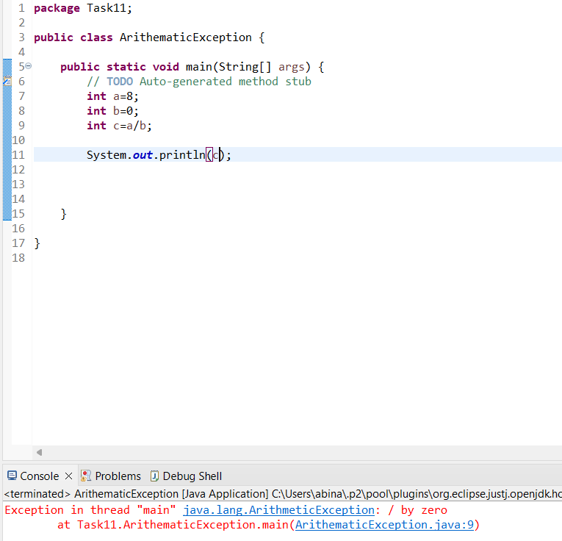

Use try and catch methods:

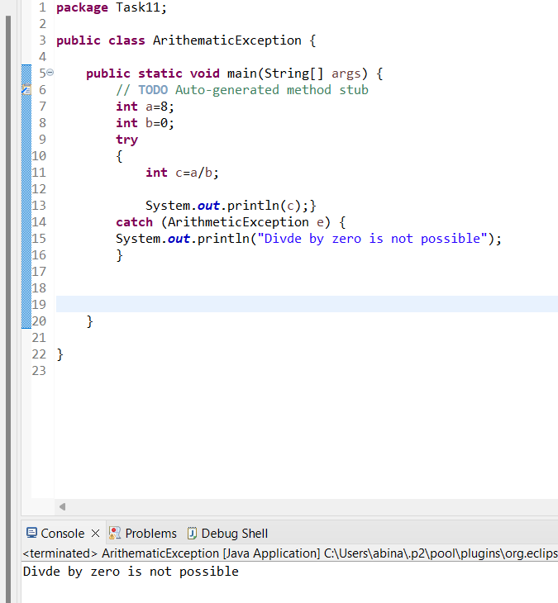

### 5.ArrayOutOfBoundException:

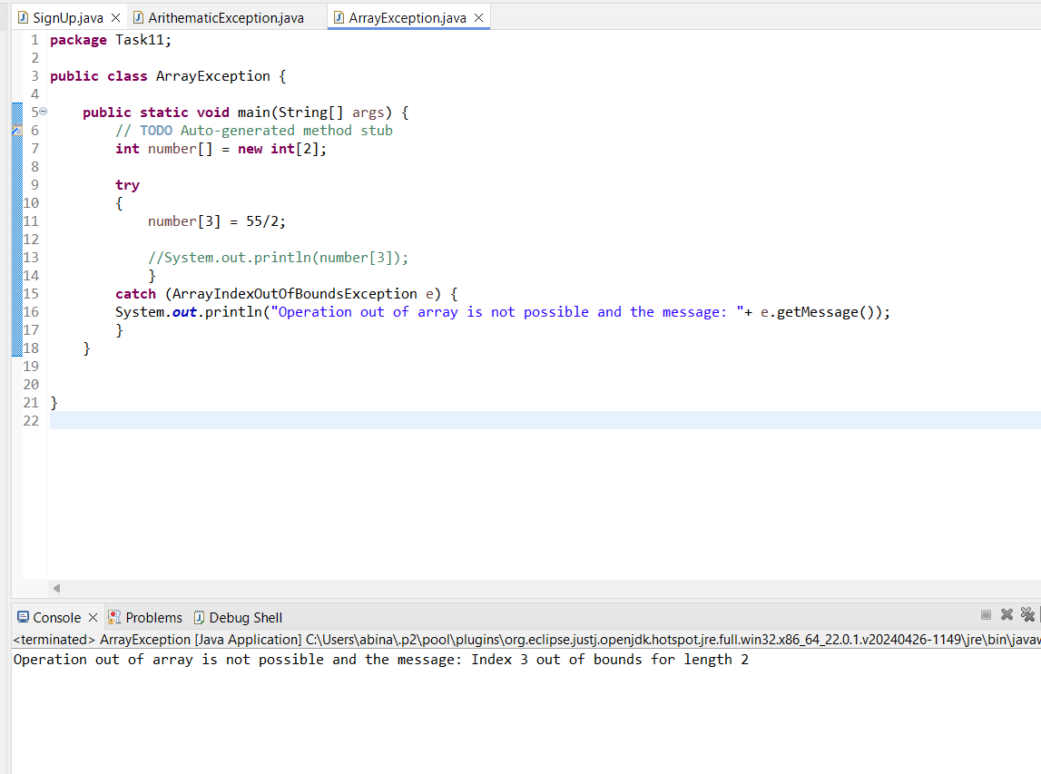

### 5.StringIndexOutOfBound Exception:

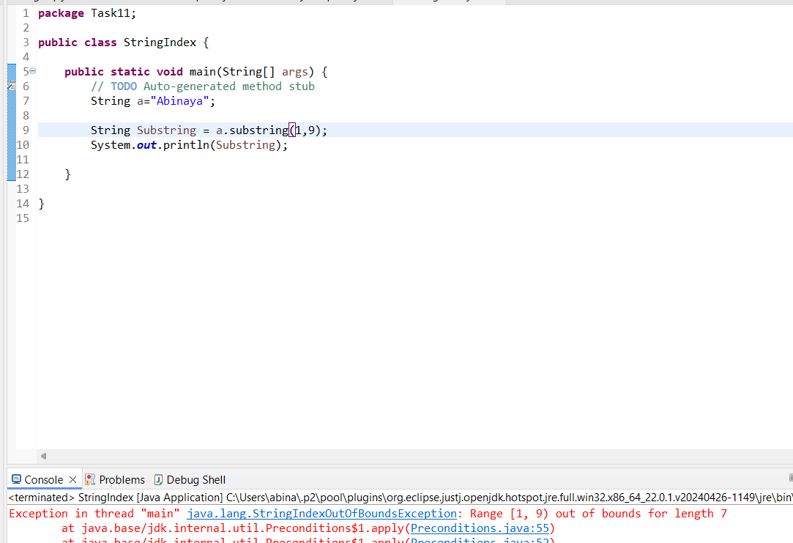

Exception handled:

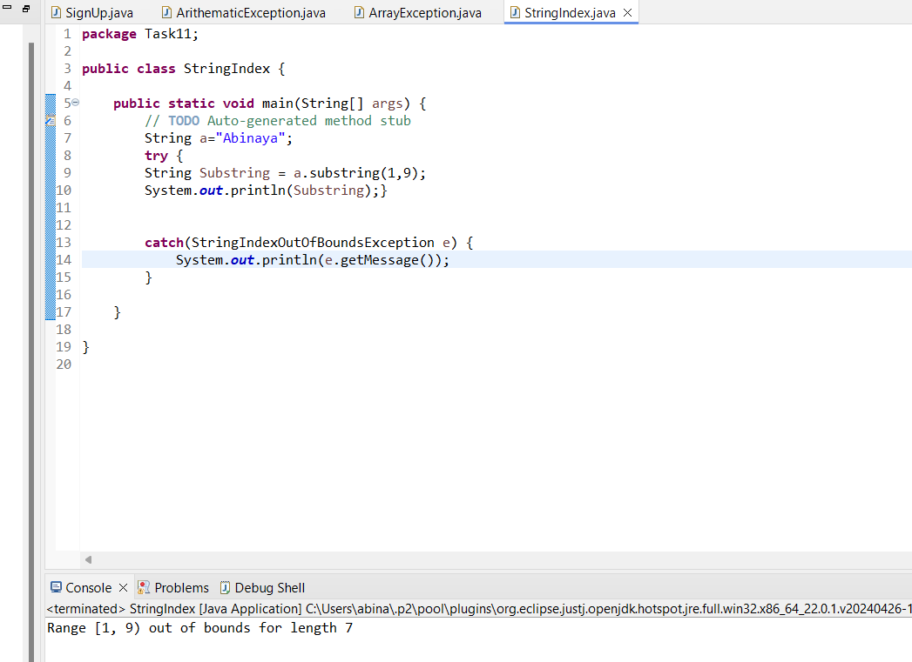

### 6.Wrong password exception:

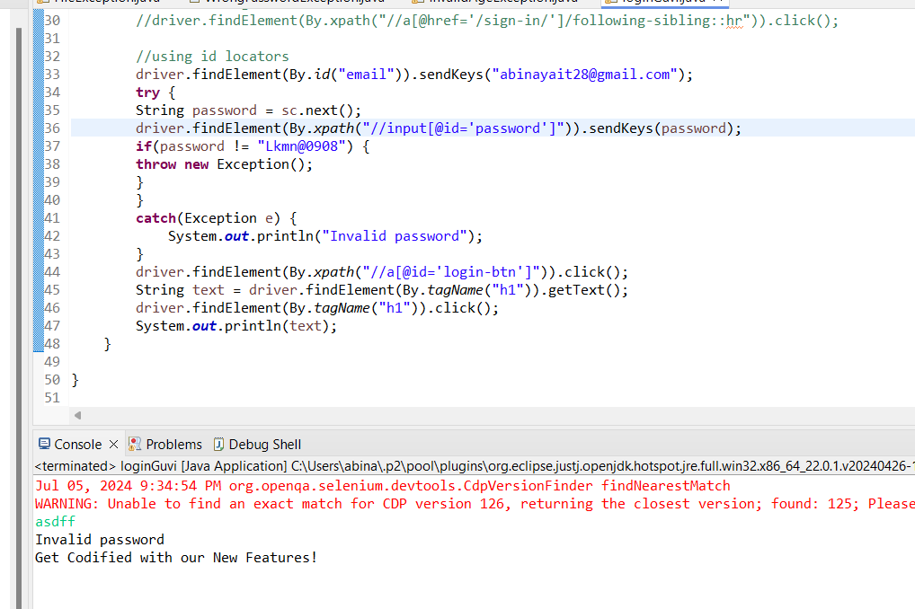

### 7.Invalid Age exception:

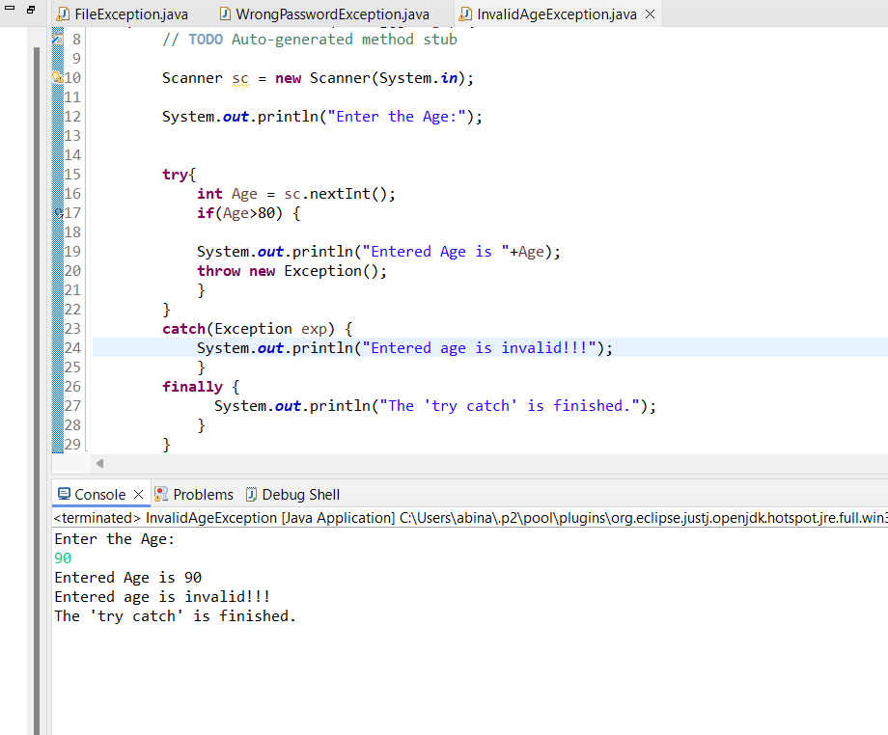

### 8.FileNotFoundException:

