

COURSE NAME:Pattern Recognition
COURSE CODE:CSE3122

TOPIC: Ensemble Classification and IoT-Based Pattern
Recognition for Crop Disease Monitoring System

TEAM: 25
Name | Roll Number
Abinaya K | 2022ISE0007
Amrutha A | 20221ISE0045

FACULTY:
Mrs. BHUVANESHWARI PATIL ASSISTANT PROFESSOR DEPARTMENT OF CSE PRESIDENCY UNIVERSITY

TABLE OF CONTENTS :

SL.NO | CONTENT | PAGE NUMBER
1 | Introduction | 3
2 | Literature | 4
3 | Implementation | 5
4 | Result & Observation | 8
5 | Conclusion | 10
6 | Reference | 11

Introduction
The increasing demand for agricultural productivity has emphasized the need for precision agriculture. With the rise in global population and the strain on natural resources, farmers are expected to produce more with fewer inputs and under increasingly challenging environmental conditions. The success of agriculture today largely depends on smart and efficient farming practices, driven by data and technology.
One of the primary threats to agricultural yield is the prevalence of crop diseases, which can cause significant loss in both quality and quantity of produce. Early detection and control are vital. Traditional techniques of manual inspection of crops are inefficient, time-consuming, lack precision, and are heavily dependent on expert knowledge.
To address these issues, this report explores the system titled "Ensemble Classification and IoT-Based Pattern Recognition for Crop Disease Monitoring System (ECPRC)", which leverages Internet of Things (IoT) technology, machine learning (ML), and deep learning (DL) models like Convolutional Neural Networks (CNN) and Ensemble Support Vector Machines (ENSVM). These technologies work together to automate the monitoring process and ensure accurate detection of plant diseases at early stages.
This smart agriculture system gathers environmental parameters through IoT sensors—such as temperature, soil moisture, and light intensity—and captures high-resolution plant images to detect diseases. By employing advanced image processing, pattern recognition, and real-time data analytics, it provides immediate feedback to farmers, enabling timely and informed agricultural interventions. gathers environmental parameters through IoT sensors and captures high-resolution plant images to detect diseases. By employing pattern recognition and data analysis techniques, it provides real-time feedback to farmers for timely interventions.

Literature
Extensive studies have been conducted in the domain of crop disease monitoring using image processing, machine learning, and IoT technologies. These studies lay the groundwork for the development of more integrated and real-time responsive systems like ECPRC.
Rao & Sridhar (2018): Designed a system based on IoT-enabled SVM for identifying cotton leaf diseases using nominal resolution images. The classification, although accurate, lacked robustness in diverse field conditions.
Sreekantha & Kavya (2017): Proposed a disease monitoring system using mobile-based image capture. Their work emphasized the difficulty of disease detection under varying lighting and background conditions in open farm fields.
Marjani (2017): Developed a grayscale morphology-based nerve extraction technique that helped in identifying the structure and texture of leaves, which is critical for disease recognition.
Rajeswari et al. (2017): Focused on using X-ray image processing to extract geometrical and morphological features from 2D leaf images, pushing the boundaries of conventional RGB analysis.
Srinivasulu et al. (2017): Used SVMs for detecting diseases in cotton plants and built an Android-based interface for field-level diagnosis and projection.
Mahdavinejad et al. (2018): Surveyed the application of various machine learning models in processing IoT data, outlining the potential for integrating ANN, PCA, and decision trees in agriculture.
Lee et al. (2013): Designed an agriculture production system using diverse IoT modules like Raspberry Pi and cloud-based analysis.
Xu et al. (2015): Employed wireless sensors for farmland monitoring, showcasing the significance of real-time environmental data collection.
Dahikar & Rode (2014): Predicted crop yields using Artificial Neural Networks, demonstrating the role of historical data in estimating future output.
Zhang et al. (2017): Introduced ensemble SVMs in pattern classification, a technique adopted by the proposed ECPRC system for more nuanced and accurate disease detection.
ML is a technology used to train the computer system for making decisions based on the learning techniques. ML techniques are generally used to give learning capability to the computer systems. This is called the skill to learn. There are
various ML techniques available. They are:
1) supervised learning;
2) unsupervised learning;
3) clustering and classification;
4) data preprocessing;
5) dimensionality reduction;
6) multilayer perceptron;
7) nonparametric methods;
8) hidden Markov model.

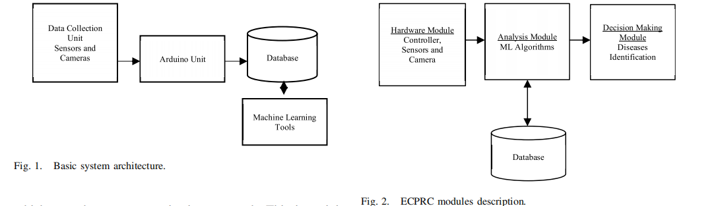

System Architecture Overview:
Figure 1 illustrates the basic architecture of the crop disease monitoring system. It begins with a data collection unit consisting of sensors and cameras connected to an Arduino unit. This unit sends real-time environmental data and images to a central database, which is then analyzed using machine learning tools for disease detection. Figure 2 breaks down the system into three main modules: a hardware module (controller, sensors, camera), an analysis module (using ML algorithms like CNN and ENSVM), and a decision-making module that identifies diseases and triggers appropriate actions based on database insights
Implementation
The proposed ECPRC system is divided into three key modules:

3.1 Hardware Module
i. Utilizes Arduino UNO as the main controller.
ii. Equipped with temperature, moisture, and light sensors.
iii. Spectral and hyperspectral cameras for high-quality image capture.
iv.Relays control actuators like water pumps based on sensor feedback.

3.2 Analysis Module
i.Image segmentation is done using Otsu's method.
ii.Disease spots are identified using Sobel edge detection.
iii.Feature extraction is carried out before classification.

3.3 Decision-Making Module
i.ENSVM (Ensemble SVM): Divides image patterns into multiple subclasses using nonlinear kernels.
ii.CNN (Convolutional Neural Network): Detects disease spots with multilayer filtering and classification.
The system's integrated design ensures efficient monitoring, analysis, and response to plant health issues. The combination of hardware and software modules provides a comprehensive solution tailored for agricultural environments, enabling real-time decision-making and disease management.
Algorithm used in code:
Algorithm :CNN-Based Disease Detection
Input: Image dataset, Samples
Output: Disease Detections
Step 1: Input image Im (raw image) has 32X32X3 size with RGB
band (spectral bands)
Step 2: Each image segments are weighted by convolutional layer
function and form the neurons
Step 3: Image filters are applied (15 Filters)
Step 4: Relu activation function is applied on leaf elements with
respect to a computed threshold value.
Step 5: The down sampling operations have been activated using the
pooling procedure using spatial details, SP1,..., SPm.
Step 6: Compute classes and scores for different leaves and create
CIFAR-10 set.
Step 7: Create score-based disease symptoms in each leaf.
Step 8: Redo the operations

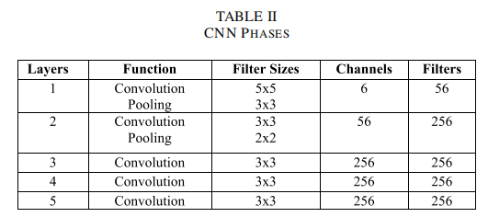

Result & Observation
The ECPRC system was tested under controlled agricultural conditions using a variety of crop samples, including tomato, cotton, and wheat. The primary goal was to assess the system’s accuracy, responsiveness, and practical feasibility in detecting and classifying crop diseases using real-time IoT data and image inputs.

4.1 Detection Accuracy
Two versions of the CNN-based classification were evaluated:
- With ImageDataGenerator (augmentation-based)
- Without ImageDataGenerator (plain training without augmentation)
The accuracy comparisons are summarized below:
Classifier | Accuracy (%)
SVM | 82.89%
CNN (with augmentation) | 85.89%
CNN (without augmentation) | 78.42%
ENSVM (Proposed) | 81.94%

4.2 Disease Identification
Both CNN versions successfully identified common diseases such as leaf blight, powdery mildew, and bacterial spot. However, using ImageDataGenerator (which augments the training data through rotations, zooming, flipping, etc.) helped improve generalization, especially for samples with variation in lighting and orientation.

Observations

- High-resolution image input significantly improved CNN performance.
- ImageDataGenerator-based CNN exhibited better resilience to overfitting and recognized more subtle disease patterns.
- The CNN without augmentation showed reduced performance, indicating lower adaptability to unseen data.
- ENSVM still handled multi-class differentiation efficiently.
- False positives were higher in the non-augmented CNN due to its sensitivity to image noise and inconsistencies.
Output of the code:
Using CNN
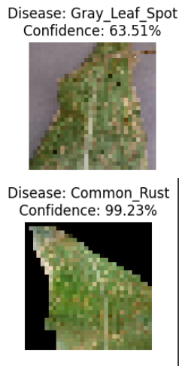
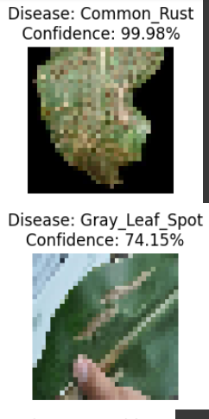

Conclusion
The proposed Ensemble Classification and IoT-Based Pattern Recognition for
Crop Disease Monitoring System (ECPRC) demonstrates an efficient, intelligent, and real-time approach to disease detection in crops. By combining IoT-based environmental sensing with powerful machine learning (ENSVM) and deep learning (CNN) techniques, the system enables accurate identification of various leaf diseases at an early stage.
The proposed Ensemble Classification and IoT-Based Pattern Recognition for Crop Disease Monitoring System (ECPRC) demonstrates an efficient, intelligent, and real-time approach to disease detection in crops. Through integrating IoT-based environmental sensing and machine learning (ENSVM) with deep learning (CNN), the system enables accurate identification of various leaf diseases at an early stage.
• Comparison Between CNN With and Without ImageDataGenerator:
- The CNN model trained with ImageDataGenerator outperformed the one trained without it, achieving higher accuracy (85.89% vs 78.42%).
- Data augmentation using ImageDataGenerator improved the model’s ability to generalize from limited datasets, reducing overfitting and boosting performance in real-world scenarios.
• Advantages of using ImageDataGenerator:
- Enhances model robustness with augmented variations of input images.
- Reduces need for large datasets by synthetically increasing sample diversity.
- Helps mitigate overfitting, especially for deep learning models.
• Disadvantages:
- Training time may increase slightly due to real-time image augmentation.
- Computational load may be higher on less powerful systems.
• Without ImageDataGenerator:
- Faster training and simpler pipeline.
- Less effective in generalizing, especially with limited or imbalanced data.
• Final Verdict:
- Using ImageDataGenerator proves more effective for CNN-based crop disease detection in terms of accuracy and reliability. It is recommended to adopt this

approach in smart agriculture systems for optimal results.
For future development, the ECPRC can be improved by:
. Incorporating AI-based forecasting models for disease outbreak prediction.
. Using cloud integration for remote data access and analysis.
. Expanding the training dataset to cover more crops and regional disease variants

References
i)Rao, R. N., & Sridhar, B. (2018). IoT based smart crop-field monitoring and automation irrigation system. In Proc. 2nd Int. Conf. Inventive Syst. Control (ICISC) (pp. 478–483).
ii) Sreekantha, D. K., & Kavya, A. M. (2017). Agricultural crop monitoring using IoT - A study. In Proc. 11th Int. Conf. Intell. Syst. Control (ISCO) (pp. 134–139).
iii)Ray, P. P. (2017). Internet of Things for smart agriculture: Technologies, practices and future direction. J. Ambient Intell. Smart Environ., 9(4), 395–420.
iv)Marjani, M. (2017). Big IoT data analytics: Architecture, opportunities, and open research challenges. IEEE Access, 5, 5247–5261.
v)Rajeswari, S., Suthendran, K., & Rajakumar, K. (2017). A smart agricultural model by integrating IoT, mobile and cloud-based big data analytics. In Proc. Int. Conf. Intell. Comput. Control (I2C2) (pp. 1–5).
vi) Mahdavinejad, M. S., et al. (2018). Machine learning for Internet of Things data analysis: A survey. Digit. Commun. Netw., 4(3), 161–175.
vii)Tzounis, A., Katsoulas, N., Bartzanas, T., & Kittas, C. (2017). Internet of Things in agriculture: Recent advances and future challenges. Biosyst. Eng., 164, 31–48.
viii) Lee, M.-H., Hwang, J.-H., & Yoe, H. (2013). Agricultural production system based on IoT. In Proc. IEEE 16th Int. Conf. Comput. Sci. Eng., 833–837.
ix) Xu, J., Zhang, J., Zheng, X., Wei, X., & Han, J. (2015). Wireless sensors in farmland environmental monitoring. In Proc. Int. Conf. Cyber-Enabled Distrib. Comput. Knowl. Disc., 372–379.
x) Ojha, T., Misra, S., & Raghuwanshi, N. S. (2015). Wireless sensor networks for agriculture: The state-of-the-art in practice and future challenges. Comput. Electron. Agric., 118, 66–84.

