9PASSPORT AUTOMATION SYSTEM

AIM:
To draw the diagrams [usecase, activity, sequence, collaboration, class, statechart,
collaboration, component, deployment, package] for the Passport Automation System.
SL.NO SOFTWARE REQUIREMENTS SPECIFICATION
Hardware Requirements
Software Requirements
Problem Analysis and Project Plan
Project Description
Reference

1.0 HARDWARE REQUIREMENTS:
Intel Pentium Processor I3/I5
1.1 SOFTWARE REQUIREMENTS:
Rational rose /Argo UML / Umbrello Tool
1.2 PROBLEM ANALYSIS AND PROJECT PLAN
To simplify the process of applying passport, software has been created by designing
through rational rose tool. Initially the applicant login the passport automation system and submits
his details. These details are stored in the database and verification process done by the passport
administrator, regional administrator and police the passport is issued to the applicant.
1.3 PROJECT DESCRIPTION:
This software is designed for the verification of the passport details of the applicant by the
central computer. The details regarding the passport will be provided to the central computer and
the computer will verify the details of applicant and provide approval to the office. Then the
passport will issue from the office to the applicant.
1.4 REFERENCES:
IEEE Software Requirement Specification format.
USE CASE DIAGRAM:
This diagram will contain the actors, use cases which are given below
Actors: Applicant, Enquiry Officer.
Use case: Applicant details, Applicant proof, Verification of proof, Issue of
passport, Cancellation of the passport.
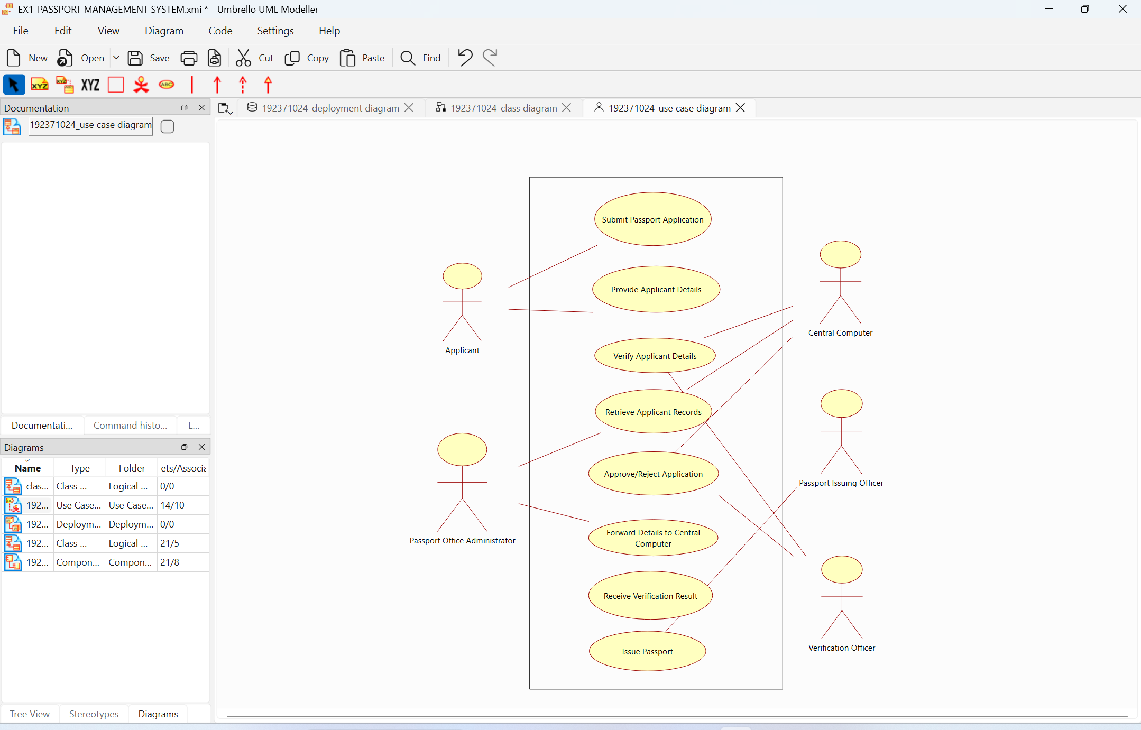

CLASS DIAGRAM:
This diagram consists of the following classes, attributes and their operations.
CLASSES ATTRIBTES OPERATIONS
Passport management system Verify details, Store proof Verification of proof()
Enquiry officer Applicant details Issue of passport()
Applicant Name, Details Apply passport()
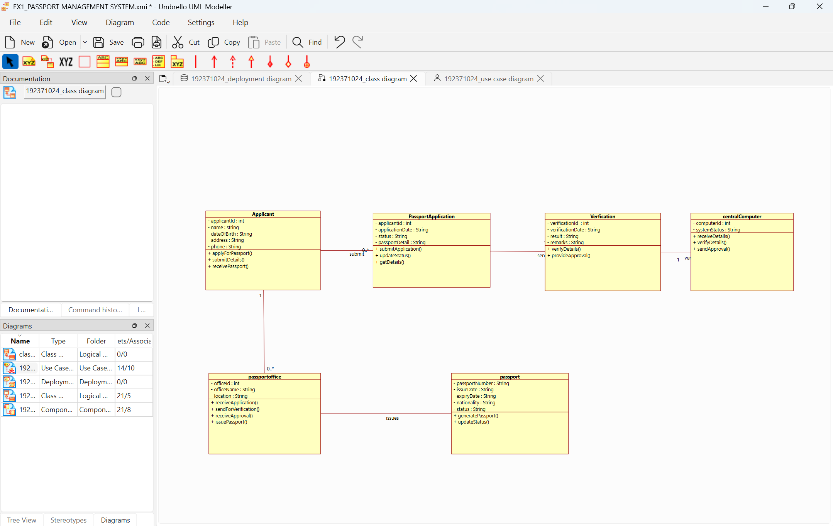
COMPONENT DIAGRAM
The component diagram's main purpose is to show the structural relationships between the
components of a system. It is represented by boxed figure. Dependencies are represented by
communication association.
