# ANNA UNIVERSITY REGIONAL CAMPUS COIMBATORE

# CHATBOT DEPLOYMENT WITH IBM CLOUD

# WATSON ASSISTANT

**Dept.of ELECTRONICS AND COMMUNICATION ENGINEERING**

Submitted by:

**S**.Abinayasaraswathi

***Consider implementing advanced features such as natural language understanding (NLU) for more accurate user intent recognition****.*

*1****. Project Setup with IBM Cloud Watson Assistant***

*- Set up an IBM Cloud Watson Assistant account and create a new assistant for your virtual guide.*

***2. Design Conversational Flows***

*- Plan and design the conversational flows of your virtual guide. Consider different user intents and the information they might seek.*

***3. Integrate with Messaging Platforms***

*- Integrate your virtual guide with popular messaging platforms like Facebook Messenger and Slack using the available APIs and tools.*

***4. Basic Intent Recognition***

*- Initially, set up basic intent recognition for common user queries, such as greeting, getting started, or asking for help.*

***5. FAQ Implementation***

*- Create a knowledge base or FAQ section within Watson Assistant to handle frequently asked questions. Train your assistant to recognize and respond to these queries accurately.*

***6. Implement NLU for Advanced Intent Recognition***

*- Enhance your virtual guide by integrating NLU capabilities to understand user intents more accurately. You can use IBM Watson's NLU capabilities for this purpose.*

***7. Data Collection and Training***

*- Gather and annotate a dataset of user queries and intents relevant to your use case.*

*- Train your NLU model to understand the nuances of user queries, allowing it to handle more diverse and complex requests.*

***8. Entity Recognition***

*- Implement entity recognition to extract specific details from user inputs, such as dates, locations, or product names.*

***9. Context Management***

*- Develop a context management system that maintains the conversation's history, allowing the virtual guide to understand and respond contextually.*

***10. Testing and Evaluation***

*- Thoroughly test your virtual guide with real user interactions on messaging platforms.*

*- Continuously evaluate the NLU model's performance and make necessary adjustments.*

*1****1. User-Friendly Conversational Design***

*- Ensure that your virtual guide communicates in a friendly and engaging manner to create a positive user experience.*

***12. Multimodal Support***

*- Consider adding support for multimedia content, such as images, videos, or documents, to enhance the information delivery.*

***13. Feedback Mechanism***

*- Implement a feedback mechanism to collect user feedback and improve the virtual guide over time.*

***14. Privacy and Security***

*- Prioritize data security and user privacy by implementing necessary safeguards and compliance measures.*

***15. Scalability***

*- Ensure that your virtual guide can handle increased user loads and scale as needed.*

***16. Analytics and Reporting***

*- Implement analytics to track user interactions and gather insights into user behavior and preferences.*

***17. Continuous Improvement***

*- Regularly update and improve the virtual guide to stay relevant and up-to-date with user needs and language changes.*

Chatbot Flow

The chatbot flow is based on three main components **Intention**, **Keywords**, **Chatflow**.

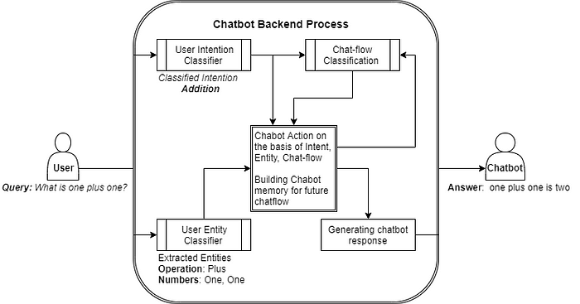

Chatbot Flow

**#Example  
User**: What is one plus one?  
**Bot**: one plus one is two.

* **Intention or Intent:**The intent is known as user intention like what the user wants to say, for what he asked the question. In the above example, we can see the user **intents** to **Addition**two numbers.
* **Keywords or Entities:**The Entities is known as the thing user want information about.In the above example, we can see that extracted entities are **Operation** i.e. **Plus**and **Numbers** i.e. **One, One**. On these entities, the bot will run its custom actions.
* **Chatflow:**The chat flow is the **backbone of chatbot conversation**. The conversation between user and chatbot must be similar like two human beings are talking to each other. The chat flow gives the chatbot task what chatbot should do on the basis of user intention, previous intention.In the above example, the chat-flow gives action for given user intent is Addition operation. All the operations and responses are generated in the Actions and Responses section.
* **Actions and Responses (Chabot Action and Generating Response)**This is a backend process of chatbot where all tasks or operations get executed. The responses are pre-defined and manipulated by Actions. After execution, the response is generated.

Let's build the chatbot model using python. In this, we will learn simple chatbot i.e.**intent-response** based chatbot. We will use only the intent classifier to create a chatbot. Its chat-flow will be a single-layered.

## Chatbot Data

Let's get training data to **chatdata.json** in which the intent and its example questions are given. In which **greet**is intent and **hi, hello** are questions.

{  
 "greet": [  
 "hi",  
 "hello",  
 "hey",  
 "hola"  
 ],  
 "goodbye": [  
 "bye",  
 "goodbye",  
 "good bye"  
 ]  
}

The response is predefined in **response.json** in which the intent and response are given.

{  
 "greet": "Hello there...!",  
 "goodbye": "Bye see you later",  
}

## Conclusion

Throughout we have learned how simple chatbot is created using Random Forest. We learned an I**ntent**-response based chatbot.

For fun, you can add funny conversations and this code to the web applications and create chatbot APIs.

**Thank you**