**ANNA UNIVERSITY REGIONAL CAMPUS COIMBATORE**

**CHATBOT DEPLOYMENT WITH IBM CLOUD WATSON ASSISTANT**

**ELETRONICS AND COMMUNICATION ENGINEERING**

**SUBMITTED BY**

S.ABINAYASARASWATHI

710021106316

**Creating a virtual guide using IBM Cloud Watson Assistant for messaging platforms like Facebook Messenger and Slack is a great idea. To start building your chatbot, follow these steps:**

**1. Define the Chatbot's Persona:**

Before diving into technical details, it's important to define the persona of your chatbot. Consider the following questions:

- What is the name and personality of your chatbot? Is it formal, friendly, or casual?

- What is the target audience for your virtual guide, and how can the persona best resonate with them?

- What kind of language and tone will the chatbot use when interacting with users?

For instance, if your virtual guide is meant for a professional audience, the persona may be more formal and business-like. On the other hand, for a more casual or general audience, a friendly and conversational persona might be suitable.

**2. Design the Conversation Flow:**

The conversation flow of your chatbot should be user-centric and aim to guide users effectively. Outline a high-level conversation flow, keeping in mind that the chatbot should be easy to use and navigate. Consider how users will initiate conversations and how they can access different features and information.

Here's a simple example of a conversation flow:

- Greeting: Start with a warm welcome message.

- Menu: Present options for users to choose from (e.g., "Get information," "FAQs," "Connect with support").

- Information Retrieval: If the user selects "Get information," provide options to gather specific information (e.g., "Operating hours," "Pricing").

- FAQs: If the user selects "FAQs," list common questions and answers.

- Connection: If the user chooses to "Connect with support," offer contact options.

**3. Configure Intents, Entities, and Dialog Nodes:**

In Watson Assistant, you'll use intents to recognize user intentions, entities to extract relevant information from user input, and dialog nodes to structure the conversation. Here's how you can set this up:

**- **Intents:\*\*** Create intents that represent user intentions. For example, you might have intents like "GetInformation," "FAQs," "ConnectSupport," etc. Train the chatbot with a variety of example user queries for each intent.

**- **Entities:\*\*** Define entities to extract specific information from user input. For example, if you have a "Location" entity, it can extract the user's location when asking about operating hours.

**- **Dialog Nodes:\*\*** Create dialog nodes to handle different parts of the conversation. Each node should be associated with a specific intent or condition. For example, a node for the "FAQs" intent will respond with answers to frequently asked questions.

- For a friendly conversational experience, make sure to use proper dialog management, such as context variables to remember user choices and maintain context throughout the conversation.

**4. Implement NLU (Natural Language Understanding):**

To improve user intent recognition, consider implementing NLU features. Watson Assistant provides NLU capabilities to understand user input more accurately. You can define synonyms, patterns, and fuzzy matching for intents and entities, making your chatbot more robust in understanding natural language.

**5. Testing and Iteration**:

Test your chatbot thoroughly to ensure it handles user queries and provides accurate responses. Collect user feedback and iterate on the chatbot's persona, conversation flow, and configuration based on real user interactions.

**1.Creating a chatbot using watson Assistant**

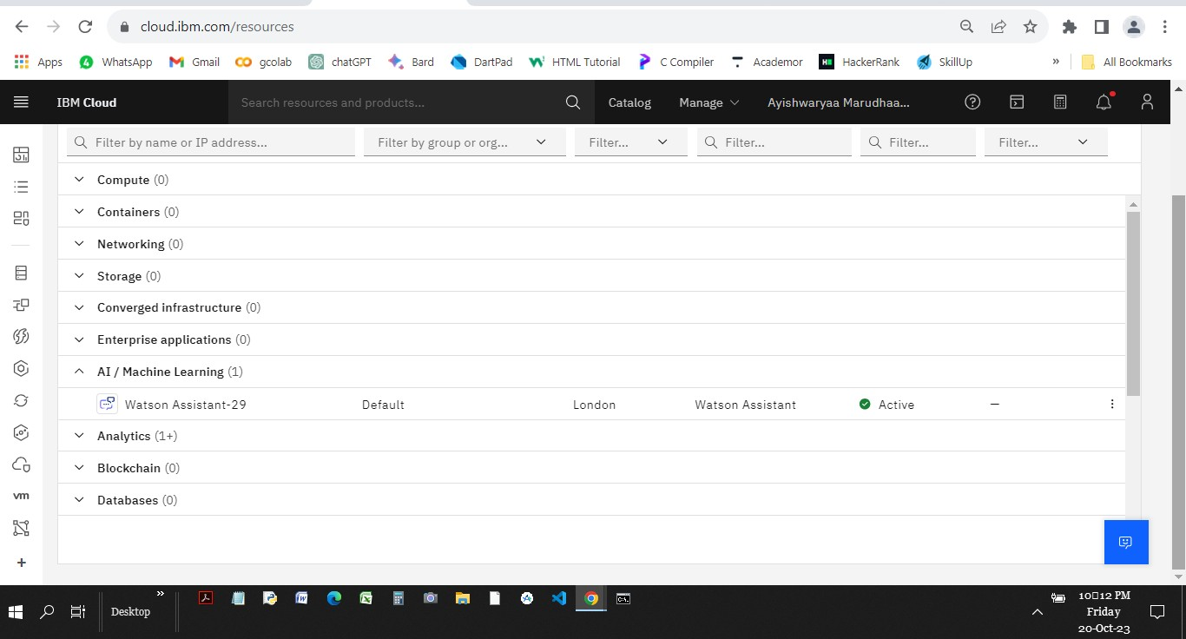

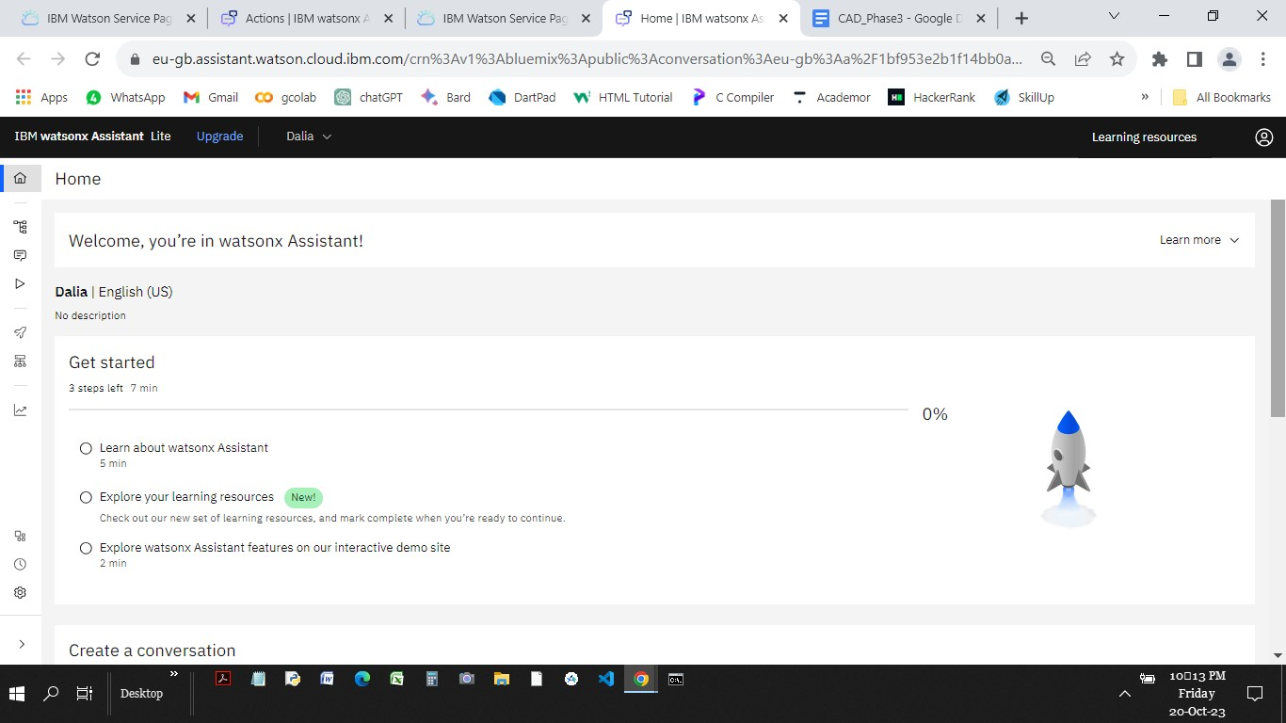

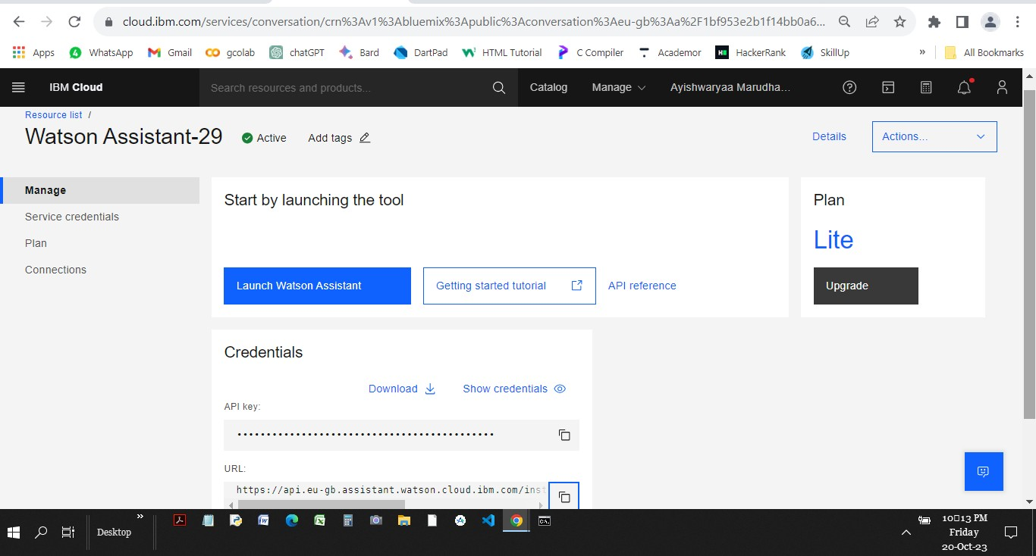

**2.Creating Intents**

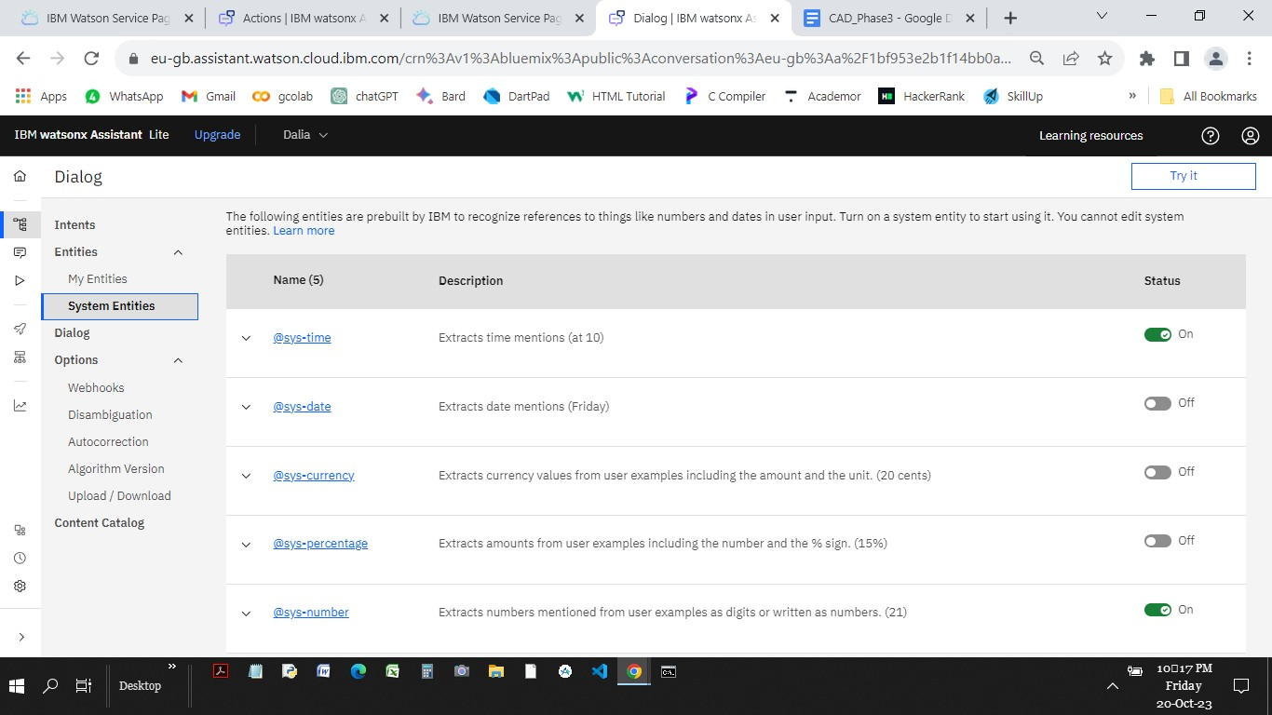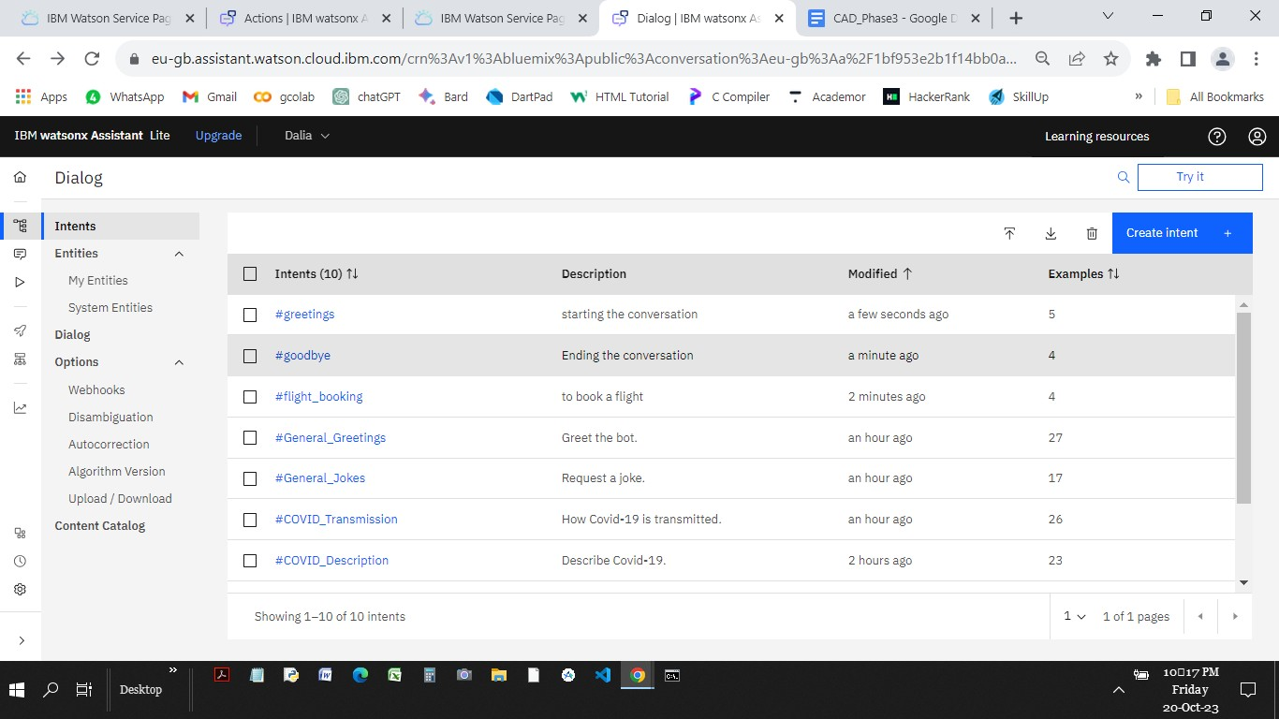

**3.USING SYSTEM ENTITIES**

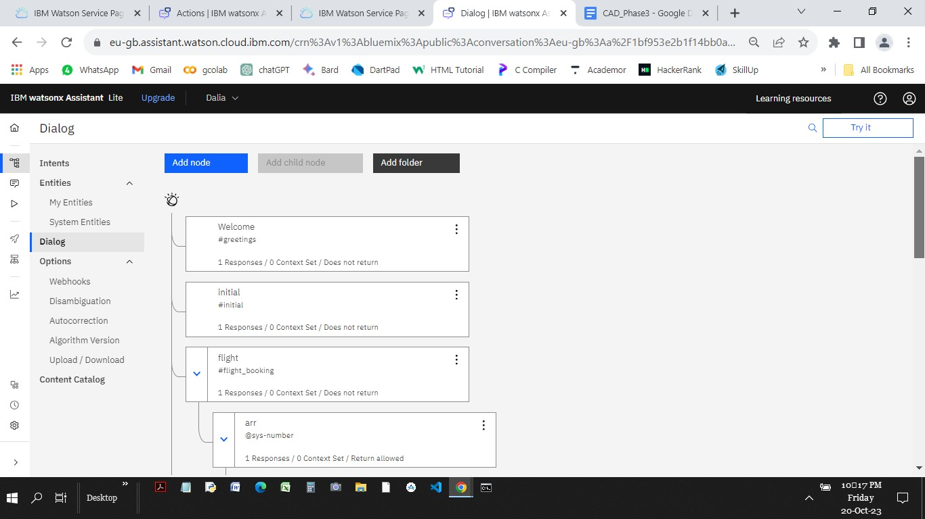**4.BUILDING DIALOG NODE FOR CREATE INTENT AND ENTITIES**

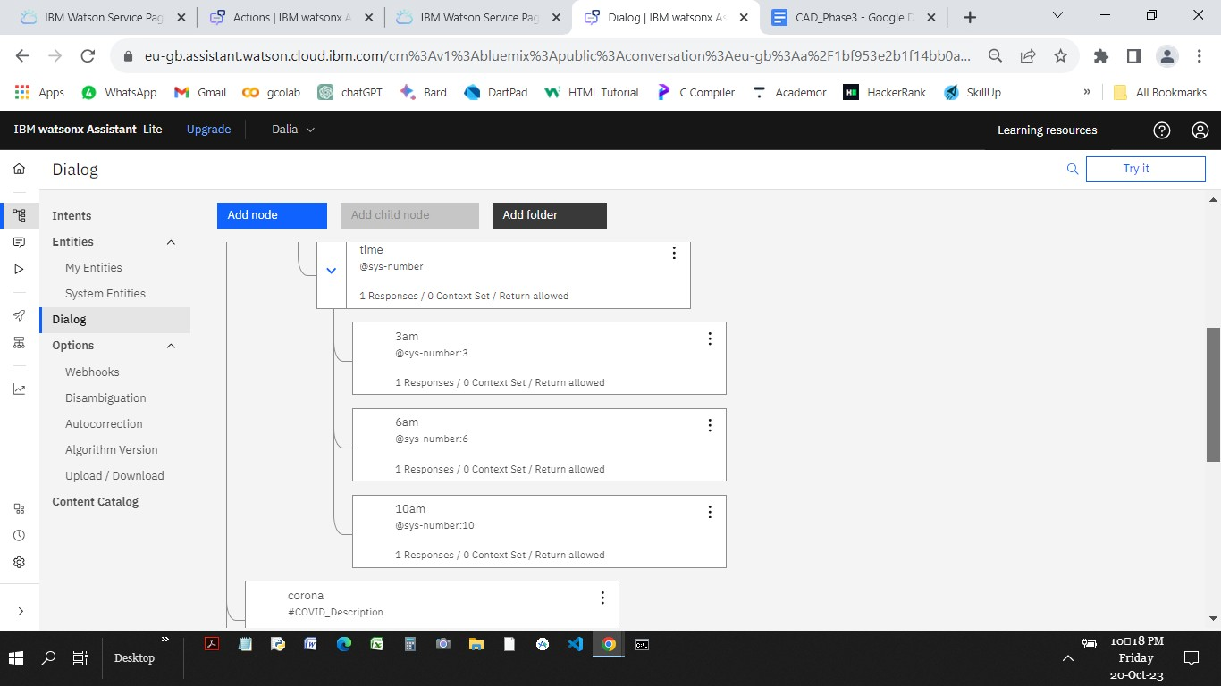

**5.TESTING THE CHATBOT SOME USER QUERIES**

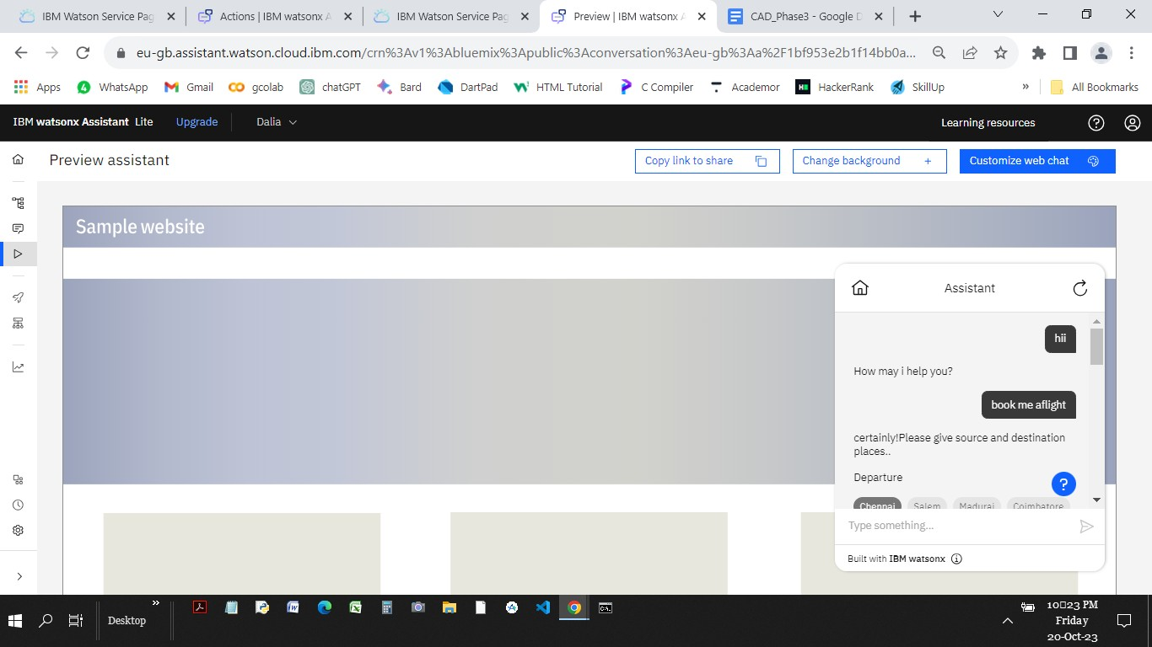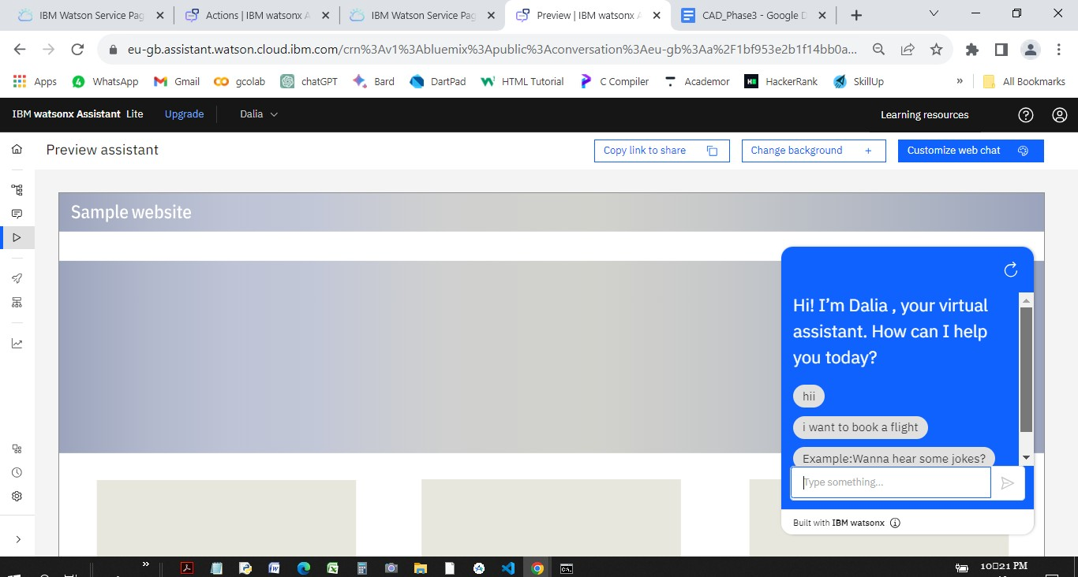

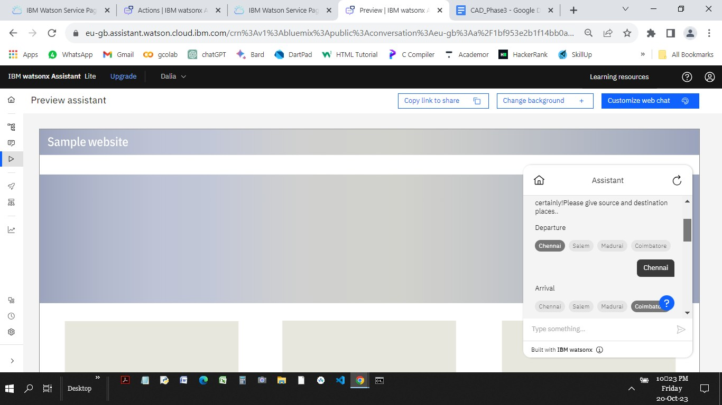

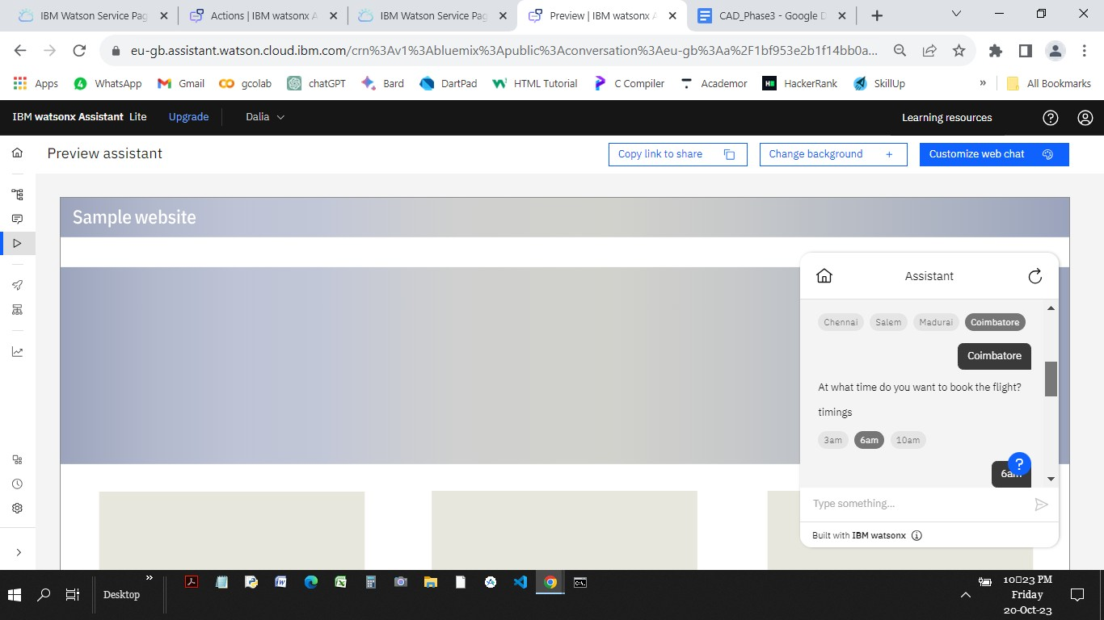

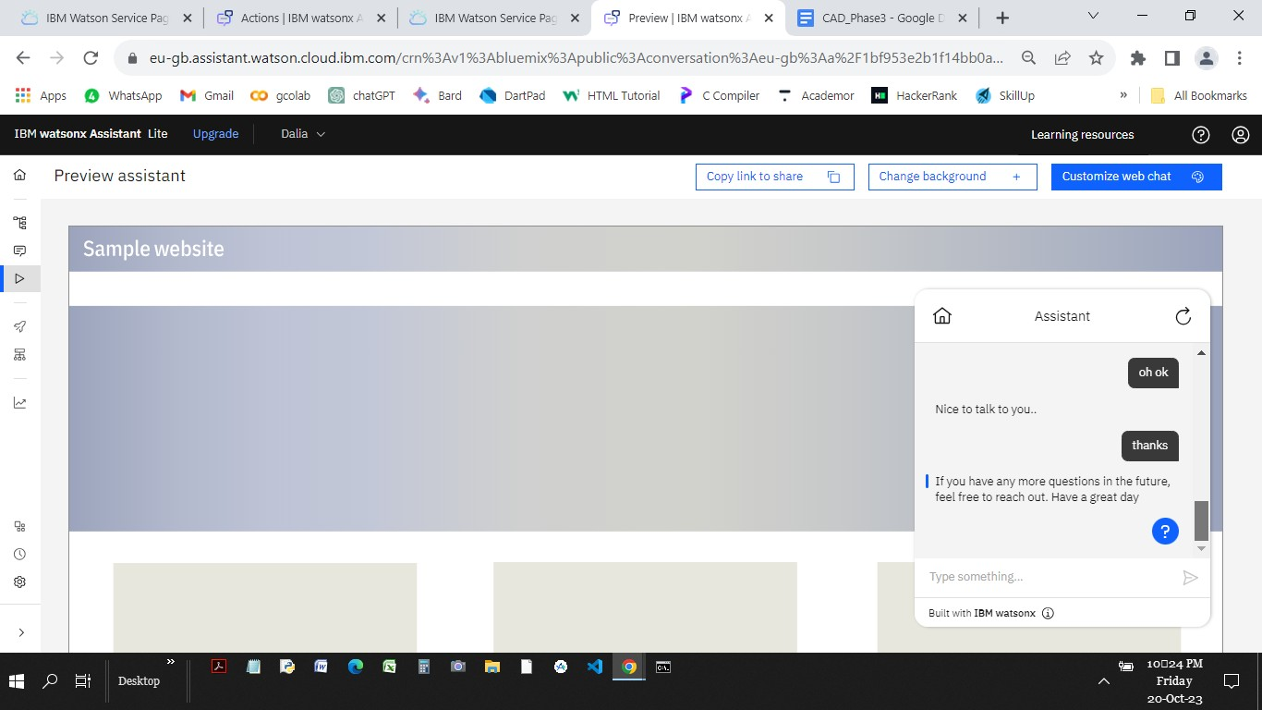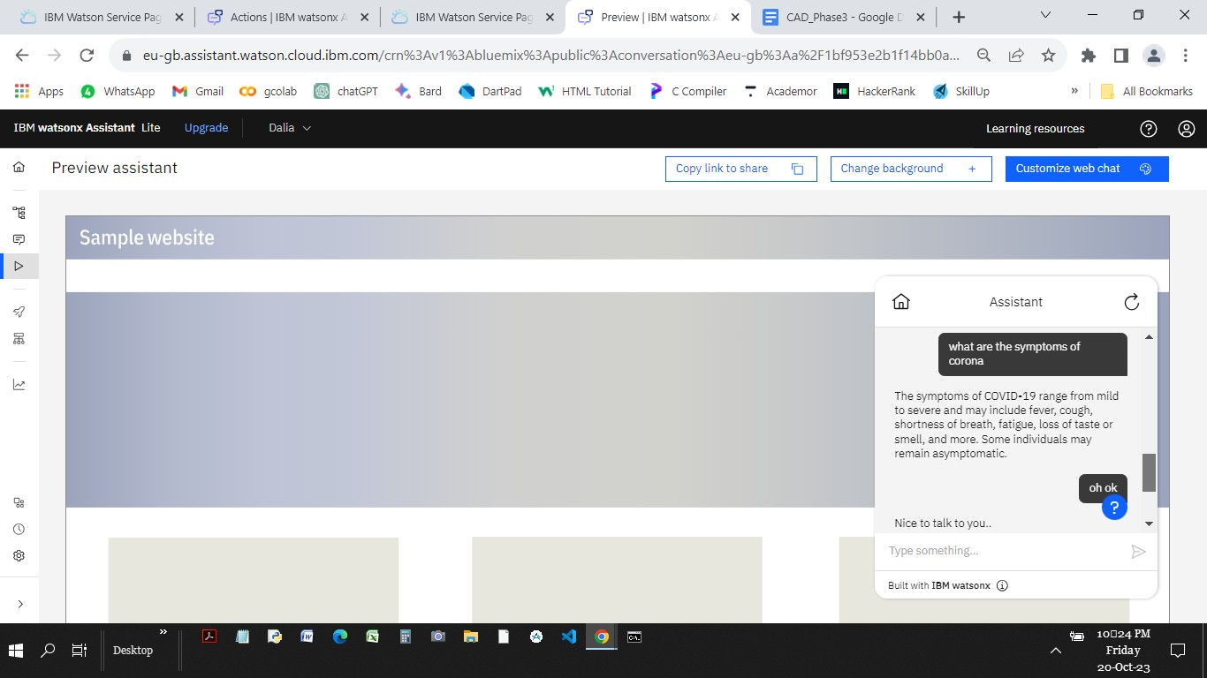

**ACTIONS**

**6.CREATING ACTIONS**:

