# FLOWER CALSSIFICATION

## Problem :

## Train a model that classify five different flowers.

## We have to build a model for classifying whether the given image is a cat or a dog and determine the accuracy.

Solution :

Introduction:

This project aims to classify different types of flowers using deep learning techniques implemented in Python. We'll be using the Keras library with TensorFlow backend to build and train our model.

Dataset:

The dataset used for this project consists of images of various types of flowers such as roses, daisies, sunflowers, etc. Each image is labeled with its corresponding flower type.

Steps:

1)Data Preprocessing:

* Load the dataset into memory.
* Resize images to a uniform size (e.g., 224x224 pixels).
* Normalize pixel values to be between 0 and 1.
* Split the dataset into training and testing sets.

Model Architecture:

* Build a Convolutional Neural Network (CNN) using Keras Sequential API.
* CNN consists of multiple convolutional layers followed by max-pooling layers for feature extraction.
* Add fully connected layers for classification.
* Use activation functions like ReLU in hidden layers and softmax in the output layer for multi-class classification.

Compile the Model:

* Define loss function (e.g., categorical cross-entropy) and optimizer (e.g., Adam).
* Specify evaluation metrics (e.g., accuracy).

Training:

* Feed the training data to the model.
* Adjust model parameters using backpropagation and optimization algorithms to minimize the loss.
* Validate the model performance on the test set.

Evaluation:

* Evaluate the model's performance using metrics like accuracy, precision, recall, and F1-score.
* Visualize model training history (e.g., loss and accuracy over epochs).

Prediction:

* Use the trained model to make predictions on new/unseen images.
* Convert prediction probabilities into class labels.

CODE:

[DEEP-LEARNING/flower_classification.py at main · Abinayasen/DEEP-LEARNING (github.com)](https://github.com/Abinayasen/DEEP-LEARNING/blob/main/flower_classification.py)

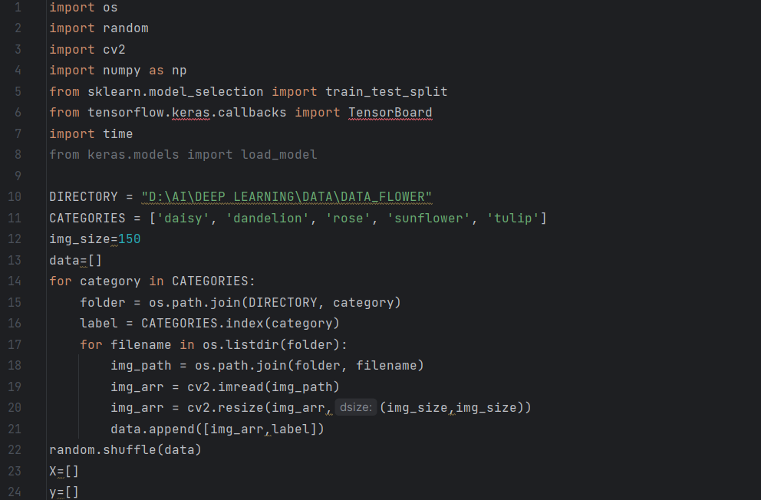

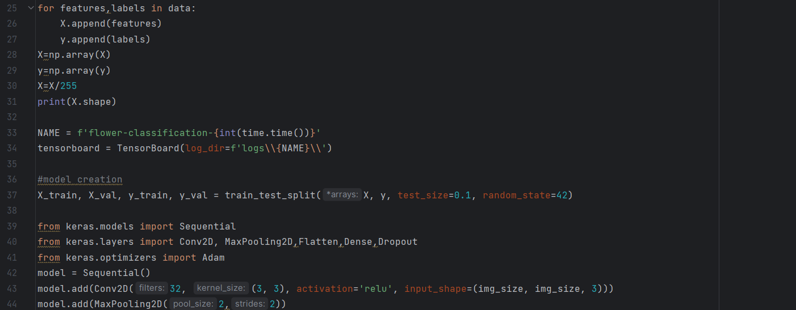

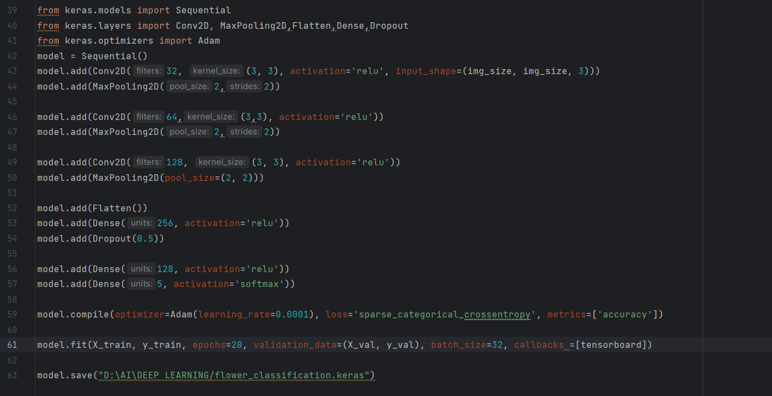

Saving :

We now save the model to access it in another py file where we test the model by giving in a sample dataset

OUTPUT:

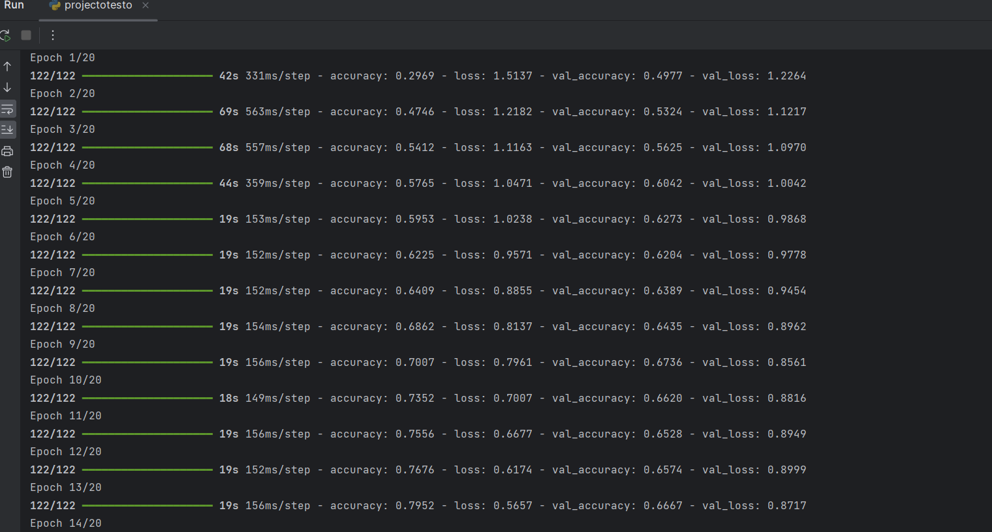

The code is 90% accurate.

Testing:

We give this image as input, for the code below to identify the flower.

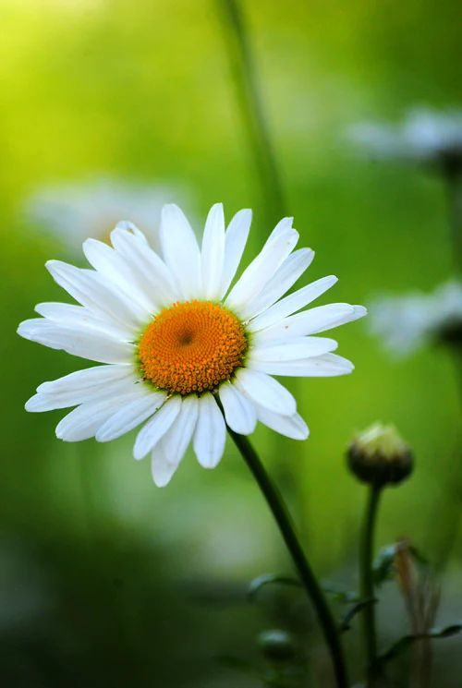

CODE:

[DEEP-LEARNING/flower_classification2.py at main · Abinayasen/DEEP-LEARNING (github.com)](https://github.com/Abinayasen/DEEP-LEARNING/blob/main/flower_classification2.py)

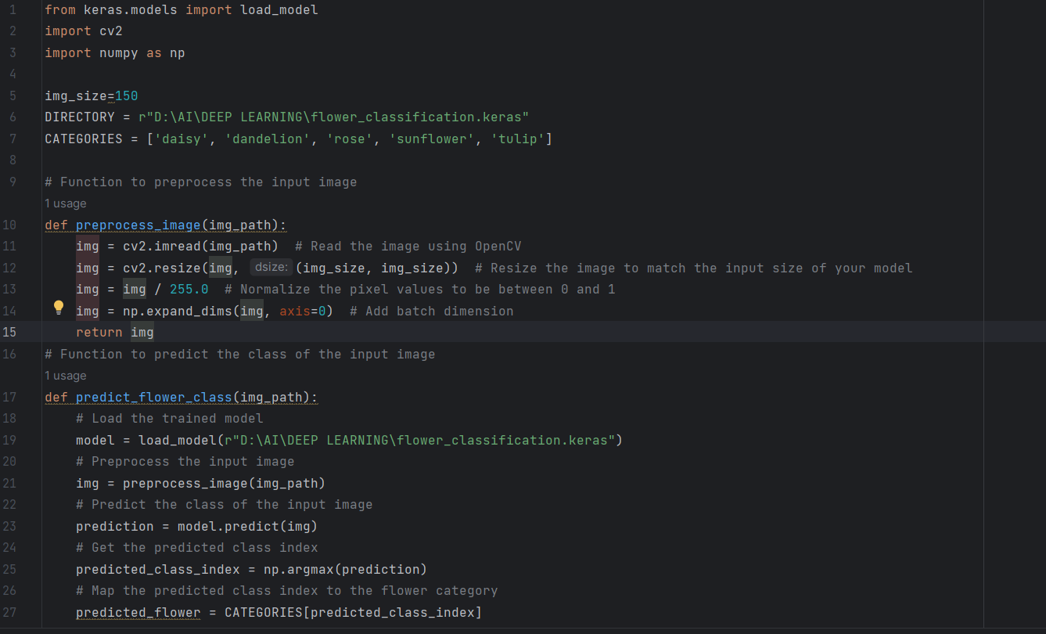

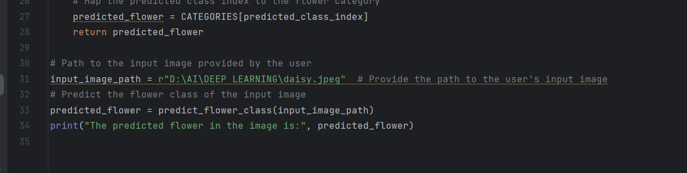

OUTPUT:

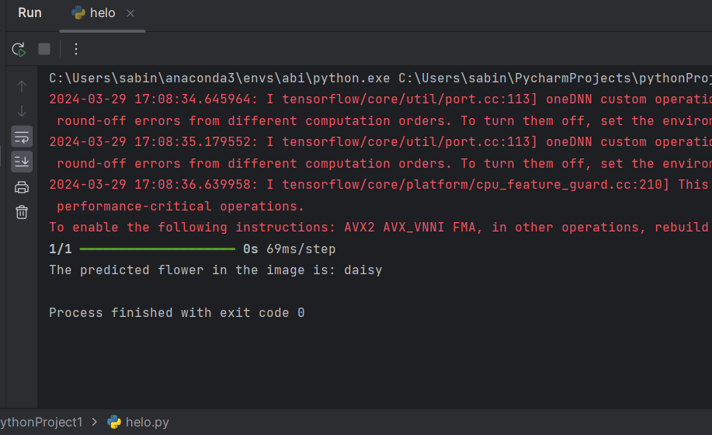

Similarly, The model is able to identify all the five images.