

Proposal Report

For IRoC-U 2025

by

<Team Name>

<Team ID>

December 2024

<Institute Name>

1 Description of ANAV 3

2 System Architecture (an illustrative example) 3

3 Identification of components with their specifications 4

4 Outline the plan for realization of ANAV 4

5 Test Plan: 4

6 System specification 5

7 Overview of the Emergency Response System. 5

8 Project management 5

9 Novelty in the overall proposal 6

10 Declaration format 6

This document is only an outline for submitting the proposal

This information sought in this outline is minimal mandatory for evaluation. However additional information is welcome.

**Before you start**

Compose the Proposal Report (PR) only after thoroughly understanding the challenge requirements and constraints outlined in the **Preliminary Round Rule Book, ISRO Robotics Challenge-URSC: IRoC-U 2025**. This requires the team's ability to formulate a proposal that fulfils the specified requirements. In the initial phase of system design, teams create a baseline design for the entire system. Therefore, it's crucial for teams to meticulously review the preliminary rules and ensure no requirement or constraint is overlooked. Additionally, the document should incorporate project management strategies to achieve the goal within the allocated time-frame.

**Document Requirements:**

1. First page: Follow the provided outline.
2. Format: A4 size, PDF format with search capability.
3. Length: Up to 30 pages, including the title page and lists of contents, figures, and tables.
4. File size: Maximum 15 MB.
5. Language: English.
6. Appendices: None.
7. Use a minimum font size of 10, with margins of at least 2.54 cm (1 inch) from all page edges (set to 'Normal' in MS Word).

**The proposal should encompass the following information:**

1. Description of ANAV illustrating various components and subsystems.
2. System architecture aligned with challenge requirements.
3. Identification of components with their specifications
4. Outline the plan for realization of ANAV with selected hardware and software.
5. Develop a plan for testing and validation.
6. Brief of system specification
7. Overview of the emergency response system.
8. Present the project management approach and timeline.
9. Novelty in the overall proposal

Include any other relevant information.

# Description of ANAV

Provide a concise overview of the ANAV, accompanied by a block schematic. Compare various potential options for aerial vehicle (Refer table-1 rule book table-1, section 7.2) and justify the selected approach.

Description should include:

1. Schematic representation of the ANAV.
2. Comprehensive understanding of the chosen aerial vehicle.
3. Explanation for selecting the proposed aerial vehicle.

# System Architecture (an illustrative example)

Provide system architecture for the ANAV that aligns with the task requirements. Enumerate all the necessary sub-systems for the task, outlining their interdependencies and interface requirements. It is recommended to convey this information through a system architecture diagram. Below is an illustrative example of helicopter system architecture for reference.

**(Note: The example is provided for reference and for illustrative purpose only).**

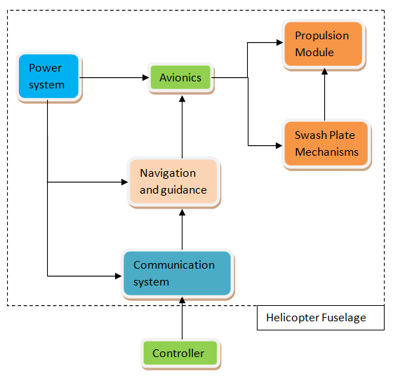

Description should include:

* Illustration of the system architecture through a diagram.
* Identification of interfaces among different sub-systems.
* Inclusion of all essential sub-systems required in the system architecture.

# Identification of components with their specifications

Enumerate, name and brief the following components/aspects as required for the selected architecture of the aerial vehicle. Present the components with supporting images, diagrams, codes, methods, categories, model whichever is applicable. Compare various potential options for selected components and justify the selection approach for mechanical, electrical, algorithms, sensors etc.

# Outline the plan for realization of ANAV

Upon identifying the components, teams should be ready to actualize them. Hardware must be classified according to their source of realization. For instance, motors will be directly procured from the market based on predetermined specifications, and the structure will be 3D printed, etc. The team is required to present the realization plan, preferably in a tabular format as provided below **(Note: The example is given for reference and does not need to be followed in the same form).**

| No. | Hardware Details | Procurement Source (Market/Fabrication/3D Printing/…..) | Specifications/ Realization Plan | Quantity |
| --- | --- | --- | --- | --- |
| 1 | AAAA | Market |  | X |
| 2 | BBBB | Manufactured / procured etc. |  | Y |
|  |  |  |  |  |

Description should include:

1. Concise description of the software implementation plan for navigation and guidance.
2. Concise description of the identified hardware for navigation and guidance.

# Test Plan:

It is important to verify whether the realized system is performing to meet the intended requirements. The team should have a clear idea of the test plan for a complete system. A team needs to identify the relevant tests required to be performed on the sub-system and system level to perform the task. A brief plan of each test should be provided in the report.

Description should include:

1. Identification of required tests.
2. Test plans for all identified tests.
3. Expected outcome of all identified tests.

# System specification

The team needs to present the system specification in tabular form. The specification given below is only a typical specification. System specification shall give a general idea about size, category, features, capabilities of ANAV etc.

Description should include:

| Sl. No. | Description | Specification |
| --- | --- | --- |
|  | Overall mass |  |
|  | Overall dimensions |  |
|  | Power requirements |  |
|  | Flight time per charge |  |
|  | Number of propellers and their size |  |
|  | Features |  |
|  | Any other specifications |  |
|  |  |  |

# Overview of the Emergency Response System.

Identify potential emergency situations anticipated during task execution. Present a system designed to address these situations, providing a brief explanation of its working principle. Additionally, consider including alternative emergency response systems, along with the rationale for choosing the proposed one.

Description should include:

1. Identification of emergency situations.
2. Description of the Response System.

# Project management

Teams are required to formulate a project management strategy, clearly delineating responsibilities among team members. The particulars should be presented, preferably in a tabular format as demonstrated here. Additionally, it should encompass schedule requirements **(Note: The example below is provided for reference only).**

| No. | Task | Main Responsibility | Deadline for Completion | Secondary Responsibility |
| --- | --- | --- | --- | --- |
| 1 | Hardware Procurement | Team Member 3 | dd-mm-yyyy | Team Member 5 |
| 2 | Algorithms | Team Member 2 | dd-mm-yyyy | Team Member 1 |
|  |  |  |  |  |
|  |  |  |  |  |

Description should include:

1. Identification of responsibilities among team members with a system breakdown structure.
2. Strategy for schedule management.

# Novelty in the overall proposal

If a team believes that their approach contains originality, they should emphasize it in this section.

# Declaration format

Declaration

We hereby declare that the aerial vehicle (rotorcraft) built/procured by team _______________ (team name), college/institute ______________ , _______________ (institute address), complies to Drone rules-2021, issued by Ministry of Civil Aviation as per the Gazette of India CG-DL-E-26082021-229221 or the latest version.

**Team lead: ___________________**

**Mentor-1: ____________________**

**Mentor-2: ____________________**