**JAVA IMPORTANT TOPICS**

**OOPs (Object-Oriented Programming System)**

**Object**

* **Object** means a real-world entity such as a pen, chair, table, computer, watch, etc.
* An object contains an address and takes up some space in memory

**CLASS**

* A class is a group of objects which have common properties
* Class doesn't consume any space.

**Inheritance**

* + When one object acquires all the properties and behaviours of a parent object, it is known as inheritance. It provides code reusability **(reusability is a mechanism which facilitates you to reuse the fields and methods of the existing class).**
  + Inheritance represents the **IS-A relationship** which is also known as a parent-child relationship. 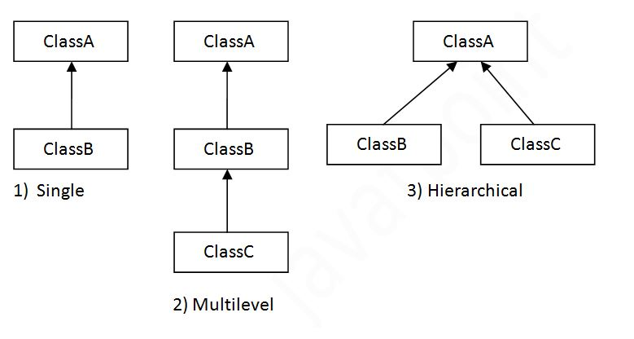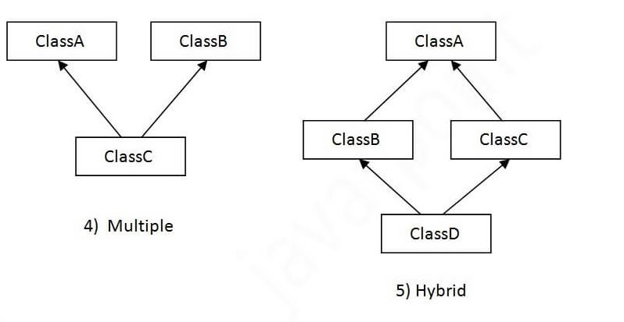
* To reduce the complexity and simplify the language, multiple inheritance is not supported in java**. (interface and super keyword to resolve the multiple inheritance in java)**

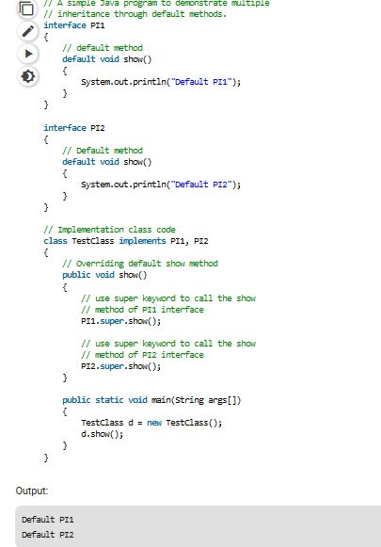

**ABSTRACT CLASS**

**Abstraction** is a process of hiding the implementation details and showing only functionality to the user.(**FOR EXAMPLE** In the software development the end user want to know the functions only they no need to know the source code and the internal functions )

An **abstract class** is a **class** that is declared **abstract**—it may or may not include **abstract** methods. **Abstract classes** cannot be instantiated, but they can be sub-classed. An **abstract class** may have static fields and static methods

**MULTITHREADING :**

It used to perform the multiple operations parallely.

**EXAMPLE:**

Multiple account holders accessing their accounts simultaneously on the server. When you insert a ATM card, it starts a thread for perform your operations.

**Overloading AND Overriding:**

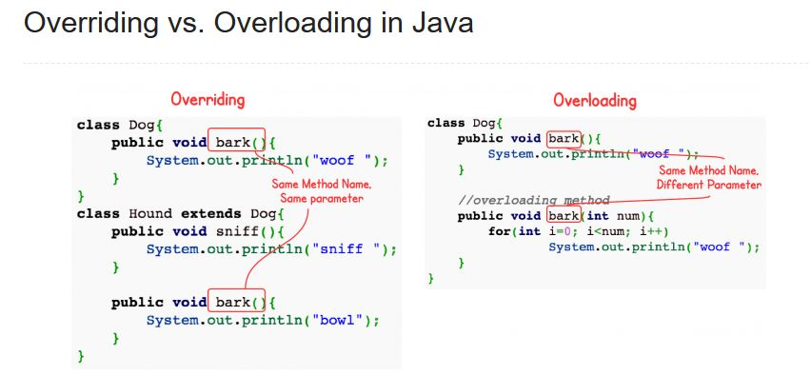

**Overloading** occurs when two or more methods in one class have the same method name but different parameters.

**Overriding** means having two methods with the same method name and parameters