POSTMAN:
Postman is an American software company that develops an API platform used by developers to design, test, build, and document APIs. The company is headquartered in San Francisco, California, United States, and was founded in 2014 by Abhinav Asthana, Ankit Sobti, and Abhijit Kane.
Postman began as a simple Chrome browser extension that allowed developers to test APIs more easily. Over time, it evolved into a comprehensive collaboration platform for API development, enabling teams to design, test, monitor, and publish APIs efficiently. Today, Postman is widely used by millions of developers and organizations worldwide to streamline the API lifecycle and improve collaboration across development teams.
The platform provides tools such as API request testing, automated testing, documentation generation, mock servers, and API monitoring. With the rapid growth of microservices and cloud-based applications, Postman has become one of the most popular tools for API development and management in modern software engineering.

LOGO:
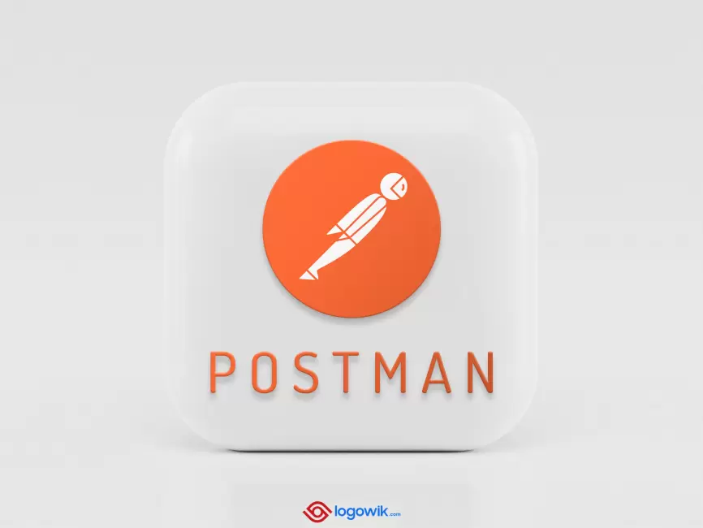

Information Security Policies –Postman
To protect customer data and ensure the security of its platform, Postman follows a comprehensive set of information security policies, practices, and procedures. These policies are designed to safeguard the confidentiality, integrity, and availability of data across the Postman ecosystem.
1. Security Governance
Postman maintains a structured security governance program that defines responsibilities, standards, and processes for protecting information assets. The company regularly reviews and updates its security policies to address emerging threats and evolving regulatory requirements.
2. Data Protection and Privacy
Postman implements strict data protection measures to ensure that user and organizational data remain secure. These measures include encryption, secure storage, and strict access control policies. The platform also follows global privacy standards to protect personally identifiable information (PII).
3. Access Control
Access to systems and data within Postman is restricted based on the principle of least privilege. Authentication mechanisms such as secure login systems and multi-factor authentication help ensure that only authorized users can access sensitive information.
4. Secure Development Practices
Postman integrates security into its software development lifecycle. Code is regularly reviewed and tested for vulnerabilities using automated and manual security testing methods to ensure the reliability and safety of the platform.
5. Network and Infrastructure Security
Postman uses secure cloud infrastructure and continuous monitoring to protect its services from unauthorized access, cyberattacks, and system failures.

Firewalls, intrusion detection systems, and regular vulnerability assessments are used to strengthen the platform’s security posture.
6. Incident Response and Monitoring
The company maintains an incident response program to quickly identify, investigate, and resolve security incidents. Continuous monitoring and logging help detect suspicious activities and enable rapid response to potential threats.
7. Compliance and Risk Management
Postman follows recognized security standards and compliance frameworks to ensure that its systems and processes meet industry security requirements. Regular audits and risk assessments are conducted to maintain a strong security environment.
Privacy Policy:-
Postman is committed to protecting the privacy and personal data of its users. The company follows strict privacy practices to ensure that personal information collected through its platform is handled responsibly, securely, and transparently.
1. Information Collection
Postman collects different types of information to provide and improve its services. This may include personal details such as name, email address, organization name, and usage data when users create an account or interact with the platform.
2. Use of Information
The information collected by Postman is used to:
- Provide and maintain the Postman platform
- Improve product features and performance
- Communicate updates, notifications, and support information
- Ensure security and prevent fraudulent activities
3. Data Sharing
Postman does not sell personal information to third parties. However, information may be shared with trusted service providers or partners who assist in operating the platform, maintaining infrastructure, or delivering services, subject to strict confidentiality agreements.
4. Data Security

Postman implements appropriate technical and organizational security measures to protect user data against unauthorized access, loss, or misuse. These measures include encryption, secure authentication, and continuous monitoring of systems.
5. User Rights and Control
Users have the right to access, update, or delete their personal information stored on the Postman platform. They can also manage privacy settings and communication preferences through their account.
6. Cookies and Tracking Technologies
Postman may use cookies and similar technologies to enhance user experience, analyze platform usage, and improve service functionality.
7. Policy Updates
Postman may update its privacy policy from time to time to reflect changes in legal requirements or platform features. Users are encouraged to review the policy periodically to stay informed about how their data is protected.

SNAPSHOTS :

