PSG COLLEGE OF TECHNOLOGY
GOAT ROBOTICS PRIVATE LIMITED





Abinesh P K
23pc02@psgtech.ac.in

Department of Applied Mathematics
And Computational Sciences

Project Title: Lane-Aware Multi-Robot Traffic Control System

Submission Date: 19th April 2026

PROJECT OVERVIEW
The Lane-Aware Multi-Robot Traffic Control System is a fully autonomous, cooperative swarm-intelligence platform for structured environments. We coordinate 10 heterogeneous robots on a 22-node, 68-edge bidirectional graph using time-space reservations, Wait-For-Graph (WFG) deadlock detection, multi-factor cooperative A*, and dynamic congestion heatmapping. We guarantee a collision-free operation via three orthogonal mechanisms and liveness through event-driven and periodic replanning.
Architecture Diagram Output summary with metrics
Core Technical Innovations
- Collision Avoidance is achieved via 3 independent, mutually reinforcing layers.
Rather than planning paths in pure space, the ReservationManager maintains a compact table that records which robot owns each edge at each future time step. When a robot receives a new path from the planner, the manager validates only the immediate near-term segment of that path (typically the next ten steps) against existing bookings.
This hybrid global-local design, directly inspired by real-robot MAPF reservation tables (arXiv:2408.14527), delivered zero collisions and zero overlapping lane usage across all 599 ticks.
- Lane Reservation Modules is handled by the Reservation Manager.
It maintains a global time-space table and, on every path request from the Intelligence Module, performs near-term strict validation (next 10 steps) plus capacity checks, with immediate pre-reservation required for all critical lanes. Successful reservations are committed atomically; conflicts or critical-lane denials instantly return a “reroute” signal to trigger replanning.
- Path Planning
Each robot computes its route using a time-aware cooperative A* algorithm that operates over a (node, time_step) state space rather than plain graph nodes. This ensures two robots never occupy the same edge at the same tick, preventing collisions at the reservation layer before any physical constraint is checked.
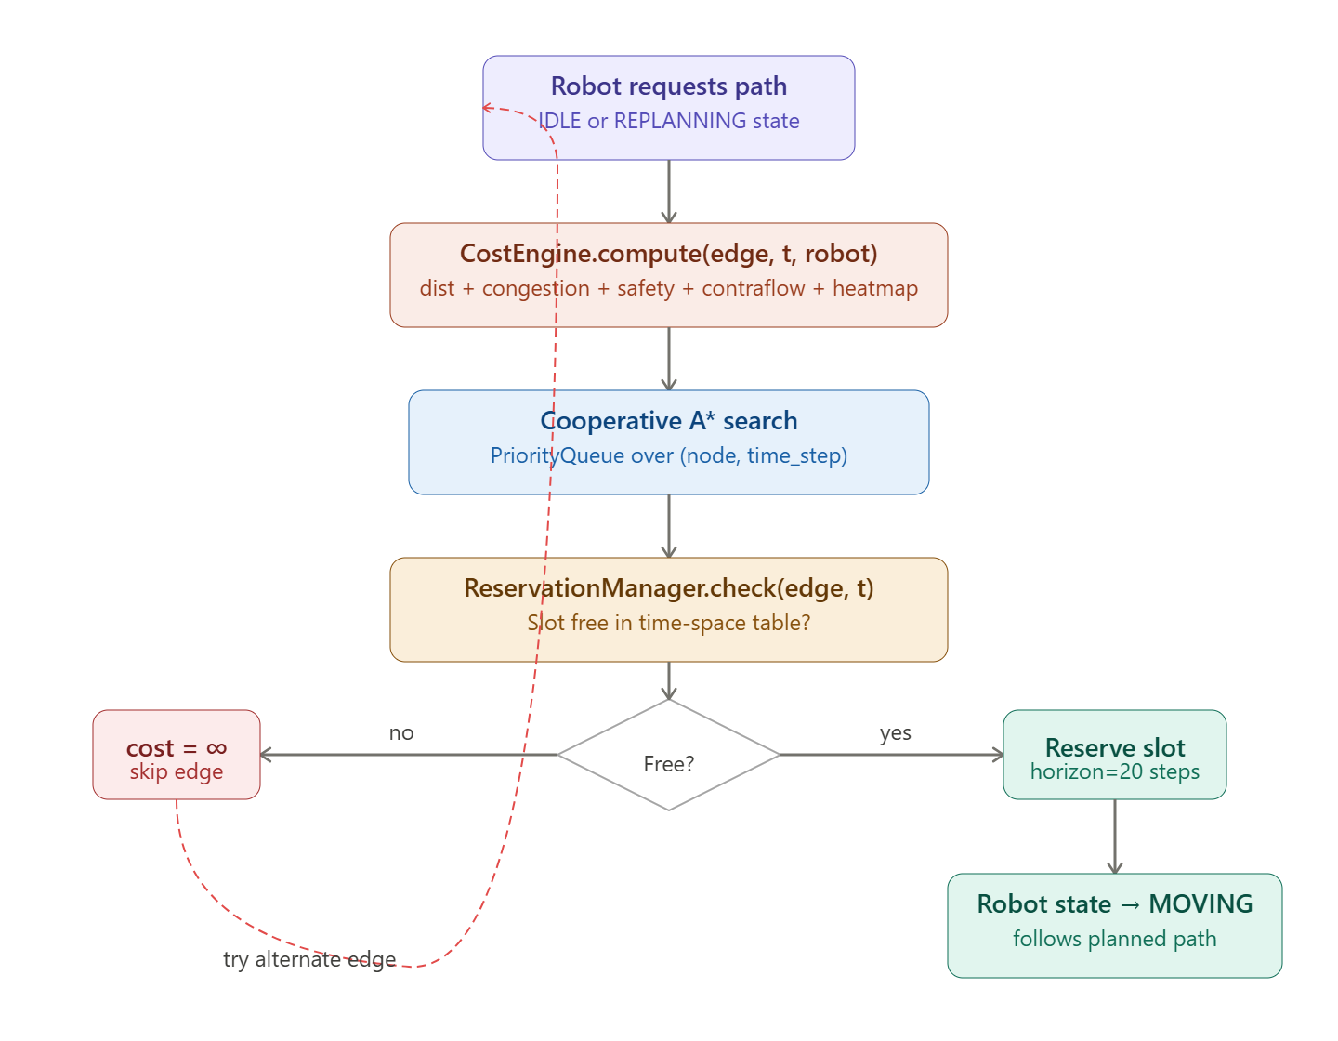
Path Planning and Cooperative A* Algorithm Flow
- Deadlock Handling
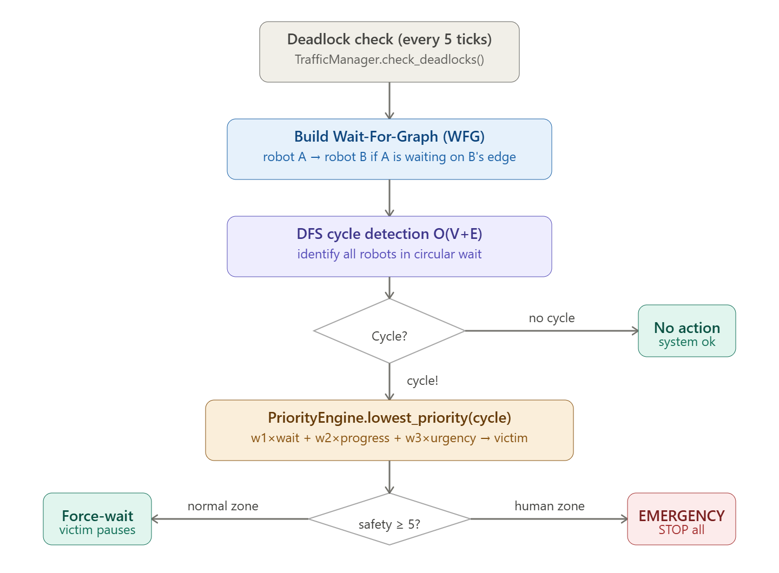
The system uses a Wait-For-Graph (WFG) engine that runs every 5 ticks. A directed edge A → B is added to the WFG whenever robot A is waiting on an edge currently held by robot B. A DFS over this graph detects circular waits in O(V + E) time.

- Intelligence Module
The Intelligence Module is realized through four tightly integrated submodules Cost Engine, Policy Engine, Priority Engine, and Flow Allocator
- CostEngine builds a fresh composite cost function on-the-fly that the cooperative A* Planner consumes for every replan.
- PolicyEngine drives all high-level decisions: it triggers event-driven replans (stuck ≥ 30 ticks, reservation denial after brief wait, deadlock participation, or congestion hotspot) and chooses wait-vs-reroute based on safety constraints and progress
- PriorityEngine computes a dynamic score used both for conflict arbitration and deadlock victim selection
- FlowAllocator periodically analyses lane usage to keep costs proactive together delivering 114 intelligent replans, full deadlock recovery, and 7.679 goals/100 ticks with zero collisions.
The dynamic congestion/heatmap weighting, event-driven replanning triggers, and hybrid priority scoring further align with lifelong MAPF congestion-avoidance techniques from “Traffic Flow Optimisation for Lifelong Multi-Agent Path Finding” (Chen et al., arXiv:2308.11234, AAAI 2024)
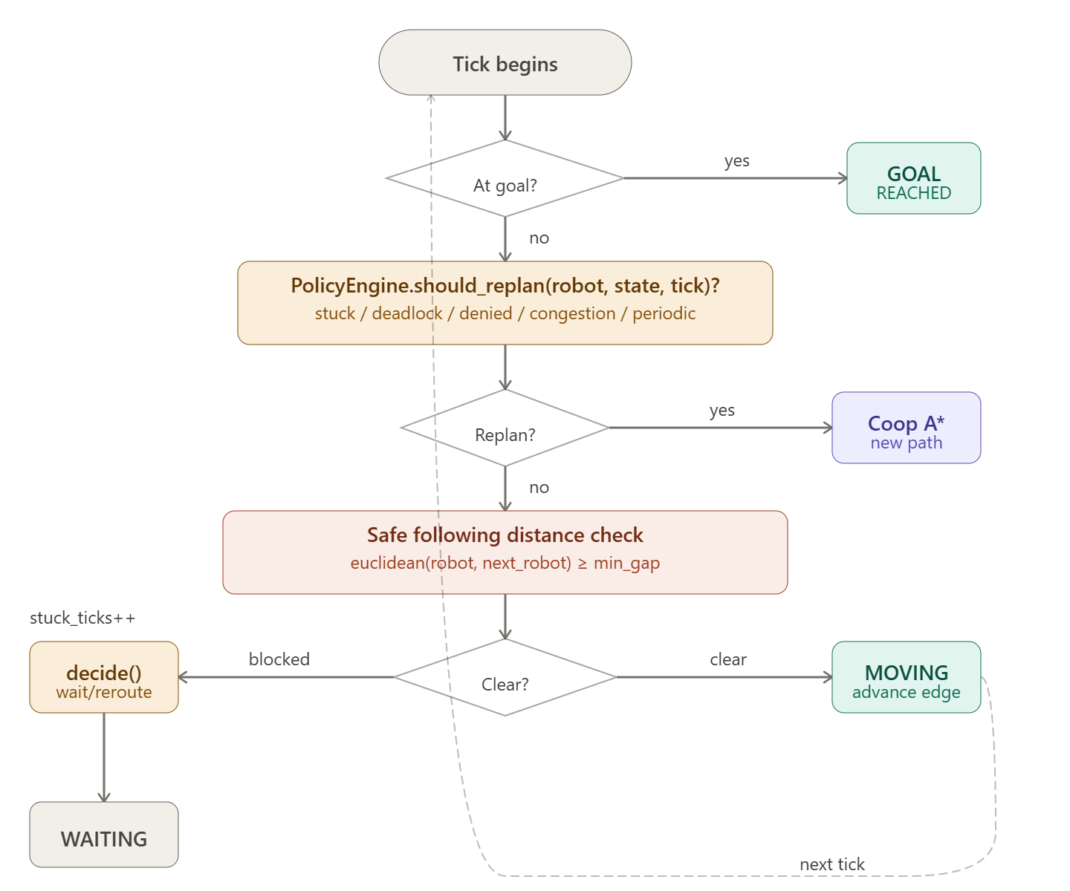
Robot Action at every tick

