SIMATS ENGINEERING
ASSESSMENT TOOL 2
COURSE CODE: ITA 06 COURSE NAME: MACHINE LEARNING

COURSE OUTCOME COVERED
CO2: Neural Network Representation, Perceptron Model, Multilayer Perceptrons, Backpropagation Algorithm, Deep Neural Networks, Genetic Algorithms, Hypothesis Space Search, Genetic Programming, Models of Evaluation and Learning (BL1, BL2)

Assessment Tool Weightage: 40%

QUESTIONS: 15 Total Marks:100
Code of Conduct:
I ____Abinesh H(192424387)_____ (Name / Reg No) certify that this submission is my original work and that I have adhered to the guidelines specified for this assessment.
I understand that any violation of academic integrity rules will result in disciplinary action.

Annexure A
Analytical Problem Solving
Criteria | Conceptual Understanding | Accuracy of Answers | Application of Knowledge | Completeness of Response | Clarity & Presentation | Total
Weightage | 35% | 20% | 25% | 10% | 10%
Q1
Q2
Q3

Signature of the student Total Marks Awarded
Annexure A

Short Answer Test
1. With the help of a neat sketch, explain the different functional blocks present in a machine learning system, including data collection, preprocessing, feature extraction, model training, and evaluation. Illustrate the working of the system by providing suitable examples for both supervised and unsupervised learning approaches, clearly highlighting how labelled and unlabelled data are handled within the learning process. (5 Marks)
2. Design a machine learning system for disaster management to predict events such as floods and earthquakes using both historical and real-time data sources. Explain the selection of an appropriate model, including whether a neural network or any other algorithm is suitable for this task, along with justification. Describe the data preprocessing steps and feature selection techniques required to improve model performance. Further, explain the complete process of training, validating, and evaluating the model, and discuss how such a system can assist authorities in early warning, risk assessment, and effective emergency response. (5 Marks)
3. In the context of neural networks, consider a multilayer perceptron used for binary classification. Explain how the backpropagation algorithm updates the weights in the network during training. Illustrate the process using a simple example by describing the forward pass, error calculation, and backward propagation of errors. Discuss how learning rate and activation functions influence the convergence and accuracy of the model. (5 Marks)
4. In the context of Genetic Algorithms, consider a dataset representing different candidate solutions for maximizing a fitness function based on two parameters: Speed and Accuracy. Each solution is evaluated as either suitable (Yes) or not suitable (No). Using the Genetic Algorithm approach, analyze how the population evolves by applying selection, crossover, and mutation operations. Show the step-by-step improvement of candidate solutions across generations and identify the best optimal solution. (5 Marks)
Dataset:
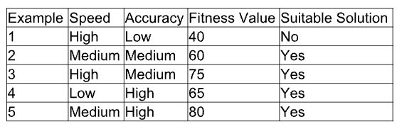
Explain how selection chooses the best individuals, how crossover generates new offspring, and how mutation helps in exploring the hypothesis space. Also, provide the final optimized solution after evolution.
5. In the context of Neural Networks for classification, consider a dataset used to predict whether a patient has a disease based on attributes such as Age, Blood Pressure, Glucose Level, and Lifestyle Risk. The output indicates whether the disease is present (Yes) or not (No). Using this dataset, explain how a neural network model can be trained using backpropagation to classify the data. Also, evaluate the model performance by comparing actual and predicted outputs. (5 Marks)
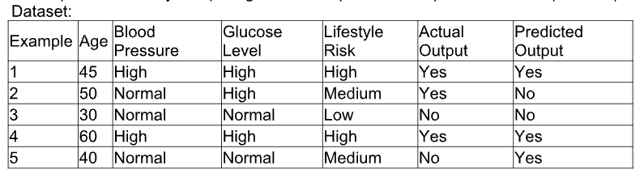
Using the above dataset, compute the values of True Positives, True Negatives, False Positives, and False Negatives. Based on these values, analyze the performance of the neural network using suitable evaluation metrics. Also, explain how preprocessing and feature selection improve the model’s accuracy and reliability.
6. With the help of a neat diagram, explain the architecture of a decision tree learning system. Describe how features are selected using measures such as entropy and information gain. Illustrate the process of tree construction and pruning using a small example dataset, and explain how overfitting can be controlled in decision tree models. (5 Marks)
7. Design a machine learning system for smart traffic management to predict traffic congestion using data such as vehicle density, time of day, weather conditions, and road type. Justify the choice of algorithm, explain preprocessing and feature engineering steps, and describe how the model can be trained, validated, and deployed for real-time decision-making. (5 Marks)
8. In the context of Convolutional Neural Networks (CNNs), explain the different layers involved, including convolutional, pooling, and fully connected layers. Describe how feature maps are generated and how backpropagation updates weights in CNNs. Illustrate the process with an example of image classification and discuss factors affecting model performance. (5 Marks)
9. Consider the application of Genetic Algorithms for feature selection in a machine learning problem. Explain how candidate feature subsets are represented as chromosomes and how fitness is evaluated. Describe the role of selection, crossover, and mutation in evolving better feature subsets, and discuss how this improves model accuracy and reduces complexity. (5 Marks)
10. In the context of classification problems, explain how different evaluation metrics such as accuracy, precision, recall, F1-score, and ROC curve are used to assess model performance. Using a sample confusion matrix, demonstrate the calculation of these metrics and discuss their importance in applications such as medical diagnosis and fraud detection.
11. With the help of a neat diagram, explain the architecture of an Artificial Neural Network (ANN). Describe the roles of input, hidden, and output layers, and explain how weights and biases are used in computation. Illustrate how forward propagation works with a simple example, and discuss how overfitting can be controlled using techniques such as dropout and regularization. (5 Marks)
12. Design a machine learning system for weather forecasting to predict rainfall using features such as temperature, humidity, wind speed, and atmospheric pressure. Justify the choice of algorithm, explain preprocessing and feature engineering steps, and describe how the model can be trained, validated, and deployed for real-time predictions. (5 Marks)
13. In the context of Recurrent Neural Networks (RNNs), explain the architecture and how they handle sequential data. Describe the concept of hidden states and how information is passed through time steps. Illustrate with an example such as text prediction or time-series forecasting, and discuss challenges like vanishing gradients and possible solutions. (5 Marks)
14. Consider the use of Genetic Algorithms for optimization problems such as scheduling tasks in a system. Explain how solutions are encoded as chromosomes and how the fitness function is defined. Describe the processes of selection, crossover, and mutation, and discuss how these operations help in finding near-optimal solutions efficiently. (5 Marks)
15. In the context of classification models, explain how performance evaluation is carried out using metrics such as accuracy, precision, recall, F1-score, and ROC-AUC. Using a sample confusion matrix, demonstrate how each metric is calculated and discuss their importance in real-world applications such as spam detection and disease diagnosis. (5 Marks)

RUBRICS FOR CALCULATION
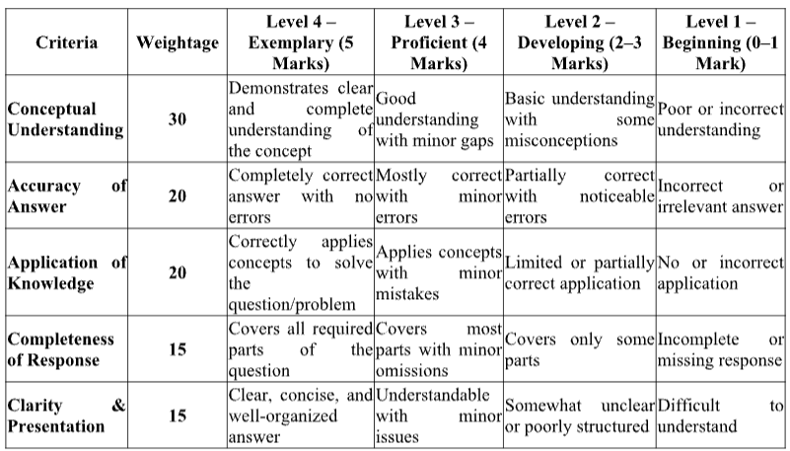

1. Functional Blocks of a Machine Learning System
Neat Sketch
Data Collection
↓
Data Preprocessing
↓
Feature Extraction / Selection
↓
Model Training
↓
Model Evaluation
↓
Prediction / Decision
Explanation
- Data Collection: Data is collected from sensors, databases, files, or websites.
- Preprocessing: Missing values, duplicate records, noise, and inconsistent data are handled.
- Feature Extraction: Important attributes are selected or created.
- Model Training: The algorithm learns patterns from the data.
- Evaluation: Performance is measured using accuracy, precision, recall, etc.
Supervised learning: Uses labelled data. Example: Student data with study hours and the label Pass/Fail.
Unsupervised learning: Uses unlabelled data. Example: Grouping customers into clusters based on purchasing behaviour.
Supervised: Features + Labels → Model → Prediction
Unsupervised: Features only → Model → Hidden Patterns/Clusters

2. Machine Learning System for Disaster Management
System Design
Historical + Real-Time Data
↓
Data Preprocessing
↓
Feature Selection
↓
ML Model
↓
Risk Prediction
↓
Early Warning / Emergency Response
Data Sources
- Historical flood and earthquake records
- Rainfall, river level, soil moisture, and temperature
- Seismic sensor data
- Satellite and IoT sensor data
Model Selection
For structured data, Random Forest, XGBoost, or Logistic Regression can be used. A neural network/LSTM is suitable when large time-series data from sensors is available.
Preprocessing
- Handle missing values
- Remove noise and duplicates
- Normalize numerical features
- Encode categorical variables
- Balance classes if disaster events are rare
Feature Selection
Important features may include rainfall, river level, soil moisture, seismic magnitude, location, and temperature.
Training and Evaluation
The dataset is divided into training, validation, and testing sets. The model is trained on historical data and evaluated using accuracy, precision, recall, F1-score, and ROC-AUC.
The system can provide early warnings, identify high-risk zones, estimate disaster probability, and help authorities plan evacuation and emergency resources.

3. Backpropagation in a Multilayer Perceptron
Architecture
Input Layer → Hidden Layer → Output Layer
x1, x2 h1, h2 y
Working
- Forward Pass: Inputs are multiplied by weights, biases are added, and activation functions produce outputs.
- Error Calculation:
$$Error=Target-Predicted$$
- Backward Propagation: The error is propagated from the output layer toward the input layer.
- Weight Update:
$$w_{new}=w_{old}+η×error×input$$
where $η$is the learning rate.
A high learning rate may cause unstable training, while a very low learning rate makes training slow. Activation functions such as ReLU and sigmoid influence gradient flow and convergence.

4. Genetic Algorithm for Speed and Accuracy
Initial Population
Solution | Speed | Accuracy | Fitness | Suitable
1 | High | Low | 40 | No
2 | Medium | Medium | 60 | Yes
3 | High | Medium | 75 | Yes
4 | Low | High | 65 | Yes
5 | Medium | High | 80 | Yes
Evolution Process
Generation 1: The best individual is Solution 5 with fitness 80.
Selection
Individuals with higher fitness are selected:
$$S_{5}\left(80\right),S_{3}\left(75\right),S_{4}\left(65\right)$$
Crossover
Parts of selected chromosomes are exchanged to generate new combinations, such as:
Parent 1: High | Medium
Parent 2: Medium | High

Offspring: High | High
This may create a candidate with high speed and high accuracy.
Mutation
A feature such as Speed or Accuracy may randomly change. Mutation helps explore new solutions and prevents premature convergence.
Final Optimized Solution
High Speed + High Accuracy is the best expected solution because it combines both desirable characteristics and should have the highest fitness.

5. Neural Network for Disease Classification
Dataset Comparison
Actual | Predicted
Yes | Yes
Yes | No
No | No
Yes | Yes
No | Yes
Confusion Matrix Values
- TP = 2: Actual Yes, Predicted Yes
- TN = 1: Actual No, Predicted No
- FP = 1: Actual No, Predicted Yes
- FN = 1: Actual Yes, Predicted No
Accuracy
$$\frac{TP+TN}{Total}=\frac{2+1}{5}=60\%$$
Precision
$$\frac{TP}{TP+FP}=\frac{2}{3}=66.67\%$$
Recall
$$\frac{TP}{TP+FN}=\frac{2}{3}=66.67\%$$
Preprocessing and Feature Selection
Numerical values should be normalized, categorical features should be encoded, and missing values should be handled. Important features such as glucose level, blood pressure, age, and lifestyle risk should be selected using correlation, feature importance, or statistical methods.

6. Decision Tree Learning System
Architecture
Root Node
/ \
Feature Test Feature Test
/ \ / \
Decision Decision ... ...
↓
Leaf Node
Entropy
Entropy measures impurity:
$$Entropy=-\sum{p_{i}}\log_{2}\left(p_{i}\right)$$
Information Gain
$$IG=Entropy\left(parent\right)-Weighted Entropy\left(children\right)$$
The feature with the highest information gain is selected as the decision node.
Tree Construction
The algorithm repeatedly selects the best feature and divides the dataset until a stopping condition is reached.
Pruning
Unnecessary branches are removed to reduce complexity and overfitting.
Overfitting can be controlled using:
- Maximum tree depth
- Minimum samples per leaf
- Pre-pruning
- Post-pruning

7. Machine Learning System for Smart Traffic Management
Input Features
- Vehicle density
- Time of day
- Weather conditions
- Road type
- Day of week
Suitable Algorithm
Random Forest or Gradient Boosting is suitable for structured traffic data. For continuous time-series traffic data, LSTM can be used.
Preprocessing
- Handle missing sensor values
- Remove outliers
- Encode road type and weather
- Normalize numerical features
Feature Engineering
Create features such as:
- Rush hour indicator
- Average vehicle density
- Previous-hour congestion
- Weather severity score
Model Process
Traffic Data → Preprocessing → Feature Engineering
↓
Model Training → Validation → Testing
↓
Real-Time Deployment
The system can predict congestion levels and help control traffic signals, suggest alternate routes, and provide real-time traffic alerts.

8. Convolutional Neural Network
CNN Architecture
Input Image
↓
Convolution Layer
↓
Feature Maps
↓
Pooling Layer
↓
Flatten
↓
Fully Connected Layer
↓
Output Class
Layers
- Convolution: Applies filters to detect edges, shapes, and patterns.
- Feature Maps: Store detected features.
- Pooling: Reduces spatial size and computation.
- Fully Connected Layer: Performs final classification.
For example, a CNN can classify an image as cat or dog.
During backpropagation, the prediction error is calculated and propagated backward. The filters' weights are updated using gradient descent.
Performance is affected by:
- Number of layers
- Filter size
- Learning rate
- Dataset size
- Overfitting
- Image quality

9. Genetic Algorithm for Feature Selection
A chromosome represents a feature subset using binary values:
Features: Age BP Glucose BMI Risk
Chromosome: 1 0 1 1 0
This means Age, Glucose, and BMI are selected.
Fitness
The fitness can be calculated using model performance:
$$Fitness=Accuracy-λ\left(Number of Features\right)$$
Operations
- Selection: Chooses feature subsets with high fitness.
- Crossover: Combines feature subsets from two parents.
- Mutation: Randomly changes 0 to 1 or 1 to 0.
The final subset can improve accuracy while reducing the number of features, computational cost, and model complexity.

10. Classification Evaluation Metrics
Assume:
- TP = 80
- TN = 90
- FP = 10
- FN = 20
Total = 200.
Accuracy
$$\frac{TP+TN}{Total}=\frac{80+90}{200}=85\%$$
Precision
$$\frac{TP}{TP+FP}=\frac{80}{90}=88.89\%$$
Recall
$$\frac{TP}{TP+FN}=\frac{80}{100}=80\%$$
F1-Score
$$F1=\frac{2TP}{2TP+FP+FN}=\frac{160}{190}=84.21\%$$
ROC Curve
The ROC curve plots:
- True Positive Rate
- False Positive Rate
A higher ROC-AUC indicates better classification ability.
In medical diagnosis, recall is important to reduce missed diseases. In fraud detection, precision is important to reduce false alarms.

11. Artificial Neural Network Architecture
Diagram
Input Layer Hidden Layer Output Layer

x1 ───────────► h1 ───────────►
│ y
x2 ───────────► h2 ───────────►
│
x3 ───────────► h3
Components
- Input Layer: Receives input features.
- Hidden Layer: Learns complex patterns.
- Output Layer: Produces the final prediction.
- Weights: Determine the importance of inputs.
- Bias: Helps shift the activation function.
Forward Propagation
$$z=w_{1}x_{1}+w_{2}x_{2}+b$$
The activation function is applied to $z$to produce the output.
Overfitting Control
- Dropout: Randomly disables neurons during training.
- Regularization: Penalizes large weights and reduces model complexity.

12. Machine Learning System for Weather Forecasting
Input Features
- Temperature
- Humidity
- Wind speed
- Atmospheric pressure
Algorithm
Random Forest or Gradient Boosting can predict rainfall occurrence from structured weather data. LSTM is suitable for sequential weather data collected over time.
Preprocessing
- Handle missing sensor values
- Remove outliers
- Normalize numerical features
- Encode categorical variables if present
Feature Engineering
Create:
- Moving averages
- Previous-day rainfall
- Humidity-pressure interaction
- Temperature change
System
Weather Data
↓
Preprocessing
↓
Feature Engineering
↓
Model Training
↓
Validation and Testing
↓
Real-Time Rainfall Prediction
The trained model can be deployed with real-time weather sensors to provide continuous rainfall predictions.

13. Recurrent Neural Network
Architecture
x₁ → [RNN Cell] → h₁
↓
x₂ → [RNN Cell] → h₂
↓
x₃ → [RNN Cell] → h₃ → Output
An RNN processes sequential data one time step at a time.
The hidden state stores information from previous time steps:
$$h_{t}=f\left(W_{x}x_{t}+W_{h}h_{t-1}+b\right)$$
For example, in text prediction, previous words influence the prediction of the next word.
Challenge
Vanishing gradients cause the network to forget information from earlier time steps.
Solutions
- LSTM
- GRU
- Proper weight initialization
- Gradient clipping
RNNs are useful for text processing, speech recognition, and time-series forecasting.

14. Genetic Algorithm for Scheduling
A scheduling solution can be represented as a chromosome:
[Task 3, Task 1, Task 4, Task 2]
The fitness function evaluates the schedule based on:
- Total completion time
- Waiting time
- Resource usage
- Number of conflicts
A possible fitness function is:
$$Fitness=\frac{1}{Total Cost}$$
Genetic Operations
- Selection: Selects schedules with better fitness.
- Crossover: Combines parts of two schedules.
- Mutation: Randomly changes task order.
Repeated generations gradually improve the scheduling solution. This approach can efficiently find near-optimal solutions for complex scheduling problems.

15. Classification Model Evaluation
Assume:
- TP = 90
- TN = 80
- FP = 10
- FN = 20
Total = 200.
Accuracy
$$\frac{90+80}{200}=85\%$$
Precision
$$\frac{90}{90+10}=90\%$$
Recall
$$\frac{90}{90+20}=81.82\%$$
F1-Score
$$F1=\frac{2\left(90\right)}{2\left(90\right)+10+20}=\frac{180}{210}=85.71\%$$
ROC-AUC
The ROC curve compares the true-positive rate with the false-positive rate at different classification thresholds. A higher AUC indicates better performance.
Spam detection: Precision is important because legitimate emails should not be incorrectly classified as spam.
Disease diagnosis: Recall is important because failing to detect a real disease can have serious consequences.

