Product Capability Overview
Bellomassi Order-to-Delivery Management Platform
BM-OVW-008 · Version 1.0 · Draft — for client review
2026-11-12

Document control
Field | Value
Document title | Product Capability Overview
Document ID | BM-OVW-008
Version | 1.0
Status | Draft — for client review
Category | Project Overview
Related module(s) | All modules
Document owner | Product Manager
Prepared by | Project documentation team (AI-assisted draft prepared from source-code analysis)
Reviewed by | Pending — not yet reviewed
Approval | Not approved — awaiting client review (no approval has been given)
Created date | 2026-11-12
Last updated date | 2026-11-12
Status labels used in this document: VERIFIED (confirmed in the current source code or existing documents) · PROTOTYPE (works in the React/LocalStorage prototype with mock or simulated behaviour) · PROPOSED (recommended production design, not built) · PENDING CONFIRMATION (needs a client decision) · NOT IMPLEMENTED · NOT VERIFIED.

Purpose
Summarise capabilities by business area with their implementation label.

Scope
All capability areas found in the source code.

Definitions
Other terms: see BM-GLO-001 (Project Glossary).

References
- BM-OVW-014 (Product Feature Catalogue)
- BM-OVW-016 (Project Feature Inventory)

1. Capability map
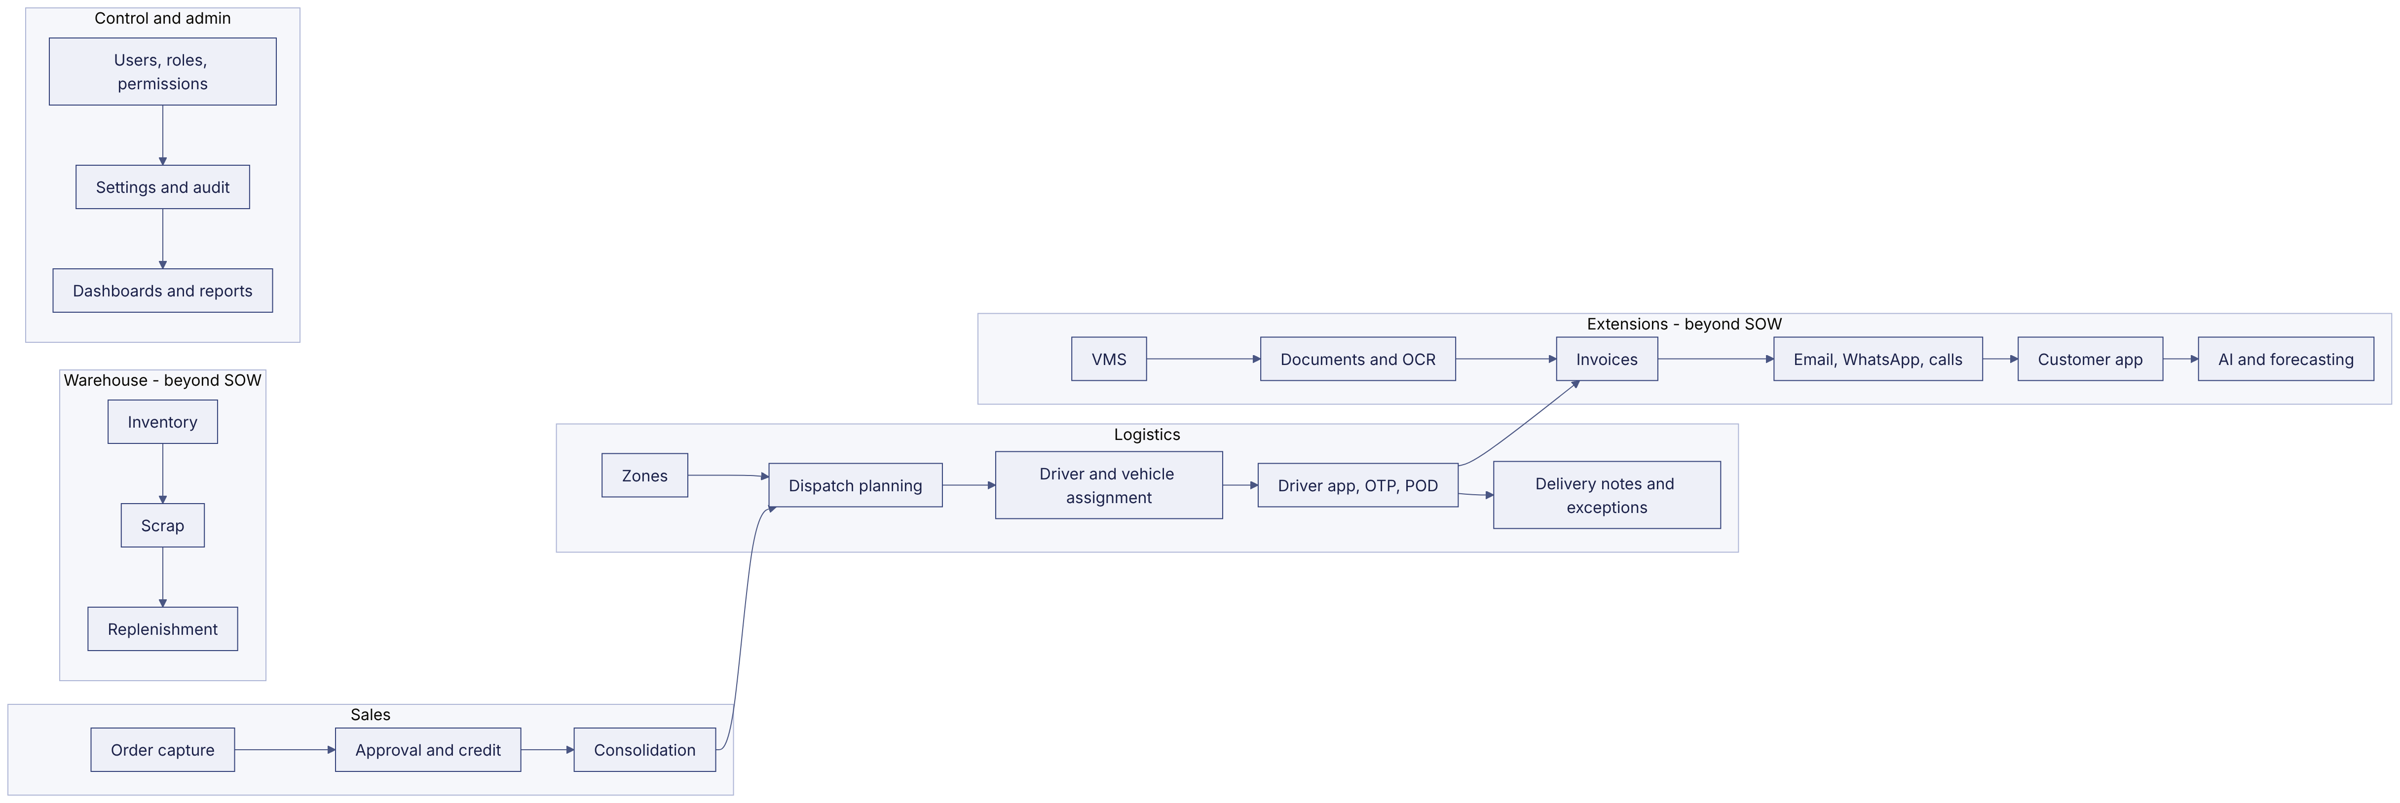

2. Capabilities and labels
Area | Capability | Label
Sales | Order capture, drafts, submit, resubmit, duplicate, timeline | VERIFIED
Sales | Approval with six checks, return, reject | VERIFIED
Sales | Approved figures set by manager | PENDING CONFIRMATION (not built)
Sales | Credit check (warning / block) | VERIFIED (balance manual)
Logistics | Consolidation per salesman | VERIFIED
Logistics | Dispatch, sequence, confirmation with stock deduction | VERIFIED
Logistics | Zone board drag and drop; traffic-aware routing | PROPOSED
Logistics | Driver stop workflow, OTP, POD, delivery notes | VERIFIED (GPS / OTP delivery simulated)
Logistics | Live tracking | PROTOTYPE (DEMO GPS)
Warehouse | Inventory, scrap, replenishment | VERIFIED — scope PENDING CONFIRMATION
Control | RBAC, users, settings, audit, notifications | VERIFIED
Control | Dashboards with period filter; 118 reports | VERIFIED (24 reports without source data)
Extensions | VMS compliance | VERIFIED
Extensions | Documents and OCR | PROTOTYPE (mock OCR)
Extensions | Invoices | VERIFIED — scope PENDING CONFIRMATION
Extensions | Email / WhatsApp / automation | PROTOTYPE (demo sending)
Extensions | Customer app | VERIFIED — scope PENDING CONFIRMATION
Extensions | AI assistant, forecasting | PROTOTYPE
Integration | SAP | PROPOSED (stage 2)
Finance | Payments, credit notes | NOT IMPLEMENTED

Revision history
Version | Date | Author | Description
1.0 | 2026-11-12 | Documentation team | Initial draft prepared from analysis of the bellomassi-premium-ui source code and existing project documents.

