Project Organization Structure
Bellomassi Order-to-Delivery Management Platform
BM-OVW-011 · Version 1.0 · Draft — for client review
2026-11-12

Document control
Field | Value
Document title | Project Organization Structure
Document ID | BM-OVW-011
Version | 1.0
Status | Draft — for client review
Category | Project Overview
Related module(s) | All modules
Document owner | Project Manager
Prepared by | Project documentation team (AI-assisted draft prepared from source-code analysis)
Reviewed by | Pending — not yet reviewed
Approval | Not approved — awaiting client review (no approval has been given)
Created date | 2026-11-12
Last updated date | 2026-11-12
Status labels used in this document: VERIFIED (confirmed in the current source code or existing documents) · PROTOTYPE (works in the React/LocalStorage prototype with mock or simulated behaviour) · PROPOSED (recommended production design, not built) · PENDING CONFIRMATION (needs a client decision) · NOT IMPLEMENTED · NOT VERIFIED.

Purpose
Propose the governance and team structure for the production project.

Scope
Proposed structure; actual names and appointments are PENDING CONFIRMATION.

Definitions
Other terms: see BM-GLO-001 (Project Glossary).

References
- BM-OVW-009 (Stakeholder Identification)
- BM-PM-004 (Resource Allocation and RACI Matrix)

1. Proposed structure — PROPOSED
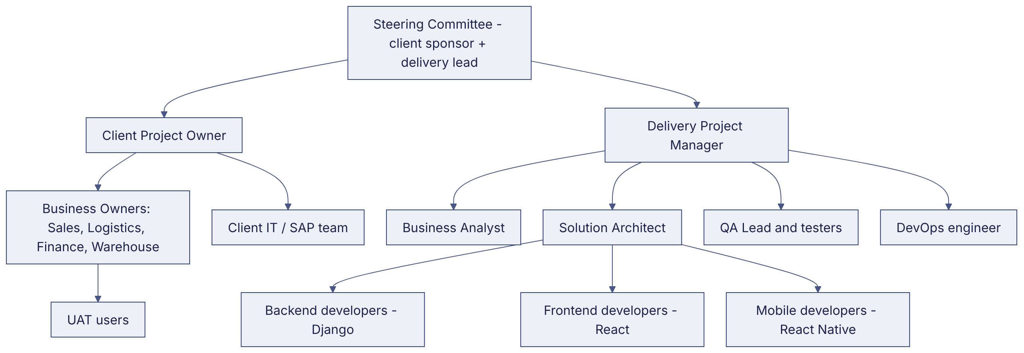

2. Roles
Role | Responsibility
Steering Committee | Scope, budget, go-live decisions
Client Project Owner | Day-to-day decisions, access to business owners
Delivery Project Manager | Plan, status, risks, changes
Business Analyst | Requirements, traceability, UAT support
Solution Architect | Architecture, security, integrations
Developers | Build backend, web, mobile
QA | Test planning and execution
DevOps | Environments, CI/CD, monitoring, backups

Revision history
Version | Date | Author | Description
1.0 | 2026-11-12 | Documentation team | Initial draft prepared from analysis of the bellomassi-premium-ui source code and existing project documents.

