Software Requirements Specification (SRS)
Bellomassi Order-to-Delivery Management Platform
BM-SYS-002 · Version 1.0 · Draft — for client review
2026-11-12

Document control
Field | Value
Document title | Software Requirements Specification (SRS)
Document ID | BM-SYS-002
Version | 1.0
Status | Draft — for client review
Category | System Requirements
Related module(s) | All modules
Document owner | Business Analyst / Solution Architect
Prepared by | Project documentation team (AI-assisted draft prepared from source-code analysis)
Reviewed by | Pending — not yet reviewed
Approval | Not approved — awaiting client review (no approval has been given)
Created date | 2026-11-12
Last updated date | 2026-11-12
Status labels used in this document: VERIFIED (confirmed in the current source code or existing documents) · PROTOTYPE (works in the React/LocalStorage prototype with mock or simulated behaviour) · PROPOSED (recommended production design, not built) · PENDING CONFIRMATION (needs a client decision) · NOT IMPLEMENTED · NOT VERIFIED.

Purpose
Specify the software requirements of the Bellomassi platform — functions, user classes, interfaces, quality attributes and data — for the production build, and record how the prototype satisfies them today.

Scope
Office web application, Drivers App, customer app (if confirmed), backend services, integrations. Requirement IDs are unique across the package (SYS-REQ, FR, NFR, RULE).

Definitions
Other terms: see BM-GLO-001 (Project Glossary).

References
- IEEE 29148 (structure inspiration)
- Scope of Work, October 2026
- BM-SYS-001 (System Requirements Document (SRD))
- BM-SYS-003 (Functional Requirements Document (Consolidated))
- BM-SYS-004 (Non-Functional Requirements)
- BM-SYS-007 (Business Rules Catalogue)
- BM-SYS-008 (Requirement Traceability Matrix)
- BM-BRD-001 (Business Requirements Document (BRD))
- BM-ARC-001 (High-Level Design (HLD))
- BM-API-001 (API Specification (Overview and Conventions))

Contents

  - System overview

  - System context

  - System-level requirements

  - Product functions

  - User classes and roles

  - Functional requirements

  - Non-functional requirements

  - External interfaces

  - Hardware requirements

  - Software requirements

  - Performance requirements

  - Security requirements

  - Availability, scalability and reliability

  - Usability and maintainability

  - Data requirements

  - Acceptance criteria

1. System overview
Bellomassi manages the order-to-delivery process of a food distributor: order capture, approval with credit control, consolidation, zone-based dispatch, driver delivery with OTP and proof of delivery, delivery notes, notifications, administration and reporting. The current implementation is a frontend prototype (React 19, LocalStorage); production requires a backend (Django REST Framework, PostgreSQL) and mobile apps (React Native) — PROPOSED.

2. System context
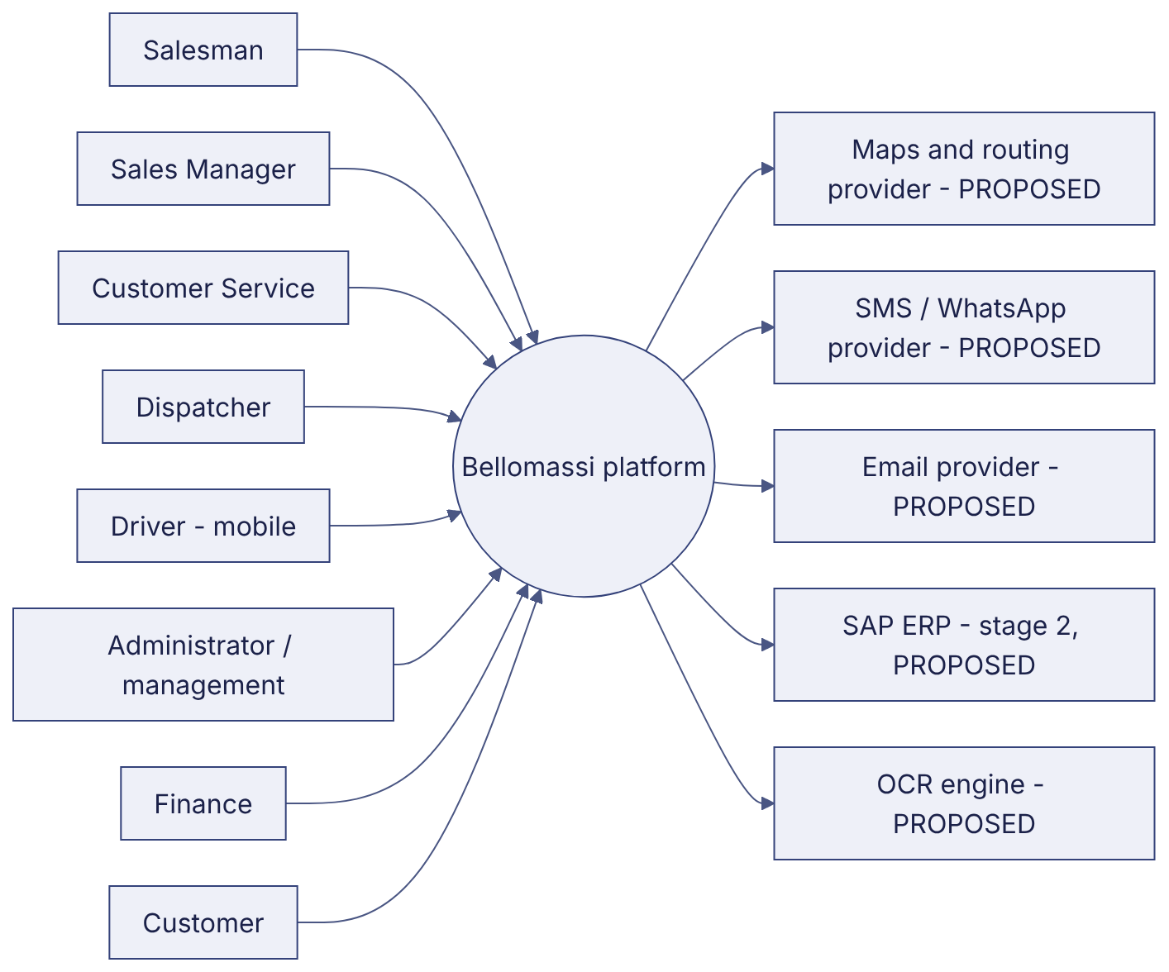

3. System-level requirements
ID | Requirement | Label
SYS-REQ-001 | The system shall maintain one order record from capture to delivery with a complete timeline. | VERIFIED
SYS-REQ-002 | The system shall enforce role-based access with permission keys and data scopes on every action. | VERIFIED (prototype client-side) / PROPOSED (server-side)
SYS-REQ-003 | The system shall provide an office web application, a driver mobile application and an administration panel. | VERIFIED (web) / PROPOSED (native mobile)
SYS-REQ-004 | The system shall notify the responsible role at every workflow hand-off. | VERIFIED (in-app)
SYS-REQ-005 | The system shall verify each delivery with a customer OTP and generate a delivery note. | VERIFIED (OTP shown in app) / PROPOSED (SMS / WhatsApp)
SYS-REQ-006 | The system shall store data centrally, shared by all users and devices, with backups. | PROPOSED (prototype: per-browser LocalStorage)
SYS-REQ-007 | The system shall track drivers’ locations during active deliveries and show them to authorised users. | PROTOTYPE (DEMO GPS) / PROPOSED
SYS-REQ-008 | The system shall integrate with SAP for items, stock, customers and credit in stage 2. | PROPOSED
SYS-REQ-009 | The system shall keep an audit trail of administrative, security and workflow events. | VERIFIED
SYS-REQ-010 | The system shall provide dashboards and exportable reports per role. | VERIFIED

4. Product functions
35 modules with 179 functional requirements — summary in BM-SYS-003 (Functional Requirements Document (Consolidated)), detail per module in folder 04 (e.g. BM-FRD-ORD (Functional Requirements — Salesman Order Management), BM-FRD-APR (Functional Requirements — Sales Manager Approval), BM-FRD-DSP (Functional Requirements — Dispatch Management), BM-FRD-DRV (Functional Requirements — Driver Application)).

5. User classes and roles
User class | Roles (code) | Device | Frequency | Technical skill
Sales | SALESMAN, SALES_MANAGER | Mobile and desktop | Daily, high | Basic
Operations office | CUSTOMER_SERVICE, DISPATCHER | Desktop / tablet | Daily, high | Basic to medium
Field | DRIVER | Smartphone | Daily, high | Basic
Finance | FINANCE | Desktop | Daily | Medium
Warehouse (extension) | WAREHOUSE_MANAGER, INVENTORY_EXECUTIVE, QA_MANAGER | Desktop / tablet | Daily | Basic
Administration | SUPER_ADMIN, ADMIN | Desktop | Daily | Medium to high
External | CUSTOMER, SUPPLIER | Smartphone / desktop | Occasional | Basic
Role details: BM-MAN-120 (Role Responsibility Matrix), permission matrix BM-SEC-005 (RBAC and Access Control Matrix).

6. Functional requirements
See BM-SYS-003 (Functional Requirements Document (Consolidated)) (consolidated, unique IDs FR--NNN) and the 35 module FRDs. Business rules: BM-SYS-007 (Business Rules Catalogue).

7. Non-functional requirements
See BM-SYS-004 (Non-Functional Requirements) (NFR-PERF, NFR-SCAL, NFR-AVL, NFR-REL, NFR-SEC, NFR-USE, NFR-ACC, NFR-MNT, NFR-DATA, NFR-COMP, NFR-PORT, NFR-OBS).

8. External interfaces
Interface | Type | Prototype | Production
User interface — office | Responsive web (React) | VERIFIED | Same, connected to API
User interface — driver | Mobile | Web /driver VERIFIED | React Native PROPOSED
User interface — customer | Mobile | Web /customer VERIFIED | PENDING CONFIRMATION
REST API | HTTPS JSON | None | PROPOSED (BM-API-001 (API Specification (Overview and Conventions)))
Real-time | WebSocket (WSS) | None | PROPOSED
Maps / routing | Google Maps JS, Routes API | Static demo map | PROPOSED
Messaging | SMS / WhatsApp provider API | Demo / mock | PROPOSED
Email | SMTP / IMAP or provider API | Demo; gateway contract NOT VERIFIED | PROPOSED
OCR | Server OCR API | Mock | PROPOSED
SAP | RFC / OData / IDoc (to confirm) | None | PROPOSED (stage 2)

9. Hardware requirements
Item | Requirement | Label
Office workstation | Any device with a current browser; 1366×768 minimum | VERIFIED
Driver phone | Android 10+ or iOS 15+, GPS, camera, mobile data, ≥ 3 GB RAM | PROPOSED
Servers | See BM-INF-003 (Infrastructure, Network Architecture and Server Specification) | PROPOSED

10. Software requirements
Browsers: current Chrome, Edge, Safari, Firefox (VERIFIED for the prototype). Production stack: Python 3.12, Django 5, DRF, PostgreSQL 16, Redis, Celery, Django Channels, Nginx, Docker; React 19 / Vite; React Native — BM-INF-001 (Technology Stack Document).

11. Performance requirements
NFR-PERF-001 … NFR-PERF-004. No production measurements exist; targets are PROPOSED.

12. Security requirements
NFR-SEC-001 … NFR-SEC-007 and the security package (BM-SEC-001 (Security Requirements Document)).

13. Availability, scalability and reliability
NFR-AVL-001 (99.5% target), NFR-SCAL-001/002, NFR-REL-001 … 003.

14. Usability and maintainability
NFR-USE-001 … 003, NFR-ACC-001, NFR-MNT-001 … 003.

15. Data requirements
Data | Requirement
Master data | Customers, products, hubs, zones, drivers, vehicles, users, roles — maintained in the Admin Panel; SAP later
Transactions | Orders, approvals, consolidations, dispatches, deliveries, OTPs, PODs, delivery notes, stock movements, scrap, documents, invoices, messages
Retention | PENDING CONFIRMATION (BM-DAT-005 (Data Retention Policy (Draft)))
Model | Prototype model BM-DAT-001 (Current Prototype Data Model (LocalStorage)); production schema BM-DAT-002 (Proposed Production Database Design)

16. Acceptance criteria
- Every FR labelled VERIFIED passes its test cases on the production build (BM-QA-011 (Functional Test Cases)).
- PROPOSED requirements are implemented or formally deferred by change request.
- PENDING CONFIRMATION items are decided and the baseline updated (BM-SYS-009 (Requirement Change Log)).
- NFR targets are measured in staging and accepted.
- UAT scenarios pass and are signed (BM-QA-012 (UAT Test Cases), BM-HND-004 (UAT Sign-Off Document)).

Revision history
Version | Date | Author | Description
1.0 | 2026-11-12 | Documentation team | Initial draft prepared from analysis of the bellomassi-premium-ui source code and existing project documents.

