Scope and Phase Plan
Bellomassi Order-to-Delivery Management Platform
BM-PLN-001 · Version 1.0 · Draft — for client review
2026-11-12

Document control
Field | Value
Document title | Scope and Phase Plan
Document ID | BM-PLN-001
Version | 1.0
Status | Draft — for client review
Category | Scope and Planning
Related module(s) | All modules
Document owner | Project Manager
Prepared by | Project documentation team (AI-assisted draft prepared from source-code analysis)
Reviewed by | Pending — not yet reviewed
Approval | Not approved — awaiting client review (no approval has been given)
Created date | 2026-11-12
Last updated date | 2026-11-12
Status labels used in this document: VERIFIED (confirmed in the current source code or existing documents) · PROTOTYPE (works in the React/LocalStorage prototype with mock or simulated behaviour) · PROPOSED (recommended production design, not built) · PENDING CONFIRMATION (needs a client decision) · NOT IMPLEMENTED · NOT VERIFIED.

Purpose
Translate the scope into a phase plan with entry / exit criteria and indicative durations.

Scope
Phase 1 (prototype, complete) to Phase 5 (enhancements). Durations and dates are estimates based on assumptions; no dates have been agreed with the client.

Definitions
Other terms: see BM-GLO-001 (Project Glossary).

References
- BM-SOW-001 (Scope of Work)
- BM-PLN-002 (Phase-wise Scope Matrix)
- BM-PM-001 (Project Plan)
- BM-RMP-001 (Prototype-to-Production Migration Roadmap (Master))

1. Phases
Phase | Objective | Main scope | Entry criteria | Exit criteria | Indicative duration (estimate)
1 Prototype | Validate workflows | React / LocalStorage prototype — complete | — | Client demo; documentation review | Done
2 Backend | Production core | Django API, PostgreSQL, auth / RBAC, SOW workflows server-side, web app integration | Scope baseline signed; hosting decided | API + web pass system tests in test env | 12–14 weeks
3 Mobile and integrations | Field and customer channels | React Native Drivers App, GPS + WebSockets, Maps / Routes, SMS / WhatsApp, email | Phase 2 API stable; provider accounts | Pilot-ready build; integration tests pass | 10–12 weeks (overlaps phase 2 by ~4 weeks)
4 Production deployment | Go-live | Security hardening, performance tests, data migration, UAT, training, go-live, hypercare | Phases 2–3 complete | UAT signed; go-live checklist complete | 6–8 weeks
5 Enhancements | Stage 2 | SAP integration; confirmed extensions; analytics | Go-live stable | Per change request | To be estimated

2. Indicative timeline — ESTIMATE (assumed start date 4 January 2027, not agreed)
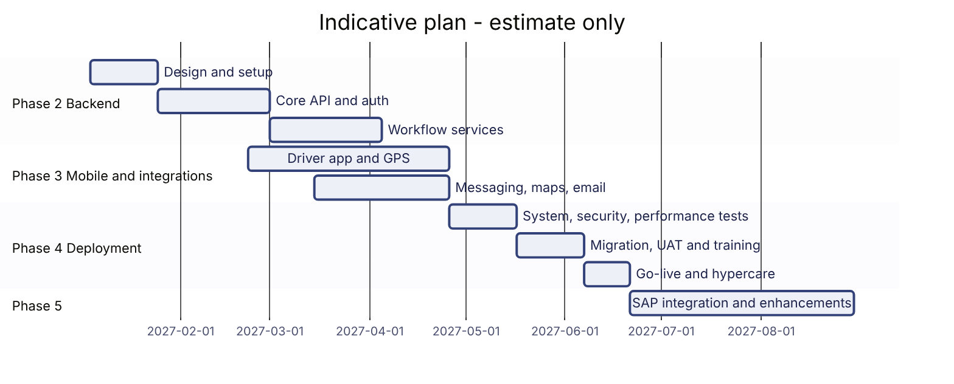

3. Decision gates
Gate | Decision needed | Owner
G0 | Approve BRD and SOW scope (extensions X-01 … X-11) | Client sponsor
G1 | Hosting, providers (maps, messaging, email) | Client IT
G2 | Pilot go / no-go after driver pilot | Logistics owner
G3 | Go-live | Steering committee
Phase assignment of every requirement: BM-PLN-002 (Phase-wise Scope Matrix).

Revision history
Version | Date | Author | Description
1.0 | 2026-11-12 | Documentation team | Initial draft prepared from analysis of the bellomassi-premium-ui source code and existing project documents.

