Business Workflow Catalogue
Bellomassi Order-to-Delivery Management Platform
BM-WF-00 · Version 1.0 · Draft — for client review
2026-11-12

Document control
Field | Value
Document title | Business Workflow Catalogue
Document ID | BM-WF-00
Version | 1.0
Status | Draft — for client review
Category | Business Workflows
Related module(s) | All modules
Document owner | Business Analyst
Prepared by | Project documentation team (AI-assisted draft prepared from source-code analysis)
Reviewed by | Pending — not yet reviewed
Approval | Not approved — awaiting client review (no approval has been given)
Created date | 2026-11-12
Last updated date | 2026-11-12
Status labels used in this document: VERIFIED (confirmed in the current source code or existing documents) · PROTOTYPE (works in the React/LocalStorage prototype with mock or simulated behaviour) · PROPOSED (recommended production design, not built) · PENDING CONFIRMATION (needs a client decision) · NOT IMPLEMENTED · NOT VERIFIED.

Purpose
Index of all 24 business workflows with links to their specifications and to the existing workflow documentation.

Scope
Order-to-delivery, approval, consolidation, dispatch, driver, customer, inventory, scrap, VMS, invoice, communication, exceptions, rejection, cancellation, returns, documents, notifications, reporting.

Definitions
Other terms: see BM-GLO-001 (Project Glossary).

References
- BM-SYS-008 (Requirement Traceability Matrix)
- BM-ARC-001 (High-Level Design (HLD))

1. Workflow catalogue
ID | Workflow | Initiating role | Trigger | Outcome
WF-01 | BM-WF-01 (WF-01 — Overall Business Workflow) | Salesman / Customer | A customer need (order by call, email, WhatsApp or app) | Order delivered, delivery note and invoice available
WF-02 | BM-WF-02 (WF-02 — Order-to-Delivery Workflow) | Salesman | Order submitted | Order DELIVERED / PARTIALLY_DELIVERED with delivery note
WF-03 | BM-WF-03 (WF-03 — Salesman Workflow) | Salesman | Start of day / customer request | Orders submitted; returned orders corrected
WF-04 | BM-WF-04 (WF-04 — Sales Manager Approval Workflow) | Sales Manager | Order SUBMITTED | APPROVED, RETURNED or REJECTED
WF-05 | BM-WF-05 (WF-05 — Customer Service Workflow) | Customer Service | Order APPROVED | READY_FOR_DISPATCH
WF-06 | BM-WF-06 (WF-06 — Credit Validation Workflow) | System / Sales Manager | Order submitted or opened for approval | Credit warning acknowledged, order returned / rejected, or approval blocked
WF-07 | BM-WF-07 (WF-07 — Order Consolidation Workflow) | Customer Service | Approved order in queue | CONSOLIDATED then READY_FOR_DISPATCH
WF-08 | BM-WF-08 (WF-08 — Dispatch Workflow) | Dispatcher | Orders READY_FOR_DISPATCH | Dispatch CONFIRMED (stock deducted) and closed
WF-09 | BM-WF-09 (WF-09 — Driver Assignment Workflow) | Dispatcher | Dispatch PLANNED | Dispatch ASSIGNED with compliant driver and vehicle
WF-10 | BM-WF-10 (WF-10 — Driver Delivery Workflow) | Driver | Dispatch CONFIRMED and date reached | Stops DELIVERED / PARTIALLY_DELIVERED / FAILED
WF-11 | BM-WF-11 (WF-11 — Customer Order Workflow) | Customer | Customer opens the catalog | Order submitted for approval
WF-12 | BM-WF-12 (WF-12 — Customer Tracking Workflow) | Customer | Driver starts the stop | Customer shares OTP; delivery note visible
WF-13 | BM-WF-13 (WF-13 — Inventory Workflow) | Warehouse / Inventory staff | Goods arrive, move or are found different | Stock and ledger updated
WF-14 | BM-WF-14 (WF-14 — Scrap Workflow) | Warehouse / QA / Inventory staff | Unusable stock found | Stock written off once after approval
WF-15 | BM-WF-15 (WF-15 — Vehicle Management Workflow) | Administrator | Vehicle / driver document recorded or expiring | Compliance state updated; assignment blocked when required
WF-16 | BM-WF-16 (WF-16 — Invoice Workflow) | Finance | Order approved or delivered | Invoice ISSUED (or CANCELLED and reissued)
WF-17 | BM-WF-17 (WF-17 — Communication Workflow) | System / user | Workflow event or manual message | Message logged (demo send) and in-app notification
WF-18 | BM-WF-18 (WF-18 — Exception Management Workflow) | Any role | Validation failure or operational exception | Exception resolved by the named role
WF-19 | BM-WF-19 (WF-19 — Rejection Workflow) | Sales Manager / reviewers | Order, scrap, replenishment or document rejected | Requester informed with reason; record closed or corrected
WF-20 | BM-WF-20 (WF-20 — Cancellation Workflow) | Dispatcher / Finance / requester | Dispatch, invoice, scrap or replenishment must be cancelled | Record CANCELLED; stock / order restored once
WF-21 | BM-WF-21 (WF-21 — Return Delivery Workflow) | Driver / Dispatcher | Delivery failed or partially accepted | Goods returned to hub; order RETURNED_TO_HUB or re-queued
WF-22 | BM-WF-22 (WF-22 — Document Upload and Verification Workflow) | Any uploader | Document uploaded | VERIFIED or REJECTED
WF-23 | BM-WF-23 (WF-23 — Notification Workflow) | System | Any workflow event | In-app notification and optional automated message
WF-24 | BM-WF-24 (WF-24 — Reporting Workflow) | Office roles | User opens a dashboard or report | KPIs, tables, CSV export or print

2. Relationship to the existing workflow documentation
The complete workflow documentation delivered on 12 November 2026 (docs/workflow/, 20 chapters, 38 diagrams, HTML / PDF / DOCX editions) is preserved unchanged and remains the narrative source. The 24 specifications in this folder restate each workflow in the standard enterprise format (ID, purpose, initiating role, preconditions, trigger, steps, decisions, approval / rejection conditions, system and user actions, status changes, notifications, exceptions, outcome) and link it to requirements and test cases.

3. Order lifecycle (overview)
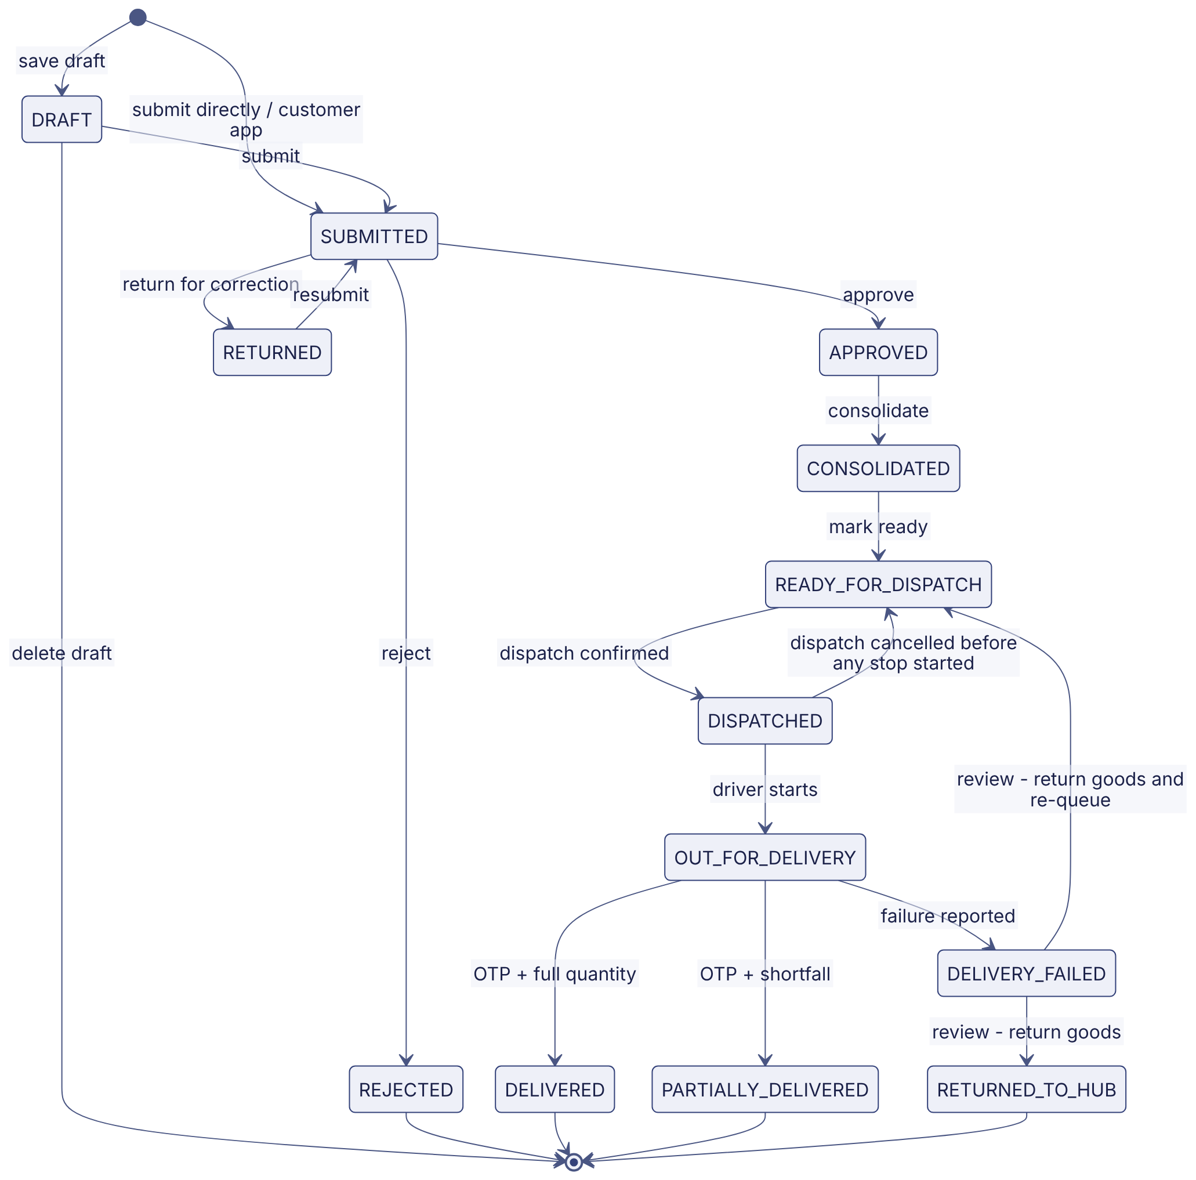

Revision history
Version | Date | Author | Description
1.0 | 2026-11-12 | Documentation team | Initial draft prepared from analysis of the bellomassi-premium-ui source code and existing project documents.

