WF-01 — Overall Business Workflow
Bellomassi Order-to-Delivery Management Platform
BM-WF-01 · Version 1.0 · Draft — for client review
2026-11-12

Document control
Field | Value
Document title | WF-01 — Overall Business Workflow
Document ID | BM-WF-01
Version | 1.0
Status | Draft — for client review
Category | Business Workflows
Related module(s) | All modules
Document owner | Business Analyst
Prepared by | Project documentation team (AI-assisted draft prepared from source-code analysis)
Reviewed by | Pending — not yet reviewed
Approval | Not approved — awaiting client review (no approval has been given)
Created date | 2026-11-12
Last updated date | 2026-11-12
Status labels used in this document: VERIFIED (confirmed in the current source code or existing documents) · PROTOTYPE (works in the React/LocalStorage prototype with mock or simulated behaviour) · PROPOSED (recommended production design, not built) · PENDING CONFIRMATION (needs a client decision) · NOT IMPLEMENTED · NOT VERIFIED.

Purpose
Show the end-to-end business flow across all roles, from order capture to delivery note and invoice.

Scope
Workflow WF-01 as implemented in the prototype, with production differences marked.

Definitions
Other terms: see BM-GLO-001 (Project Glossary).

References
- BM-WF-00 (Business Workflow Catalogue)
- BM-SYS-008 (Requirement Traceability Matrix)

Contents

  - Workflow summary

  - Step-by-step process

  - Decision points

  - Approval conditions

  - Rejection conditions

  - System actions

  - User actions

  - Status changes

  - Notifications

  - Exception scenarios

  - Workflow diagram

  - Final outcome

1. Workflow summary
Field | Value
Workflow ID | WF-01
Workflow name | Overall Business Workflow
Business purpose | Show the end-to-end business flow across all roles, from order capture to delivery note and invoice.
Initiating role | Salesman / Customer
Trigger | A customer need (order by call, email, WhatsApp or app)
Preconditions | Master data (customers, products, hubs, zones, drivers, vehicles, users) maintained; stock available at the hub.
Final outcome | Order delivered with OTP-verified proof and delivery note; invoice issued if in scope.
Related requirements | FR-ORD-002, FR-APR-003, FR-CON-003, FR-DSP-004, FR-DRV-004, FR-INVC-002
Related test cases | TC-ORD-002, TC-APR-003, TC-APR-N01, TC-CON-003, TC-DSP-004, TC-DSP-N02, TC-DSP-N03, TC-DSP-N04, TC-DRV-004, TC-INVC-002, TC-INVC-N01, TC-INVC-N02
Detailed chapter | docs/workflow/ chapter 02

2. Step-by-step process
- Salesman (or customer) captures and submits the order.
- Sales Manager approves, returns or rejects it.
- Customer Service verifies and consolidates, then releases to dispatch.
- Dispatcher plans the dispatch, assigns driver and vehicle, confirms loading (stock deducted).
- Driver delivers stops in sequence: start, reach location, OTP, proof, complete or fail.
- Delivery note generated; Finance issues the invoice (if in scope); exceptions reviewed by the Dispatcher.

3. Decision points
Approve / return / reject; consolidation checks complete; driver and vehicle compliant; OTP valid; all quantities delivered.

4. Approval conditions
Sales Manager approval (all blocking checks pass, warnings acknowledged).

5. Rejection conditions
Rejection with reason (final) or return for correction.

6. System actions
Numbering, validation, notifications, timeline events, stock movements, delivery creation, OTP generation, delivery note.

7. User actions
Data entry, decisions, confirmations, handover.

8. Status changes
Order DRAFT → SUBMITTED → APPROVED → CONSOLIDATED → READY_FOR_DISPATCH → DISPATCHED → OUT_FOR_DELIVERY → DELIVERED (or exception statuses).

9. Notifications
Each hand-off notifies the next role in-app; automated email / WhatsApp per rule (demo).

10. Exception scenarios
See WF-18.

11. Workflow diagram
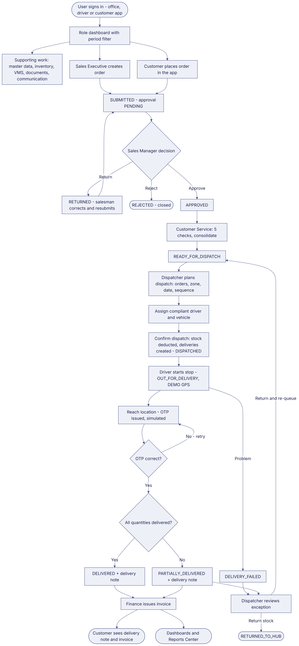
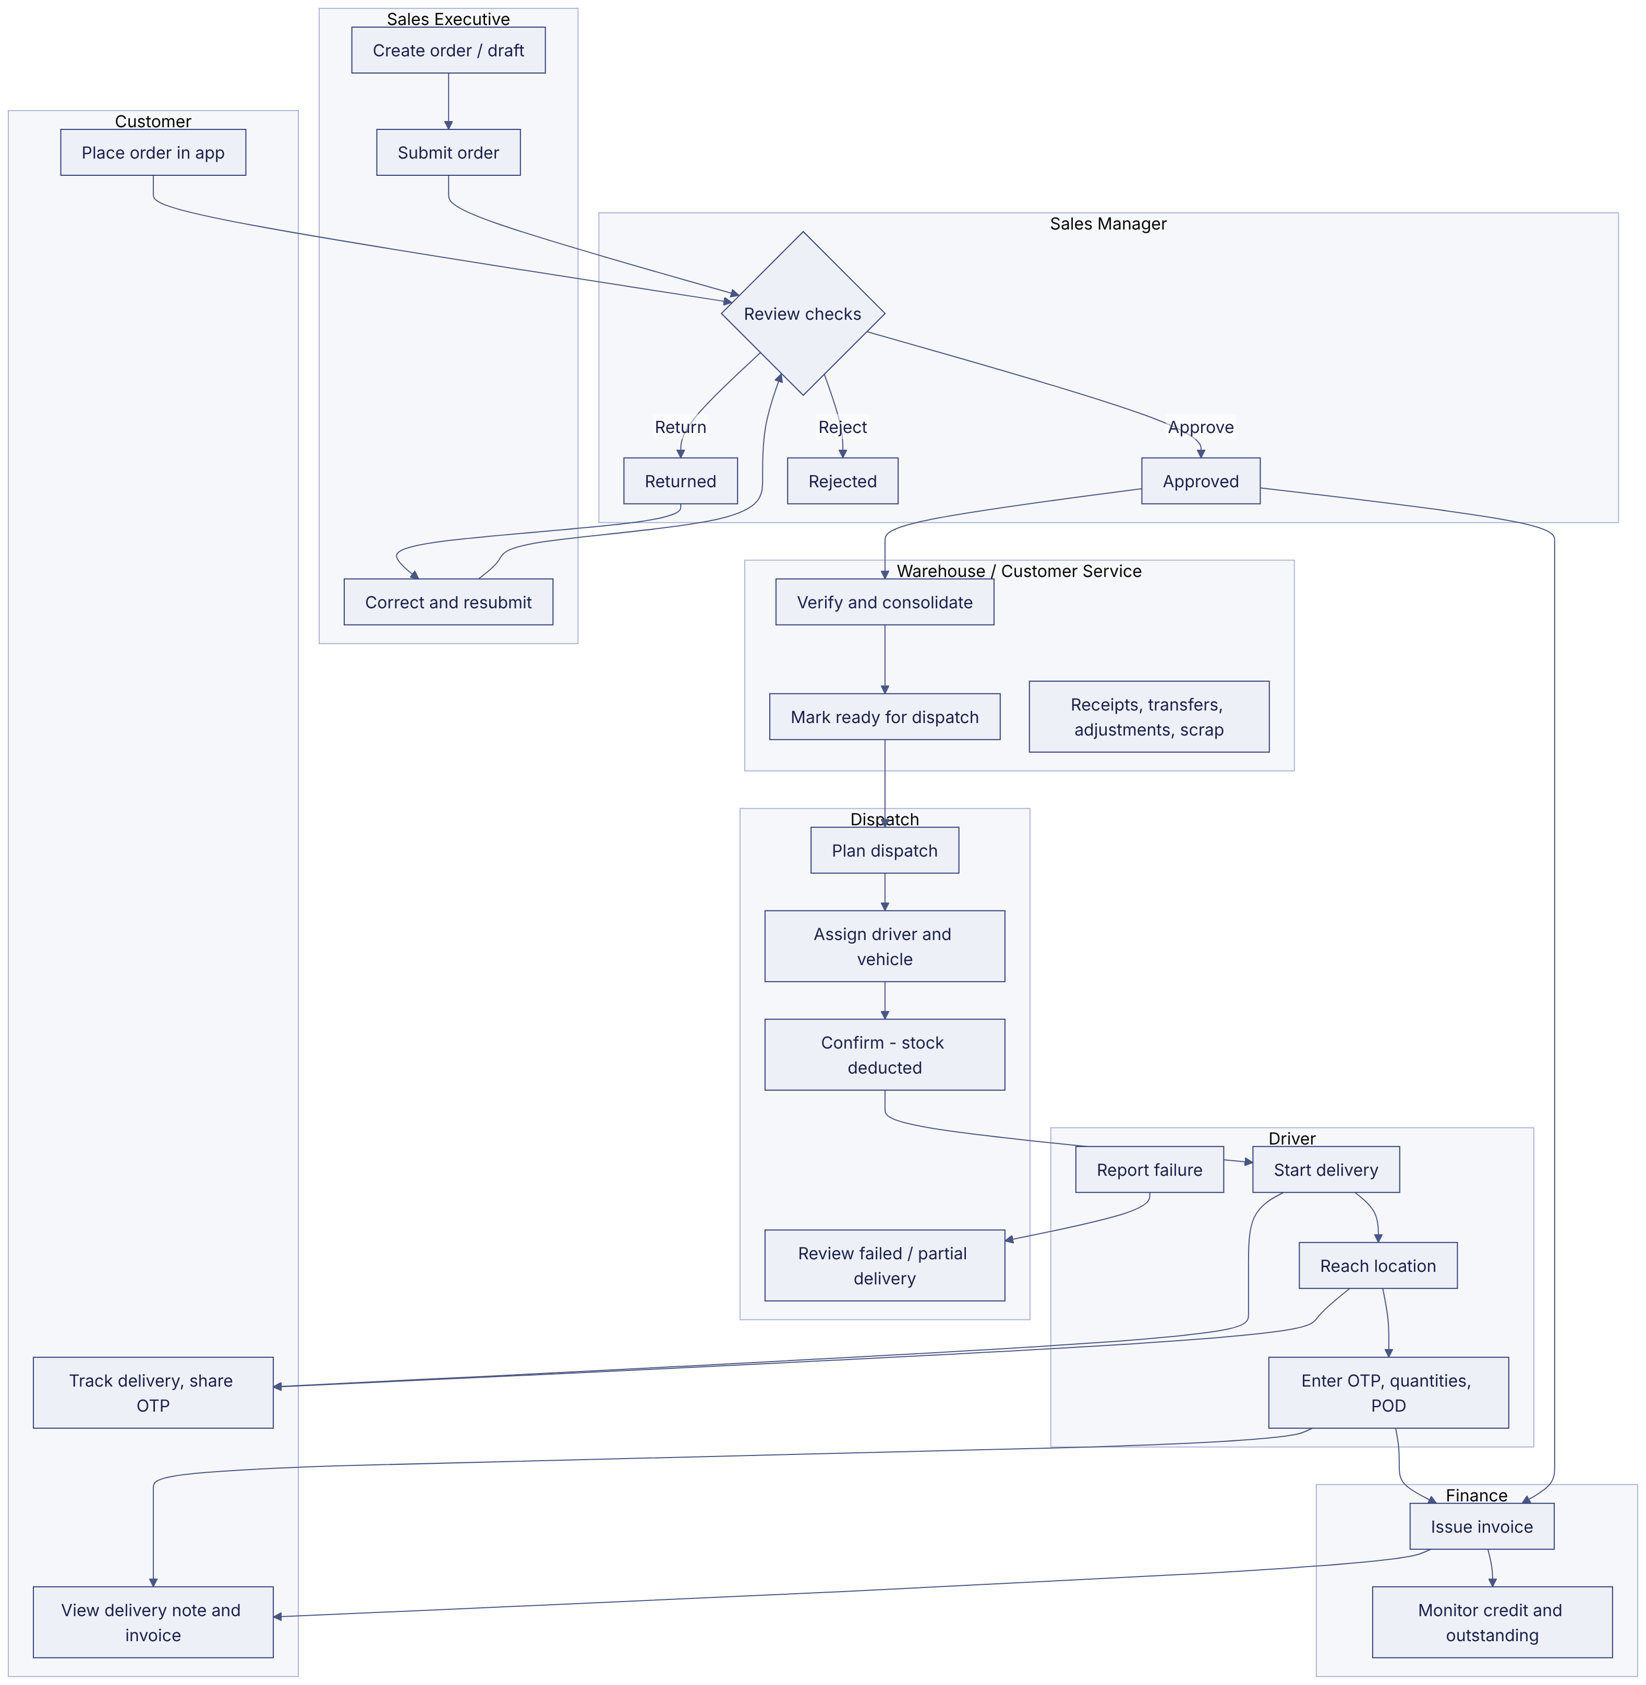
Implementation label: diagrams describe the prototype behaviour (VERIFIED in source code) unless a step is marked PROPOSED / NOT IMPLEMENTED.

12. Final outcome
Order delivered with OTP-verified proof and delivery note; invoice issued if in scope.

Revision history
Version | Date | Author | Description
1.0 | 2026-11-12 | Documentation team | Initial draft prepared from analysis of the bellomassi-premium-ui source code and existing project documents.

