WF-02 — Order-to-Delivery Workflow
Bellomassi Order-to-Delivery Management Platform
BM-WF-02 · Version 1.0 · Draft — for client review
2026-11-12

Document control
Field | Value
Document title | WF-02 — Order-to-Delivery Workflow
Document ID | BM-WF-02
Version | 1.0
Status | Draft — for client review
Category | Business Workflows
Related module(s) | All modules
Document owner | Business Analyst
Prepared by | Project documentation team (AI-assisted draft prepared from source-code analysis)
Reviewed by | Pending — not yet reviewed
Approval | Not approved — awaiting client review (no approval has been given)
Created date | 2026-11-12
Last updated date | 2026-11-12
Status labels used in this document: VERIFIED (confirmed in the current source code or existing documents) · PROTOTYPE (works in the React/LocalStorage prototype with mock or simulated behaviour) · PROPOSED (recommended production design, not built) · PENDING CONFIRMATION (needs a client decision) · NOT IMPLEMENTED · NOT VERIFIED.

Purpose
Specify the core order lifecycle and the system effect of each step.

Scope
Workflow WF-02 as implemented in the prototype, with production differences marked.

Definitions
Other terms: see BM-GLO-001 (Project Glossary).

References
- BM-WF-00 (Business Workflow Catalogue)
- BM-SYS-008 (Requirement Traceability Matrix)

Contents

  - Workflow summary

  - Step-by-step process

  - Decision points

  - Approval conditions

  - Rejection conditions

  - System actions

  - User actions

  - Status changes

  - Notifications

  - Exception scenarios

  - Workflow diagram

  - Final outcome

1. Workflow summary
Field | Value
Workflow ID | WF-02
Workflow name | Order-to-Delivery Workflow
Business purpose | Specify the core order lifecycle and the system effect of each step.
Initiating role | Salesman
Trigger | Order submitted
Preconditions | Active customer, hub and products.
Final outcome | Delivered order with delivery note and stock movements.
Related requirements | FR-ORD-002, FR-APR-003, FR-CON-002, FR-CON-003, FR-DSP-001, FR-DSP-004, FR-DRV-002, FR-DRV-004
Related test cases | TC-ORD-002, TC-APR-003, TC-APR-N01, TC-CON-002, TC-CON-N01, TC-CON-003, TC-DSP-001, TC-DSP-004, TC-DSP-N02, TC-DSP-N03, TC-DSP-N04, TC-DRV-002, TC-DRV-N01, TC-DRV-N02, TC-DRV-N03, TC-DRV-004
Detailed chapter | docs/workflow/ chapter 06

2. Step-by-step process
- Create order and submit (number BM-ORD-… assigned).
- Approval checks run; manager decides.
- Customer Service ticks five checks and consolidates.
- Order marked READY_FOR_DISPATCH.
- Dispatcher creates dispatch and sequence; assigns resources; confirms — stock deducted and deliveries created; order DISPATCHED.
- Driver starts (OUT_FOR_DELIVERY), reaches location (OTP issued), completes with OTP (DELIVERED / PARTIALLY_DELIVERED).

3. Decision points
Blocking checks; warnings; stock sufficient at confirmation; OTP; quantities.

4. Approval conditions
Approval, consolidation checklist, dispatch confirmation tick.

5. Rejection conditions
Rejection; cancellation of dispatch.

6. System actions
submitOrder, approveOrder, consolidateOrder, markReadyForDispatch, createDispatch, assignDispatch, confirmDispatch, startDelivery, markArrived, confirmDelivery.

7. User actions
Each role acts on its queue.

8. Status changes
As WF-01; dispatch DRAFT → PLANNED → ASSIGNED → CONFIRMED → IN_TRANSIT → COMPLETED.

9. Notifications
New order for approval; awaiting consolidation; ready for dispatch; dispatch assigned / confirmed; out for delivery; delivered.

10. Exception scenarios
Stock short at confirmation; non-compliant resources; wrong OTP; partial / failed delivery.

11. Workflow diagram
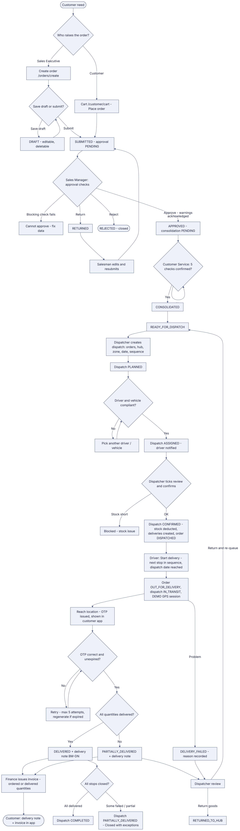
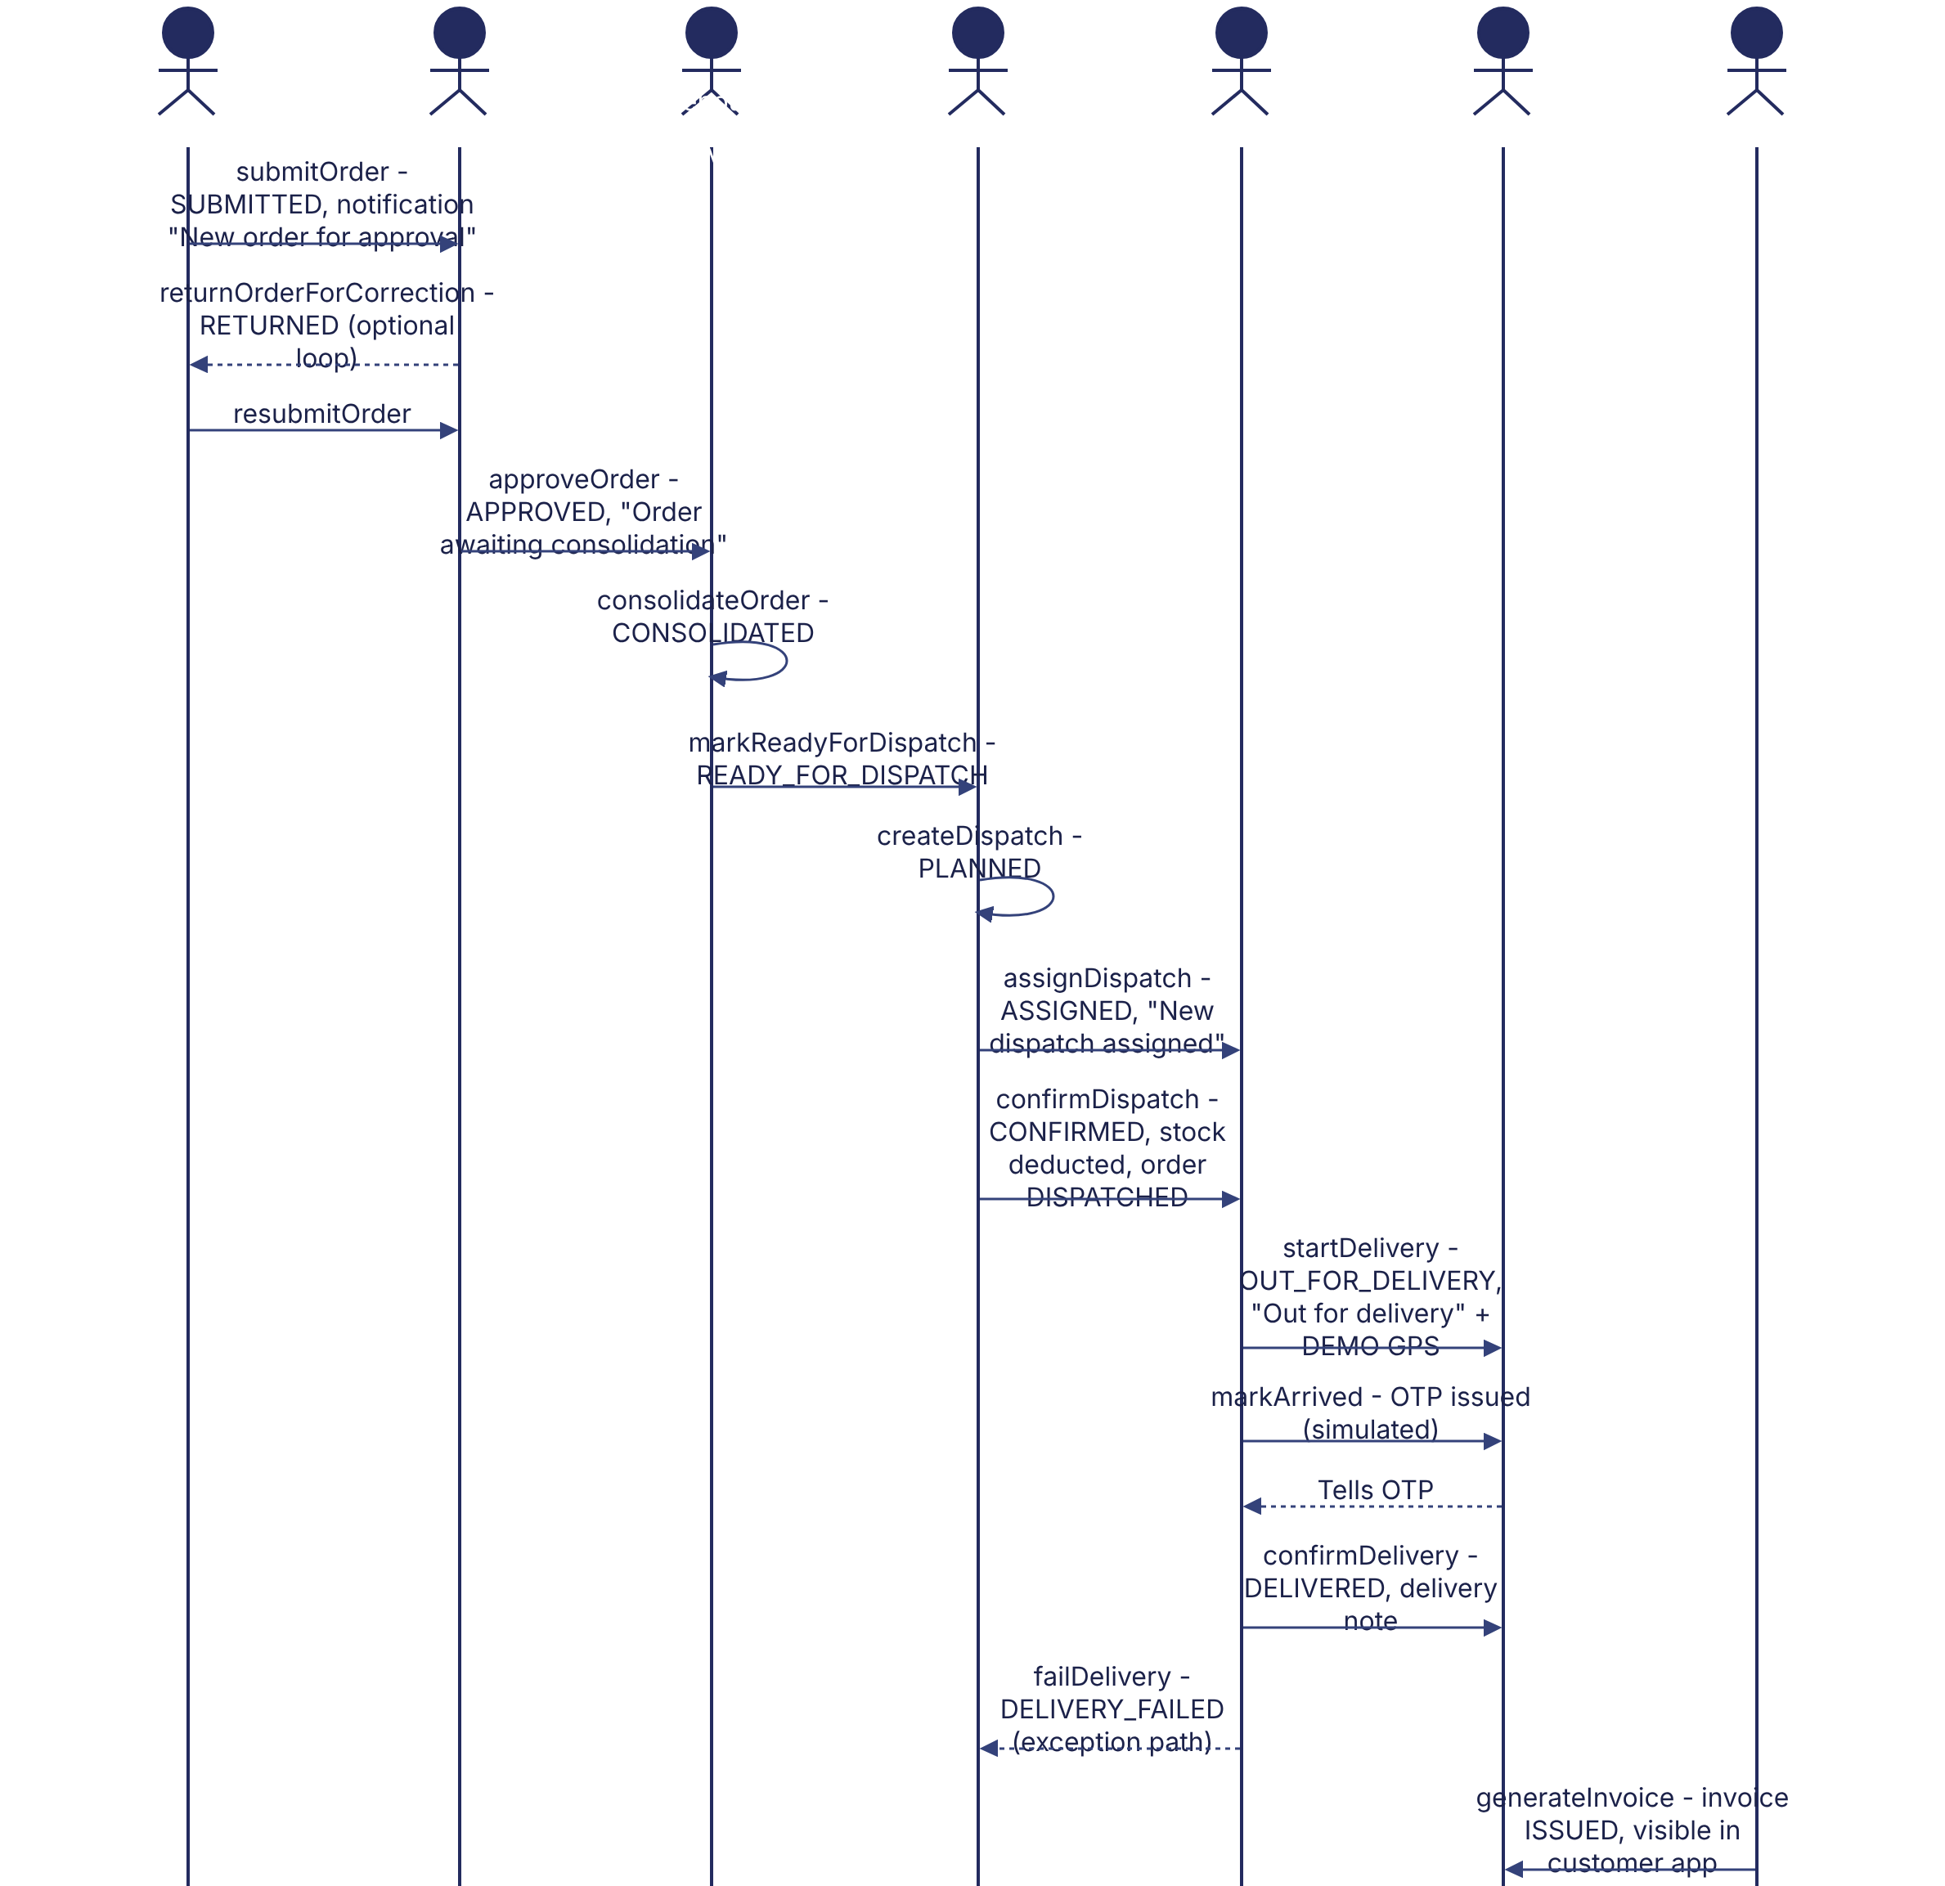
Implementation label: diagrams describe the prototype behaviour (VERIFIED in source code) unless a step is marked PROPOSED / NOT IMPLEMENTED.

12. Final outcome
Delivered order with delivery note and stock movements.

Revision history
Version | Date | Author | Description
1.0 | 2026-11-12 | Documentation team | Initial draft prepared from analysis of the bellomassi-premium-ui source code and existing project documents.

