WF-03 — Salesman Workflow
Bellomassi Order-to-Delivery Management Platform
BM-WF-03 · Version 1.0 · Draft — for client review
2026-11-12

Document control
Field | Value
Document title | WF-03 — Salesman Workflow
Document ID | BM-WF-03
Version | 1.0
Status | Draft — for client review
Category | Business Workflows
Related module(s) | All modules
Document owner | Business Analyst
Prepared by | Project documentation team (AI-assisted draft prepared from source-code analysis)
Reviewed by | Pending — not yet reviewed
Approval | Not approved — awaiting client review (no approval has been given)
Created date | 2026-11-12
Last updated date | 2026-11-12
Status labels used in this document: VERIFIED (confirmed in the current source code or existing documents) · PROTOTYPE (works in the React/LocalStorage prototype with mock or simulated behaviour) · PROPOSED (recommended production design, not built) · PENDING CONFIRMATION (needs a client decision) · NOT IMPLEMENTED · NOT VERIFIED.

Purpose
Describe the salesman’s daily work: capture, submit, correct returned orders, follow up calls.

Scope
Workflow WF-03 as implemented in the prototype, with production differences marked.

Definitions
Other terms: see BM-GLO-001 (Project Glossary).

References
- BM-WF-00 (Business Workflow Catalogue)
- BM-SYS-008 (Requirement Traceability Matrix)

Contents

  - Workflow summary

  - Step-by-step process

  - Decision points

  - Approval conditions

  - Rejection conditions

  - System actions

  - User actions

  - Status changes

  - Notifications

  - Exception scenarios

  - Workflow diagram

  - Final outcome

1. Workflow summary
Field | Value
Workflow ID | WF-03
Workflow name | Salesman Workflow
Business purpose | Describe the salesman’s daily work: capture, submit, correct returned orders, follow up calls.
Initiating role | Salesman
Trigger | Start of day / customer request
Preconditions | Salesman account; assigned customers.
Final outcome | Orders submitted for approval.
Related requirements | FR-ORD-001, FR-ORD-002, FR-ORD-005, FR-CALL-001
Related test cases | TC-ORD-001, TC-LS-N02, TC-ORD-002, TC-ORD-005, TC-CALL-001
Detailed chapter | docs/workflow/ chapter 04

2. Step-by-step process
- Open dashboard → “Needs your action”.
- Correct returned orders (highlighted section) and resubmit.
- Capture new orders (from calls, email, WhatsApp) — optionally from a call record.
- Save draft or submit.
- Log calls and follow-ups.
- Track statuses and notifications.

3. Decision points
Draft or submit; respond to warnings.

4. Approval conditions
—

5. Rejection conditions
Receives returns / rejections with reason.

6. System actions
Validation, warnings, numbering, notifications.

7. User actions
Data entry, corrections.

8. Status changes
DRAFT → SUBMITTED; RETURNED → SUBMITTED.

9. Notifications
Approved, returned, rejected, ready for dispatch.

10. Exception scenarios
Validation errors; credit / stock warnings.

11. Workflow diagram
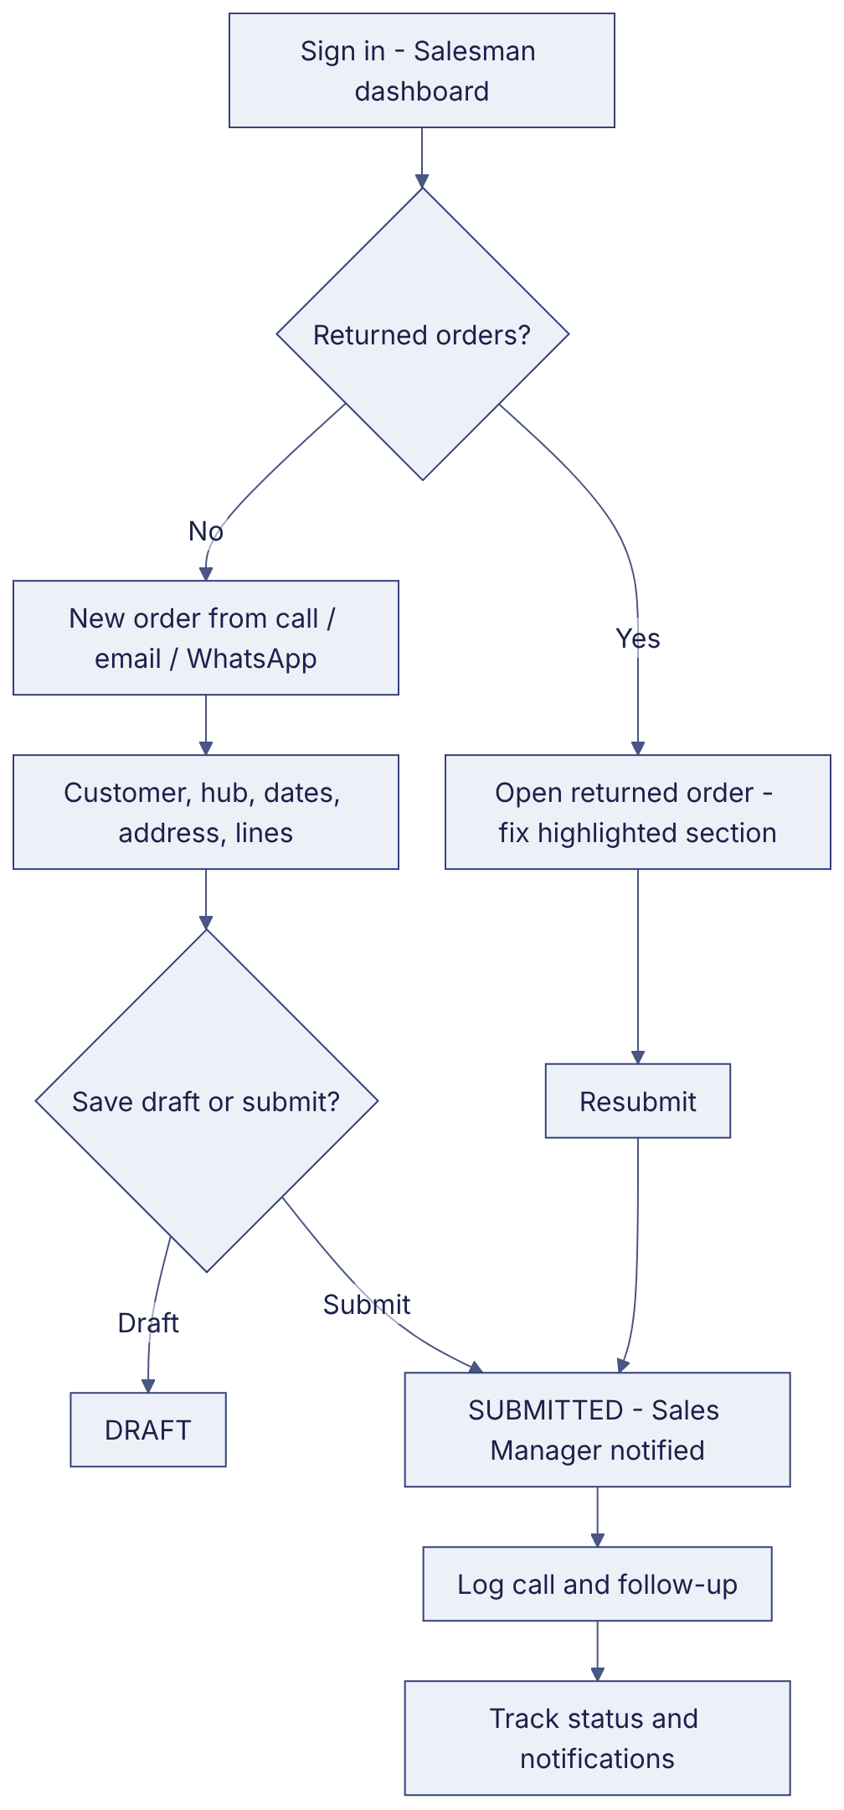
Implementation label: diagrams describe the prototype behaviour (VERIFIED in source code) unless a step is marked PROPOSED / NOT IMPLEMENTED.

12. Final outcome
Orders submitted for approval.

Revision history
Version | Date | Author | Description
1.0 | 2026-11-12 | Documentation team | Initial draft prepared from analysis of the bellomassi-premium-ui source code and existing project documents.

