WF-04 — Sales Manager Approval Workflow
Bellomassi Order-to-Delivery Management Platform
BM-WF-04 · Version 1.0 · Draft — for client review
2026-11-12

Document control
Field | Value
Document title | WF-04 — Sales Manager Approval Workflow
Document ID | BM-WF-04
Version | 1.0
Status | Draft — for client review
Category | Business Workflows
Related module(s) | All modules
Document owner | Business Analyst
Prepared by | Project documentation team (AI-assisted draft prepared from source-code analysis)
Reviewed by | Pending — not yet reviewed
Approval | Not approved — awaiting client review (no approval has been given)
Created date | 2026-11-12
Last updated date | 2026-11-12
Status labels used in this document: VERIFIED (confirmed in the current source code or existing documents) · PROTOTYPE (works in the React/LocalStorage prototype with mock or simulated behaviour) · PROPOSED (recommended production design, not built) · PENDING CONFIRMATION (needs a client decision) · NOT IMPLEMENTED · NOT VERIFIED.

Purpose
Specify the Sales Manager decision on submitted orders.

Scope
Workflow WF-04 as implemented in the prototype, with production differences marked.

Definitions
Other terms: see BM-GLO-001 (Project Glossary).

References
- BM-WF-00 (Business Workflow Catalogue)
- BM-SYS-008 (Requirement Traceability Matrix)

Contents

  - Workflow summary

  - Step-by-step process

  - Decision points

  - Approval conditions

  - Rejection conditions

  - System actions

  - User actions

  - Status changes

  - Notifications

  - Exception scenarios

  - Workflow diagram

  - Final outcome

1. Workflow summary
Field | Value
Workflow ID | WF-04
Workflow name | Sales Manager Approval Workflow
Business purpose | Specify the Sales Manager decision on submitted orders.
Initiating role | Sales Manager
Trigger | Order SUBMITTED
Preconditions | Order SUBMITTED with approval PENDING.
Final outcome | Recorded decision with reason.
Related requirements | FR-APR-001, FR-APR-002, FR-APR-003, FR-APR-004, FR-APR-005
Related test cases | TC-APR-001, TC-APR-002, TC-APR-N04, TC-APR-003, TC-APR-N01, TC-APR-004, TC-APR-005, TC-APR-N02
Detailed chapter | docs/workflow/ chapter 07

2. Step-by-step process
- Open approval queue (oldest first).
- Open order; system runs six checks.
- Approve (acknowledge warnings, remarks if required) or return / reject with reason and remarks.

3. Decision points
Blocking checks; warnings; decision.

4. Approval conditions
All blocking checks pass; warnings acknowledged; remarks given if required.

5. Rejection conditions
Reason from list + remarks; reject is final; return sends back to salesman.

6. System actions
Approval record + timeline in one transaction; notifications; automation events.

7. User actions
Review and decide.

8. Status changes
SUBMITTED → APPROVED / RETURNED / REJECTED.

9. Notifications
Approved → salesman + Customer Service; returned / rejected → salesman.

10. Exception scenarios
Repeated decision refused; draft cannot be decided.

11. Workflow diagram
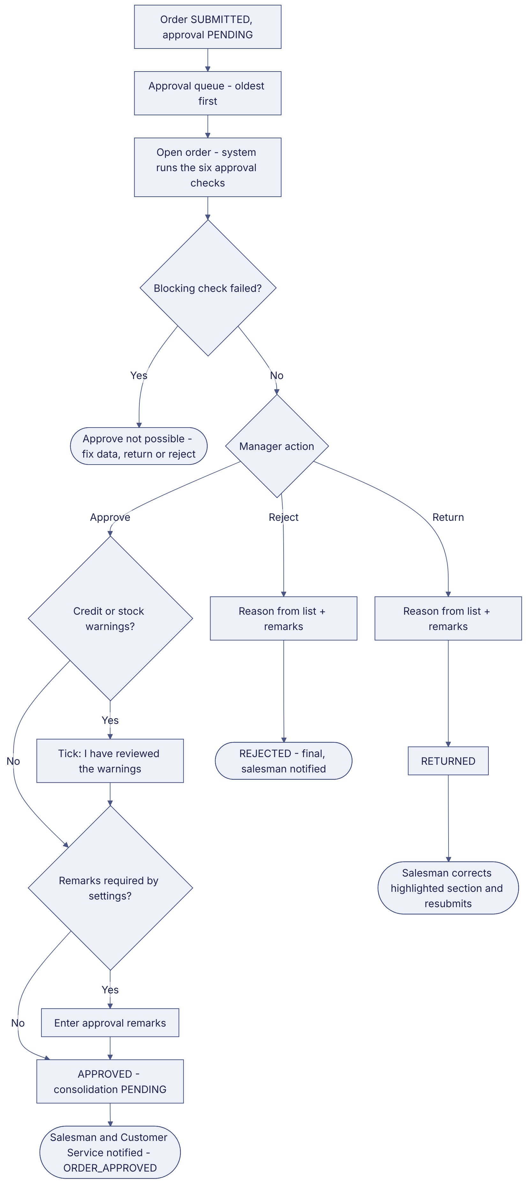
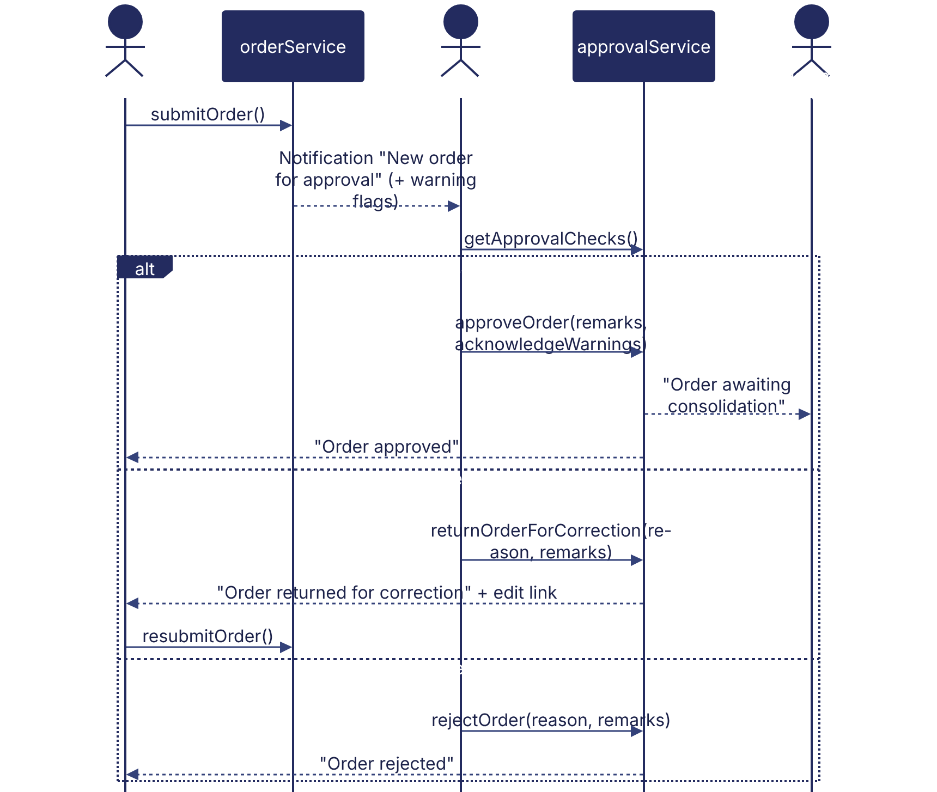
Implementation label: diagrams describe the prototype behaviour (VERIFIED in source code) unless a step is marked PROPOSED / NOT IMPLEMENTED.

12. Final outcome
Recorded decision with reason.

Revision history
Version | Date | Author | Description
1.0 | 2026-11-12 | Documentation team | Initial draft prepared from analysis of the bellomassi-premium-ui source code and existing project documents.

