WF-05 — Customer Service Workflow
Bellomassi Order-to-Delivery Management Platform
BM-WF-05 · Version 1.0 · Draft — for client review
2026-11-12

Document control
Field | Value
Document title | WF-05 — Customer Service Workflow
Document ID | BM-WF-05
Version | 1.0
Status | Draft — for client review
Category | Business Workflows
Related module(s) | All modules
Document owner | Business Analyst
Prepared by | Project documentation team (AI-assisted draft prepared from source-code analysis)
Reviewed by | Pending — not yet reviewed
Approval | Not approved — awaiting client review (no approval has been given)
Created date | 2026-11-12
Last updated date | 2026-11-12
Status labels used in this document: VERIFIED (confirmed in the current source code or existing documents) · PROTOTYPE (works in the React/LocalStorage prototype with mock or simulated behaviour) · PROPOSED (recommended production design, not built) · PENDING CONFIRMATION (needs a client decision) · NOT IMPLEMENTED · NOT VERIFIED.

Purpose
Describe Customer Service’s daily work.

Scope
Workflow WF-05 as implemented in the prototype, with production differences marked.

Definitions
Other terms: see BM-GLO-001 (Project Glossary).

References
- BM-WF-00 (Business Workflow Catalogue)
- BM-SYS-008 (Requirement Traceability Matrix)

Contents

  - Workflow summary

  - Step-by-step process

  - Decision points

  - Approval conditions

  - Rejection conditions

  - System actions

  - User actions

  - Status changes

  - Notifications

  - Exception scenarios

  - Workflow diagram

  - Final outcome

1. Workflow summary
Field | Value
Workflow ID | WF-05
Workflow name | Customer Service Workflow
Business purpose | Describe Customer Service’s daily work.
Initiating role | Customer Service
Trigger | Order APPROVED
Preconditions | Approved orders exist.
Final outcome | Orders released to dispatch.
Related requirements | FR-CON-001, FR-CON-002, FR-CON-003, FR-DOC-003
Related test cases | TC-CON-001, TC-CON-002, TC-CON-N01, TC-CON-003, TC-DOC-003, TC-DOC-N01
Detailed chapter | docs/workflow/ chapter 04

2. Step-by-step process
- Open consolidation queue grouped by salesman.
- For each order tick the five checks, review stock, add notes, consolidate.
- Mark ready for dispatch.
- Review documents in the OCR queue.
- Handle customer calls.

3. Decision points
All checks confirmed?

4. Approval conditions
Consolidation (checklist).

5. Rejection conditions
Customer Service cannot reject; issues go to the Sales Manager / Administrator.

6. System actions
Consolidation record, notifications.

7. User actions
Verification.

8. Status changes
APPROVED → CONSOLIDATED → READY_FOR_DISPATCH.

9. Notifications
Dispatcher informed.

10. Exception scenarios
Incomplete checklist; non-approved order.

11. Workflow diagram
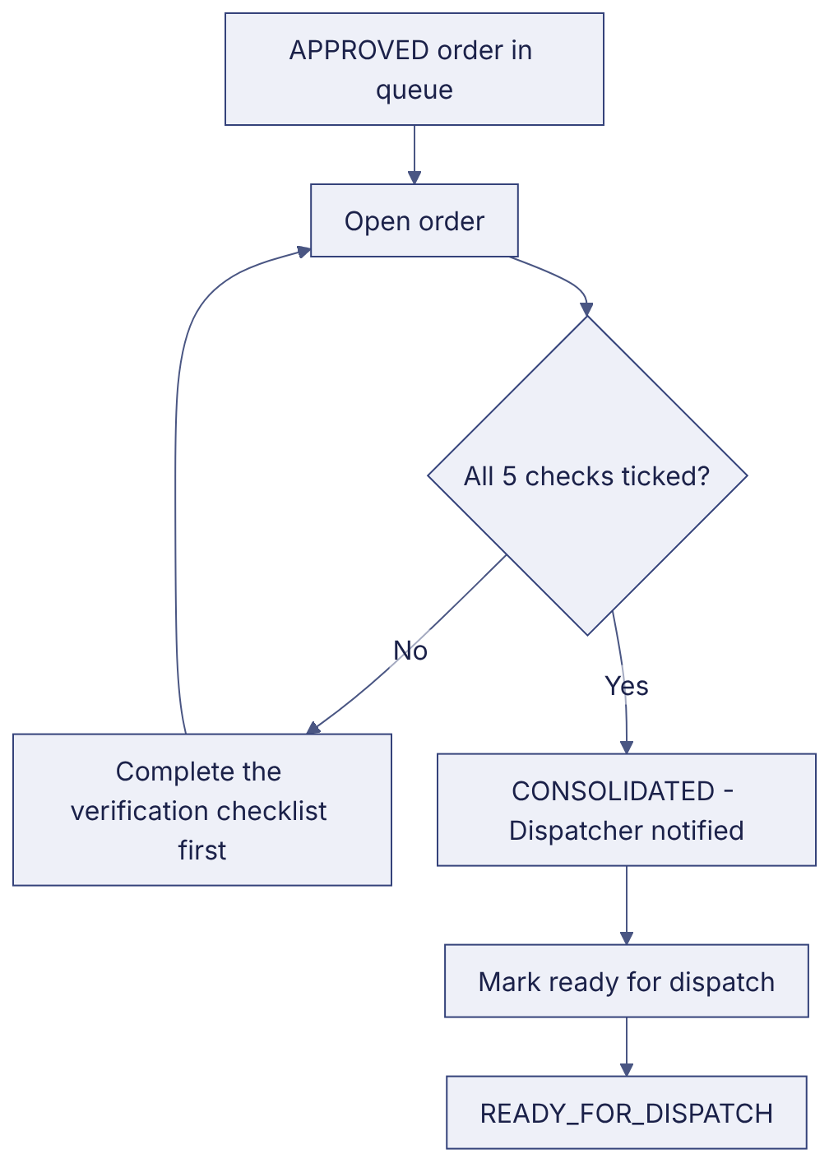
Implementation label: diagrams describe the prototype behaviour (VERIFIED in source code) unless a step is marked PROPOSED / NOT IMPLEMENTED.

12. Final outcome
Orders released to dispatch.

Revision history
Version | Date | Author | Description
1.0 | 2026-11-12 | Documentation team | Initial draft prepared from analysis of the bellomassi-premium-ui source code and existing project documents.

