WF-06 — Credit Validation Workflow
Bellomassi Order-to-Delivery Management Platform
BM-WF-06 · Version 1.0 · Draft — for client review
2026-11-12

Document control
Field | Value
Document title | WF-06 — Credit Validation Workflow
Document ID | BM-WF-06
Version | 1.0
Status | Draft — for client review
Category | Business Workflows
Related module(s) | All modules
Document owner | Business Analyst
Prepared by | Project documentation team (AI-assisted draft prepared from source-code analysis)
Reviewed by | Pending — not yet reviewed
Approval | Not approved — awaiting client review (no approval has been given)
Created date | 2026-11-12
Last updated date | 2026-11-12
Status labels used in this document: VERIFIED (confirmed in the current source code or existing documents) · PROTOTYPE (works in the React/LocalStorage prototype with mock or simulated behaviour) · PROPOSED (recommended production design, not built) · PENDING CONFIRMATION (needs a client decision) · NOT IMPLEMENTED · NOT VERIFIED.

Purpose
Specify how credit exposure is checked.

Scope
Workflow WF-06 as implemented in the prototype, with production differences marked.

Definitions
Other terms: see BM-GLO-001 (Project Glossary).

References
- BM-WF-00 (Business Workflow Catalogue)
- BM-SYS-008 (Requirement Traceability Matrix)

Contents

  - Workflow summary

  - Step-by-step process

  - Decision points

  - Approval conditions

  - Rejection conditions

  - System actions

  - User actions

  - Status changes

  - Notifications

  - Exception scenarios

  - Workflow diagram

  - Final outcome

1. Workflow summary
Field | Value
Workflow ID | WF-06
Workflow name | Credit Validation Workflow
Business purpose | Specify how credit exposure is checked.
Initiating role | System / Sales Manager
Trigger | Order submitted or opened for approval
Preconditions | Customer credit settings maintained.
Final outcome | Credit-controlled approval.
Related requirements | FR-CRD-001, FR-CRD-002, FR-CRD-003
Related test cases | TC-CRD-001, TC-CRD-002, TC-CRD-N01, TC-CRD-003
Detailed chapter | docs/workflow/ chapter 07

2. Step-by-step process
- On order entry and approval the system computes projected balance = balance + order total.
- If projected balance > limit: credit warning flag.
- At approval: warning must be acknowledged; if the setting blocks, Approve is disabled.
- Manager may return with “Reduce order value (credit)” or reject with “Credit limit exceeded”.

3. Decision points
Within limit? Blocking setting on?

4. Approval conditions
Acknowledged warning (non-blocking mode).

5. Rejection conditions
Return / reject with credit reasons.

6. System actions
getOrderCreditPosition, approval checks.

7. User actions
Manager decision.

8. Status changes
No separate status; affects approval outcome.

9. Notifications
Warning flags on “New order for approval”. Finance notification NOT IMPLEMENTED (G-02).

10. Exception scenarios
Balance is not updated automatically (no payments).

11. Workflow diagram
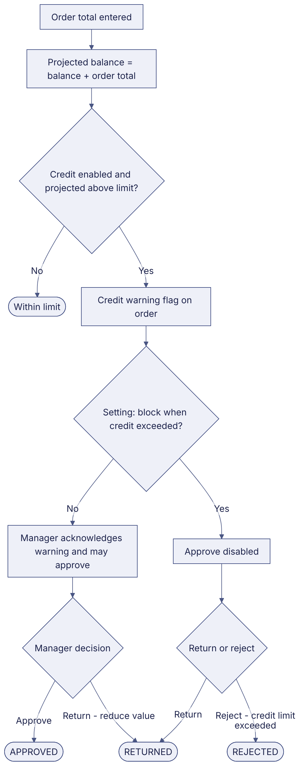
Implementation label: diagrams describe the prototype behaviour (VERIFIED in source code) unless a step is marked PROPOSED / NOT IMPLEMENTED.

12. Final outcome
Credit-controlled approval.

Revision history
Version | Date | Author | Description
1.0 | 2026-11-12 | Documentation team | Initial draft prepared from analysis of the bellomassi-premium-ui source code and existing project documents.

