WF-07 — Order Consolidation Workflow
Bellomassi Order-to-Delivery Management Platform
BM-WF-07 · Version 1.0 · Draft — for client review
2026-11-12

Document control
Field | Value
Document title | WF-07 — Order Consolidation Workflow
Document ID | BM-WF-07
Version | 1.0
Status | Draft — for client review
Category | Business Workflows
Related module(s) | All modules
Document owner | Business Analyst
Prepared by | Project documentation team (AI-assisted draft prepared from source-code analysis)
Reviewed by | Pending — not yet reviewed
Approval | Not approved — awaiting client review (no approval has been given)
Created date | 2026-11-12
Last updated date | 2026-11-12
Status labels used in this document: VERIFIED (confirmed in the current source code or existing documents) · PROTOTYPE (works in the React/LocalStorage prototype with mock or simulated behaviour) · PROPOSED (recommended production design, not built) · PENDING CONFIRMATION (needs a client decision) · NOT IMPLEMENTED · NOT VERIFIED.

Purpose
Specify consolidation in detail.

Scope
Workflow WF-07 as implemented in the prototype, with production differences marked.

Definitions
Other terms: see BM-GLO-001 (Project Glossary).

References
- BM-WF-00 (Business Workflow Catalogue)
- BM-SYS-008 (Requirement Traceability Matrix)

Contents

  - Workflow summary

  - Step-by-step process

  - Decision points

  - Approval conditions

  - Rejection conditions

  - System actions

  - User actions

  - Status changes

  - Notifications

  - Exception scenarios

  - Workflow diagram

  - Final outcome

1. Workflow summary
Field | Value
Workflow ID | WF-07
Workflow name | Order Consolidation Workflow
Business purpose | Specify consolidation in detail.
Initiating role | Customer Service
Trigger | Approved order in queue
Preconditions | Order APPROVED, consolidation PENDING.
Final outcome | Order in ready queue.
Related requirements | FR-CON-001, FR-CON-002, FR-CON-003, FR-CON-004
Related test cases | TC-CON-001, TC-CON-002, TC-CON-N01, TC-CON-003, TC-CON-004
Detailed chapter | docs/workflow/ chapter 05

2. Step-by-step process
- Open order from queue.
- Confirm: customer and address verified; hub confirmed; products and units checked; quantities match; hub stock reviewed.
- Consolidate.
- Mark ready for dispatch.

3. Decision points
All five checks?

4. Approval conditions
Checklist complete.

5. Rejection conditions
—

6. System actions
Consolidation record; notifications; ORDER_READY event.

7. User actions
Verification.

8. Status changes
APPROVED → CONSOLIDATED → READY_FOR_DISPATCH.

9. Notifications
Dispatcher, salesman.

10. Exception scenarios
“Only approved orders can be consolidated.”; duplicate consolidation refused.

11. Workflow diagram
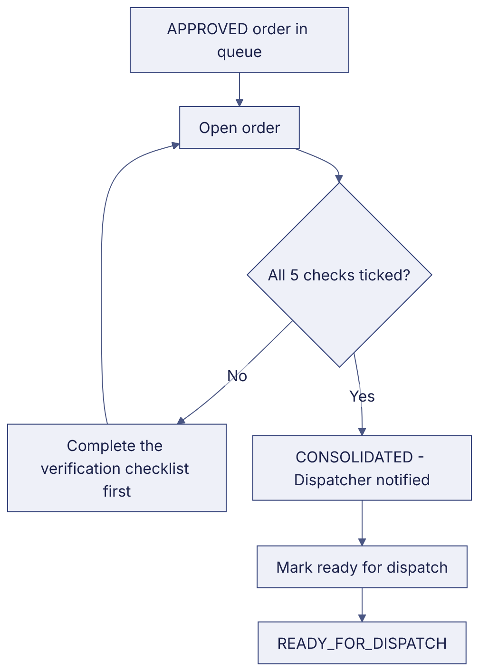
Implementation label: diagrams describe the prototype behaviour (VERIFIED in source code) unless a step is marked PROPOSED / NOT IMPLEMENTED.

12. Final outcome
Order in ready queue.

Revision history
Version | Date | Author | Description
1.0 | 2026-11-12 | Documentation team | Initial draft prepared from analysis of the bellomassi-premium-ui source code and existing project documents.

