WF-08 — Dispatch Workflow
Bellomassi Order-to-Delivery Management Platform
BM-WF-08 · Version 1.0 · Draft — for client review
2026-11-12

Document control
Field | Value
Document title | WF-08 — Dispatch Workflow
Document ID | BM-WF-08
Version | 1.0
Status | Draft — for client review
Category | Business Workflows
Related module(s) | All modules
Document owner | Business Analyst
Prepared by | Project documentation team (AI-assisted draft prepared from source-code analysis)
Reviewed by | Pending — not yet reviewed
Approval | Not approved — awaiting client review (no approval has been given)
Created date | 2026-11-12
Last updated date | 2026-11-12
Status labels used in this document: VERIFIED (confirmed in the current source code or existing documents) · PROTOTYPE (works in the React/LocalStorage prototype with mock or simulated behaviour) · PROPOSED (recommended production design, not built) · PENDING CONFIRMATION (needs a client decision) · NOT IMPLEMENTED · NOT VERIFIED.

Purpose
Specify dispatch planning, confirmation and closing.

Scope
Workflow WF-08 as implemented in the prototype, with production differences marked.

Definitions
Other terms: see BM-GLO-001 (Project Glossary).

References
- BM-WF-00 (Business Workflow Catalogue)
- BM-SYS-008 (Requirement Traceability Matrix)

Contents

  - Workflow summary

  - Step-by-step process

  - Decision points

  - Approval conditions

  - Rejection conditions

  - System actions

  - User actions

  - Status changes

  - Notifications

  - Exception scenarios

  - Workflow diagram

  - Final outcome

1. Workflow summary
Field | Value
Workflow ID | WF-08
Workflow name | Dispatch Workflow
Business purpose | Specify dispatch planning, confirmation and closing.
Initiating role | Dispatcher
Trigger | Orders READY_FOR_DISPATCH
Preconditions | READY_FOR_DISPATCH orders; active zones, drivers and vehicles.
Final outcome | Confirmed vehicle run.
Related requirements | FR-DSP-001, FR-DSP-002, FR-DSP-003, FR-DSP-004, FR-DSP-005, FR-DSP-007
Related test cases | TC-DSP-001, TC-DSP-002, TC-DSP-N01, TC-DSP-003, TC-DSP-004, TC-DSP-N02, TC-DSP-N03, TC-DSP-N04, TC-DSP-005, TC-DSP-N05, TC-DSP-007
Detailed chapter | docs/workflow/ chapter 11

2. Step-by-step process
- Select ready orders, hub, zone, date.
- Sequence stops (suggested or drag and drop).
- Save draft or plan.
- Assign driver and vehicle (WF-09).
- Review and confirm loading — stock deducted once; deliveries created.
- Monitor; dispatch closes when all stops close.

3. Decision points
Order eligible? Draft or plan? Stock sufficient?

4. Approval conditions
Dispatcher confirmation tick.

5. Rejection conditions
Cancellation with reason (before any stop starts).

6. System actions
Numbering BM-DSP-…, timeline, stock movements, deliveries, notifications.

7. User actions
Planning and confirmation.

8. Status changes
DRAFT → PLANNED → ASSIGNED → CONFIRMED → IN_TRANSIT → COMPLETED / PARTIALLY_DELIVERED; CANCELLED.

9. Notifications
Driver assigned / confirmed / sequence updated / cancelled; Administrator on confirmation.

10. Exception scenarios
Ineligible order; stock short; non-compliant resources.

11. Workflow diagram
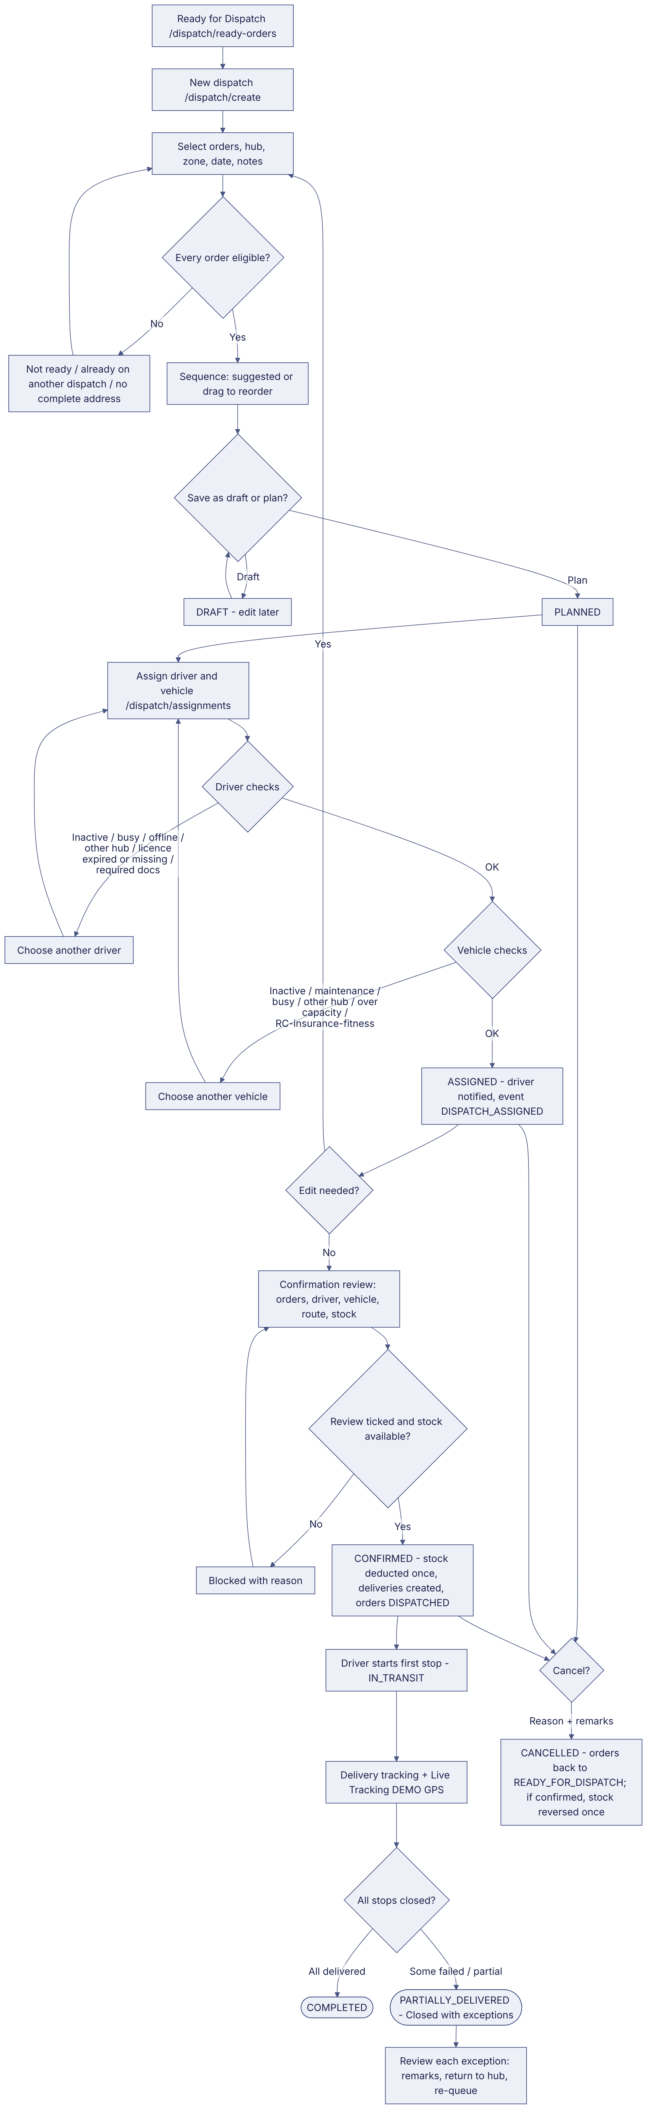
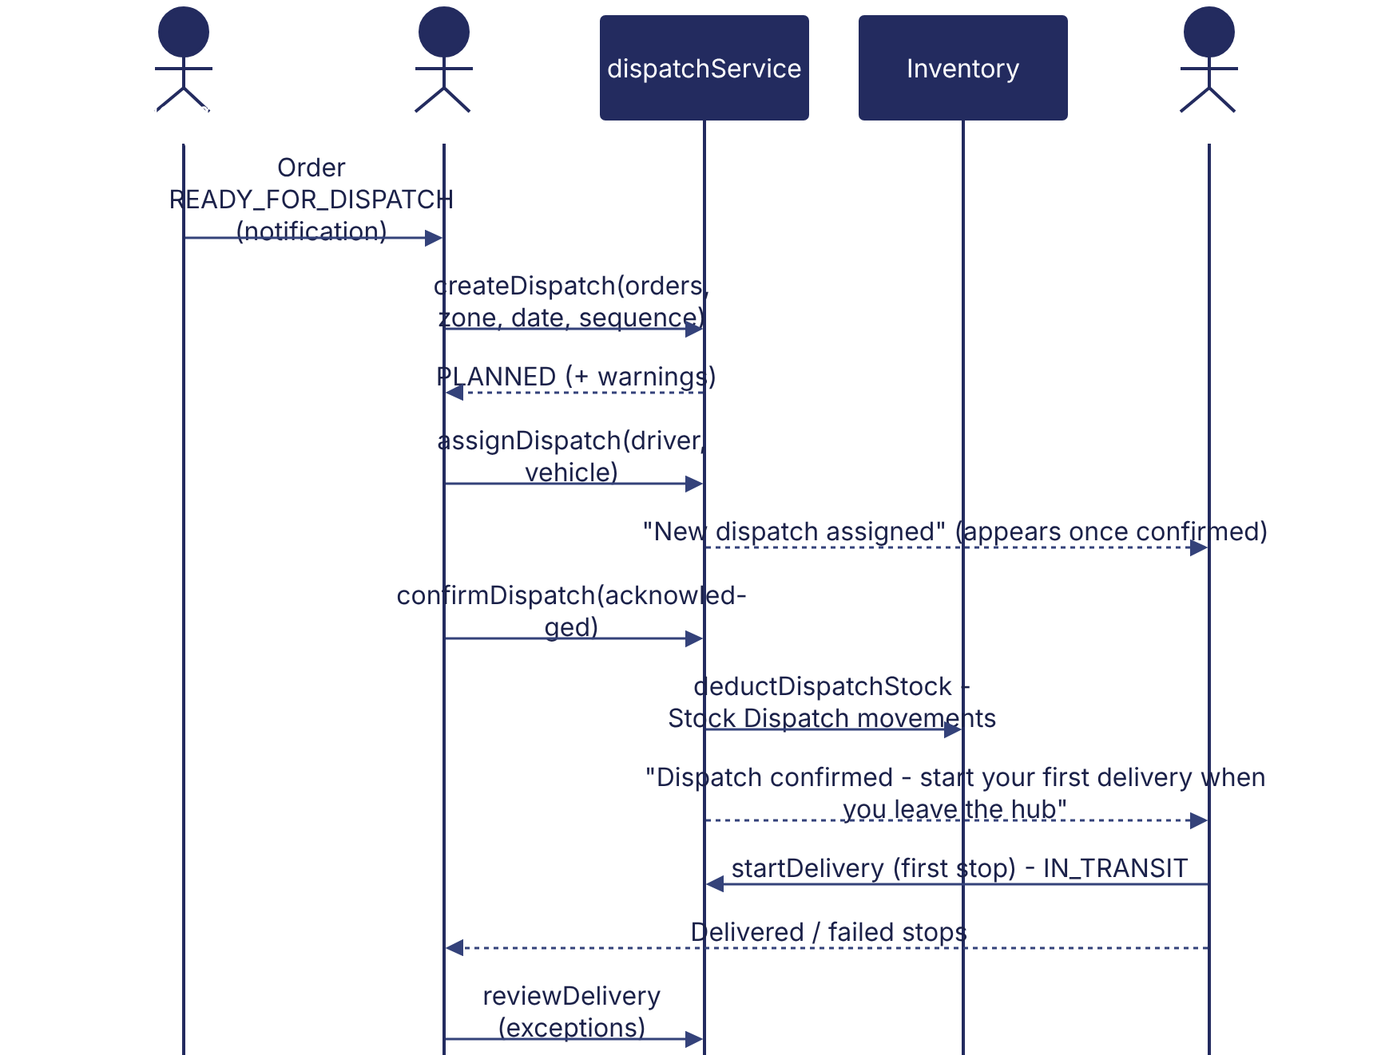
Implementation label: diagrams describe the prototype behaviour (VERIFIED in source code) unless a step is marked PROPOSED / NOT IMPLEMENTED.

12. Final outcome
Confirmed vehicle run.

Revision history
Version | Date | Author | Description
1.0 | 2026-11-12 | Documentation team | Initial draft prepared from analysis of the bellomassi-premium-ui source code and existing project documents.

