WF-09 — Driver Assignment Workflow
Bellomassi Order-to-Delivery Management Platform
BM-WF-09 · Version 1.0 · Draft — for client review
2026-11-12

Document control
Field | Value
Document title | WF-09 — Driver Assignment Workflow
Document ID | BM-WF-09
Version | 1.0
Status | Draft — for client review
Category | Business Workflows
Related module(s) | All modules
Document owner | Business Analyst
Prepared by | Project documentation team (AI-assisted draft prepared from source-code analysis)
Reviewed by | Pending — not yet reviewed
Approval | Not approved — awaiting client review (no approval has been given)
Created date | 2026-11-12
Last updated date | 2026-11-12
Status labels used in this document: VERIFIED (confirmed in the current source code or existing documents) · PROTOTYPE (works in the React/LocalStorage prototype with mock or simulated behaviour) · PROPOSED (recommended production design, not built) · PENDING CONFIRMATION (needs a client decision) · NOT IMPLEMENTED · NOT VERIFIED.

Purpose
Specify driver and vehicle assignment with compliance checks.

Scope
Workflow WF-09 as implemented in the prototype, with production differences marked.

Definitions
Other terms: see BM-GLO-001 (Project Glossary).

References
- BM-WF-00 (Business Workflow Catalogue)
- BM-SYS-008 (Requirement Traceability Matrix)

Contents

  - Workflow summary

  - Step-by-step process

  - Decision points

  - Approval conditions

  - Rejection conditions

  - System actions

  - User actions

  - Status changes

  - Notifications

  - Exception scenarios

  - Workflow diagram

  - Final outcome

1. Workflow summary
Field | Value
Workflow ID | WF-09
Workflow name | Driver Assignment Workflow
Business purpose | Specify driver and vehicle assignment with compliance checks.
Initiating role | Dispatcher
Trigger | Dispatch PLANNED
Preconditions | Dispatch PLANNED or ASSIGNED.
Final outcome | Compliant assignment.
Related requirements | FR-DRA-001, FR-DRA-002, FR-DRA-003, FR-VMS-002
Related test cases | TC-DRA-001, TC-DRA-002, TC-DRA-N01, TC-DRA-003, TC-DRA-N02, TC-VMS-002
Detailed chapter | docs/workflow/ chapter 11

2. Step-by-step process
- Open Driver Assignment.
- Choose driver — system checks status, availability, hub, licence, required documents.
- Choose vehicle — status, availability, hub, capacity vs load, required documents.
- Save assignment; driver notified.

3. Decision points
Driver issues? Vehicle issues?

4. Approval conditions
No blocking issue.

5. Rejection conditions
Assignment refused with issue list.

6. System actions
driverAssignmentIssues, vehicleAssignmentIssues, VMS compliance.

7. User actions
Selection.

8. Status changes
PLANNED → ASSIGNED.

9. Notifications
Driver: “New dispatch assigned”; previous driver: “Removed from …”.

10. Exception scenarios
Expired licence / documents, over capacity, busy resource.

11. Workflow diagram
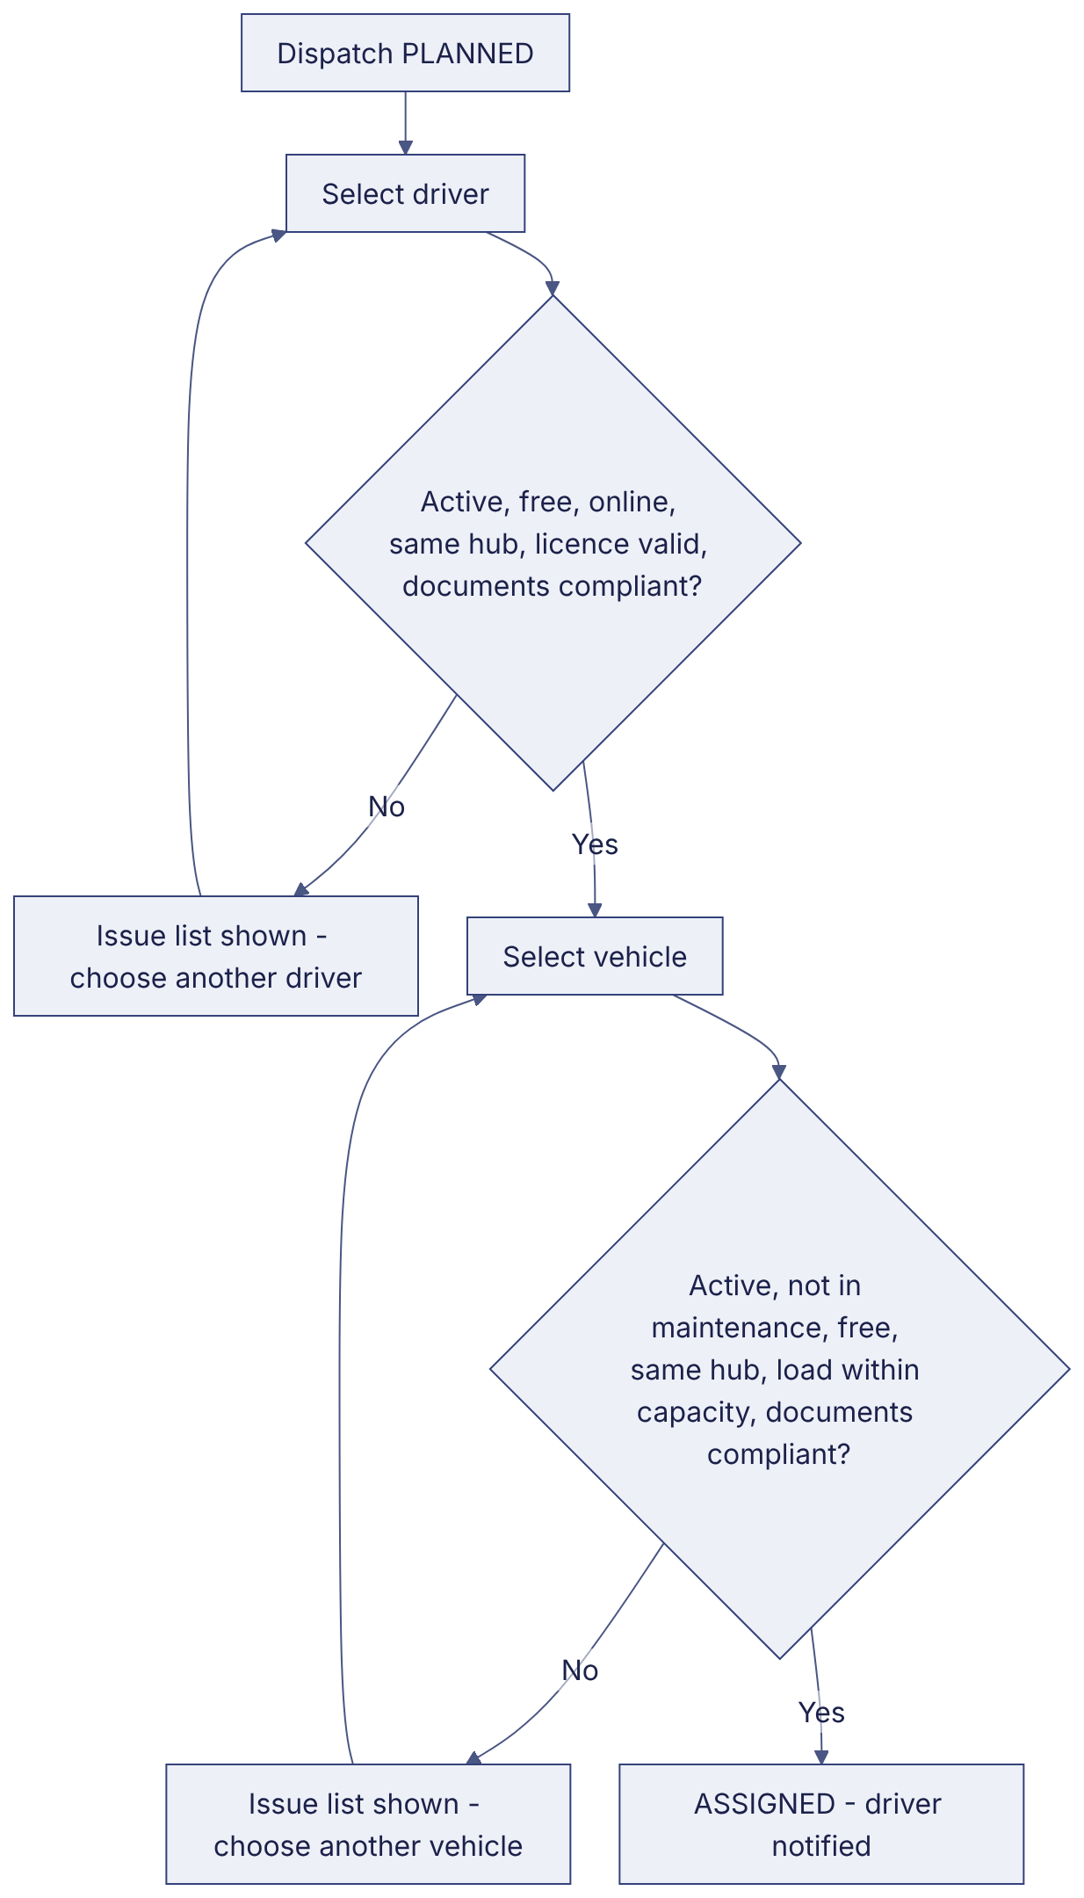
Implementation label: diagrams describe the prototype behaviour (VERIFIED in source code) unless a step is marked PROPOSED / NOT IMPLEMENTED.

12. Final outcome
Compliant assignment.

Revision history
Version | Date | Author | Description
1.0 | 2026-11-12 | Documentation team | Initial draft prepared from analysis of the bellomassi-premium-ui source code and existing project documents.

