WF-10 — Driver Delivery Workflow
Bellomassi Order-to-Delivery Management Platform
BM-WF-10 · Version 1.0 · Draft — for client review
2026-11-12

Document control
Field | Value
Document title | WF-10 — Driver Delivery Workflow
Document ID | BM-WF-10
Version | 1.0
Status | Draft — for client review
Category | Business Workflows
Related module(s) | All modules
Document owner | Business Analyst
Prepared by | Project documentation team (AI-assisted draft prepared from source-code analysis)
Reviewed by | Pending — not yet reviewed
Approval | Not approved — awaiting client review (no approval has been given)
Created date | 2026-11-12
Last updated date | 2026-11-12
Status labels used in this document: VERIFIED (confirmed in the current source code or existing documents) · PROTOTYPE (works in the React/LocalStorage prototype with mock or simulated behaviour) · PROPOSED (recommended production design, not built) · PENDING CONFIRMATION (needs a client decision) · NOT IMPLEMENTED · NOT VERIFIED.

Purpose
Specify the driver’s stop workflow.

Scope
Workflow WF-10 as implemented in the prototype, with production differences marked.

Definitions
Other terms: see BM-GLO-001 (Project Glossary).

References
- BM-WF-00 (Business Workflow Catalogue)
- BM-SYS-008 (Requirement Traceability Matrix)

Contents

  - Workflow summary

  - Step-by-step process

  - Decision points

  - Approval conditions

  - Rejection conditions

  - System actions

  - User actions

  - Status changes

  - Notifications

  - Exception scenarios

  - Workflow diagram

  - Final outcome

1. Workflow summary
Field | Value
Workflow ID | WF-10
Workflow name | Driver Delivery Workflow
Business purpose | Specify the driver’s stop workflow.
Initiating role | Driver
Trigger | Dispatch CONFIRMED and date reached
Preconditions | Dispatch CONFIRMED; date reached; driver linked to user.
Final outcome | Stop closed with proof.
Related requirements | FR-DRV-001, FR-DRV-002, FR-DRV-003, FR-DRV-004, FR-DRV-005, FR-OTP-002, FR-POD-001
Related test cases | TC-DRV-001, TC-DRV-002, TC-DRV-N01, TC-DRV-N02, TC-DRV-N03, TC-DRV-003, TC-DRV-004, TC-DRV-005, TC-OTP-002, TC-OTP-N01, TC-OTP-N02, TC-POD-001, TC-POD-N02
Detailed chapter | docs/workflow/ chapter 08

2. Step-by-step process
- Open Today; tap next stop.
- Start delivery (blocked if not next / not confirmed / future).
- Drive (DEMO GPS in prototype).
- Reach location — OTP issued.
- Enter quantities, receiver, optional signature / photo, OTP.
- Complete (DELIVERED / PARTIALLY_DELIVERED) or report failure.

3. Decision points
Can start? OTP valid? All delivered? Problem?

4. Approval conditions
OTP verification.

5. Rejection conditions
Failure with reason.

6. System actions
Tracking session, OTP, delivery note, notifications, dispatch closing.

7. User actions
Driver actions; customer gives OTP.

8. Status changes
Delivery DISPATCHED → OUT_FOR_DELIVERY → DELIVERED / PARTIALLY_DELIVERED / FAILED.

9. Notifications
Customer and Dispatcher at each step.

10. Exception scenarios
Wrong / expired / locked OTP; out of sequence; failure.

11. Workflow diagram
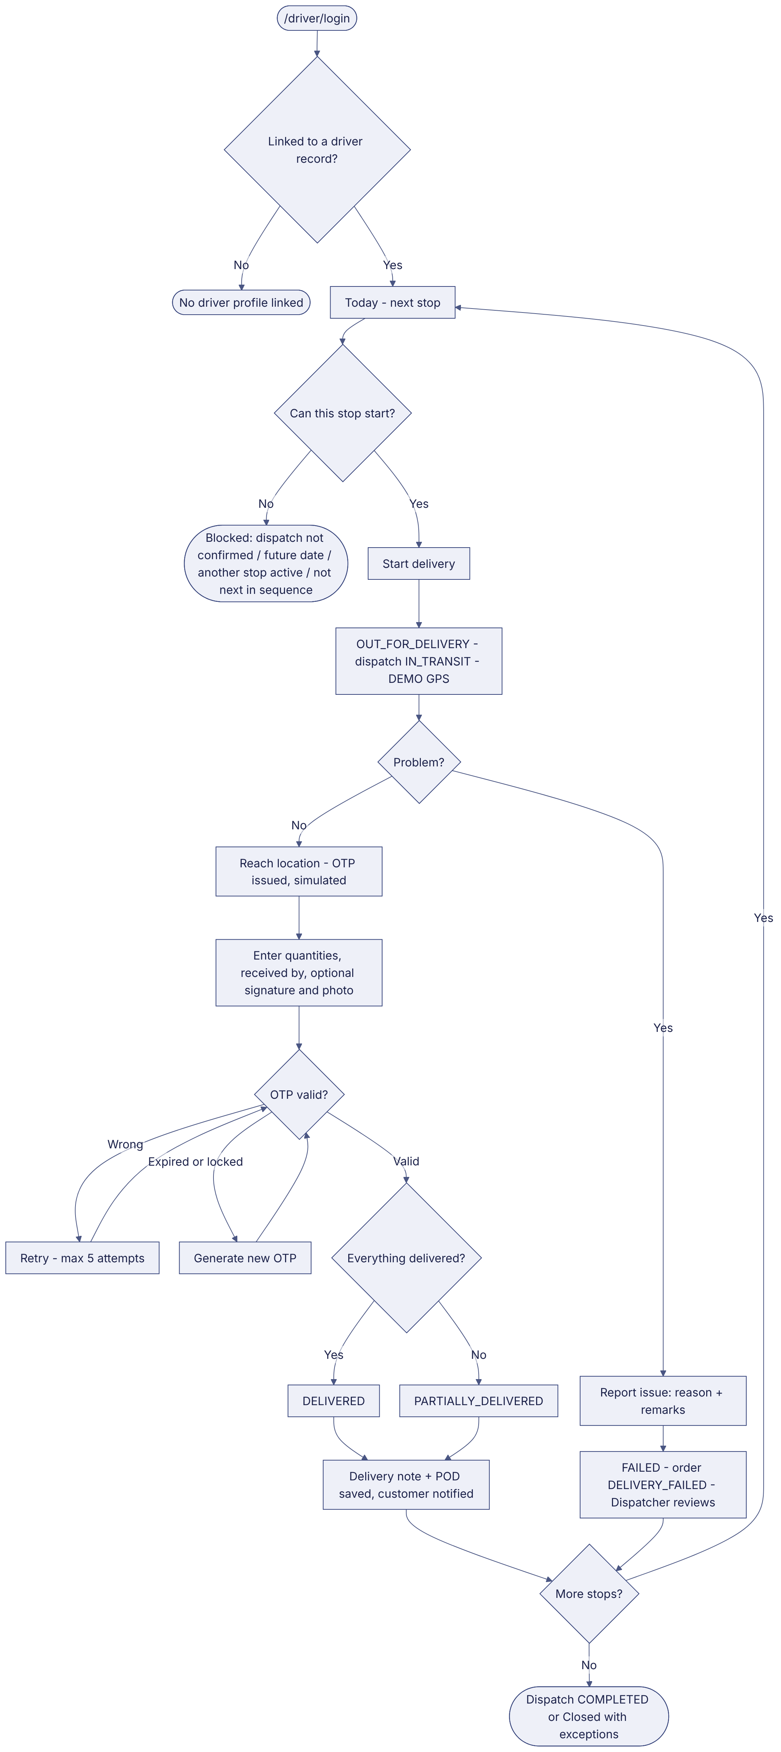
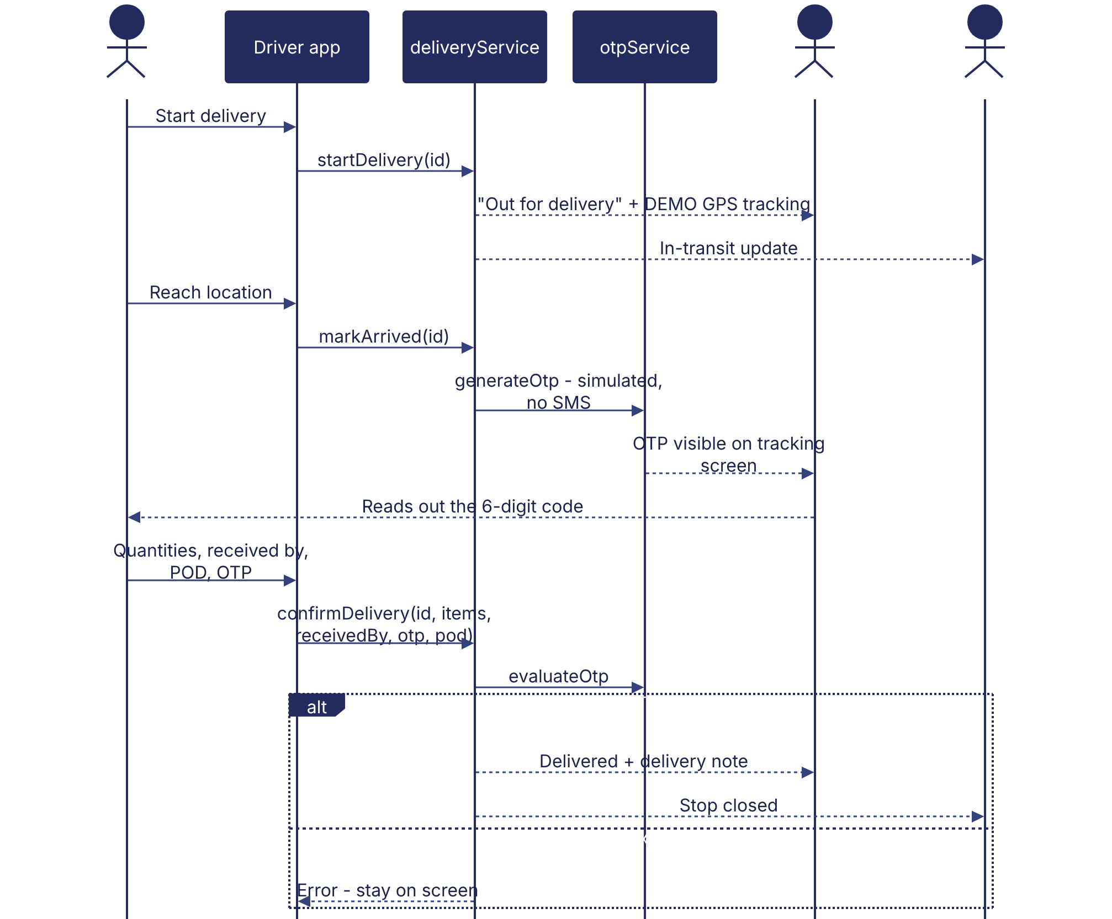
Implementation label: diagrams describe the prototype behaviour (VERIFIED in source code) unless a step is marked PROPOSED / NOT IMPLEMENTED.

12. Final outcome
Stop closed with proof.

Revision history
Version | Date | Author | Description
1.0 | 2026-11-12 | Documentation team | Initial draft prepared from analysis of the bellomassi-premium-ui source code and existing project documents.

