WF-11 — Customer Order Workflow
Bellomassi Order-to-Delivery Management Platform
BM-WF-11 · Version 1.0 · Draft — for client review
2026-11-12

Document control
Field | Value
Document title | WF-11 — Customer Order Workflow
Document ID | BM-WF-11
Version | 1.0
Status | Draft — for client review
Category | Business Workflows
Related module(s) | All modules
Document owner | Business Analyst
Prepared by | Project documentation team (AI-assisted draft prepared from source-code analysis)
Reviewed by | Pending — not yet reviewed
Approval | Not approved — awaiting client review (no approval has been given)
Created date | 2026-11-12
Last updated date | 2026-11-12
Status labels used in this document: VERIFIED (confirmed in the current source code or existing documents) · PROTOTYPE (works in the React/LocalStorage prototype with mock or simulated behaviour) · PROPOSED (recommended production design, not built) · PENDING CONFIRMATION (needs a client decision) · NOT IMPLEMENTED · NOT VERIFIED.

Purpose
Specify customer self-service ordering.

Scope
Workflow WF-11 as implemented in the prototype, with production differences marked.

Definitions
Other terms: see BM-GLO-001 (Project Glossary).

References
- BM-WF-00 (Business Workflow Catalogue)
- BM-SYS-008 (Requirement Traceability Matrix)

Contents

  - Workflow summary

  - Step-by-step process

  - Decision points

  - Approval conditions

  - Rejection conditions

  - System actions

  - User actions

  - Status changes

  - Notifications

  - Exception scenarios

  - Workflow diagram

  - Final outcome

1. Workflow summary
Field | Value
Workflow ID | WF-11
Workflow name | Customer Order Workflow
Business purpose | Specify customer self-service ordering.
Initiating role | Customer
Trigger | Customer opens the catalog
Preconditions | Customer user linked to a customer record.
Final outcome | Order in approval queue.
Related requirements | FR-CAP-001, FR-CAP-002, FR-CAP-006
Related test cases | TC-CAP-001, TC-CAP-002, TC-CAP-N01, TC-CAP-N02, TC-CAP-006
Detailed chapter | docs/workflow/ chapter 09

2. Step-by-step process
- Browse catalog; add to cart.
- Review cart totals and credit warning.
- Enter delivery details (address, date tomorrow–60 days, time slot, reference, remarks).
- Place order; confirm.
- Order submitted for Sales Manager approval.

3. Decision points
Address registered or other; time slot.

4. Approval conditions
Sales Manager approval (WF-04).

5. Rejection conditions
Manager rejects; customer sees “Not accepted”.

6. System actions
placeCustomerOrder → submitOrder (source customer_app; VIP → High priority).

7. User actions
Customer.

8. Status changes
SUBMITTED (Pending approval).

9. Notifications
Order placed; later approved / rejected.

10. Exception scenarios
Empty cart; invalid date; unlinked login.

11. Workflow diagram
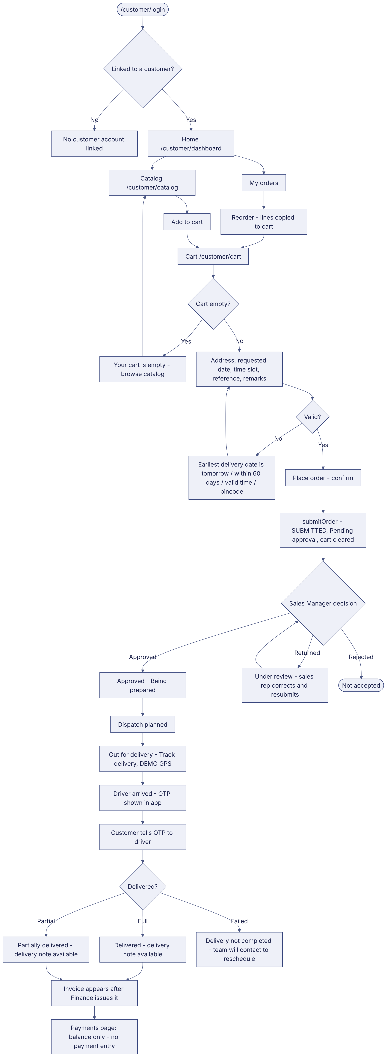
Implementation label: diagrams describe the prototype behaviour (VERIFIED in source code) unless a step is marked PROPOSED / NOT IMPLEMENTED.

12. Final outcome
Order in approval queue.

Revision history
Version | Date | Author | Description
1.0 | 2026-11-12 | Documentation team | Initial draft prepared from analysis of the bellomassi-premium-ui source code and existing project documents.

