WF-12 — Customer Tracking Workflow
Bellomassi Order-to-Delivery Management Platform
BM-WF-12 · Version 1.0 · Draft — for client review
2026-11-12

Document control
Field | Value
Document title | WF-12 — Customer Tracking Workflow
Document ID | BM-WF-12
Version | 1.0
Status | Draft — for client review
Category | Business Workflows
Related module(s) | All modules
Document owner | Business Analyst
Prepared by | Project documentation team (AI-assisted draft prepared from source-code analysis)
Reviewed by | Pending — not yet reviewed
Approval | Not approved — awaiting client review (no approval has been given)
Created date | 2026-11-12
Last updated date | 2026-11-12
Status labels used in this document: VERIFIED (confirmed in the current source code or existing documents) · PROTOTYPE (works in the React/LocalStorage prototype with mock or simulated behaviour) · PROPOSED (recommended production design, not built) · PENDING CONFIRMATION (needs a client decision) · NOT IMPLEMENTED · NOT VERIFIED.

Purpose
Specify customer delivery tracking and OTP handover.

Scope
Workflow WF-12 as implemented in the prototype, with production differences marked.

Definitions
Other terms: see BM-GLO-001 (Project Glossary).

References
- BM-WF-00 (Business Workflow Catalogue)
- BM-SYS-008 (Requirement Traceability Matrix)

Contents

  - Workflow summary

  - Step-by-step process

  - Decision points

  - Approval conditions

  - Rejection conditions

  - System actions

  - User actions

  - Status changes

  - Notifications

  - Exception scenarios

  - Workflow diagram

  - Final outcome

1. Workflow summary
Field | Value
Workflow ID | WF-12
Workflow name | Customer Tracking Workflow
Business purpose | Specify customer delivery tracking and OTP handover.
Initiating role | Customer
Trigger | Driver starts the stop
Preconditions | Customer has an order on a confirmed dispatch.
Final outcome | Handover confirmed by the customer.
Related requirements | FR-CAP-003, FR-CAP-004, FR-OTP-001, FR-CAP-005
Related test cases | TC-CAP-003, TC-CAP-004, TC-OTP-001, TC-CAP-005
Detailed chapter | docs/workflow/ chapter 09

2. Step-by-step process
- Driver starts the stop — customer notified “Out for delivery”.
- Customer opens Track delivery (DEMO GPS map, own vehicle only).
- Driver reaches location — OTP shown in large digits with expiry.
- Customer reads OTP to driver.
- Delivery completed — delivery note available.

3. Decision points
—

4. Approval conditions
Customer OTP.

5. Rejection conditions
Customer may refuse — driver records failure “Customer Refused”.

6. System actions
Tracking session; OTP; notifications.

7. User actions
Customer shares OTP.

8. Status changes
OUT_FOR_DELIVERY → DELIVERED.

9. Notifications
Out for delivery; driver arrived; delivered / not completed.

10. Exception scenarios
OTP expiry → new OTP.

11. Workflow diagram
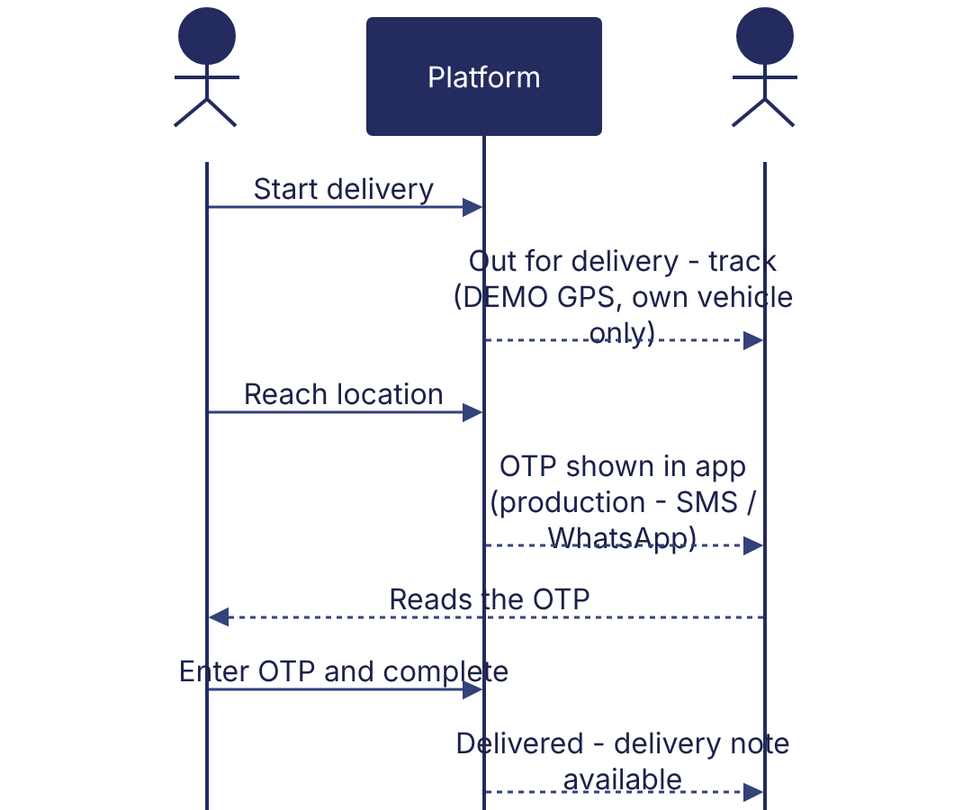
Implementation label: diagrams describe the prototype behaviour (VERIFIED in source code) unless a step is marked PROPOSED / NOT IMPLEMENTED.

12. Final outcome
Handover confirmed by the customer.

Revision history
Version | Date | Author | Description
1.0 | 2026-11-12 | Documentation team | Initial draft prepared from analysis of the bellomassi-premium-ui source code and existing project documents.

