WF-13 — Inventory Workflow
Bellomassi Order-to-Delivery Management Platform
BM-WF-13 · Version 1.0 · Draft — for client review
2026-11-12

Document control
Field | Value
Document title | WF-13 — Inventory Workflow
Document ID | BM-WF-13
Version | 1.0
Status | Draft — for client review
Category | Business Workflows
Related module(s) | All modules
Document owner | Business Analyst
Prepared by | Project documentation team (AI-assisted draft prepared from source-code analysis)
Reviewed by | Pending — not yet reviewed
Approval | Not approved — awaiting client review (no approval has been given)
Created date | 2026-11-12
Last updated date | 2026-11-12
Status labels used in this document: VERIFIED (confirmed in the current source code or existing documents) · PROTOTYPE (works in the React/LocalStorage prototype with mock or simulated behaviour) · PROPOSED (recommended production design, not built) · PENDING CONFIRMATION (needs a client decision) · NOT IMPLEMENTED · NOT VERIFIED.

Purpose
Specify stock receipts, transfers, adjustments and replenishment.

Scope
Workflow WF-13 as implemented in the prototype, with production differences marked.

Definitions
Other terms: see BM-GLO-001 (Project Glossary).

References
- BM-WF-00 (Business Workflow Catalogue)
- BM-SYS-008 (Requirement Traceability Matrix)

Contents

  - Workflow summary

  - Step-by-step process

  - Decision points

  - Approval conditions

  - Rejection conditions

  - System actions

  - User actions

  - Status changes

  - Notifications

  - Exception scenarios

  - Workflow diagram

  - Final outcome

1. Workflow summary
Field | Value
Workflow ID | WF-13
Workflow name | Inventory Workflow
Business purpose | Specify stock receipts, transfers, adjustments and replenishment.
Initiating role | Warehouse / Inventory staff
Trigger | Goods arrive, move or are found different
Preconditions | Hubs and products with inventory tracking.
Final outcome | Accurate stock.
Related requirements | FR-INV-001, FR-INV-002, FR-INV-003, FR-INV-004, FR-INV-005
Related test cases | TC-INV-001, TC-INV-N02, TC-INV-002, TC-INV-003, TC-INV-004, TC-INV-005
Detailed chapter | docs/workflow/ chapter 10

2. Step-by-step process
- Receive goods (GRN) — stock up.
- Transfer between hubs — draft or complete.
- Adjust stock with type and reason.
- Review low stock; create replenishment draft; admin approves and converts; receive goods against it.

3. Decision points
Transfer now or draft; adjustment type.

4. Approval conditions
Replenishment approval by Administrator.

5. Rejection conditions
Replenishment rejection with reason.

6. System actions
Movement ledger; low-stock status.

7. User actions
Warehouse staff.

8. Status changes
Transfer Draft → Completed / Cancelled; replenishment DRAFT → … → RECEIVED.

9. Notifications
Low stock alerts.

10. Exception scenarios
Insufficient stock; inactive hub.

11. Workflow diagram
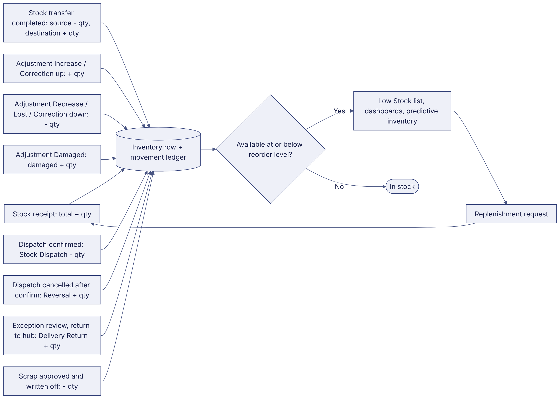
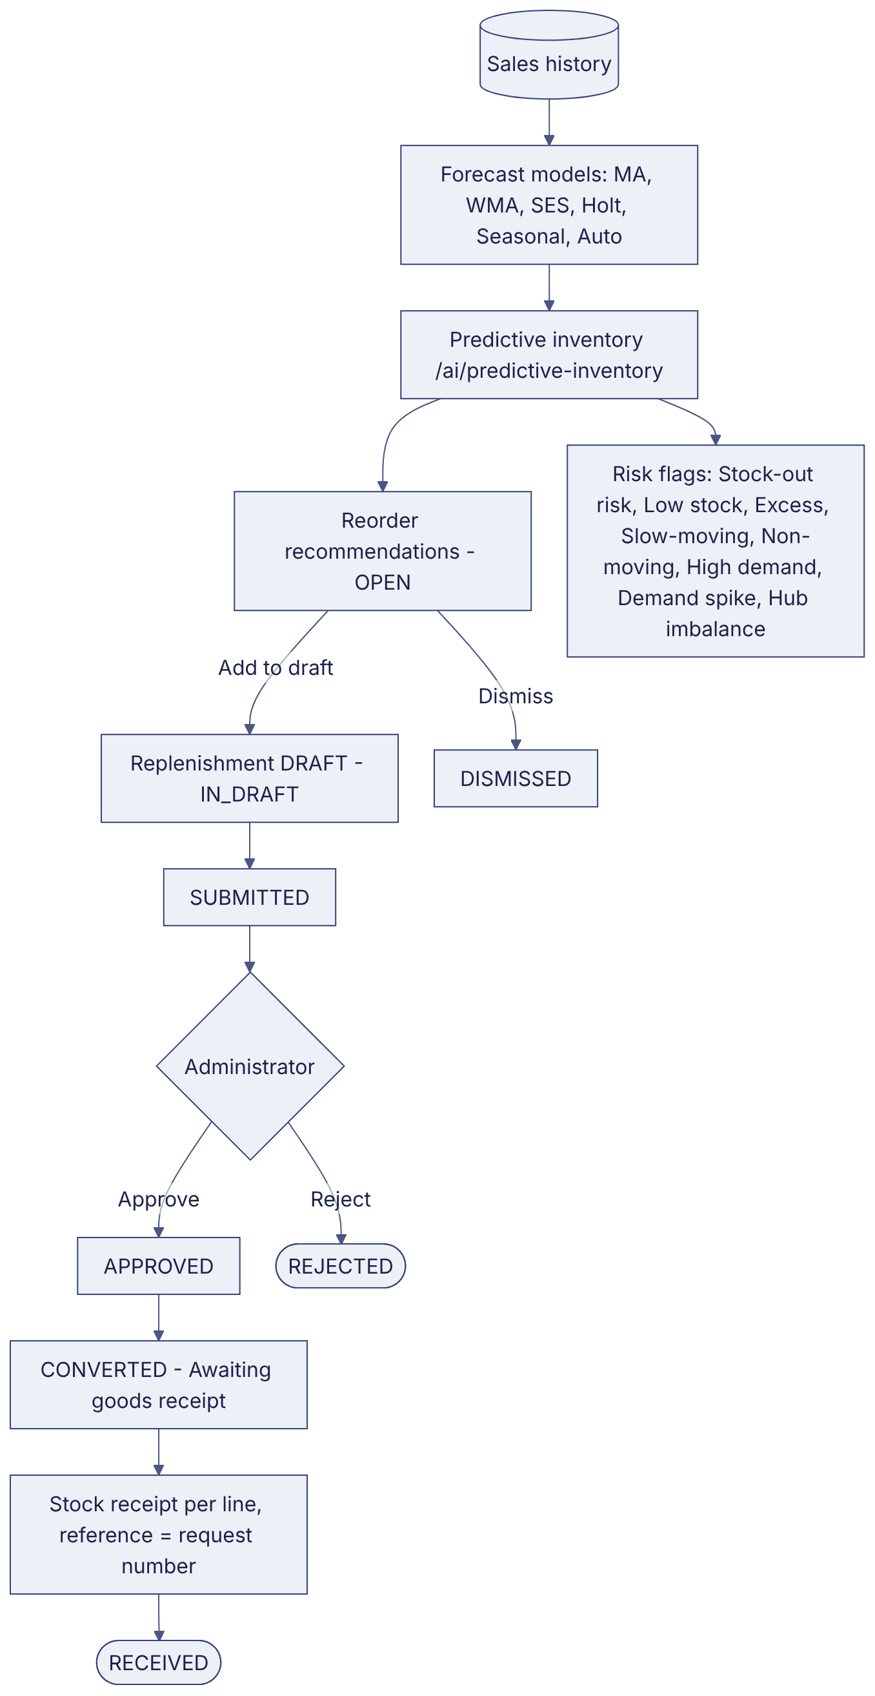
Implementation label: diagrams describe the prototype behaviour (VERIFIED in source code) unless a step is marked PROPOSED / NOT IMPLEMENTED.

12. Final outcome
Accurate stock.

Revision history
Version | Date | Author | Description
1.0 | 2026-11-12 | Documentation team | Initial draft prepared from analysis of the bellomassi-premium-ui source code and existing project documents.

