WF-14 — Scrap Workflow
Bellomassi Order-to-Delivery Management Platform
BM-WF-14 · Version 1.0 · Draft — for client review
2026-11-12

Document control
Field | Value
Document title | WF-14 — Scrap Workflow
Document ID | BM-WF-14
Version | 1.0
Status | Draft — for client review
Category | Business Workflows
Related module(s) | All modules
Document owner | Business Analyst
Prepared by | Project documentation team (AI-assisted draft prepared from source-code analysis)
Reviewed by | Pending — not yet reviewed
Approval | Not approved — awaiting client review (no approval has been given)
Created date | 2026-11-12
Last updated date | 2026-11-12
Status labels used in this document: VERIFIED (confirmed in the current source code or existing documents) · PROTOTYPE (works in the React/LocalStorage prototype with mock or simulated behaviour) · PROPOSED (recommended production design, not built) · PENDING CONFIRMATION (needs a client decision) · NOT IMPLEMENTED · NOT VERIFIED.

Purpose
Specify scrap write-off.

Scope
Workflow WF-14 as implemented in the prototype, with production differences marked.

Definitions
Other terms: see BM-GLO-001 (Project Glossary).

References
- BM-WF-00 (Business Workflow Catalogue)
- BM-SYS-008 (Requirement Traceability Matrix)

Contents

  - Workflow summary

  - Step-by-step process

  - Decision points

  - Approval conditions

  - Rejection conditions

  - System actions

  - User actions

  - Status changes

  - Notifications

  - Exception scenarios

  - Workflow diagram

  - Final outcome

1. Workflow summary
Field | Value
Workflow ID | WF-14
Workflow name | Scrap Workflow
Business purpose | Specify scrap write-off.
Initiating role | Warehouse / QA / Inventory staff
Trigger | Unusable stock found
Preconditions | Unusable stock at hub.
Final outcome | Stock written off with evidence.
Related requirements | FR-SCR-001, FR-SCR-002, FR-SCR-003, FR-SCR-004
Related test cases | TC-SCR-001, TC-SCR-002, TC-SCR-N02, TC-SCR-N03, TC-SCR-003, TC-SCR-N01, TC-SCR-004
Detailed chapter | docs/workflow/ chapter 07, 10

2. Step-by-step process
- Create request (reason, qty, source, batch, photo).
- Submit.
- Approver (not requester) approves or rejects.
- Approver posts write-off once.

3. Decision points
Approve or reject.

4. Approval conditions
Different user with scrap.approve.

5. Rejection conditions
Reason ≥ 5 characters.

6. System actions
Eligibility check; Scrap Write-off movement.

7. User actions
Requester, approver.

8. Status changes
DRAFT → PENDING_APPROVAL → APPROVED → COMPLETED; REJECTED; CANCELLED.

9. Notifications
Pending requests on warehouse dashboard.

10. Exception scenarios
Quantity above eligible; missing photo / batch; duplicate.

11. Workflow diagram
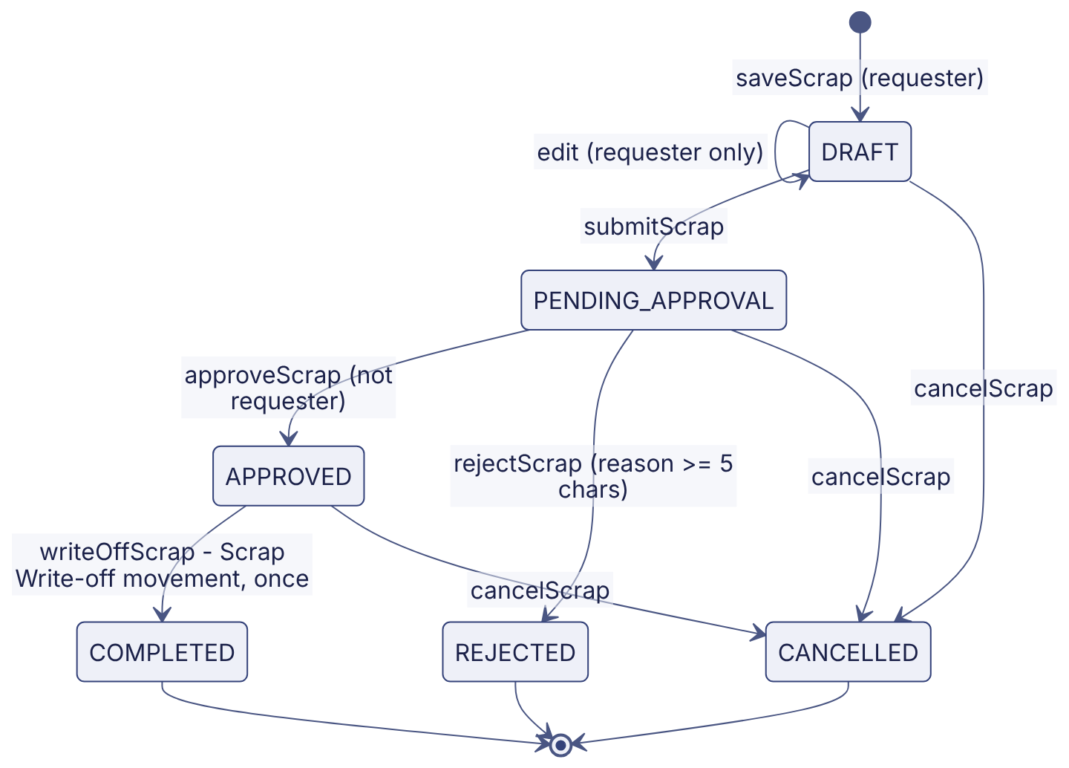
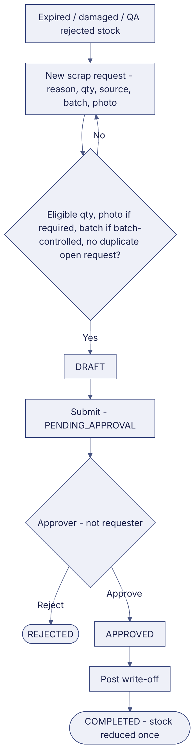
Implementation label: diagrams describe the prototype behaviour (VERIFIED in source code) unless a step is marked PROPOSED / NOT IMPLEMENTED.

12. Final outcome
Stock written off with evidence.

Revision history
Version | Date | Author | Description
1.0 | 2026-11-12 | Documentation team | Initial draft prepared from analysis of the bellomassi-premium-ui source code and existing project documents.

