WF-15 — Vehicle Management Workflow
Bellomassi Order-to-Delivery Management Platform
BM-WF-15 · Version 1.0 · Draft — for client review
2026-11-12

Document control
Field | Value
Document title | WF-15 — Vehicle Management Workflow
Document ID | BM-WF-15
Version | 1.0
Status | Draft — for client review
Category | Business Workflows
Related module(s) | All modules
Document owner | Business Analyst
Prepared by | Project documentation team (AI-assisted draft prepared from source-code analysis)
Reviewed by | Pending — not yet reviewed
Approval | Not approved — awaiting client review (no approval has been given)
Created date | 2026-11-12
Last updated date | 2026-11-12
Status labels used in this document: VERIFIED (confirmed in the current source code or existing documents) · PROTOTYPE (works in the React/LocalStorage prototype with mock or simulated behaviour) · PROPOSED (recommended production design, not built) · PENDING CONFIRMATION (needs a client decision) · NOT IMPLEMENTED · NOT VERIFIED.

Purpose
Specify vehicle and driver compliance management.

Scope
Workflow WF-15 as implemented in the prototype, with production differences marked.

Definitions
Other terms: see BM-GLO-001 (Project Glossary).

References
- BM-WF-00 (Business Workflow Catalogue)
- BM-SYS-008 (Requirement Traceability Matrix)

Contents

  - Workflow summary

  - Step-by-step process

  - Decision points

  - Approval conditions

  - Rejection conditions

  - System actions

  - User actions

  - Status changes

  - Notifications

  - Exception scenarios

  - Workflow diagram

  - Final outcome

1. Workflow summary
Field | Value
Workflow ID | WF-15
Workflow name | Vehicle Management Workflow
Business purpose | Specify vehicle and driver compliance management.
Initiating role | Administrator
Trigger | Vehicle / driver document recorded or expiring
Preconditions | Vehicles and drivers recorded.
Final outcome | Only compliant fleet on the road.
Related requirements | FR-VMS-001, FR-VMS-002, FR-VMS-003, FR-VMS-004
Related test cases | TC-VMS-001, TC-VMS-002, TC-VMS-003, TC-VMS-004
Detailed chapter | docs/workflow/ chapter 11

2. Step-by-step process
- Record document numbers and expiry dates; upload files.
- Compliance computed per document.
- Expiry register reviewed; scan raises events.
- Assignment blocked for expired required documents.

3. Decision points
Required? Expired / warning / missing?

4. Approval conditions
Document verification (WF-22).

5. Rejection conditions
—

6. System actions
complianceService, expiry events.

7. User actions
Administrator / Dispatcher.

8. Status changes
VALID / MONTH / WEEK / TODAY / EXPIRED / MISSING.

9. Notifications
DOCUMENT_EXPIRING / DOCUMENT_EXPIRED (automation).

10. Exception scenarios
Assignment refused.

11. Workflow diagram
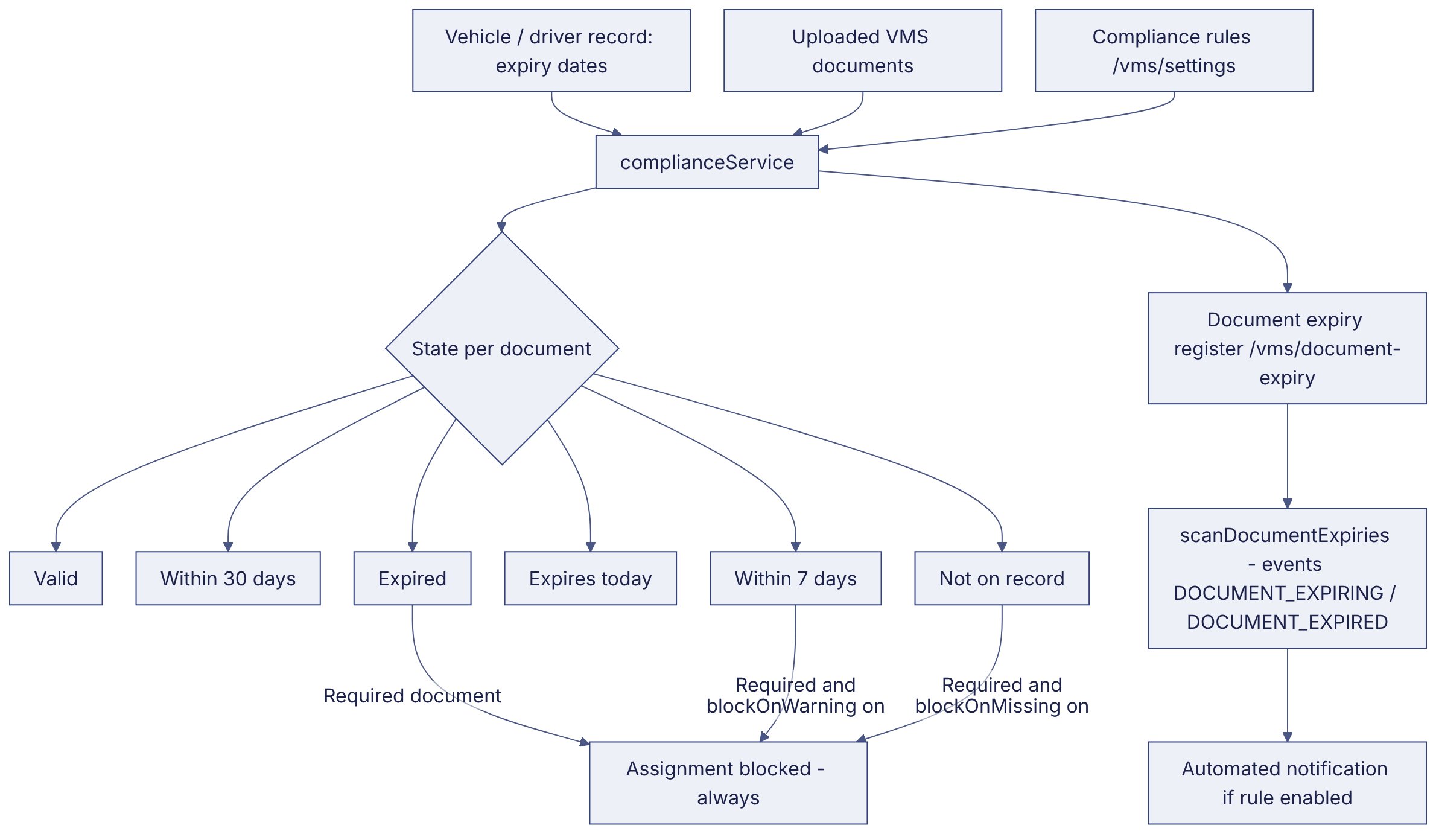
Implementation label: diagrams describe the prototype behaviour (VERIFIED in source code) unless a step is marked PROPOSED / NOT IMPLEMENTED.

12. Final outcome
Only compliant fleet on the road.

Revision history
Version | Date | Author | Description
1.0 | 2026-11-12 | Documentation team | Initial draft prepared from analysis of the bellomassi-premium-ui source code and existing project documents.

