WF-16 — Invoice Workflow
Bellomassi Order-to-Delivery Management Platform
BM-WF-16 · Version 1.0 · Draft — for client review
2026-11-12

Document control
Field | Value
Document title | WF-16 — Invoice Workflow
Document ID | BM-WF-16
Version | 1.0
Status | Draft — for client review
Category | Business Workflows
Related module(s) | All modules
Document owner | Business Analyst
Prepared by | Project documentation team (AI-assisted draft prepared from source-code analysis)
Reviewed by | Pending — not yet reviewed
Approval | Not approved — awaiting client review (no approval has been given)
Created date | 2026-11-12
Last updated date | 2026-11-12
Status labels used in this document: VERIFIED (confirmed in the current source code or existing documents) · PROTOTYPE (works in the React/LocalStorage prototype with mock or simulated behaviour) · PROPOSED (recommended production design, not built) · PENDING CONFIRMATION (needs a client decision) · NOT IMPLEMENTED · NOT VERIFIED.

Purpose
Specify invoice issue and cancellation (scope to be confirmed).

Scope
Workflow WF-16 as implemented in the prototype, with production differences marked.

Definitions
Other terms: see BM-GLO-001 (Project Glossary).

References
- BM-WF-00 (Business Workflow Catalogue)
- BM-SYS-008 (Requirement Traceability Matrix)

Contents

  - Workflow summary

  - Step-by-step process

  - Decision points

  - Approval conditions

  - Rejection conditions

  - System actions

  - User actions

  - Status changes

  - Notifications

  - Exception scenarios

  - Workflow diagram

  - Final outcome

1. Workflow summary
Field | Value
Workflow ID | WF-16
Workflow name | Invoice Workflow
Business purpose | Specify invoice issue and cancellation (scope to be confirmed).
Initiating role | Finance
Trigger | Order approved or delivered
Preconditions | Order APPROVED or later without active invoice; active template.
Final outcome | Invoice issued.
Related requirements | FR-INVC-001, FR-INVC-002, FR-INVC-003, FR-INVC-004
Related test cases | TC-INVC-001, TC-INVC-002, TC-INVC-N01, TC-INVC-N02, TC-INVC-003, TC-INVC-N03, TC-INVC-004
Detailed chapter | docs/workflow/ chapter 12

2. Step-by-step process
- New invoice — select order.
- Choose template and options (quantity basis, dates, discount, charges, demo tax).
- Preview; issue (BM-INV-YYYY-NNNNN).
- Print / email (demo) / visible to customer.
- Cancel with reason if wrong; reissue.

3. Decision points
Eligible? Quantity basis?

4. Approval conditions
—

5. Rejection conditions
Cancellation.

6. System actions
Snapshot, numbering, totals, event INVOICE_GENERATED.

7. User actions
Finance.

8. Status changes
ISSUED → CANCELLED.

9. Notifications
Admin and Finance.

10. Exception scenarios
Draft / unapproved order; duplicate; zero total.

11. Workflow diagram
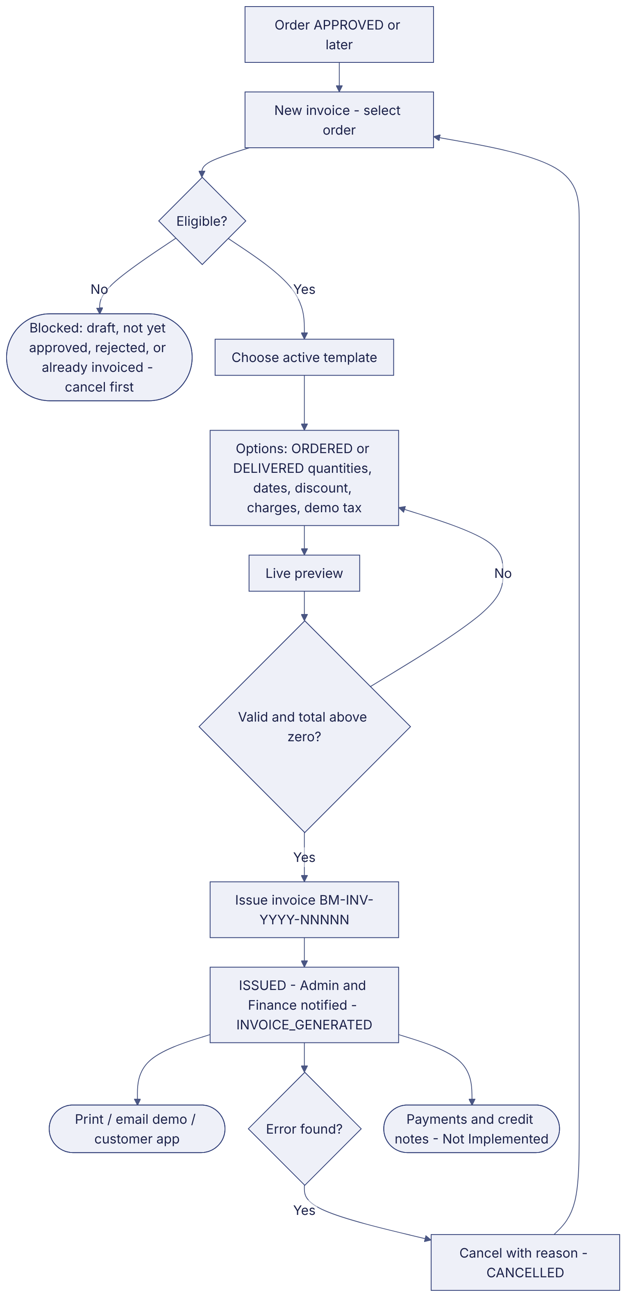
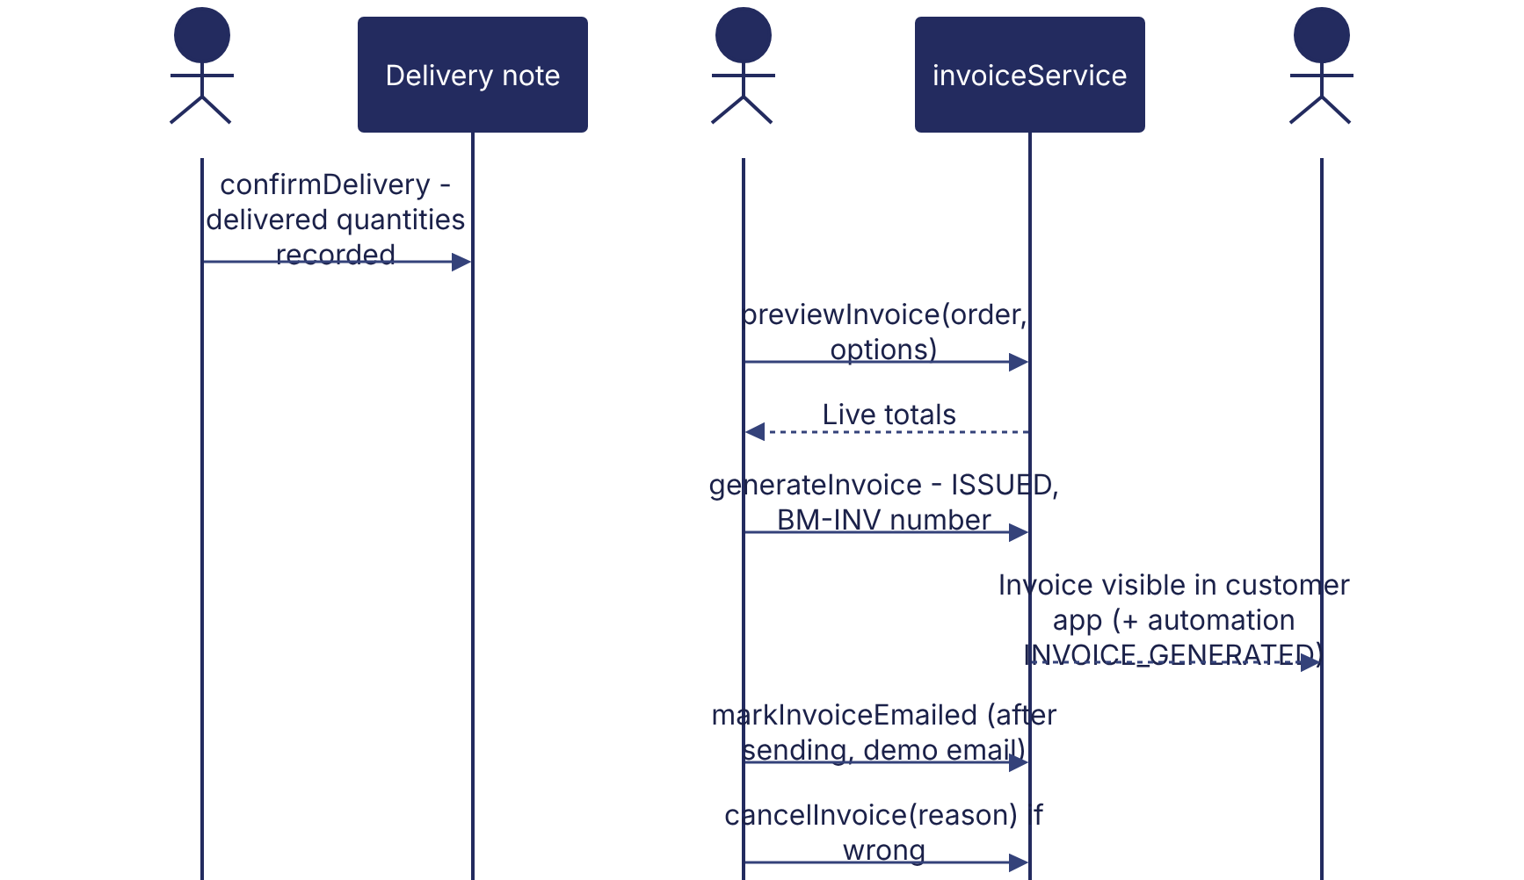
Implementation label: diagrams describe the prototype behaviour (VERIFIED in source code) unless a step is marked PROPOSED / NOT IMPLEMENTED.

12. Final outcome
Invoice issued.

Revision history
Version | Date | Author | Description
1.0 | 2026-11-12 | Documentation team | Initial draft prepared from analysis of the bellomassi-premium-ui source code and existing project documents.

