WF-17 — Communication Workflow
Bellomassi Order-to-Delivery Management Platform
BM-WF-17 · Version 1.0 · Draft — for client review
2026-11-12

Document control
Field | Value
Document title | WF-17 — Communication Workflow
Document ID | BM-WF-17
Version | 1.0
Status | Draft — for client review
Category | Business Workflows
Related module(s) | All modules
Document owner | Business Analyst
Prepared by | Project documentation team (AI-assisted draft prepared from source-code analysis)
Reviewed by | Pending — not yet reviewed
Approval | Not approved — awaiting client review (no approval has been given)
Created date | 2026-11-12
Last updated date | 2026-11-12
Status labels used in this document: VERIFIED (confirmed in the current source code or existing documents) · PROTOTYPE (works in the React/LocalStorage prototype with mock or simulated behaviour) · PROPOSED (recommended production design, not built) · PENDING CONFIRMATION (needs a client decision) · NOT IMPLEMENTED · NOT VERIFIED.

Purpose
Specify manual and automated communication.

Scope
Workflow WF-17 as implemented in the prototype, with production differences marked.

Definitions
Other terms: see BM-GLO-001 (Project Glossary).

References
- BM-WF-00 (Business Workflow Catalogue)
- BM-SYS-008 (Requirement Traceability Matrix)

Contents

  - Workflow summary

  - Step-by-step process

  - Decision points

  - Approval conditions

  - Rejection conditions

  - System actions

  - User actions

  - Status changes

  - Notifications

  - Exception scenarios

  - Workflow diagram

  - Final outcome

1. Workflow summary
Field | Value
Workflow ID | WF-17
Workflow name | Communication Workflow
Business purpose | Specify manual and automated communication.
Initiating role | System / user
Trigger | Workflow event or manual message
Preconditions | Templates and settings; automation switched on for automated messages.
Final outcome | Message logged.
Related requirements | FR-EML-001, FR-OWA-001, FR-AUTO-001, FR-AUTO-002, FR-NOTF-001
Related test cases | TC-EML-001, TC-OWA-001, TC-AUTO-001, TC-AUTO-002, TC-NOTF-001
Detailed chapter | docs/workflow/ chapter 13

2. Step-by-step process
- Workflow event fires.
- In-app notification created.
- Automation: check duplicate, switch, rule; resolve recipients; render template.
- Send via email / WhatsApp (demo or gateway); log history.
- Users may also compose messages manually.

3. Decision points
Automation on? Rule enabled? Channel?

4. Approval conditions
—

5. Rejection conditions
—

6. System actions
fireEvent, sendEmail, sendWhatsapp.

7. User actions
Compose, templates.

8. Status changes
Message statuses (demo: SENT_DEMO).

9. Notifications
—

10. Exception scenarios
Skipped (no rule / template / address).

11. Workflow diagram
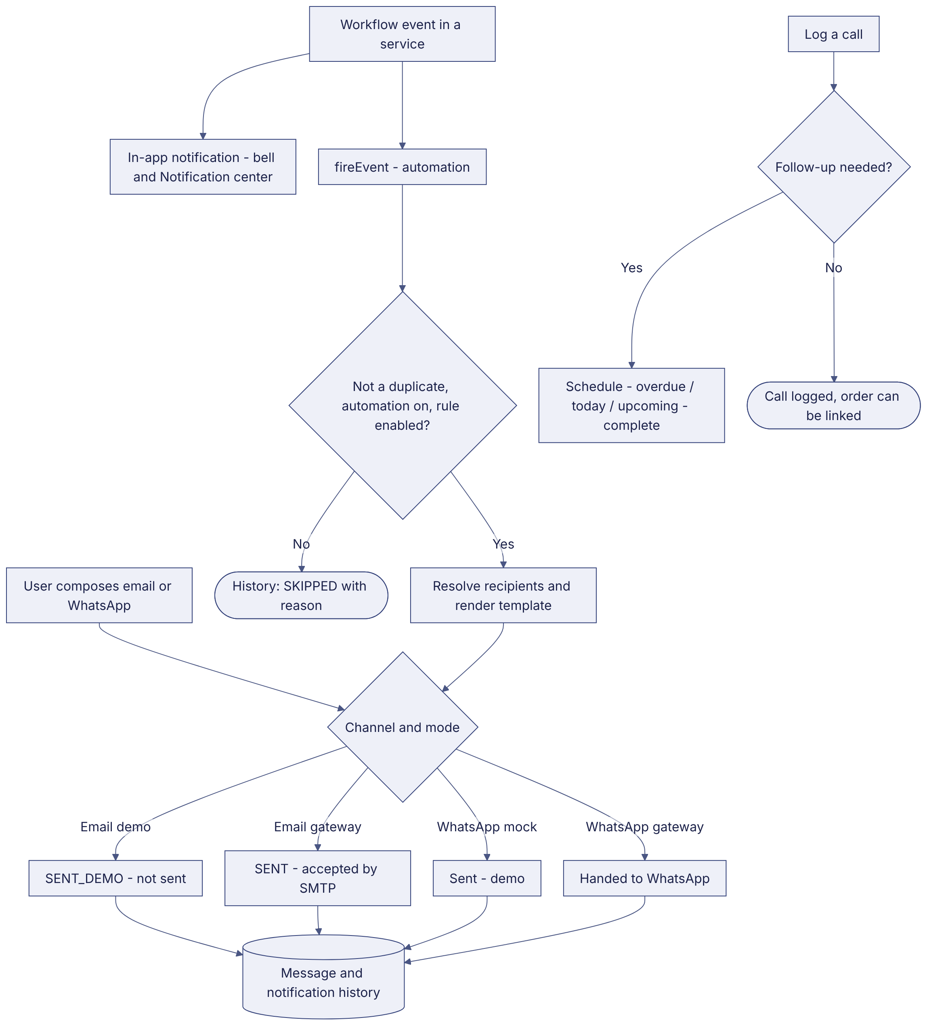
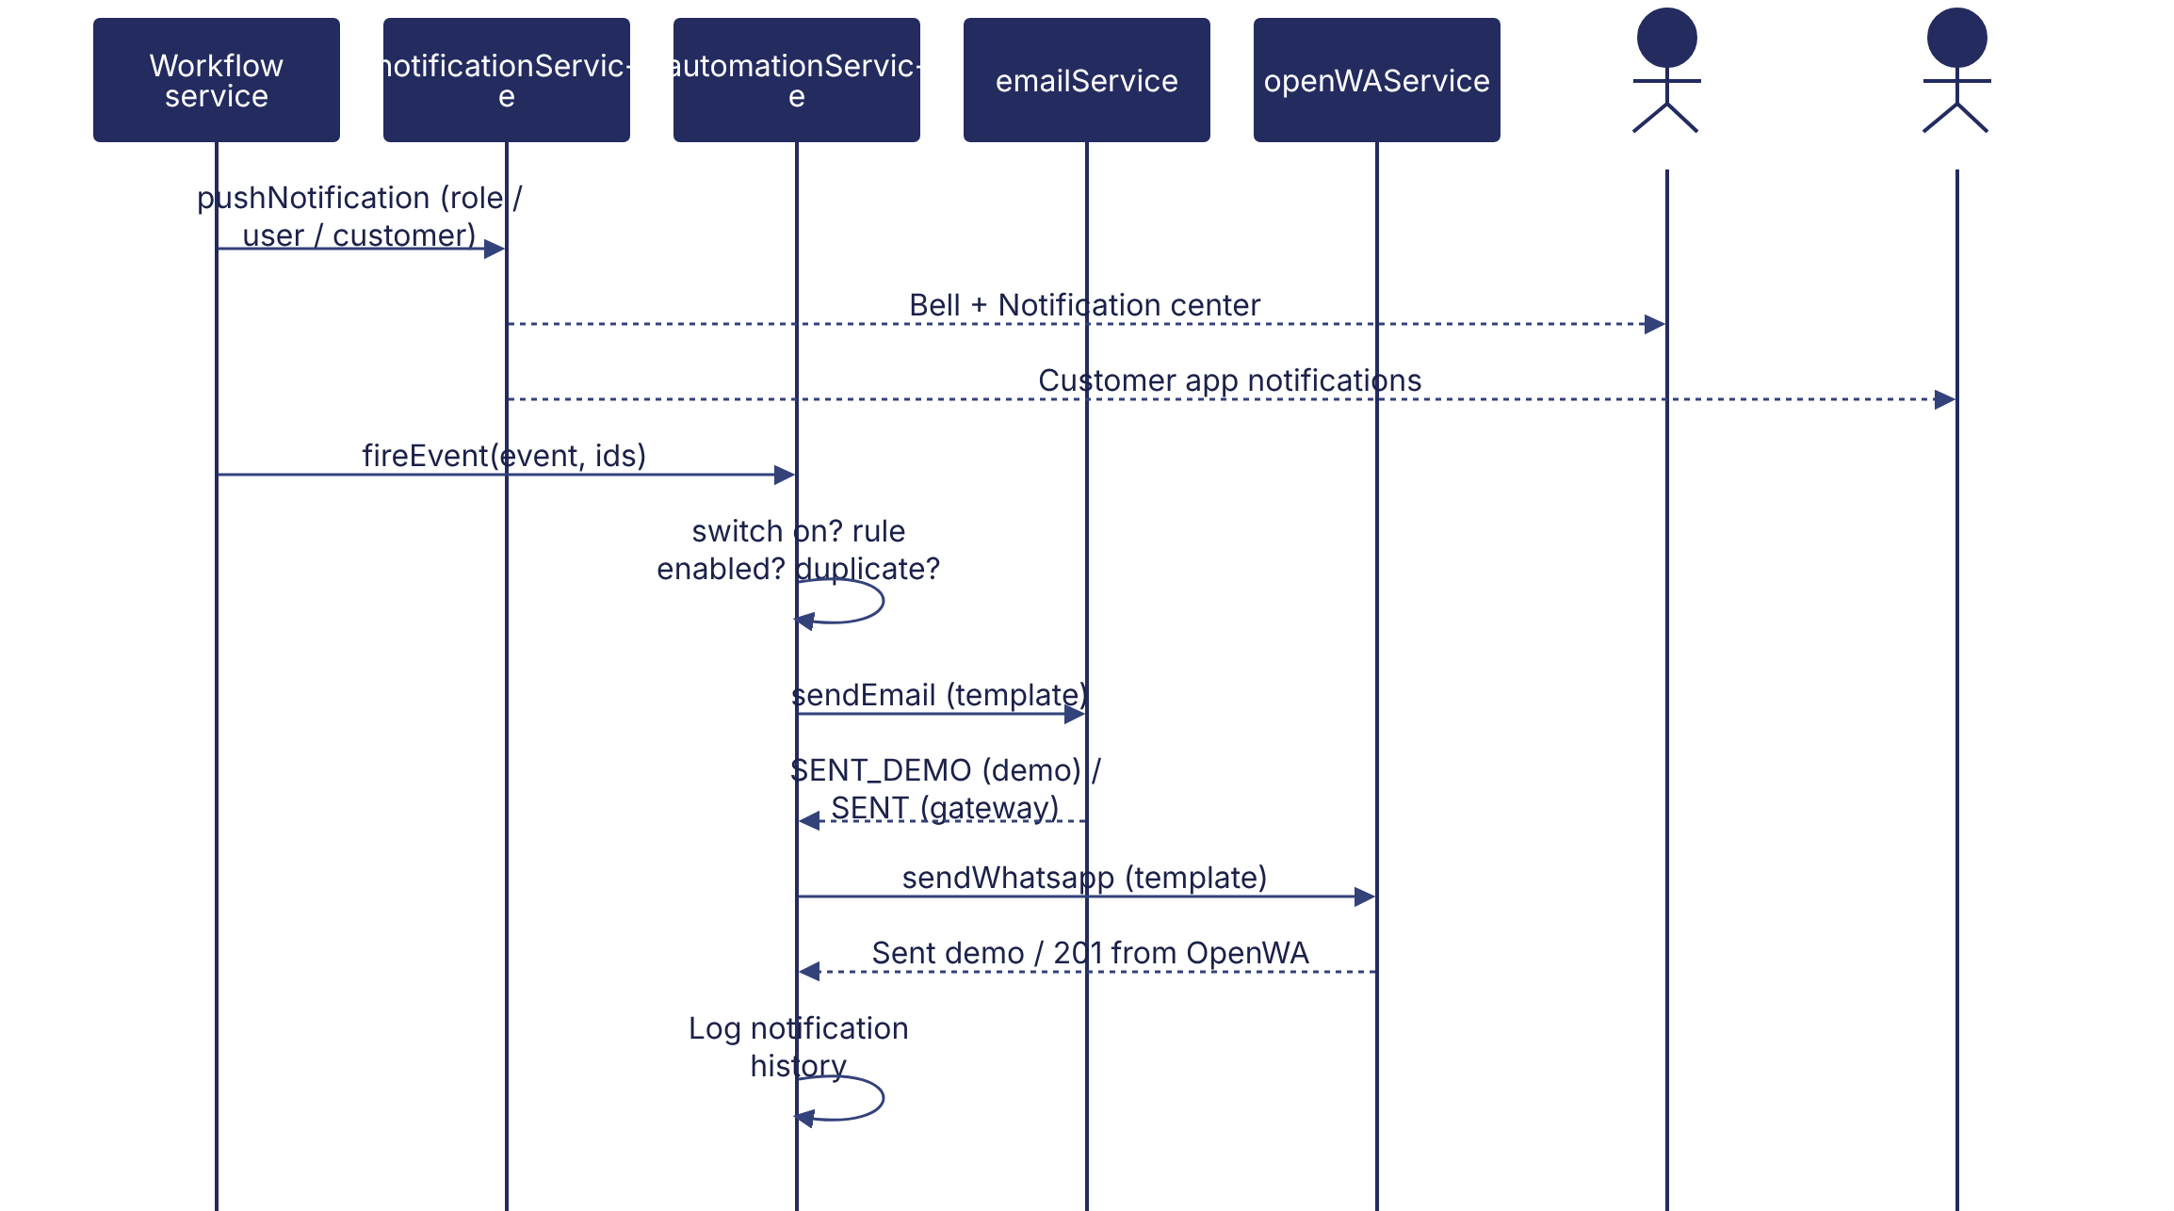
Implementation label: diagrams describe the prototype behaviour (VERIFIED in source code) unless a step is marked PROPOSED / NOT IMPLEMENTED.

12. Final outcome
Message logged.

Revision history
Version | Date | Author | Description
1.0 | 2026-11-12 | Documentation team | Initial draft prepared from analysis of the bellomassi-premium-ui source code and existing project documents.

